Drug Tables

Name of Condition (TEMPLATE- DO NOT REMOVE)
Def’n
Therapeutic goals
Algorithm
Non-pharmacological options
Education/counseling
Pharmacological Therapy
Drug/Dose | Indication | Adverse fx (AE) and Drug interactions (DI) | Contraindications & special considerations
1st Line Therapies
AEs:

DIs:
2nd Line Therapies
Notes
Monitoring
Referral
Other notes

Table of Contents

Name of Condition (TEMPLATE- DO NOT REMOVE) 1
Thera I: Fall/Winter 2024 Readings 5
Powerpoints: 5
Adverse Events (AEs) Overview 6
Medications to Watch 6
Medications of Concern 6
What Providers Can Do: 7
Reporting Adverse Reactions 7
Key Principles 8
Required Information on Medication Labels 9
Scope of Practice 10
Practice Standards 10
Collaboration, Consultation, and Referral 11
Conflict of Interest 11
Discontinuing NP-Client Relationship 11
Legal Requirements and Restrictions 11
3 Nursing Practice Standards: Authority, Context, and Competence 11
Controlled Acts 12
Delegation 12
Initiation 12
Quality Practice Setting 12
Nursing Accountabilities: Context 13
3. Competence 13
Competence in Nursing 13
Nursing Accountabilities: Competence 13
Overseas Coverage: 14
In-Canada IFHP Coverage: 15
Rational Prescribing: 16
Systematic Approaches to Pharmacotherapy Selection: 16
I Can PresCribE A Drug Mnemonic: 16
Week 2: HEENT (Ears/Eyes) 17
Intranasal corticosteroids (RX files) 17
IV vs Oral Antibiotics (RX files) 17
Acute Conjunctivitis (Pink Eye) 19
Blepharitis 21
Herpes Simplex Virus: Keratitis or Keratoconjunctivitis 22
Otitis Externa (Swimmer’s Ear) 22
Otitis Media (Acute, With Effusion, or Chronic Suppurative) 24
Chalazion 26
Dry Eye 27
Allergic Rhinitis 28
Otitis Media (Acute, With Effusion, or Chronic Suppurative) 31
Week 3: HEENT (Nose/Throat) 34
Pharyngitis 34
Laryngitis 36
Laryngotracheobronchitis (croup) 37
Epiglotittis: Medical Emergency 39
Influenza (Flu) Prevention and Seasonal Influenza- post-exposure antiviral prophylaxis 40
Seasonal Influenza- treatment for those at risk/symptomatic 43
Sinusitis- acute- adult & children 44
Pertussis (Whooping Cough) 46
Fever in children 48
CHRONIC COUGH 51
COVID 55
Upper Respiratory Tract Infection (Acute Rhinitis) – “Viral Rhinitis” on CPS 58
BACTERIAL MENINGITIS (ADULT AND CHILDREN) 59
Week 4/5: Skin Conditions 66
Impetigo & Bullous Impetigo- Adult & Children 67
Cutaneous Infections- Uncomplicated (Folliculitis, Furuncles, Carbuncles) 69
Cutaneous Infections - Complicated (e.g. perirectal abscess, decubitus ulcer) 72
Cellulitis (Mild) 72
Cellulitis- Severe (Non-Fascial) 74
Cellulitis: Facial 75
Cellulitis – Special Considerations: Diabetic Foot (Mild-Moderate) 77
Cellulitis – Special Considerations: Diabetic Foot (severe) 78
MRSA 80
Community-acquired MRSA 81
Bites: Cat, Dog, Wild Animal and Human 83
Herpes Simplex Virus-Mucocutaneous 86
Warts- common, plantar, anogenital 88
Head Lice 90
Scabies 91
Varicella Zoster Virus (Shingles) 92
Chicken Pox (Treatment and Post-exposure Prevention) 93
Onychomycosis (nail fungus) 94
Oral Candidiasis 96
Common Fungal Skin Infections 97
ACNE 97
Topical Corticosteroids 103
Treatment guide to common skin conditions 107
Rosacea 110
Atopic Dermatitis (Eczema) 112
Atopic, Contact and Stasis Dermatitis 115
Psoriasis 117
Diaper Dermatitis (Diaper Rash) 118
PPTs on Ulcers 1
Week 6/7: Cardiology 1
HTN Treatment Guidelines and Med info 1
Geriatric HTN 1
Lipid Lowering Agents (Rx files) 1
Geri Dyslipidemia (Rx files) 1
Framingham Risk Score (FRS)- 10 yr estimate of CVD Risk 1
Oral Antiplatelets 1
Oral Anticoagulants 1
Warfarin Tips and Dosing Nomograms 1
Atrial Fibrillation 1
Non-valvular Atrial Fibrillation: Anticoagulation 1
Summary 1
Venous Thromboembolism- VTE (includes PE, DVT) 1
Raynaud Phenomenon 1
Intermittent Claudication 1
Prevention Infective Endocarditis- Prophylaxis 1
Stable Angina 1
Syncope 1
Smoking Cessation 1
Post-myocardial infarction 1
Geri RX Files- Chronic Coronary Disease In Older Adults 1
RX Files Heart Failure with Reduced Ejection Fraction (HFrEF: Treatment Overview) 1
RXFILES-Heart Failure Medication when Patient is Sick (2020) 1
Rx Files Furosemide Sliding scale for HF outpatients 1
Week 8: Respiratory 1
Asthma (MUMS Respiratory Guidelines & RX Files Meds) 1
COPD (MUMS Respiratory Guidelines & RX Files Meds) 1
Acute Bronchitis 1
Acute Exacerbations of Chronic Bronchitis or COPD 1
Pneumonia-Adult 1
Pneumonia- Long-Term Care: Mild to Moderate 1
Pneumonia- Adult: Requiring Hospitalization (non-ICU) 1
Pneumonia- Children: Outpatients & Hospitalized 1
Pneumonia- Community Acquired 1
Asthma & COPD Inhalational Devices 1
Canadian Tuberculosis Standards 8th Edition 1
Week 9: GI 1
Constipation 1
Traveller’s Diarrhea – Treatment and Prevention 1
C.Diff 1
Helicobacter pylori infection -MUMS 1
GI Acid Suppression Medication Overview (RXFiles-evidence, tips and pearls, geri and comparison chart) 1
Inflammatory Bowel Disease (eCPS)- Crohn’s Disease and Ulcerative Colitis 1
Irritable Bowel Syndrome (IBS)- RXFiles/eCPS 1
Colic (eCPS) **FOCUS ON PARENT’S MENTAL HEALTH** 1
Dyspepsia and GERD (eCPS) 1
Drug Use during Pregnancy (eCPS) 1
Probiotics (Rx chart) 1
Managing Proton Pump Inhibitor Use in Older Adults 1
Week 11/12: GU 1
Epididymitis 1
Pelvic Inflammatory Disease (Outpatient) 1
Vulvovaginitis: Trichomoniasis 1
Vulvovaginitis: Bacterial Vaginosis (BV) 1
Vulvovaginitis: Vulvovaginal Candidiasis (VVC) 1
Urethritis - Gonococcal (Adult & Children) 1
Urethritis - Nongonococcal 1
Cervicitis 1
Genital Herpes (HSV 1 or 2) - Adult & Children 1
External Genital Warts (HPV) 1
Guideline: Recommendations for chlamydia, gonorrhea, and syphylis 1
Age of Sexual Consent 1
CNO Practice Guideline: Consent 1
CNO Practice Standard: Confidentiality and Privacy — Personal Health Information 1
Infections Characterized by Genital Ulcers (CPS) 1
Ontario HIV Testing Guidelines 1
PrEP and HIV Newsletter (Rx files) (i dont know if the newsletter includes: HIV overview or drug comparison chart, drug interactions?) 1
Pre-exposure Prophylaxis (PrEP) for Prevention of HIV 1
Acute UTI: Clinical Decision Aid 1
Acute UTI: Female, Uncomplicated 1
Recurrent Cystitis - Female 1
Asymptomatic Bacteruria 1
Acute Cystitis in Pregnant Women 1

Antibiotics Contraindicated in Pregnancy
MCAT acronym
Metronidazole, Chloramphenicol, Aminoglycosides (tobramycin, gentamicin), Tetracyclines

Thera I: Fall/Winter 2024 Readings

Week 1:

Powerpoints:
Ontario Drug Benefit Program
- Refer to powerpoint
Prescription writing for PHCNPs Fall 2024.pptx
- Refer to powerpoint
Drug Action and Pharmacokinetics
- Refer to powerpoint
The Non-Insured Health Benefits (NIHB) program provides coverage for various health benefits to eligible First Nations and Inuit individuals. 13
Eligibility: 13
1. First Nations Individuals: Must be registered under the Indian Act (Status Indians). 13
2. Inuit Individuals: Must be recognized by an Inuit land claim organization as outlined in the NIHB eligibility criteria. 13
3. Children: Those under 2 years old whose parents are eligible for NIHB benefits. 13
Coverage: 13
● Eligibility Verification: Clients must present their health care provider with their client identification to confirm eligibility. Providers should ideally submit claims directly to Express Scripts Canada, so clients do not pay at the point of service. 13
● Direct Coverage: Some clients might receive their health benefits directly from specific First Nations or Inuit governments or health authorities 13
For Providers: 13
● Claims Submission: Providers enrolled with NIHB can submit claims directly to Express Scripts Canada for eligible services. 13
Overseas Coverage: 13
In-Canada IFHP Coverage: 14
Rational Prescribing: 15
Systematic Approaches to Pharmacotherapy Selection: 15
I Can PresCribE A Drug Mnemonic:

Readings:

RxFiles: Patient Safety: Drug Considerations

Adverse Events (AEs) Overview
- Definition: An AE is a noxious and unintended response to a drug that occurs with normal use or testing for diagnosis, treatment, or prophylaxis of disease, excluding undesirable patient effects.

Medications to Watch
- High-Alert Meds:
  - Anticoagulants/Antiplatelets: Heparin, warfarin, clopidogrel.
  - Opioids: Morphine, hydromorphone, fentanyl.
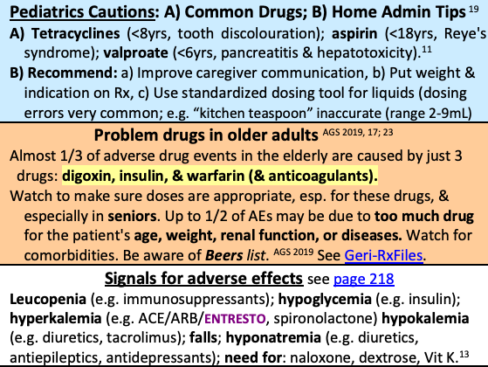
  - Chemotherapeutic Agents: Immunomodulators, denosumab.
  - Antibiotics (IV): Vancomycin, aminoglycosides.
  - Neuromuscular Blockers: Succinylcholine, rocuronium.
  - Injectables: lidocaine, magnesium sulfate inj, nitroprusside,
  - Psych meds/anticonvulsants: carbamazepine, phenytoin, phenobarbital & valproic acid digoxin, lithium, tacrolimus, theophylline
  - Other High-Alert Meds: Insulin, magnesium sulfate (IV), etc.

Medications of Concern
- Toxicity Risk Medications:
  - Antibiotics: Aminoglycosides, vancomycin.
  - Cardiotoxic Drugs: Doxorubicin, trastuzumab.
  - Sedatives: Benzodiazepines, zolpidem, etc.
- Potential for Severe Adverse Reactions:
  - Stevens-Johnson Syndrome (SJS) and Toxic Epidermal Necrolysis (TEN): Allopurinol, lamotrigine, phenytoin.
  - QT Prolongation: Citalopram, ciprofloxacin, levofloxacin, most antipsychotics especially clozapine.
New Medications to the Market:
  - Use Caution Until Proven Otherwise:
    - New drugs have less known safety profiles.
    - Post-market surveillance is critical in the first 2-5 years.
    - Healthcare providers are advised to remain cautious until sufficient evidence is available.
- Opioids:
  - Use the lowest effective dose, carefully monitor for side effects, and use adjunctive therapies.

What Providers Can Do:
- Medication Administration:
  - Avoid the use of multiple similar drugs.
  - Use appropriate dosing strategies (e.g., calibrated syringes, oral syringes for oral meds).
  - Avoid double coverage with similar drugs.
  - Encourage patients to review all medications with their providers.
  - Avoid polypharmacy.
- Safety Interventions:
  - Educate patients on proper drug use, potential side effects, and the importance of adherence.
  - Use error-proof systems (e.g., barcodes, labeled syringes).
  - Implement strategies for high-risk drugs (e.g., triple-check systems).

Reporting Adverse Reactions
- What Should Be Reported?
  - Report all serious AEs, including death, disability, hospitalization, and life-threatening reactions.
  - Reports should be submitted to MedEffect Canada.
Nurse Practitioner: Medication
- The Medication Practice Standard outlines nurses' accountabilities during various medication practices, including administration, dispensing, storage, inventory management, and disposal.
- Public Protection: The standard emphasizes three key principles to ensure safe medication practices:
  - Authority
  - Competence
  - Safety
- Scope of Application:
  - Applies to all nurses, including Registered Nurses (RNs), Registered Practical Nurses (RPNs), and Nurse Practitioners (NPs).

Key Principles
- Authority
  - Nurses’ Authority:
    - Nurses must have the appropriate authority to engage in medication practices.
    - RNs and RPNs: Require an order for medication practices when:
      - A controlled act is involved.
      - Administering prescription medications.
      - Legislation requires it in the practice setting.
    - Order Requirements:
      - Orders must be clear, complete, and appropriate.
      - Direct orders (for one client) are necessary for controlled substances; directives may apply to multiple clients.
    - Therapeutic Relationship: Nurses must maintain a therapeutic nurse-client relationship in all medication practices.
    - Follow-Up: If a medication order is unclear, incomplete, or inappropriate, the nurse must not proceed and must follow up with the prescriber.
- Competence
  - Knowledge, Skill, and Judgment:
    - Nurses must ensure they possess the necessary knowledge, skill, and judgment to perform medication practices safely.
  - Client Collaboration:
    - Engage the client in discussions about their medication history and decisions regarding their care plan. Provide education on medication use and strategies to minimize risks.
  - Evidence-Informed Practice:
    - Ensure that medication practices are based on the latest evidence.
    - Assess the appropriateness of the medication considering the client, the medication, and the environment.
  - Professional Limits:
    - Nurses should recognize the limits of their competence and seek help when necessary.
    - They must not engage in practices for which they are not competent.
- Safety
  - Safe Care Promotion:
    - Nurses must contribute to a culture of safety in their practice environments during medication practices.
  - Administration and Documentation:
    - Administer medication via the route indicated by the prescriber.
    - Dispense medication directly to the client or their representative.
    - Document and retain all necessary information on medication labels as part of the client's health record.
  - Medication Expiry and Storage:
    - Ensure that the medication will not expire before the expected use date.
    - Verify that medication has been obtained and stored safely and legally.
  - Risk Minimization:
    - Implement strategies to minimize the risks of misuse, addiction, and drug diversion.
  - Error and Adverse Reaction Management:
    - Take action to prevent, resolve, or minimize harm from medication errors or adverse reactions.
    - Report errors, near misses, or adverse reactions promptly.
  - Compliance with Policies:
    - Follow all relevant legislation, employer policies, and standards of practice related to medication storage, transportation, documentation, and disposal.
  - Ethical Conduct:
    - Avoid any conduct that could lead to a conflict of interest or personal/financial gain from medicatiQ on practices.
  - System Collaboration:
    - Work with the healthcare team to develop, implement, and evaluate systems that support safe medication practices.

Required Information on Medication Labels
- Labels for dispensed medications must include:
  - Identification number (if applicable).
  - Dispensing nurse’s name and title, and the prescriber’s name and title if applicable.
  - Name, address, and phone number of the dispensing location.
  - Medication identification (name, strength, manufacturer).
  - Quantity dispensed.
  - Date dispensed.
  - Expiry date (if applicable).
  - Client’s name.
  - Directions for use.
- Record Keeping: A copy of the information on the medication label must be kept in the client's health record.

Practice Standard Nurse Practitioner (2023)
- The CNO standards define nurse accountability and public expectations for safe practice.
- Nurse Practitioner (NP): Registered Nurses in the Extended Class with additional education, experience, and exams.
- Authorized Activities: NPs can diagnose, order/interpret diagnostic tests, and prescribe medications/treatments across various care settings.

Scope of Practice
- Nursing Scope: Defined by the Regulated Health Professions Act, 1991 and Nursing Act, 1991:
  - Nursing Practice: Involves health promotion, assessment, care, and treatment through supportive, preventive, therapeutic, palliative, and rehabilitative means.
- Controlled Acts (Authorized under the Nursing Act, 1991):
  - Communicating a diagnosis to a client.
  - Performing procedures below the dermis/mucous membrane.
  - Insertion of instruments beyond specified body parts (e.g., ear canal, nasal passages, etc.).
  - Applying/prescribing forms of energy.
  - Setting/casting fractures or joint dislocations.
  - Administering substances by injection/inhalation.
  - Prescribing, dispensing, or compounding medications.
  - Providing psychotherapy for serious mental disorders.
- Other Authorized Activities: NPs can order and apply specified tests.

Practice Standards
- General Practice:
  - Compliance with CNO standards, guidelines, and laws.
  - Use of protected NP titles.
  - Maintain competence in clinical NP practice.
  - Demonstrate NP competencies and limit practice to specialty areas.
- Health Assessment:
  - Conduct comprehensive/focused assessments.
  - Perform necessary assessment procedures.
  - Identify urgent/emergent situations.
- Diagnosis:
  - Develop differential diagnoses.
  - Order/perform appropriate tests and procedures.
  - Ensure timely follow-up and communication of results/diagnoses.
- Therapeutic Management:
  - Formulate/document care plans based on assessment and diagnosis.
  - Provide pharmacological interventions, considering client preferences and evidence-informed practice.
  - Monitor client responses and adjust treatment as needed.
  - Apply strategies to mitigate risks (e.g., medication misuse).
- Controlled Substances:
  - Assess risks of misuse/addiction/diversion before prescribing.
  - Educate clients on safe use, storage, and disposal.
  - Prescribe minimum necessary quantities in episodic care.
- Medical Cannabis:
  - Use caution due to variability in composition/potency.
  - Inform clients about risks and adhere to Cannabis Act regulations.

Collaboration, Consultation, and Referral
- Collaboration: Establish relationships with other healthcare providers.
- Consultation/Referral: Engage other professionals when needed for safe and comprehensive care.
- Verbal Orders: Provide only when immediate documentation isn’t possible; sign as soon as possible.

Conflict of Interest
- Professional Integrity: Avoid using NP designation for personal gain.
- Manage Risks: Develop strategies to ensure decisions are evidence-informed.
- Prescribing for Relatives: Only in emergencies when no other provider is available.

Discontinuing NP-Client Relationship
- Criteria for Discontinuation:
  - Client requests.
  - Alternative services arranged.
  - Reasonable time for client to find a replacement.
- Ethical Obligations:
  - Continue care until another provider is found.
  - Document the reasons and actions taken.

Legal Requirements and Restrictions
- Delegation:
  - NPs cannot delegate certain controlled acts (e.g., prescribing medication, psychotherapy).
  - Authorization of directives is allowed within legal boundaries.
Practice Standard Scope of Practice (2023)

3 Nursing Practice Standards: Authority, Context, and Competence
- Authority, Context, Competence are essential for safe, effective nursing practice. Nurses must demonstrate these accountabilities to ensure it is appropriate to perform activities.
1. Authority
- Legislated Scope of Practice: Nurses must be aware of their legislated scope, including controlled acts and authorizing mechanisms.
- Legal Authority: Nurses must ensure they have legal authority before performing any activity, including compliance with legislation and assessing the context and competence.
- Compliance: Nurses must practice in accordance with all applicable legislation (Regulated Health Professions Act (RHPA) & Nursing Act, 1991).

Controlled Acts
- Acts that can only be performed by authorized regulated health professionals, as they may be harmful if done without the necessary knowledge, skill, and judgment.
- NP-Specific Controlled Acts:
  - Communicating a diagnosis to a client.
  - Performing procedures below the dermis/mucous membrane.
  - Inserting instruments beyond specified body parts (e.g., ear canal, nasal passages).
  - Applying or ordering forms of energy.
  - Setting/casting fractures or joint dislocations.
  - Administering substances by injection/inhalation.
  - Prescribing, dispensing, selling, or compounding drugs.
  - Treating serious disorders via psychotherapy techniques.

Delegation
- By Nurses: Nurses authorized to perform controlled acts can delegate them to others, including unregulated care providers. The nurse is responsible for the decision and the delegatee's competence.
- To Nurses: Nurses can receive delegation for controlled acts they are not authorized to perform. Responsibility lies with the nurse performing the delegated act.
- NPs and Delegation: NPs cannot delegate the following controlled acts:
  - Prescribing/dispensing medication.
  - Ordering forms of energy.
  - Setting fractures/joint dislocations.
  - Providing psychotherapy for serious mental disorders.

Initiation
- When Authorizing Mechanisms Aren’t Required: Initiation allows RNs/RPNs to independently assess and perform specific controlled acts without an order, depending on the practice setting and informed consent.
2. Context
- Practice Environment: Nurses must consider whether their practice environment supports the performance of an activity and has the necessary resources for safe client care.

Quality Practice Setting
- Supportive Workplaces: Environments that support nursing practice, foster professional development, and ensure safety precautions are in place.
- Compliance: Nurses must ensure their practice aligns with all relevant legislation and employer policies, prioritizing CNO standards if conflicts arise.
- Collaboration: Client safety requires partnership between employers and nurses, focusing on collaboration within the health care team for the best client outcomes.

Nursing Accountabilities: Context
- Policy Compliance: Ensure policies support the performance of activities.
- Resource Advocacy: Advocate for necessary resources and safe practice environments.
- Collaboration: Foster interprofessional relationships for effective client care.
- Risk Assessment: Evaluate environmental risks and ensure safety.
- Client-Centered Care: Perform activities only when safe and appropriate, ensuring compliance with safety standards.

3. Competence
- Knowledge, Skill, and Judgment: Nurses must ensure they have the competence to safely perform activities, including leadership, decision-making, and critical-thinking skills.

Competence in Nursing
- Self-Reflection & Lifelong Learning: Nurses must continually reflect on their practice and identify learning needs to ensure safe client care, participating in quality assurance activities.
- CNO Quality Assurance Program: Nurses are required to participate in this program to maintain competence.

Nursing Accountabilities: Competence
- Safe Performance: Demonstrate the knowledge, skill, and judgment required for safe and effective activity performance.
- Client Assessment: Determine if a client’s condition warrants the activity.
- Consultation: Seek additional expertise or transfer care when necessary.
- Self-Reflection: Continuously seek learning opportunities to improve practice and participate in the CNO’s Quality Assurance Program.

List of Error-Prone Abbreviations
- Download document to review

Resources for seminars, clinicals, and assignments

ICANPRESCRIBE Condition Template 2024.docx
- In class worksheet
Cases Decision Aid
- In class worksheet
Drugs Funded by Ontario Drug Benefits: e-Formulary Search
- In class resource

Non-Insured Health Benefits for First Nations and Inuit
The Non-Insured Health Benefits (NIHB) program provides coverage for various health benefits to eligible First Nations and Inuit individuals.
Eligibility:
- First Nations Individuals: Must be registered under the Indian Act (Status Indians).
- Inuit Individuals: Must be recognized by an Inuit land claim organization as outlined in the NIHB eligibility criteria.
- Children: Those under 2 years old whose parents are eligible for NIHB benefits.
Coverage:
- Eligibility Verification: Clients must present their health care provider with their client identification to confirm eligibility. Providers should ideally submit claims directly to Express Scripts Canada, so clients do not pay at the point of service.
- Direct Coverage: Some clients might receive their health benefits directly from specific First Nations or Inuit governments or health authorities
For Providers:
- Claims Submission: Providers enrolled with NIHB can submit claims directly to Express Scripts Canada for eligible services.

Interim Federal Health Program
The Interim Federal Health Program (IFHP) provides health coverage to specific groups in Canada, including:
- Resettled Refugees:
  - Government-assisted, Blended visa office-referred, Joint assistance sponsorship, privately sponsored, and certain refugees under humanitarian considerations.
- Protected Persons:
  - Includes: Those with positive asylum claim or pre-removal risk assessment (PRRA) decisions.
- Refugee Claimants:
  - Individuals awaiting a decision on their claim, those with a positive PRRA decision, or whose claim is rejected or ineligible but has a PRRA application.
- Victims of Human Trafficking:
  - Those with a valid temporary resident permit.
- Victims of Domestic Violence
- Detainees

Overseas Coverage:
- For Resettlement Candidates: Covers pre-departure medical services including:
  - Immigration Medical Exams (IME)
  - Vaccinations
  - Medical support for safe travel
  - Health measures during disease outbreaks

In-Canada IFHP Coverage:
- Basic Coverage: Includes in-patient and out-patient hospital services, medical care, diagnostic and laboratory services, ambulance services.
- Supplemental Coverage: Includes limited vision care, urgent dental care, home and long-term care, services from allied health-care practitioners, assistive devices.
- Prescription Drug Coverage: Includes prescription medications listed on provincial/territorial drug formularies.
- IME Coverage: All beneficiaries are covered for one IME and related diagnostic tests.
- The IFHP does not cover costs claimable under other public or private insurance plans, and it does not coordinate benefits with other plans.

How to Report Adverse Drug Reactions

Why You Should Report a Side Effect
- Consumer Contribution: Reporting adverse reactions or problems helps make health and cannabis products safer for all Canadians.
- Importance of Timeliness: Report as soon as possible, even if unsure if a specific product caused the reaction.
- Value of Each Report: Every report counts, contributing to a broader understanding of a product's safety.
Understanding Signals in Health Product Safety
- What is a Signal?
  - A signal is an initial indicator of a potential issue with a drug, health, or cannabis product.
  - A single report is usually not enough to confirm a signal; multiple reports help in establishing a clearer connection.
  - Signals help evaluate the relationship between a product and an adverse reaction or problem, though they are not definitive proof of causation.
Benefits of Reporting Adverse Reactions
- Identifying Safety Issues: Helps in recognizing potential safety concerns associated with health products.
- Improving Product Safety: Contributes to making health products safer for all users by identifying rare or serious adverse reactions.
- Enhancing Global Knowledge: Adds valuable data to international databases on the benefits, risks, and effectiveness of drugs, health, and cannabis products.
- Facilitating Regulatory Actions: Your report can lead to changes in product labels, or even the removal of unsafe products from the Canadian market.
- Informing Stakeholders: Helps in communicating changes in product safety information to industry professionals, hospitals, healthcare providers, and consumers.
Steps Following a Report
- Monitoring and Evaluation: All reports are monitored and evaluated to determine the appropriate actions.
- Protective Actions: Based on the findings, steps are taken to protect Canadian consumers, which may include regulatory changes or product recalls.

I Can PresCribE A Drug Framework

Rational Prescribing:
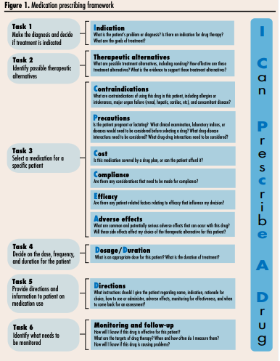
- Rational prescribing involves choosing the most appropriate therapeutic regimen for a specific patient, considering various factors like the diagnosis, patient needs, and available therapeutic options.
- Prescribing or prescription errors are prevalent, with studies indicating that up to 11% of all prescriptions in primary care may contain errors.
- Proper training in rational pharmacotherapy can lead to improved prescribing habits, at least in the short term, which underscores the importance of integrating these principles into residency curricula.

Systematic Approaches to Pharmacotherapy Selection:
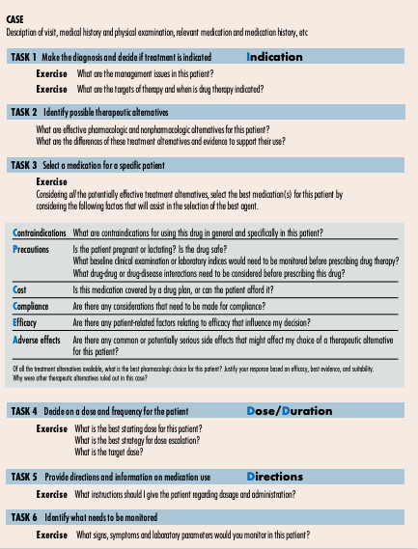
- WHO Guidelines: The World Health Organization (WHO) has published a "Guide to Good Prescribing," which advocates for a global approach to rational prescribing. This guide includes steps such as creating a personal formulary, defining the problem, specifying therapeutic objectives, ensuring medication efficacy and safety, informing the patient, and monitoring results.

I Can PresCribE A Drug Mnemonic:
- The mnemonic "I Can PresCribE A Drug" was developed to aid in rational prescribing. It includes specific steps that guide learners in selecting the best medication for a patient.
  - Indication: Identify the diagnosis and determine if therapy is needed.
  - Contraindications: Determine if any medications are contraindicated based on the patient’s condition.
  - Precautions: Evaluate any necessary precautions, including pregnancy, lab indices, and potential drug-disease or drug-drug interactions.
  - Cost/Compliance: Consider drug costs, coverage, and ease of administration to ensure compliance.
  - Efficacy: Assess the efficacy of treatment options, considering evidence from clinical trials and guidelines.
  - Adverse Drug Effects: Evaluate common and serious adverse drug reactions to further refine the choice.
  - Dosage/Duration/Direction: Determine the appropriate dosage, duration of therapy, and directions for the patient.

Week 2: HEENT (Ears/Eyes)

Intranasal corticosteroids (RX files)
Examples: beclomethasone, budesonide, fluticasone, ciclesonide, mometasone
Indications: allergic/non-allergic rhinitis
Adverse effects: Epistaxis, transient nasal irritation, burning/stinging, pharyngitis, sneezing
Contraindications: Combining steroids - systemic fx may be of increased concern when steroids are combined (e.g. intranasal steroids + prednisone)
Precautions:
- Excess nasal secretions may decrease effectiveness (blowing nose first +/- decongestants can help minimize this)
- Hypothyroid and cirrhosis can increase steroid effects

IV vs Oral Antibiotics (RX files)
Beta-lactamase (e.g. N gonorrhae, H. influenzae, E. Coli): an important mechanism bacteria use to resist beta-lactam antibx is the beta-lactamase enzyme which cleaves the beta-lactam ring
- Adding clavulanic acid to amoxicillin can renew coverage of these organisms
- However, resistance can still occur such as through extended-spectrum beta-lactamase (ESBL) which resists all penicillins, cephalosporins, and all beta-lactam/beta-lactamase inhibitor combos

Penicillin allergy and cephalosporin cross-reactivity:
- In anaphylactic penicillin allergies: risk of cross-reactivity is low (1-2%); however the usual recommendation is to avoid cephalosporins
- In mild penicillin allergy (e.g. rash only), risk of rxn is <0.1% and cephalosporin considered safe

Which antibx are assoc with QTC prolongation?
- Macrolides (e.g. clarithro, azithro, erythro) and fluoroquinolones (e.g. moxiflocacin, levofloxacin)

How do you reduce diarrhea when prescribing amoxicillin/clavulanate?
- Use high dose 7:1 formulation and smaller dose, more frequently

Antibx | AE | DI | Monitor
Penicillins (e.g. amoxicillin, ampicillin) | Rash, N/VD, | -Can increase INR with warfarin  -?may cause oral contraceptive failure  -Risk of allergy cross-reactivity with penicillins and cephalosporins | Anaphylaxis
Cephalosporins (e.g. cephlexin, cefixime, ceftriaxone) | Rash, nausea, diarrhea |  | Anaphylaxis
Macrolides (e.g. Azithromycin, clarithromycin, erthromycin) | GI upset, increased LFTs, headache, insomnia, QT prolongation  Caution: increased risk of malformations in pregnancy | -Clarithromycin and erythromycin CYP3A4 and p-glycoprotein inhibitors | LFTs, CBC (with prolonged therapy)
Tetracyclines (e.g. doxycycline, minocycline) | GI upset, photosensitivity (use sunscreen if long-term use), esophageal irritation and ulceration  Contraindicated: pregnancy, children <8 years, severe renal or hepatic dysfunction | -decreased GI absorption of electrolyte supplements (Fe, Ca, Mg - separate doses by 2h)  - Increased INR and bleeding risk with warfarin  -May decrease oral contraceptive effectiveness
Fluoroquinolones (e.g. ciprofloxacin, levofloxacin) | GI upset, headache, dizziness, rash, increased WTC, confusion, increase/decrease in blood sugar, QT prolongation  Contraindicated: tendinopathy/tendon rupture  Caution: >60 yo, renal impairment, <18 yo | Increased INR with warfarin, QTC prolongation, decreased absorption of electrolyte supplements | Joint pain, blood glucose if diabetic, labs if prolonged therapy (CBC, SCr, LFTs)
Antifolates  (e.g. trimethoprim/sulfamethoxazole) | N/V, skin rxn  Contraindicated:  Under 2months, pregnancy  hx of drug induced immune thrombocytopenia from sulfonamides or trimethoprim; megaloblastic anemia from folate deficiency, severe liver disease, pregnancy | Increased INR/bleed risk, hypoglycemia risk, | CBC, Scr, BUN, K+ (if >3-5 d of therapy)
Other: lots of others antibx in the chart (e.g. flagyl, macrobid, vanco) if you want to see more. Only included the major categories in this table

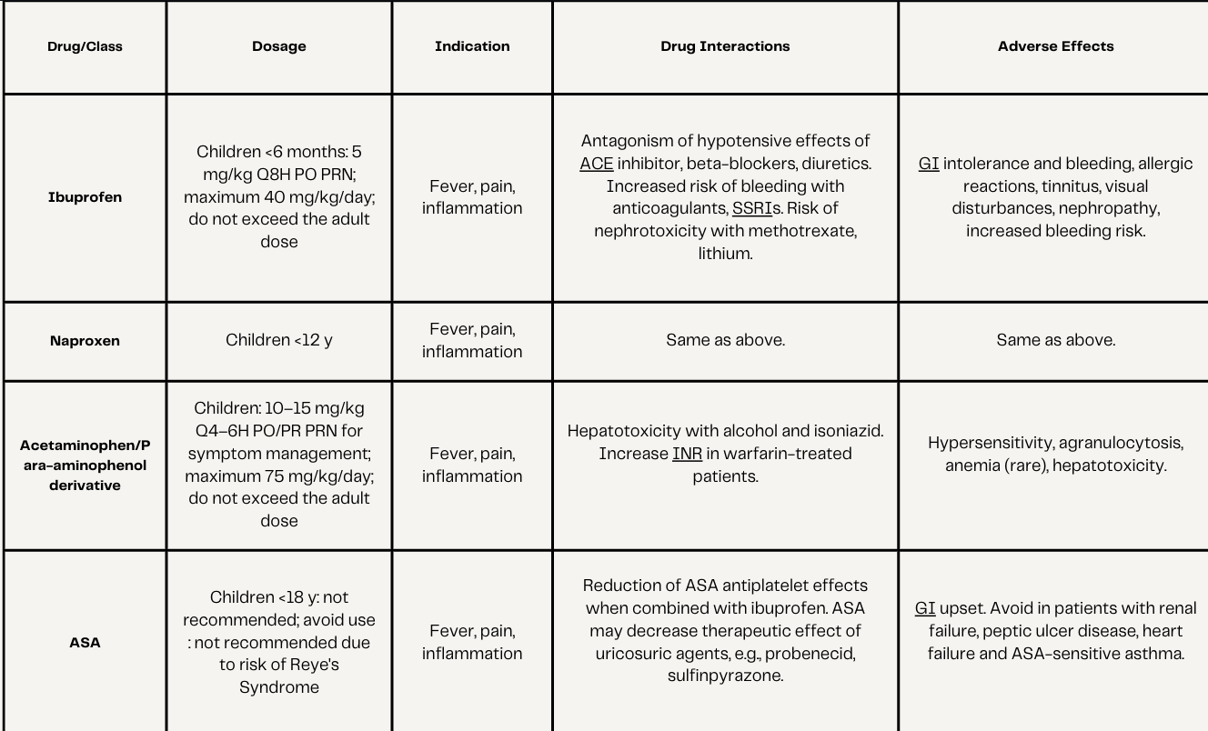

Acute Conjunctivitis (Pink Eye)
Def’n | Inflammation/infx of conjunctiva
Therapeutic goals | Resolution of infx, decrease in S/S within 48 h, prevent transmission to others
Algorithm | There are ‘red eye’ algorithms in CPS if interested
Non-pharmacological options | 1. Advise regarding self-limiting nature of condition.  2. Both the bacterial and viral forms highly contagious for 48-72 hours; restrict contact with others 24-48 hours after treatment is initiated. Avoid sharing personal items and ensure careful handwashing.  3. Cleanse affected eye(s) by wiping from the inner canthus outward using a single tissue/cotton ball.  4. Clean eyelashes several times a day with baby shampoo and warm water.  5. Cold compresses to comfort (e.g., 10-15 minutes on then off).  6. If there is poor response after using topical medication for 2-3 days, consider resistant bacterial infection or non-infectious cause (viral, allergy).  7. Avoiding wearing contact lenses while sleeping, showering and swimming will reduce chances of conjunctivitis. Proper contact lens care and hygiene should be utilized
Education/counseling
Pharmacological Therapy
Drug/Dose | Indication | Adverse fx (AE) and Drug interactions (DI) | Contraindications & special considerations
1st Line Therapies
Duration of therapy = 5-7 days
No antibx or antiviral needed | Viral (adenovirus, cosackievirus, ECHO virus) *More common in adults | N/A | N/A
OTC: Gramicidin-polymyxin B drops (Polysporin drops) 1 drop QID x5-7 days | Bacterial (S. Aureus, S. pneumoniae, H. influenzae, M. catarrhalis) *More common in children | AEs: Antibacterials: corneal epithelial toxicity, allergy, and bacterial resistance (prolonged use)
Fusidic Acid 1% drops (Children>2 yrs) - 1 drop BID x5-7 d |  |  | Broad spectrum and BID dosing makes it very useful for children and elderly
Erythromycin 0.5% ointment 0.5-1 inch QID x5-7 days
Fluoroquinolones (e.g. moxifloxacin 0.5% 1 drop TID x7 days; Besifloxacin 0.6% drops 1 drop TIDx7 days,, ciprofloxacin 0.3% drops) | For more severe cases: e.g. suspected Pseudomonas from contact lenses, corneal involvement, treatment failure
Notes
Monitoring | - Bacterial: F/U within 2 d of initiating tx  - Viral: F/U within 1 wk of initiating tx
Referral | N/A?
Other notes | Clinical Cues (differentiating b/w bacterial, viral, allergic):  - Bacterial -Rapid onset, uni/bi-lateral conjunctival redness, gluey sticky eyelids in AM with crusty lashes  - Viral: Rapid onset, thin watery clear discharge with minimal lash crusts  - Allergic: very similar to viral except more itchy, worse with rubbing  Avoid topical corticosteroids - should only be prescribed by ophthalmologist d/t potential AE (e.g. corneal ulcers)  Delayed prescribing - since it’s self-limiting, can initiate antibiotics only if symptoms don’t improve within 3 days of onset as a strategy.  -Ideally start abx day 2-5, after day 6 it is not recommended as infx has already started to heal.

Blepharitis
Def’n | Chronic condition; Inflammation of eyelid causing red, irritated itchy eyelids and formation of dandruff-like scales on eyelashes. Etiology can be sebhorreic, bacterial, mixed, or d/t meibomian gland dysfunction
Therapeutic goals | Reduce inflammation and discomfort; reduce risk of recurrence and of complications such as conjunctivitis and keratitis
Non-pharmacological options | - *Lid hygiene is the main treatment and works best once daily or BID – apply hot compress for 5 min to soften scales and crusts then scrub the eyelid margin and bases of eyelashes with washcloth, warm water and baby shampoo  - Artificial tears 4-8x/day PRN to alleviate symptoms  - Avoid rubbing or irritating eyelids, exposure to wind/smoke/cosmetics/other irritants, avoid wearing contacts
Education/counseling
Pharmacological Therapy
Drug/Dose | Indication | Adverse fx (AE) and Drug interactions (DI) | Contraindications & special considerations
1st Line Therapies
Lid hygiene is most important
Erythromycin 0.5% ointment ½ inch QHS | Bacteria or mixed or meibomian gland dysfunction  (S. Aureus, S. epidermidis) | AEs: corneal epithelial toxicity, allergy and bacterial resistance (prolonged use)
2nd Line Therapies
Tobramycin 0.3% ointment ½ inch QHS | Bacteria or mixed or meibomian gland dysfunction  (S. Aureus, S. epidermidis) | AEs: corneal epithelial toxicity, allergy and bacterial resistance (prolonged use)
Notes
Monitoring | - F/U in 1 week if pt requires anti-infective therapy
Referral | Ophthalmologist if loss of visual acuity, moderate or severe pain, severe or chronic redness, corneal involvement, recurrent episodes or lack of response to therapy
Other notes | Opthalmic antibiotic ointments – helpful in short term of acute phase but resistance and consequent lack of efficacy rapidly ensue if tx is prolonged; use of high dose, short duration will minimize development of resistance and maximize efficacy  - Opthalmic ointments are preferred to solutions/drops because they remain in contact with the line margin for longer periods of time  Topical corticosteroids - not usually recommended; requires ophthalmologist evaluation

Herpes Simplex Virus: Keratitis or Keratoconjunctivitis
Def’n | HSV can cause keratitis and/or conjunctivitis. Red, irritated, watery eye often accompanied by multiple vesicles on eyelid; eyelid edema and ulcers may be present; may involve cornea
Therapeutic goals | Ameliorate symptoms, prevent corneal injury with vision impairment
Pharmacological Therapy
Drug/Dose | Indication | Adverse fx (AE) and Drug interactions (DI) | Contraindications & special considerations
1st Line Therapies
Trifluridine (Viroptic) - instill 1 drop Q2h while awake until lesion is re-epithelialized (max 9 drops daily)  then 1 drop Q4h x7 d (max 5 drops daily)  [Anti-viral] | Herpes Simplex 1 or 2 | AEs: Burning/stinging | N/A
Notes
Referral | Consult ophthalmologist for all HSV eye infx d/t risk of visual impairment if HSV suspected

Otitis Externa (Swimmer’s Ear)
Def’n | Inflammation of external ear canal +/- pinna or tympanic membrane involvement
Therapeutic goals | Eliminate pathogenic microbes, remove debris, control pain/fever
Algorithm | N/A
Non-pharmacological options | - Aural toilet: important if there’s significant debris in ear that can be reached (adequate cleansing of ear canal with removal of debris required so topical therapy can be effective)  - Can use ear wicks if canal not patent for drug delivery
Education/counseling | After swimming, remove as much moisture from ear as possible; can try hair dryer, tilting head, and/or in presence of intact TM can use few drops of vinegar to ear  -Avoid Q-tips/trauma to clean ears
Pharmacological Therapy
Drug/Dose | Indication | Adverse fx (AE) and Drug interactions (DI) | Contraindications & special considerations
1st Line Therapies
OTC Polysporin drops 1-2 drops QID x 7 days | Without tympanic membrane perforation | AEs: potentially ototoxic | C/I: DO NOT use in non-intact TM d/t ototoxicity
Ciprodex otic suspension 4 drops BID x 7 days | With OR without tympanic membrane defect  Useful for underlying dermatitis | AE: prolonged use of steroid/antibx combos can result in secondary fungal infx and mycelial plug | C/I: Hypersensitivity to other quinolones, including nalidixic acid.  Hypersensitivity to other corticosteroids.  Fungal or parasitic otic infections.
Clotrimazole 1% cream BID x 1-3 weeks | Otitis Externa: Otomycosis  Fungal infection (e.g. candida)
Tolnaftate 1% cream BID x 1-3 weeks | Otitis Externa: Otomycosis  Fungal infection (e.g. candida)
Locacorten Vioform ear drops 2-3 drops BID | Otitis Externa: Otomycosis  Fungal infection (e.g. candida)
Notes
Monitoring | S/S of otitis externa should be significantly reduced within 48-72 h and completely resolved within 1 week (most patients) or 2 weeks
Referral | - If persists >7 days, reassess and refer  - Refer all otomycosis to a specialist

Otitis Media (Acute, With Effusion, or Chronic Suppurative)
Def’n | - Acute otitis media +/- effusion – bacterial infx of middle ear  - Otitis media with effusion (OME) – presence of fluid in middle ear without S/S of infection and distinguished from acute otitis media (which has acute onset, purulent middle ear effusion and inflammation)  - May occur spontaneously because of poor eustachian tube function or as an inflammatory response following acute otitis media  - After bacteria eradication, effusion may persist for up to 1-3 months > so if middle ear fluid detected in asymptomatic children, no need for further tx as long as no other symptoms  - Chronic suppurative – term used to describe either recurrent or persistent bacterial infx of middle ear – hallmark features incl: presence of a tympanic membrane perforation, conductive hearing loss, and presence of malodorous aural discharge  - ENT referral if cholesteatoma
Therapeutic goals | - Relieve symptoms, sterilize middle ear, prevent complications (e.g. mastoiditis, intracranial infx, facial paralysis)
Algorithm | 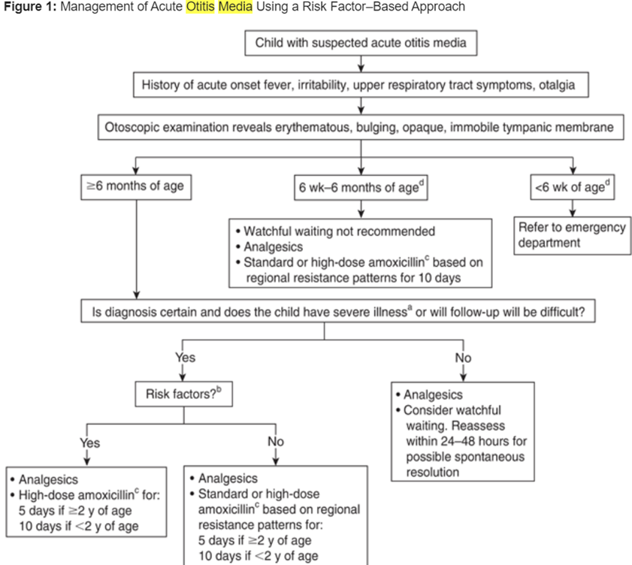
Non-pharmacological options | Watchful waiting: The high spontaneous recovery rate (80-90%) of acute otitis media may warrant watchful waiting for 48-72h before starting antibiotic therapy in previously healthy children  - Only appropriate if: age >6 months, parent can watch them for 2-3 days and F/U,  - Return if S/S don’t improve after 2-3 days or immediately if symptoms worsen or new symptoms appear > verify dx of acute otitis media > start antibx therapy
Education/counseling | - Tylenol/advil can be given for 2-3 d to treat earache
Pharmacological Therapy
Drug/Dose | Indication | Adverse fx (AE) and Drug interactions (DI) | Contraindications & special considerations
1st Line Therapies
Duration of therapy:
5 days for children >2 yo with uncomplicated otitis media
10 days for younger children or children of any age with complications (e.g. perforated eardrum or recurrent otitis media)
ADULTS: Amoxicillin 500mg TID F5D | Acute Otitis Media - WITHOUT TM perforation  S. Pneumoniae, H. Influenzae | AEs: Occasionally mild diarrhea, rash  DIs: allopurinol, hormonal contraceptives, methotrexate, tetracyclines, vitamin K antagonists | Contraindications: hypersensitivity to penicillins or other beta-lactam antibx
PEDS: Amoxicillin 80-90 mg/kg/day divided BID or TID (max 4 g/day)
ADULTS/Peds: Ciprodex 4 drops BID | Acute Otitis Media -  WITH tympanic membrane perforation or ventilation tubes  S. Aureus, P. Aeruginosa | N/A | Contraindications: Hypersensitivity to other quinolones, including nalidixic acid.  Hypersensitivity to other corticosteroids.  Fungal or parasitic otic infections.
ADULTS/Peds: Ciprodex 4 drops BID | Chronic suppurative - S. aureus, S pneumoniae | N/A
2nd Line Therapies
Amoxi-clav is typically used for tx failure or recurrence as it possesses added benefit of stability against beta-lactamases; makes it effective against most penicillin resistant bacteria
ADULT: Amoxicillin/Clavulanate 500mg TID or 875mg BID | Acute Otitis Media -  Without tympanic membrane perforation  S. Pneumoniae, H. Influenzae, Group A Strep, S. Aureus | AEs: Diarrhea common  DIs: contraceptives (may reduce efficacy by lowering estrogen reabsorption), anticoags (can increase PTT/INR) | Contraindications: hypersensitivity to penicillin or cephalosporin group of B-lactams  Suspected mononucleosis
PEDS: Amoxicillin/clavulanate 40-80 mg/kg/day divided BID (max 4 g/day) | Acute Otitis Media - Without TM perforation  S. Pneumoniae, H. Influenzae
Adults/Peds: Sofracort (framycetin sulfate-dexamethasone-gramicidin) 2-3 drops TID or QID | Chronic suppurative | AE: risk of ototoxicity (avoid in perforated eardrum) | Contraindications: viral and fungal infx, perforated ear drum b/c risk of ototoxicity
Notes
Referral | For chronic suppurative otitis media - refer if there is any cholesteatoma (growth behind the tympanic membrane aka eardrum); may require surgical consult
Other notes | Therapeutic tips:  - Most children will have middle ear effusions after completion of therapy > no need to treat abnormal appearing tympanic membrane in asymptomatic child (can persist up to 3 mo)  - Probiotics can reduce risk of antibiotic assoc diarrhea  ***High dose 7:1 formulation less risk of diarrhea or spread dose over more administrations***  Give for 10 days if perforated ear drum or recurrent infx (more than 3 in 6m or 4 in a year). Give a higher dose if in daycare, less than 2 years, or had abx in the last 3 months.

Chalazion
Def’n | Chronic lipogranulomatous inflammation of meibomian gland located in the eyelid margin. Inflammation occurs from occlusion of ducts
Therapeutic goals | Resolve lesion, prevent recurrence
Algorithm | 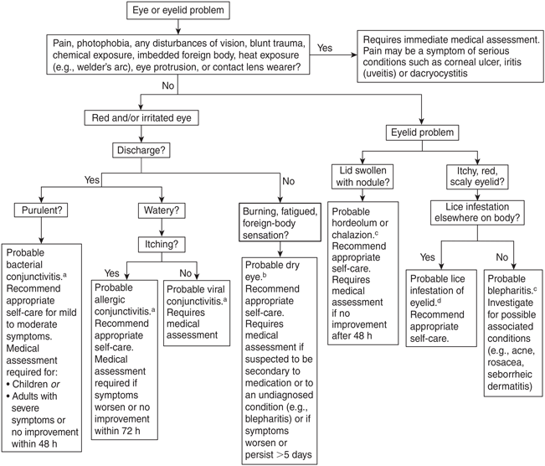
Non-pharmacological options | 25-50% of lesions resolve with warm compresses applied several times a day to soften sebaceous secretions that may be blocking meibomian gland orifices then massage eyelid
Education/counseling | Not infectious cause so no other tx needed
Notes
Referral | Larger lesions may require surgical excision or steroid injections > refer to ophthalmologist

Dry Eye
Def’n | -loss of homeostasis of the tear film and accompanied ocular symptoms
Therapeutic goals | -ease discomfort, minimize symptoms; prevent/delay complications
Algorithm
Non-pharmacological options | -altering environment (humidifier, no smoke), lifestyle changes (screen time)
Education/counseling | -screen time, decrease contributing medications, contact lens
Pharmacological Therapy
Drug/Dose | Indication | Adverse fx (AE) and Drug interactions (DI) | Contraindications & special considerations
1st Line Therapies
Systane Gel  Apply to inside of lower lid TID-QID for 3-5 days | Dry eye | AEs: preservative toxicity; filmy/blurry vision  DIs: | -if applying >4x/day use preservative free
2nd Line Therapies
Corticosteroids- fluorometholone | 1-2 drops BID-QID for 2 weeks | AES: stinging upon instillation
Notes
Monitoring | -3-5 days symptoms should improve
Referral
Other notes

Allergic Rhinitis
Def’n | -inflammation of the nasal mucosa following inhalation of allergen
Therapeutic goals | -prevent symptoms by avoiding  -alleviate signs and symptoms, minimize adverse effects, improve quality of life
Algorithm | 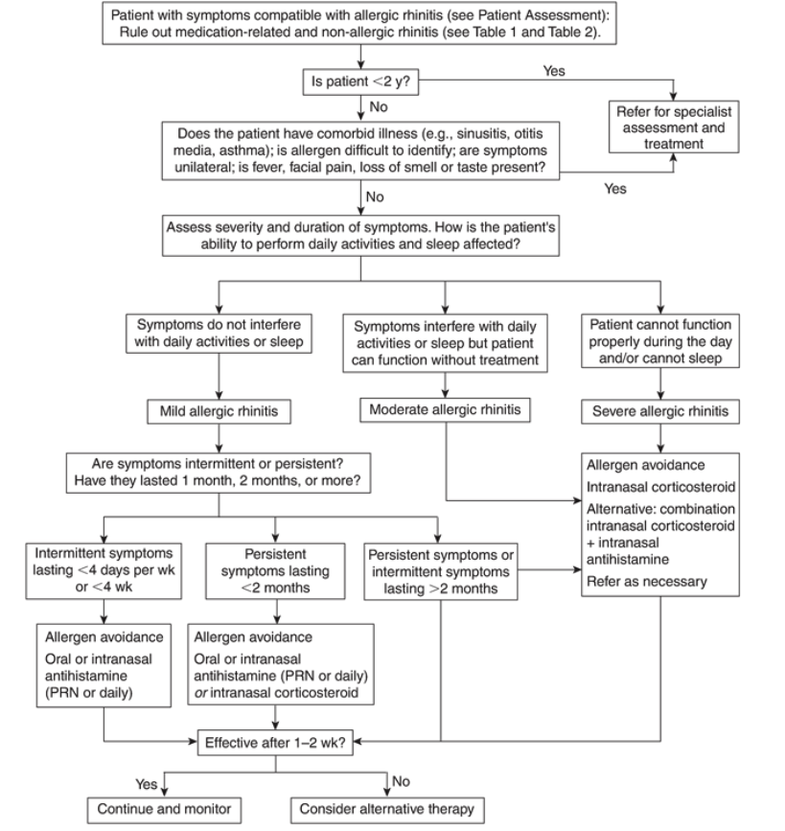  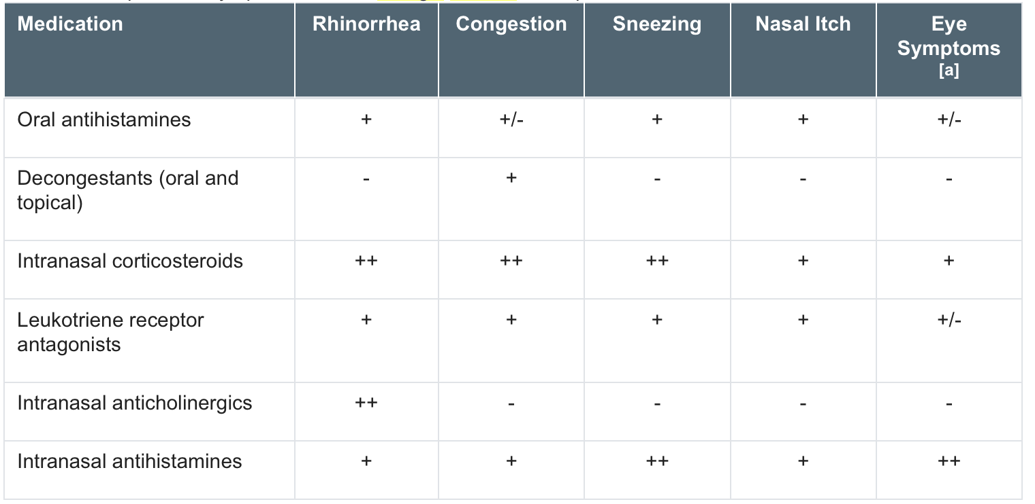  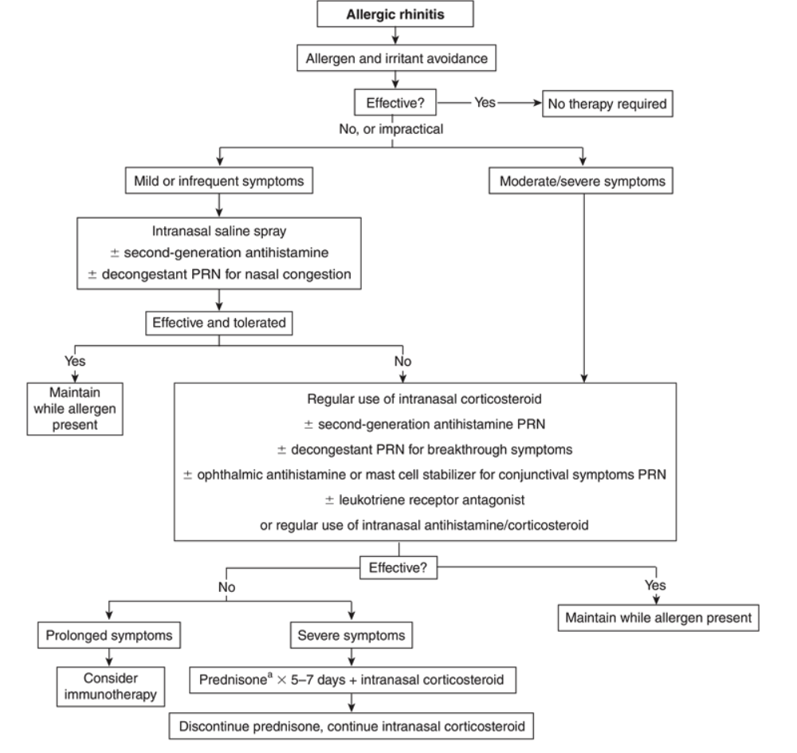
Non-pharmacological options | Intranasal saline  Avoid Allergens
Education/counseling | Prevention
Pharmacological Therapy
Drug/Dose | Indication | Adverse fx (AE) and Drug interactions (DI) | Contraindications & special considerations
1st Line Therapy- Mild Allergic Rhinitis
Second-generation antihistamines PRN or daily  Ceterizine 5-10mg q24h (sedative)  Desloratadine | -mild symptoms, unavoidable allergen  -rhinorrhea, sneezing, nasal itch | AEs: sedation, anticholinergic effects, headache  DIs:CNS depression when combined with alcohol, sedatives; anticholinergic increases with TCAs | -safe in pregnancy  -less sedative than 1st line, ceterizine can still be sedative
1st Line Therapy- Moderate/Severe Allergic Rhinitis
Intranasal corticosteroids  Mometasone, fluticasone furoate, beclomethasone 2 sprays (50 mcg/spray) in each nostril BID | -moderate to severe symptoms  -rhinorrhea, congestion, sneezing, nasal itch, eye symptoms | AEs: burning or stinging, nosebleed, growth suppression with long term use  DIs: | -safe in pregnancy  -7-14 day for full onset, start 2 weeks before allergic symptoms usually begin
Second & Third Line Therapies
Mast Cell Stabilizers |  |  | -start before exposure and throughout season
Decongestants (pseudoephedrine) | -congestion |  | -adjunctive therapy
Leukotriene Receptor Antagonists | -rhinorrhea, congestion, sneezing, nasal itch
Combination Therapies |  |  | 2nd gen am + 1 gen pm  Anti + decongest  Anti + corticosteroid
Notes
Monitoring | Patient to monitor symptoms, drowsiness, [insomnia and BP-oral decongestant]
Peds  Pregnancy and Breast feeding | Peds: over 6m use 2nd generation antihistamine, over 2 year use ICS  -don't use decongestant under 6 years  -Pregnant or breastfeeding: ICS and 1st and 2nd generation antihistamines are safe. Don't use oral decongestant or immunotherapy
Referral
Other notes | Symptom combination first and second line (CHART)

Otitis Media (Acute, With Effusion, or Chronic Suppurative)
Def’n | - Acute otitis media +/- effusion – bacterial infx of middle ear  - Otitis media with effusion (OME) – presence of fluid in middle ear without S/S of infection and distinguished from acute otitis media (which has acute onset, purulent middle ear effusion and inflammation)  - May occur spontaneously because of poor eustachian tube function or as an inflammatory response following acute otitis media  - After bacteria eradication, effusion may persist for up to 1-3 months > so if middle ear fluid detected in asymptomatic children, no need for further tx as long as no other symptoms  - Chronic suppurative otitis media – term used to describe either recurrent or persistent bacterial infx of middle ear – hallmark features incl: presence of a tympanic membrane perforation, conductive hearing loss, and presence of malodorous aural discharge  - ENT referral if cholesteatoma
Therapeutic goals | - Relieve symptoms, sterilize middle ear, prevent complications (e.g. mastoiditis, intracranial infx, facial paralysis)
Algorithm
Non-pharmacological options | Watchful waiting (only in children>6 months): The high spontaneous recovery rate (80-90%) of acute otitis media may warrant watchful waiting for 48-72h before starting antibiotic therapy in previously healthy children. Most children do well and thus spared the risks assoc with repeated antibx prescriptions.  - Return if symptoms don’t improve after 2-3 days or immediately if symptoms worsen or new symptoms appear > verify dx of acute otitis media > start antibx therapy
Education/counseling | - Tylenol/advil can be given for 2-3 d to treat earache
Pharmacological Therapy
Drug/Dose | Indication | Adverse fx (AE) and Drug interactions (DI) | Contraindications & special considerations
1st Line Therapies
Duration of therapy:
5 days for children>2 yo with uncomplicated otitis media
10 days for younger children or children of any age with complications (e.g. perforated eardrum or recurrent otitis media)
ADULTS/Peds: Ciprodex (ciprofloxacin and dexamethasone)  4 drops BID | Acute Otitis Media -  WITH tympanic membrane perforation or ventilation tubes  S. Aureus, P. Aeruginosa | AEs: ear discomfort  DIs: None | Contraindications: Hypersensitivity to cipro, dex, or other quinolones or corticosteroids  Fungal or parasitic otic infections.
2nd Line Therapies
Amoxi-clav is typically used for tx failure or recurrence as it possesses added benefit of stability against beta-lactamases; makes it effective against most penicillin resistant bacteria
ADULT: Amoxicillin/Clavulanate 500mg TID or 875mg BID | Acute Otitis Media -  Without tympanic membrane perforation | AEs: Diarrhea common  DIs: contraceptives (may reduce efficacy by lowering estrogen reabsorption), anticoags (can increase PTT/INR) | Contraindications: hypersensitivity to penicillin or cephalosporin group of B-lactams  Suspected mononucleosis
Cefprozil 250-500mg BID | Acute Otitis Media -  Without tympanic membrane perforation
Cefuroxime | Acute Otitis Media -  Without tympanic membrane perforation
PEDS: Amoxicillin/clavulanate 40-80 mg/kg/day divided BID (max 4 g/day) | Acute Otitis Media -  Without tympanic membrane perforation
Notes
Monitoring | Didn’t really say on CPS
Referral | For chronic suppurative otitis media - refer if there is any cholesteatoma (growth behind the tympanic membrane aka eardrum); may require surgical consult
Other notes | Therapeutic tips:  - Most children will have middle ear effusions after completion of therapy > no need to treat abnormal appearing tympanic membrane in asymptomatic child (can persist up to 3 mo)  - Probiotics can reduce risk of antibiotic assoc diarrhea  ***MUMS states 7 day duration for certain conditions, just have a reference to support justification***  - When prescribing high-dose amoxicillin/clavulanate, in order to reduce the risk of diarrhea, it is best to give 2 simultaneous prescriptions: 1 prescription of amoxicillin 40 mg/kg/day plus 1 prescription of 7:1 formulation amoxicillin/clavulanate liquid (Clavulin-200 or Clavulin-400) dosed at 40 mg/kg/day of the amoxicillin component

Week 3: HEENT (Nose/Throat)

Pharyngitis
Pharyngitis is the inflammation of the pharynx and the surrounding lymph tissue.
- May be due to viral, bacterial, and fungal agents; environmental irritants; and other atypical agents.
  - Viral agents include coxsackievirus, enteric cytopathic human orphan (ECHO) viruses, and Epstein–Barr virus.
  - Bacterial agents include Group A beta-hemolytic Streptococcus, Neisseria gonorrhoeae, and Corynebacterium diphtheriae.
  - The fungal source is Candida albicans.
  - Atypical agents include Mycoplasma pneumoniae and Chlamydia trachomatis (rare). E. Non-infectious causes include allergic rhinitis, postnasal drip, mouth breathing, and trauma.
Sore Throat Score: 80-90% of the time uncomplicated pharyngitis is NOT a Group A Streptococcal infection (i.e., Strep throat) and does not require antibiotic therapy. Sore Throat Score can assist in the treatment management
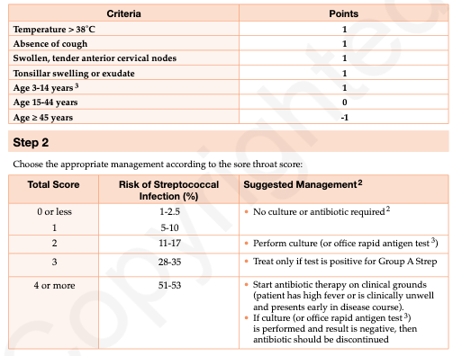
Therapeutic goals | - Relieve symptoms of sore throat and eliminate spread to other individuals
Algorithm | N/A
Non-pharmacological options | NSAIDs, acetaminophen (adults and children). Medicated lozenges (e.g., benzocaine) can be used in adults, but they should be avoided in children due to the choking risk. The use of corticosteroids for symptom management is controversial, with some conflicting evidence.  Gargle salt water
Education/counseling | Remain home for 48 hours after starting abx, increase fluids,
Pharmacological Therapy
Drug/Dose | Indication | Adverse fx (AE) and Drug interactions (DI) | Contraindications & special considerations
1st Line Therapies
Viral (NO abx needed) | Low sore throat score, viral features:  Conjunctivitis,  cough, hoarseness, coryza, anterior  stomatitis, discrete ulcerative lesions | N/A | N/A
Penicillin V 300mg (500 000 units) TID or 600mg BID  Peds: ≤ 27 kg: 40 mg/kg/day  divided BID-TID  (Maximum: 750 mg/day)  > 27 kg: Use adult dos | High Sore throat score and evident of bacterial pharyngitis  (Group A beta-hemolytic Streptococcus, Neisseria gonorrhoeae, and Corynebacterium diphtheriae.) | AEs:  DIs: Cephalosporins…but if the allergy is vague (w/o angioedema, bronchospasm, anaphylactic shock), any cephalosporin can be prescribed with relative safety | -Regimens require  10 days  in order to achieve successful treatment
Amoxicillin 500mg BID  Peds: 40 mg/kg/day divided BID(Maximum: 1 g/day) |  | AEs:  DIs: Cephalosporins | Regimens require  10 days  in order to achieve successful treatment
2nd Line Therapies
Cephalexin  500mg BID  Peds:25-50 mg/kg/day divided QID (Maximum: 1 g/day) | High Sore throat score, evidence of bacterial pharyngitis  High Sore throat score, evidence of bacterial pharyngitis | AEs:  DIs:Penicillin | Regimens require  10 days  in order to achieve successful treatment
Cefadroxil  500mg BID  Peds:30 mg/kg/day divided BID or once daily (Max: 2g/day) | High Sore throat score, evidence of bacterial pharyngitis and allergy to penicillin | AEs:  DIs:Penicillin
Cefprozil 250mg BID  Peds:15 mg/kg/day divided BID(Maximum: 500 mg/day) | High Sore throat score, evidence of bacterial pharyngitis and allergy to penicillin | AEs:  DIs:Penicillin
Cefuroxime  250mg BID  Peds:20 mg/kg/day divided BID(Maximum: 500 mg/day) | High Sore throat score, evidence of bacterial pharyngitis and allergy to penicillin | AEs:  DIs:
Notes
Monitoring | Those experiencing significant difficulties swallowing, drooling, presence of altered voice (‘hot potato’ voice) or airway obstruction (i.e., stridor) should be considered to have epiglottitis, peritonsillar abscess, or retropharyngeal abscess, until proven otherwise.
Referral | Refer the client to an otolaryngologist if peritonsillar abscess is noted or if the client has severe dysphagia or dyspnoea, signaling possible airway obstruction.
Other notes | If the antigen test is negative,then culture is still required for children. In adults, a negative antigen test alone is reasonable  Approximately 20% of the population may carry Group A Strep asymptomatically.  IF ASYMPTOMATIC consider only treating if individuals have a family history of rheumatic fever, an outbreak of rheumatic fever, an outbreak of pharyngitis in a closed community, or repeat transmission within families (≥3 culture confirmed episodes of symptomatic pharyngitis).  Perform swab during an asymptomatic period to document carrier status.

Laryngitis
Def’n | Inflammation of the larynx. Symptoms often include a hoarse voice and may include fever, cough, pain in the front of the neck, and trouble swallowing. Typically, these last under two weeks
Therapeutic goals | Heal vocal cords, limit irritation, symptom management.
Algorithm | N/A
Non-pharmacological options | Analgesics  Fluid intake  Lozenges  Saltwater gargles  Menthol inhalations & Humidifiers
Education/counseling | No smoking  No throat clearing  Rest vocal cords
Pharmacological Therapy
Notes
Monitoring | Antibiotics not needed! Symptomatic tx: analgesic, fluid, lozenge, etc.; rest voice, avoid clearing throat.
Referral | Specialist referral if persists >2-3 weeks.
Other notes

Laryngotracheobronchitis (croup)
Def’n | Croup (laryngotracheobronchitis) is a common cause of upper airway obstruction in children. It is most prevalent in the late fall to early winter months.​ Though common in children between 6 months and 3 years of age, croup can also occur in children as young as 3 months and as old as 15 years of age.​
Therapeutic goals | Relieve airway inflammation, improve breathing and oxygenation, maintain hydration and comfort, decrease the duration and severity of symptoms, minimize anxiety of the child and parent(s), decrease intubations, hospitalizations and return visits to physicians
Algorithm | 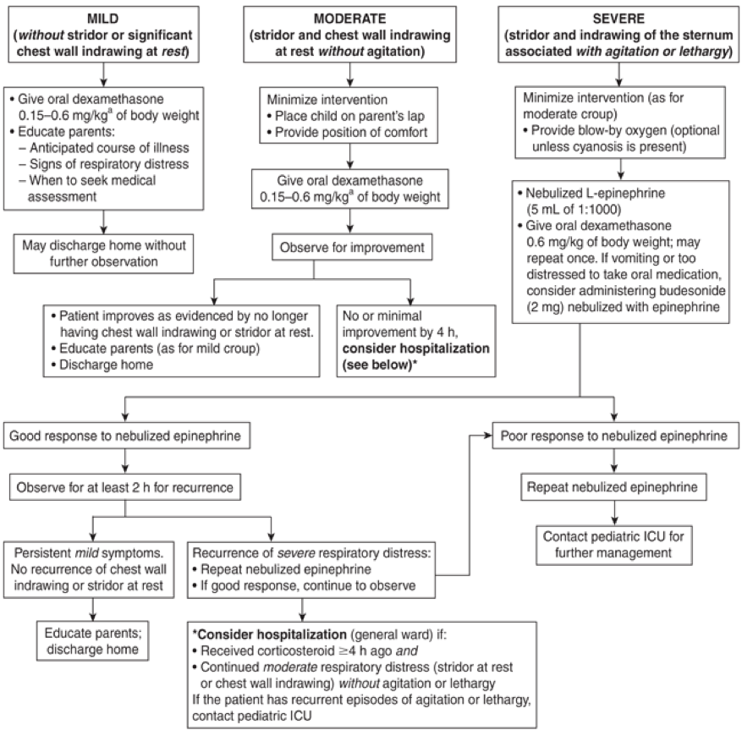  Management of croup in an outpatient setting algorithm
Non-pharmacological options | - Keep child calm by ensuring a calm and reassuring atmosphere. This will minimize oxygen demand and respiratory muscle fatigue.  - Children with mild to moderate croup may derive adequate short-term relief from breathing in cool air. This can be achieved by dressing them warmly and opening a bedroom window or freezer door for a few minutes while allowing them to breathe in the cool air; the child should not be left alone.  - Oxygen therapy in conjunction with corticosteroids and epinephrine is reserved for children with hypoxia and significant respiratory distress. It should never be forced on a child, especially if it results in significant agitation. Administration of oxygen through a plastic hose with the end opening held near the child’s nose and mouth (called “blow-by” oxygen) is often the most beneficial way of administering oxygen.  - Evidence has established that mist (bedside humidified air, mist tent) is not effective at reducing respiratory distress and should not be used. ​Placing a child in a mist tent—a wet, cold, confined environment separated from parents—may provoke anxiety and agitation.​
Education/counseling
Pharmacological Therapy
Drug/Dose | Indication | Adverse fx (AE) and Drug interactions (DI) | Contraindications & special considerations
1st Line Therapies
Dexamethasone 0.15-0.6 mg/kg PO/IM/IV once (Maximum 0.6 mg/kg/day or 10 mg/day) | Symptomatic croup, mild-moderate case | AEs: N/A  DIs: N/A | May supplement initial dose in 6-24h as necessary.
Budesonide Pulmicort 2mg (4 mL of 0.5 mg/mL solution) via nebulizer | Symptomatic croup, mild-moderate case
L-epinephrine 5 ml of 1mg/ml solution via nebulizer | Symptomatic croup, severe case |  | For all children of age and size
Notes
Monitoring | Improvement generally begins within 2-3 hours after a single oral dose and usually continues for 24-48 hours
Referral | See algorithm
Other notes

Epiglotittis: Medical Emergency
Def’n | Inflammation of the epiglottis—rapid in onset and include trouble swallowing which can result in drooling, changes to the voice, fever, and an increased breathing rate.
Therapeutic goals | Establish airway control, treat symptoms, minimize inflammation
Algorithm | N/A
Non-pharmacological options | Supportive care
Education/counseling | DO NOT attempt to visualize airway as it may cause obstruction and educate parents to provide reassurance and support to pt to relieve anxiety
Pharmacological Therapy
Drug/Dose | Indication | Adverse fx (AE) and Drug interactions (DI) | Contraindications & special considerations
1st Line Therapies
Cefotaxime IV 1-2g q8H  Peds:100-150 mg/kg/day divided q4-6h with max 8g/day | Epiglottitis due to:  Adults:  Group A Strep  S. pneumoniae  H. influenzae  type B (rare)  Children:  S. aureus  Group A Strep  H. influenzae  type B (rare)  S. pneumoniae | AEs:  DIs: | Can give for mild penicillin allergy
Ceftriaxone IV 1-2g q24h  Peds: 75-100mg/kg/day divided q12-24h with max 4g/day |  |  | Can give for mild penicillin allergy
Cefuroxime IV 750mg-1.5g q8h  Peds: 100-150mg/kg/day divided q8h with max 4.5g/day) |  |  | Can give for mild penicillin allergy
2nd Line Therapies
Levofloxacin IV 500mg q24h | Epiglotitis and allergy to penicillin
Notes
Monitoring | Measures to secure the airway may be required. Factors associated with a higher need for airway intervention include stridor, muffled voice, rapid clinical course and diabetes mellitus.  Throat examination may precipitate airway obstruction.
Referral | Contact infectious disease or public health regarding prophylaxis with rifampin for close contacts.  For children’s dosing, consult with specialist where possible
Other notes | If epiglottitis is suspected (e.g., stridor, high fever, drooling, severe sore throat), one should also consider bacterial tracheitis  Consider adding vancomycin and/or metronidazole if MRSA and/or anaerobes are suspected.

Influenza (Flu) Prevention and Seasonal Influenza- post-exposure antiviral prophylaxis
Def’n | In healthy individuals, this diagnosis refers to an acute infection where sinus, throat, and lower airway symptoms are present but not severe. Severe symptoms, especially with muscle aches and fatigue, may indicate influenza or parainfluenza.
Therapeutic goals | Hydrate, manage symptoms
Algorithm | N/A
Non-pharmacological options | Patients should stay hydrated and can use saline sprays or gargles, analgesics, and decongestants for short-term symptom relief. However, cough and cold medications are not recommended for children.
Education/counseling | Purulent (thick or discolored) nasal or throat secretions are common but do not signal bacterial infection. Antibiotics do not speed up recovery in healthy individuals and are unnecessary.  Vaccination and regular hand washing are the primary prevention strategies.
Pharmacological Therapy
Drug/Dose | Indication | Adverse fx (AE) and Drug interactions (DI) | Contraindications & special considerations
1st Line Therapies: Begin prophylaxis within 36 h after exposure if using zanamivir; within 48 h for other agents
Oseltamivir  1-12 years, <15-40kg: 30-60mg daily x 7-10 days. | 1-12 years old with Influenza A or B | AEs:  DIs: | Begin prophylaxis within 48hrs of exposure
Oseltamivir (75 mg once daily x 10 days) | >12 years old with Influenza A or B | AEs: Nephrotoxic, dosing adjustments needed if renal impairment, consult the product monograph.  DIs: | Begin prophylaxis within 48hrs of exposure
Zanamivir (10 mg (2 inhalations x 5 mg) once daily x 10 days) | ≥7 years old with Influenza A or B | AEs: Risk of bronchospasm if hx asthma or COPD (not recommended), but if used, should have a fast-acting bronchodilator on hand.  DIs: Lactose | Begin prophylaxis within 36hrs of exposure
Notes
Pregnancy | Oseltamivir has more supporting data for use during pregnancy compared to zanamivir, though both are considered safe for breastfeeding.
Monitoring | Bronchospasms for Zanamivir and kidney function if Oseltamivir
Referral | 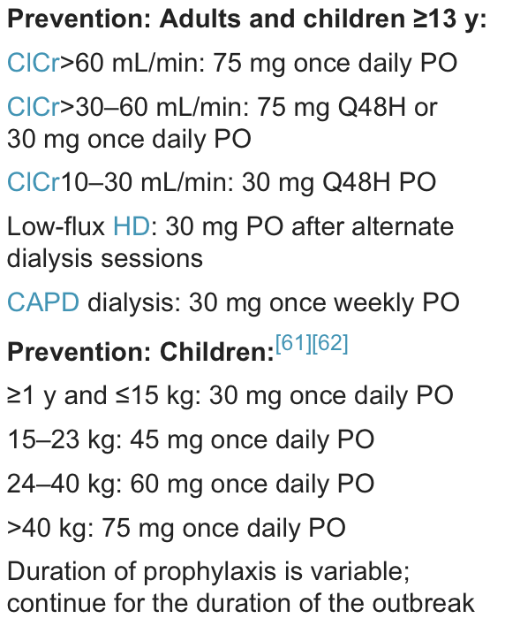
Other notes | Antiviral medications should not be used for post-exposure prevention in healthy children or adults. To reduce the risk of developing resistance, these medications should be used prudently.  Consider chemoprophylaxis for influenza only if…  - High-risk individuals: (e.g., elderly, immunocompromised) who have had close contact with a confirmed or suspected influenza  - Healthcare and public health workers/first responders: Workers with unprotected contact exposure to a confirmed or suspected case  - Institutional settings (LTC or hospitals): If two or more residents develop flu-like illness within 72 hours and have laboratory-confirmed influenza. Prophylaxis should last for at least 2 weeks and continue for 1 week after the last case is identified.  - Household settings: For vulnerable family members upon diagnosis of an index case. Prophylaxis may last for 10 days or up to 14 days if the index case is a child or elderly individual due to prolonged virus shedding.

Seasonal Influenza- treatment for those at risk/symptomatic
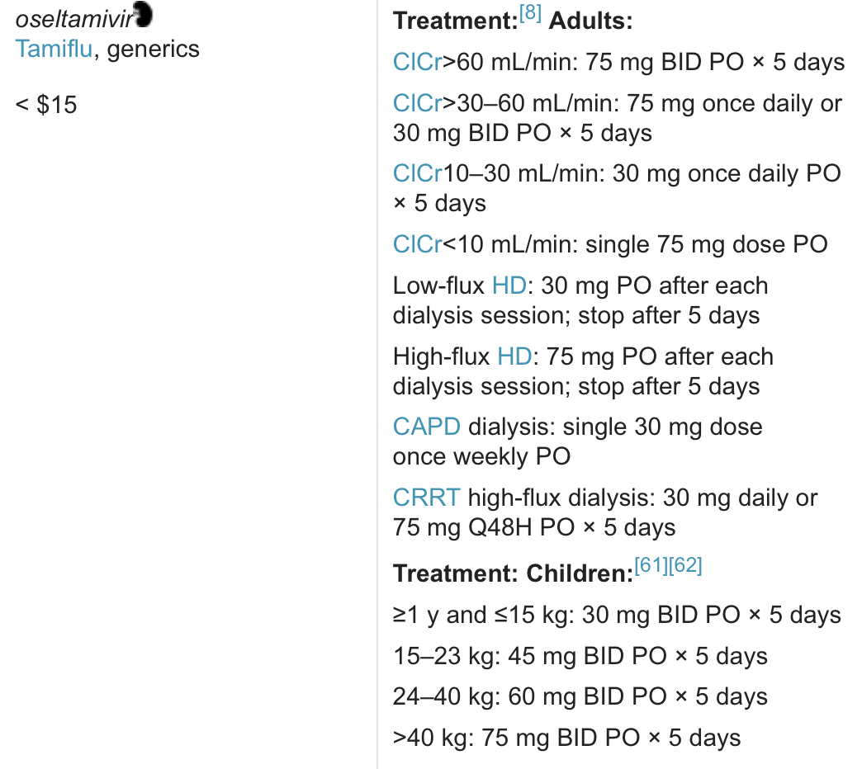
Def’n | See above
Therapeutic goals | See above
Algorithm | N/A
Non-pharmacological options | Flu is self-limiting; treatment includes rest, fluid intake, non-prescription analgesics, and vaccinations (antiviral medications are not a substitute for influenza vaccination)
Education/counseling
Pharmacological Therapy
Drug/Dose | Indication | Adverse fx (AE) and Drug interactions (DI) | Contraindications & special considerations
1st Line Therapies: Begin antiviral treatment within 36-48 hours of onset of symptoms; effect is negligible after this time. The 48 hour window may be extended in cases of severe, complicated or progressive disease
Oseltamivir (Consult product monograph) | 1-12 years old with Influenza A or B | AEs:  DIs:
Oseltamivir (75 mg twice daily x 5 days) | >12 years old with Influenza A or B | AEs: Nephrotoxic, dosing adjustments needed if renal impairment, consult the product monograph.  DIs:
Zanamivir (10 mg (2 inhalations x 5 mg) twice daily x 5 days) | ≥7 years old with Influenza A or B | AEs: Risk of bronchospasm if hx asthma or COPD (not recommended), but if used, should have a fast-acting bronchodilator on hand.  DIs: Lactose
Notes
Monitoring | See above
Referral | See above
Other notes | When influenza is known to be circulating in the community, suspect patient has influenza if some or all of the following are present: fever/chills, abrupt onset of constitutional and respiratory signs and symptoms, myalgia, headache, severe malaise, loss of appetite and non-productive cough.

Sinusitis- acute- adult & children
Def’n | A diagnosis of acute bacterial sinusitis may be more likely when: TWO or MORE MAJOR symptoms are present (ONE of which is nasal obstruction or nasal purulence/discoloured postnasal drainage). Other Major Symptoms: Facial pain/pressure/fullness; hyposmia/anosmia. In addition, the symptoms have not improved after 7 days or have worsened after 5 to 7 days.  Common symptoms include nasal congestion, discharge (any color), and day/night cough. Less common symptoms might be halitosis, facial pain/headache, fatigue, irritability, and low-grade fever.
Therapeutic goals
Algorithm | N/A
Non-pharmacological options | Saline rinses or sprays.  Can also use oral decongestants, intranasal steroids and may be used alone (i.e., without antibiotics) for the treatment of mild to moderate sinusitis for adults.  Antihistamines and decongestants are not recommended for children. Saline rinse alone is sufficient. May consider intranasal corticosteroid if needed.
Education/counseling | Likely will resolve on its own…only a small percentage (less than 2%) of viral upper respiratory infections are complicated by bacterial sinusitis. Most cases of acute sinusitis are viral and resolve within 5 to 7 days without the need for antibiotics
Pharmacological Therapy
Drug/Dose | Indication | Adverse fx (AE) and Drug interactions (DI) | Contraindications & special considerations
1st Line Therapies
Viral | No abx needed | AEs:  DIs:
Amoxicillin 500 mg TID 5-10 days  Peds: 80 mg/kg/day divided BID or TID (Maximum: 4 g/day) | S/S of sinusitis (infection with S. pneumoniae, H. influenzae, M. catarrhalis, S. aureus) | AEs:  DIs: Penicillin
2nd Line Therapies
Amoxicillin/Clavulanate 500 mg TID or 875 mg BID 5-10 days  Peds: 40-80 mg/kg/day amoxicillin divided BID(Maximum: 4 g/day) | S/S of sinusitis (infection with S. pneumoniae, H. influenzae, M. catarrhalis, S. aureus) | AEs: Diarrhea  DIs: Penicillin
Cefprozil 250-500 mg BID 5-10 days  Peds: 30 mg/kg/day divided BID(Maximum: 1 g/day) |  | AEs: Diarrhea  DIs: Penicillin
Cefuroxime 250-500 mg BID 5-10 days  Peds: 30-40 mg/kg/day divided BID(Maximum: 1 g/day) |  | AEs: Diarrhea  DIs:
Doxycycline 100 mg BID first day then 100 mg once daily for 5-10 days  ADULT ONLY |  | AEs: GI upset, photosensitivity, esophageal irritation and ulceration  DIs: | Contraindicated: pregnancy, children <8 years, severe renal or hepatic dysfunction  -Decreased GI absorption of electrolyte supplements (Fe, Ca, Mg  - separate doses by 2h)  - Increased INR and bleeding risk with warfarin  -May decrease oral contraceptive effectiveness
Notes
Monitoring | - If persistent symptoms lasting more than 10 days but less than 30 days without improvement pt may have acute bacterial sinusitis.  - Monitor for severe symptoms, such as fever and purulent nasal discharge, help differentiate it from viral infections. The 10-day mark is crucial for distinguishing simple viral infections from sinusitis.  - F/U in 3 days (should be improvement) – if no improvement, switch therapies – successful therapy in 10 days usually
Referral | - Refer to ENT if >4 episodes/year of bacterial, if they fail second line therapy, if they have anatomic anomalies, or develop complications or chronic sinusitis  - ER referral: systemic toxicity, altered mental status, severe headache, swelling of orbit, change in VA, black and necrotic tissue or discharge  - Watchful waiting: defer abx for 7 days after dx with acute bacterial rhinosinusitis while providing symptom management – give rescue Rx to start if symptoms don’t improve or worsen in time frame – ok if present with symptoms that haven’t worsened, haven’t had symptoms for more than 10 days, and you feel confident they’ll F/U  - INCS reduce severity of symptoms and faster recovery (can be used without abx for mild-mod cases) – try for 72 hrs before giving abx
Other notes | Antihistamines have not been proven to be effective.  If child is under 2, in daycare, or recurrent infection in last 3 months consider higher pediatric dose.

Pertussis (Whooping Cough)
Def’n | highly contagious respiratory tract infection. In many people, it's marked by a severe hacking cough followed by a high-pitched intake of breath that sounds like "whoop” caused by B. Pertussis. Suspect pertussis in individuals with paroxysmal cough of any duration; cough with inspiratory whoop; cough ending in vomiting or gagging or associated with apnea with no other known cause.
Therapeutic goals
Algorithm | N/A
Non-pharmacological options | N/A
Education/counseling | Maintenance of high vaccination rates is the most effective way to prevent pertussis.  Minimizing exposure of infants is also effective.  Individuals spontaneously clear pertussis from their nasopharynx within 3-4 weeks of cough onset in 80-90% of cases. Untreated and unvaccinated infants can remain culture positive for > 6 weeks
Pharmacological Therapy
Drug/Dose | Indication | Adverse fx (AE) and Drug interactions (DI) | Contraindications & special considerations
1st Line Therapies
Erythromycin 1-2 g/day divided BID, TID or QID 5-7 days | Pertusis | AEs: see abx table on page 1  DIs: | ADULTS ONLY
Clarithromycin 250-500 mg BID 5-7 days  Peds:15 mg/kg/day divided BID 5-7 days | Pertusis | AEs: see abx table on page 1  DIs:
Azithromycin 500 mg daily on first day then 250 mg daily x 4 days  Peds: 10 mg/kg/day on first day then 5 mg/kg/day x 4 days | Pertusis | AEs: see abx table on page 1  DIs:
2nd Line Therapies
TMP/SMX 2 tabs BID or 1 DS tab BID  Peds:5-10 mg/kg/day divided BID | Pertusis
Notes
Monitoring
Referral | Notify the Medical Officer of Health and consult with public health authorities and ensure that all household contacts, regardless of age and immunization status, are offered chemoprophylaxis (especially is 3rd trimester or under 1 year and in the same household); same drug regimen as for active case
Other notes | Antibiotic therapy started 3 weeks after the onset is of no benefit since the organism may be cleared.  Patient is usually considered infectious until 3 weeks after the onset of cough (without therapy), or until 5 days after the start of therapy

Fever in children
Def’n | Fever occurs when the hypothalamus raises the body's temperature set-point, prompting the body to balance heat loss and production at a higher temperature. This differs from hyperthermia, where heat production surpasses heat loss without a change in the set-point.
Therapeutic goals | Provide patient comfort  Balance the benefit of symptomatic treatment with possible adverse effects and cost of medication  In children, relieve parental anxiety  In pregnant women during the 1​st trimester, reduce risk of adverse fetal outcome(s)
Algorithm (and related info lol) | 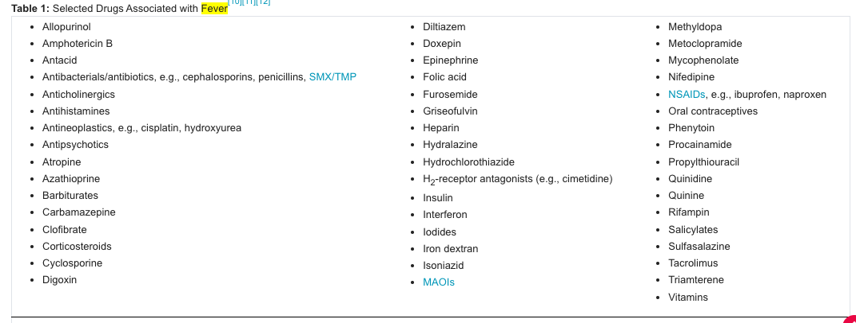  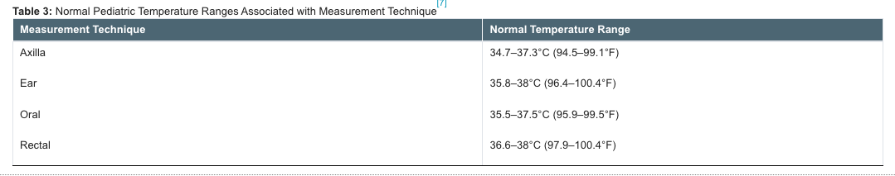
Non-pharmacological options | - Remove excess clothing and bedding  - Increase fluid intake to replace water loss during fever  - Maintain ambient temperatures around 20–21°C  - Avoid physical exertion  - Physical cooling methods (convection, evaporation, conduction) counteract fever but may cause discomfort (shivering, vasoconstriction  - Pharmacologic methods preferred as they lower the hypothalamic set-point  - Physical methods used in rare cases where core temperature exceeds 41–42°C:  - Sponging with tepid or cold water (evaporation) can reduce body heat; sponging with alcohol is not recommended  - Ice packs or cooling blankets lower temperature through conduction  - Circulating fans (with or without ice) transfer heat from the skin through convection
Education/counseling | - No evidence supports the benefits of reducing fever with antipyretics; the main goal is patient comfort.  - Antipyretics may be used if fever's metabolic demands outweigh clinical benefits. Antipyretics also provide pain relief, improving comfort.  - Acetaminophen and ibuprofen are commonly used for fever reduction and are safe in therapeutic doses.  - Naproxen sodium and ASA are antipyretic options for adults; ASA is not recommended for children due to Reye syndrome risk.  - Alternating acetaminophen and ibuprofen is not recommended due to lack of evidence supporting greater benefit or safety.  - In children, use doses of acetaminophen or ibuprofen based on the child's weight, not on age. Maximum dose per day should be specified.  - Concentrations of liquid acetaminophen and ibuprofen preparations vary according to product. Remind caregivers to check the concentration of a product each time medication is given.  - Acetaminophen is the drug most frequently involved in analgesic overdose in children <6 years of age. Store antipyretics in locked cabinets to prevent inappropriate access. Instruct parents to use a calibrated measuring device, and educate them about the many formulations available and the potential for error with substitution or the combination of products
Pharmacological Therapy
Drug/Dose | Indication | Adverse fx (AE) and Drug interactions (DI) | Contraindications & special considerations
1st Line Therapies
Ibuprofen  Children <6 months: 5 mg/kg Q8H PO PRN; maximum 40 mg/kg/day; do not exceed the adult dose  Children >6 months: 5–10 mg/kg Q6–8H PO PRN for symptom management; maximum 40 mg/kg/day; do not exceed the adult dose  Adults: 200–400 mg Q4-6H PO PRN; maximum for self-care 1200 mg/day; maximum if supervised by HCP 2400 mg/day | Fever | AEs:Uncommon with infrequent use and recommended dose.  GI intolerance and bleeding, allergic reactions, tinnitus, visual disturbances, nephropathy.  Sodium and water retention.  Dehydration enhances risk of renal toxicity.  Platelet dysfunction can result in increased bleeding risk.  DIs:Increased risk of GI pain/ulceration with alcohol, corticosteroids. Antagonism of hypotensive effects of ACE inhibitor, beta-blockers, diuretics. Increased risk of bleeding with anticoagulants, SSRIs. Increased levels of cyclosporine (and risk of nephrotoxicity) with methotrexate​, lithium. Reduction of ASA antiplatelet effects when combined with ibuprofen
Naproxen  Children <12 y: not recommended  Adults: 220 mg Q8–12H PO PRN; maximum 440 mg/day | Fever | NOT RECOMMENDED IN CHILDREN UNDER 12
Tylenol  Children: 10–15 mg/kg Q4–6H PO/PR PRN for symptom management; maximum 75 mg/kg/day; do not exceed the adult dose  Adults: 325–650 mg Q4-6H PO/PR PRN; maximum 4000 mg/day | Fever | AEs:Uncommon with infrequent use and recommended dose.  Hypersensitivity, agranulocytosis, anemia (rare).  Chronic use and overdose associated with hepatotoxicity, nephropathy.  Potential for toxicity enhanced if concurrent dehydration, prolonged fasting, diabetes mellitus, obesity, concomitant viral infection or family history of hepatotoxic reaction  DIs:Increased risk of hepatotoxicity with alcohol and isoniazid. Decreased acetaminophen levels with enzyme inducers, e.g., barbiturates, carbamazepine, phenytoin. Acetaminophen has been reported to increase INR in warfarin-treated patients.​[40] Check INR if acetaminophen ≥2 g/day is used for ≥3 consecutive days. Adjust warfarin dosage as required.
Aspirin  Children <18 y: not recommended; avoid use  Adults: 325–650 mg Q4–6H PO PRN; maximum 4000 mg/day | Fever | NOT RECOMMENDED IN CHILDREN DUE TO RYES
Notes
Monitoring | Monitor temperature
Referral | If fever with unknown cause send to ED
Other notes | Only tylenol is safe in pregnancy. Tylenol and ibuprofen are safe breastfeeding.  Fever in infants under 3 months (temperature ≥ 38°C) is a medical emergency.  Immediate action: Infants require immediate evaluation due to a high risk of serious bacterial infection (e.g., sepsis, meningitis, UTI).  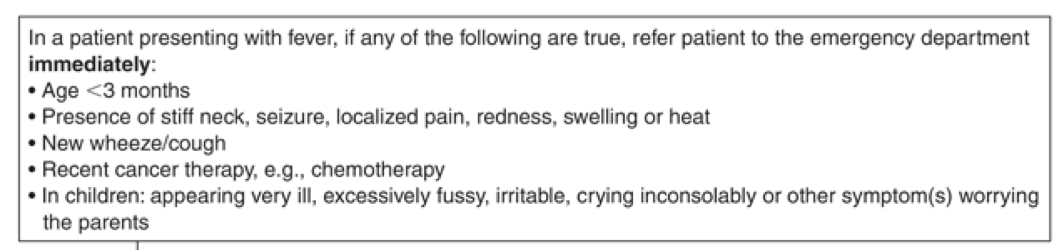

CHRONIC COUGH
Def’n | Chronic cough (cough lasting >8 weeks) adversely affects quality of life. In nonsmokers with a negative chest radiograph who are not taking an ACE inhibitor, chronic cough can be attributed to upper airway cough syndrome (UACS; formerly known as postnasal drip syndrome), asthma, GERD or nonasthmatic eosinophilic bronchitis (NAEB) in the majority of cases
Therapeutic goals | - Choose appropriate and effective therapy based on cough etiology  - Resist nonspecific cough suppression therapy, which may delay diagnosis of a curative cause  - Prevent complications attributable to cough, e.g., rib fractures, syncope, loss of sleep, aggravation of stress incontinence, exercise intolerance, emesis, epistaxis, ocular injury/hemorrhage  - Ensure uncommon but more serious causes, such as lung cancer, are not missed
Algorithm | 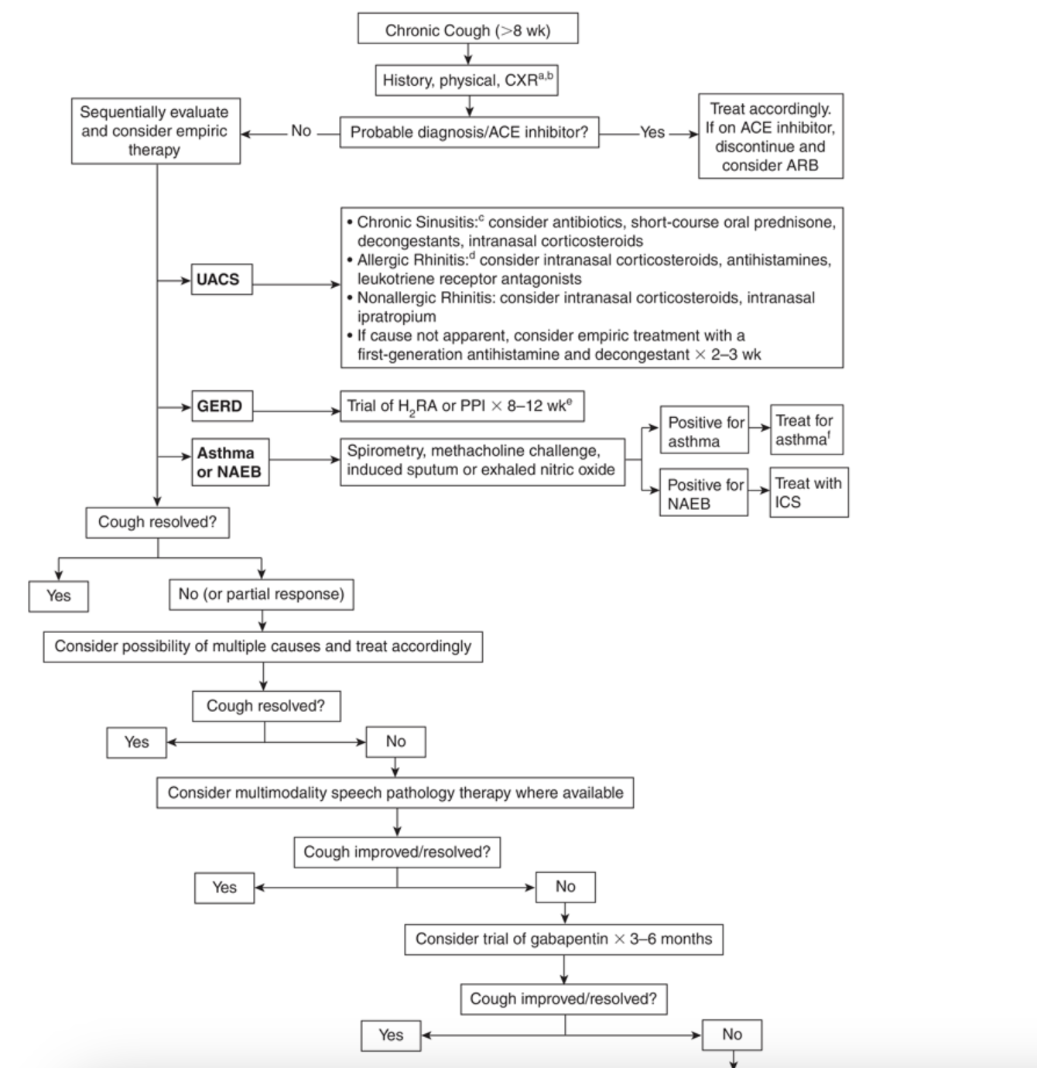  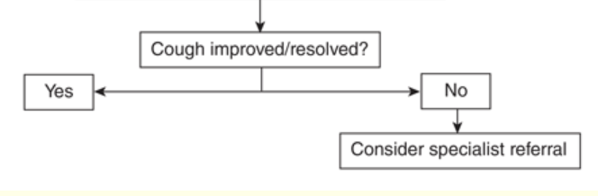  Therapy of chronic cough is directed at the cause, once identified:  - Chronic upper airway cough syndrome (post nasal drip) secondary to rhinosinus diseases: choose treatment according to the specific cause if known.​If the cause is not apparent, the combination of a first-generation antihistamine and a decongestant is recommended empirically for cough related to postnasal drip; first-generation antihistamines are more effective.  - Nonallergic rhinitis: appropriate therapy may include intranasal corticosteroids or intranasal ipratropium.​  - Allergic rhinitis: appropriate therapy may include antihistamines, intranasal corticosteroids or leukotriene receptor antagonists, e.g., montelukast  - Chronic sinusitis: appropriate therapy may include antibiotics, short-course oral prednisone, intranasal corticosteroids or oral decongestants​.  - NAEB/Asthma: responds to inhaled corticosteroids.​  - GERD: H₂-receptor antagonist (H₂RA) or PPI for a minimum of 2–3 months  - ACE inhibitor–induced cough: Stop ACE inhibitor as a trial.​  - Antitussives: used to enable sleep or in certain social settings. Use with caution when cough is productive.  - Gabapentin (up to 900 mg twice daily) used for unexplained chronic cough. Gabapentin should be re-evaluated at 6 months.
Non-pharmacological options | - Advice on smoking cessation ( a temporary worsening of cough may occur, which may persist for several months).  - Recommend that the patient avoids exposure to allergens and irritants.  - Advice on lifestyle modifications for GERD, e.g., weight loss, specific food/beverage avoidance, nocturnal elevation of head of bed.  - Recommend daily large volume (>150 mL) hypertonic saline nasal irrigation for chronic rhinosinusitis  - Multimodality speech pathology therapy can be beneficial in laryngeal dysfunction
Education/counseling
Pharmacological Therapy
Drug/Dose | Indication | Adverse fx (AE) and Drug interactions (DI) | Contraindications & special considerations
1st Line Therapies
First generation antihistamine with decongestant is recommended for post nasal drip. | Recommended if cause is not known
First generation antihistamine  -chlorpheniramine  4–8 mg HS PO  -diphenhydramine  (Benadryl)  25–50 mg Q6–8H PO; maximum 300 mg/day |  | AEs:sedation and anticholinergic effects  DIs:  -increased CNS depression when combined with sedatives.  -increased anticholinergic effects when combined with scopolamine and tricyclic antidepressants
Decongestant  Pseudoephedrine:  -60 mg Q4–6H PO or  120 mg SR Q12H PO  Maximum: 240 mg/24 h | Combine with first generation antihistamine for cough associated with nonallergic rhinitis | AEs  Insomnia, tremor, irritability, headache, palpitations, tachycardia, urinary retention.  DIs  -Beta blocker effect may be reduced  -use with MAOI can increase HTN  -use with SNRI can cause tachycardia and vasopressor | Contraindicated for patients with HTN and CAD
2nd Line Therapies
Antitussives  Codeine:  5–20 mg Q4–8H PO​  Maximum: 120 mg/day  Dextromethorphan (robitussin):  15–30 mg Q6–8H PO  Maximum: 120 mg/day  Hydrocodone:  5 mg Q4–6H PO​  Maximum: 30 mg/24 h | Used to enable sleep or in social settings  Used for patients with upper respiratory tract infections or chronic bronchitis. | AEs  -constipation, drowsiness, nausea  DIs  -avoid using with sedatives due to risk of respiratory depression | Short term relief of cough
Gaba  Gabapentin:  Starting dose: 300 mg daily PO  Titration: increase daily to maximum tolerated dose or 900 mg BID PO  Maximum: 900 mg BID PO | Unexplained cough | AEs  -sedation, ataxia, tremor; less commonly: GI upset, peripheral edema, vision changes, weight gain. respiratory depression.  DIs  Increased hypotensive effect with antihypertensives. Decreased clearance with oral contraceptives or TCAs. Decreased clearance with CYP1A2 inhibitors, may increase phenytoin levels | **discontinue after 6 month trial if no benefit is seen
Notes
Monitoring
Referral | SLP, specialist referral if no medications are working
Other notes | Information is limited regarding the prevalence, etiology and therapeutic options for chronic cough in pregnancy. Many of the common causes of cough can be exacerbated by pregnancy. This is most obvious for GERD because of smooth muscle relaxation and increased abdominal pressure. Lifestyle modifications and antacids are the first-line approach.

COVID
Def’n | Coronavirus disease 2019 (COVID-19) is caused by the novel coronavirus SARS-CoV-2.
Therapeutic goals | - Prevent spread  - Alleviate symptoms  - Prevent complications where possible  - Vaccines-prevent COVID (do not take vaccine during infection)
Algorithm
Non-pharmacological options
Education/counseling
Pharmacological Therapy
Drug/Dose | Indication | Adverse fx (AE) and Drug interactions (DI) | Contraindications & special considerations
Dexamethasone  IV or PO at doses of 6 mg in adults  PEDS:  0.15 mg/kg (up to 6 mg) in children for 10 days or until discharge, whichever is sooner | Standard of care for patients admitted to the hospital for COVID for patients that require supplemental oxygen.  Administered IV or PO at doses of 6 mg in adults or 0.15 mg/kg (up to 6 mg) in children for 10 days or until discharge, whichever is sooner. | AEs:  DIs: | Dexamethasone (or an equivalent corticosteroid) is not indicated for patients with COVID-19 who are not admitted to hospital.
Remdesivir  (antiviral nucleotide analogue)  Treatment of Nonhospitalized high-risk adults:  -200 mg IV infusion on day 1,  -100 mg IV infusion on days 2 and 3  -Discontinue if eGFR falls to <30 mL/min | Used for patients hospitalized with severe COVID and non-hospitalized patients at risk of progression to severe COVID | AEs:  Elevated transaminase levels, headache, nausea, rash.  DIs:  Chloroquine and hydroxychloroquine may diminish the therapeutic effect of remdesivir. | -Initiate treatment within 7 days of symptom onset.  Severe renal impairment:  (eGFR <30 mL/min): not recommended.  Hepatic impairment: Do not initiate or continue treatment in patients with ALT ≥5 × ULN.
Nirmatrelvir/​ritonavir  (antiviral protease inhibitor  Treatment of Nonhospitalized high-risk adults:  -2 tabs nirmatrelvir  -150 mg plus 1 tab ritonavir 100 mg PO BID × 5 days  -If eGFR ≥30 to <60 mL/min: 150/100 mg BID PO × 5 days | Protease inhibitor that stops the replication of SARS-CoV-2 | AEs:  Mostly mild: altered sense of taste, elevated blood pressure, GI effects (diarrhea, vomiting), headache, muscle pain.  Hepatotoxicity has been reported in patients receiving ritonavir long term  DIs:  Numerous drug interactions | -Not approved for use in pediatric patients (<18 y).  -Initiate treatment only after diagnosis with a positive viral test and within 3–5 days of symptom onset.  -Can be taken with or without food. Tablets should be swallowed whole; do not chew, break or crush.  -Severe renal impairment  (eGFR <30 mL/min): not recommended.  Severe hepatic impairment:  not recommended.
2nd Line Therapies
Corticosteroid inhaled  Budesonide/  Treatment of Moderate to higher risk adults:​  800 mcg inhaled BID × 14 days | Used to minimize symptoms of SOB and cough | AEs:  Cough, sore mouth, sore throat, dysphonia (hoarseness), oral candidiasis (thrush).  DIs:  Strong CYP3A4 inhibitors, e.g., ritonavir, azole antivirals, can increase systemic exposure to budesonide. | TO reduce adverse effects with inhaled corticosteroids, advise patients to rinse mouth with water after each dose, clean dentures or use with a spacer device, where appropriate.
Monoclonal Antibodies  Sotrovimab  Treatment of Nonhospitalized high-risk patients:​  500 mg IV infusion (over 60 min) × single dose |  | AEs:  Diarrhea, injection site pain, bleeding, swelling.  Rare: anaphylaxis, infusion-related reactions.  DIs:  -Not renally excreted or metabolized by CYP enzymes.  -No formal drug interaction studies have been performed. | Approved for use only in certain adults or adolescents (≥12 y weighing ≥40 kg).  -Initiate treatment within 7 days of symptom onset.  -Monoclonal antibody utility is limited by diminished efficacy against circulating strains of SARS-CoV-2.  -Prescribers should check current guidance to determine if use is appropriate.
SSRI (fluvoxamine)  Has anti-inflammatory effects  Fluvoxamine  Treatment of Moderate to higher risk adults:​  50 mg PO daily, titrated up to 100 mg PO BID for a total of 15 days | -Preventing disease progression and hospitalization  -Used in mildly ill patients presenting within 7 days of symptom onset who are: when nirmatrelvir/ritonavir is not available or contraindicated. | AEs:  CNS effects: highly sedating, anxiety, agitation, insomnia, headache, extrapyramidal effects.  Significant GI effects: nausea, vomiting, diarrhea, constipation, increased risk of upper GI bleeding.  Others: dry mouth, increased sweating, sexual dysfunction, SIADH with hyponatremia.  DIs:  Numerous drug interactions
Notes
Monitoring | -In the outpatient setting, treatment for patients with mild to moderate COVID-19 symptoms is usually supportive. For management of fever and pain, both acetaminophen and nonsteroidal anti-inflammatory drugs (NSAIDs).
Referral
Other notes | For hospitalized patients, continuation of prophylactic antithrombotics post discharge for COVID-19 is not recommended.

Upper Respiratory Tract Infection (Acute Rhinitis) – “Viral Rhinitis” on CPS
Def’n | Common Cold. Benign, self-limited viral infx caused by several viruses (e.g. rhinovirus, coronavirus) causing symptoms of rhinorrhea and nasal congestion.
Therapeutic goals | Prevent infx, reduce symptos, prevent transmission
Non-pharmacological options | - PO fluids, saline nasal irrigation, lozenges, honey  - Insufficient evidence to support practice of inhaling steam  Prevention:  - Ginseng extract: daily can prevent URTIs  - Probiotics: can prevent acute URTIs
Education/counseling | Prevention: avoid contact with sick people, handwashing, masking  Self-limiting: resolves within 10-14 d
Pharmacological Therapy
1. OTC analgesics and antipyretics (e.g. ASA, ibuprofen, naproxen, tylenol)
2. Anticholinergic agents (intranasal ipratropium) – for rhinorrhea and sneezing
3. Decongestants – topical preferred over oral d/t similar efficacy and fewer AEs
o Limit use to 3-5 days to avoid rebound congestion
Antihistamines – not recommended; don’t significant improve symptoms or recovery

BACTERIAL MENINGITIS (ADULT AND CHILDREN)
Def’n | Meningitis is an inflammation of the cranial and spinal leptomeninges.  The most common pathogens that cause bacterial meningitis include Streptococcus pneumoniae, Neisseria meningitidis and Haemophilus influenzae
Therapeutic goals | - When a clinical diagnosis of meningitis is made, provide empiric antibiotic therapy with drugs that penetrate the central nervous system  - Modify therapy if required once a pathogen is identified  - Eradicate bacteria from the CNS  - Decrease morbidity and mortality  - Manage and minimize acute and chronic complications that can lead to permanent neurologic damage  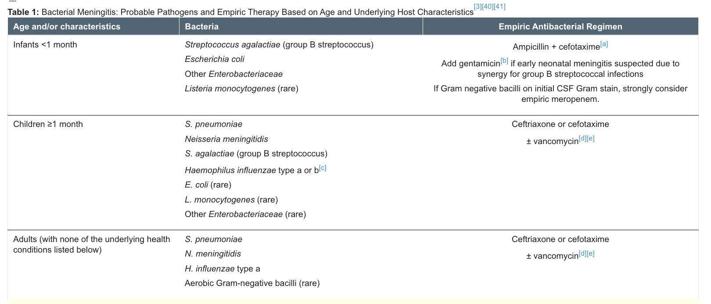  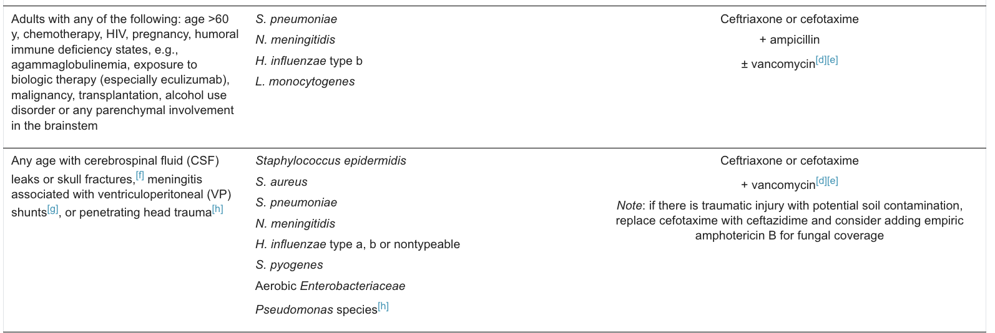  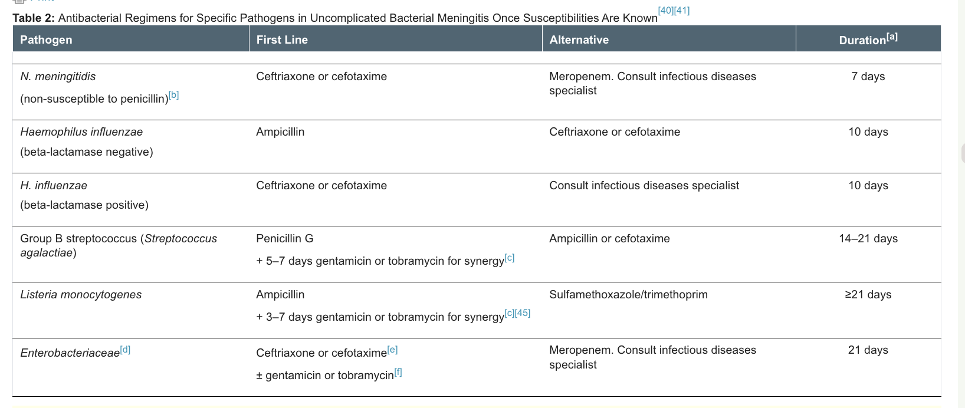
Algorithm | -Antibiotic therapy should be administered as early as possible and cover a broad spectrum and choose the most likely cause of the organism.  -Treat for meningitis even if microorganisms are isolated from blood cultures only as CSF can be negative.  -Revaluate drug therapy after cultures come back  -In all individuals >1 month of age with presumed meningitis, use ceftriaxone or cefotaxime followed ≥2 hours later by vancomycin as empiric therapy. This will provide coverage for penicillin-susceptible and -resistant S. pneumoniae, N. meningitidis and H. influenzae
Non-pharmacological options
Education/counseling | - Close contacts of individuals with invasive meningococcal disease (IMD) are at increased risk of developing meningitis; this risk persists up to 1 year after disease in the index case. Therefore, meningococcal vaccines should be given.  - Close contacts are generally considered household members or persons in the same daycare,local public health units generally assist in contact tracing for these cases, which may also include individuals directly exposed to a patient’s oral secretions within 7 days of symptom onset.  - To reduce the risk of infection, postexposure prophylaxis is therefore recommended for close contacts.  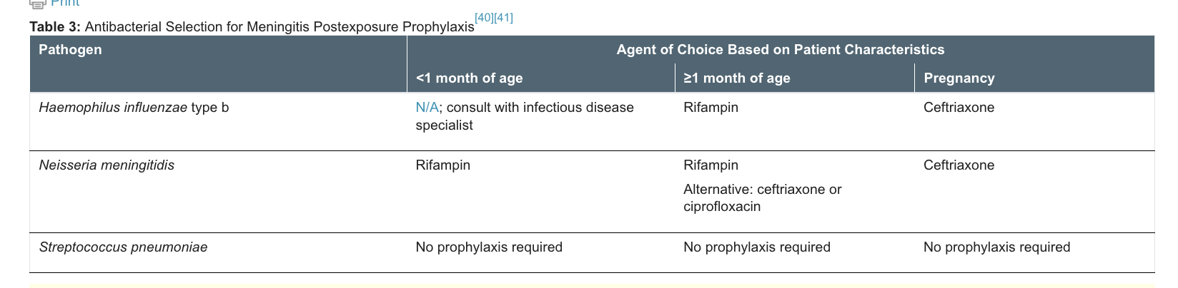  - Cephalosporins (ceftriaxone), fluoroquinolones (ciprofloxacin), rifamycin (rifampin) are postexposure prophylaxis treatments that can be given to close contact
Pharmacological Therapy
Drug/Dose | Indication | Adverse fx (AE) and Drug interactions (DI) | Contraindications & special considerations
IV antibiotic therapy for bacterial meningitis
Aminoglycosides  -gentamicin:  Neonates ≤7 days:  <1.2 kg: 2.5 mg/kg Q18–24H  Neonates >7 days and older children:  1.2–2 kg: 2.5 mg/kg Q12H  >2 kg: 2.5 mg/kg Q8H  Adults and adolescents:  1–2 mg/kg Q8H  - tobramycin:  Neonates ≤7 days:  <1.2 kg: 2.5 mg/kg Q18–24H  Neonates >7 days and older children:  1.2–2 kg: 2.5 mg/kg Q12H  >2 kg: 2.5 mg/kg Q8H  Adults and adolescents:  1–2 mg/kg Q8H |  | AEs:  Nephrotoxicity, ototoxicity,  DIs:  Enhanced toxicity with use of amphotericin B, magnesium, cephalosporins, penicillins, loop diuretics, vancomycin, cisplatin, cyclosporine, indomethacin. | Should be used in conjunction with other bactericidal drugs
Carbapenem  -meropenem  Neonates:  80 mg/kg/day divided Q12H  Infants >4 wk and children: 120 mg/kg/day divided Q8H  Adults: 6 g/day divided Q8H |  | AEs:  -Diarrhea, nausea, hypersensitivity reactions, seizures  DIs:  Decreases valproic acid levels | With poor renal function increased risk of seizures
Cephalosporin  Cefotaxime:  Neonates ≤7 days:  <2 kg: 100 mg/kg/day divided Q12H  ≥2 kg: 100–150 mg/kg/day divided Q8H  Neonates >7 days:  1.2–2 kg: 150 mg/kg/day divided Q8H  >2 kg: 150–200 mg/kg/day divided Q6–8H  Infants ≥6 wk and children ≤12 y: 300 mg/kg/day divided Q6H  Adults and children >12 y: 2 g Q4–6H  Maximum: 12 g/day  Ceftazidime:  Neonates ≤7 days:  <2 kg: 100 mg/kg/day divided Q12H  ≥2 kg: 100–150 mg/kg/day divided Q8–12H  Infants >7 days and children: 150 mg/kg/day divided Q8H  Adults: 2 g Q8H  Maximum: 6 g/day  Ceftriaxone  Infants and children: 100 mg/kg divided Q12H  Alternative regimen: loading dose of 100 mg/kg Q12H х 2 doses, then 100 mg/kg/day divided Q12H  Adults: 2 g Q12H  Maximum: 4 g/day |  | AEs:  Hypersensitivity, phlebitis, diarrhea, pseudomembranous colitis, transient elevation in liver enzymes, leukopenia, neutropenia, eosinophilia, thrombocytopenia.  . | -Seizures, nephrotoxicity with large doses.  **Cefotaxime is used preferentially over ceftriaxone in infants <6 wk of age.**  **Ceftriaxone is contraindicated in neonates <6 wk of age**.
Glycopeptides  Vancomycin  Neonates:​  >2 kg or PCA >37 wk: 22.5 mg/kg/dose Q12H  Infants >4 wk and children: 60 mg/kg/day divided Q6H  Maximum: 1 g/dose or 4 g/day prior to therapeutic drug monitoring  Adults: 15–20 mg/kg Q8–12H |  | AEs:  Vancomycin infusion reaction: flushing, hypotension with rapid IV infusion; phlebitis.  -can cause nephrotoxicity and ototoxicity | -Target trough concentration of 15–20 mg/L may be used until further guidance becomes available  -Vancomycin should not be used for longer than 24 h if cultures are negative; discontinue if penicillin- or ceftriaxone-susceptible.
Penicillin  Ampicillin  Neonates ≤7 days:  ≤2 kg: 100 mg/kg/day divided Q12H  >2 kg: 150 mg/kg/day divided Q8H  GBS: 200 mg/kg/day divided Q8H  Neonates >7 days:  <1.2 kg: 100 mg/kg/day divided Q12H  1.2–2 kg: 150 mg/kg/day divided Q8H  >2 kg: 200 mg/kg/day divided Q6H  GBS: 300–400 mg/kg/day divided Q4–6H  Older infants and children: 200 mg/kg/day divided Q4–6H  GBS: 400 mg/kg/day divided Q4–6H  Adults: 2 g Q4H  Maximum: 12 g/day  penicillin G  Neonates ≤7 days: GBS: 450 000 units/kg/day divided Q8H  Neonates >7 days: GBS: 450 000–500 000 units/kg/day divided Q4H  Older infants and children:  400 000 units/kg/day divided Q4H  Maximum: 24 million units/day  Adults: 20–24 million units/day divided Q4H |  | AEs  -Rash, hypersensitivity, drug fever, hemolytic anemia, interstitial nephritis, seizures (with high doses).  DIs:  -increase rash with allopurinol use  -tetracyclines can decrease the effect
Sulfonamide  (sulfamethoxazole/​trimethoprim (septra)).  Infants ≥2 months, children and adults:  10–20 mg/kg/day (based on trimethoprim component) divided Q6–12H |  | AEs:  Nausea, vomiting, hypersensitivity reactions (may be severe), myelosuppression, hyperkalemia (with higher doses).  DIs:  -May increase the effect of phenytoin, sulfonylureas and warfarin.  -Enhanced bone marrow suppression with methotrexate. | -Contraindicated use in neonates  -
2nd Line Therapies
Adjuvant corticosteroids  -The recommended dose for children is  0.6 mg/kg/day in 4 divided doses for 2 days  Dexamethasone  -10 mg every 6 hours for 4 days has been used  - 0.15 mg/kg every 6 hours for 2–4 days | Found to be beneficial in reducing inflammation  Children: found to prevent hearing loss  adults:
Notes
-In patients <1 month of age, cefotaxime, ampicillin and gentamicin cover the most common pathogens (e.g., GBS, E. coli).

-In all individuals >1 month of age with presumed meningitis, use ceftriaxone or cefotaxime followed ≥2 hours later by vancomycin as empiric therapy

-Penicillin G can be used in patients with meningitis who have blood or CSF isolates of S. pneumoniae

-The conjugated pneumococcal vaccine is routinely recommended for all infants
Monitoring | Close contact post exposure prophylaxis
Referral
Other notes | **The Canadian and global implementation of universal infant immunization programs using conjugated H. influenzae type b, S. pneumoniae and N. meningitidis vaccines have significantly decreased the rates of bacterial meningitis.***  I dont think we need to know this but i will put it in here just in case:  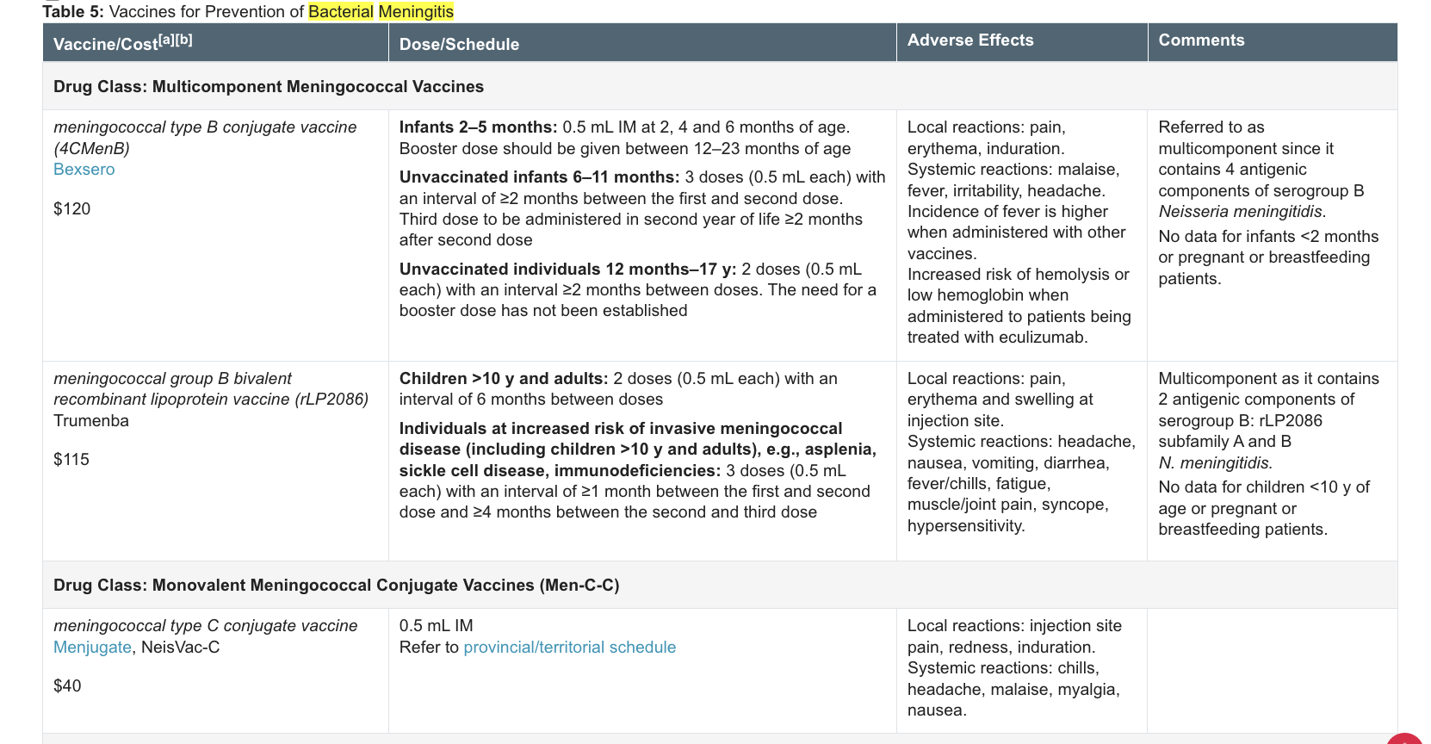  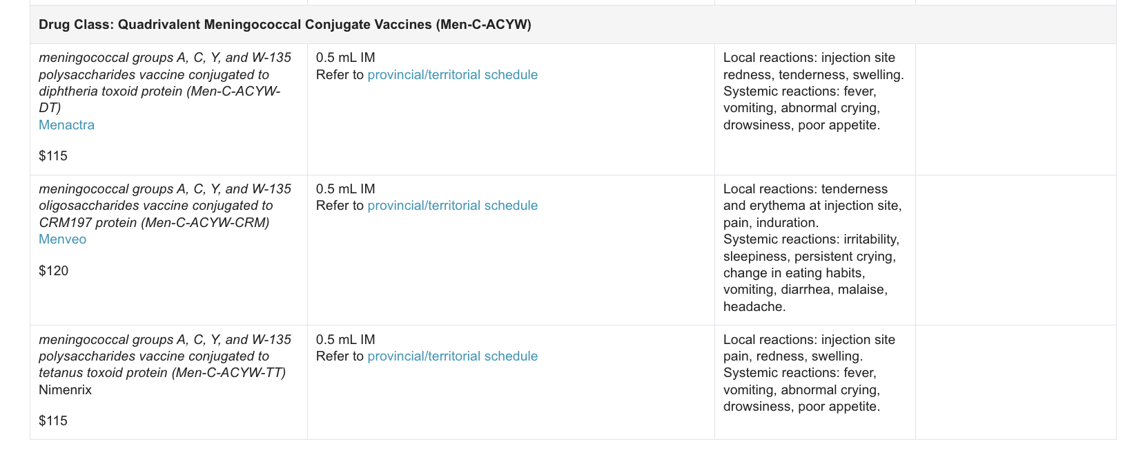

Week 4/5: Skin Conditions

Impetigo & Bullous Impetigo- Adult & Children
Def’n | Bullous impetigo is a form of impetigo caused by Staphylococcus aureus, where the bacteria produce an epidermolytic toxin that causes the skin to blister. These blisters (bullae) are filled with fluid and can rupture easily, leaving raw skin underneath. Non-bullous impetigo is caused by Staphylococcus aureus and/or Streptococcus pyogenes. It doesn't involve blisters; instepad, it appears as red sores or small pustules that eventually form honey-colored crusts after breaking open. A common finding in both forms of impetigo is that they primarily affect the outer layers of the skin, are highly contagious, and are often seen in children.
Therapeutic goals
Algorithm
Non-pharmacological options | Good hygiene, warm compress, wash hands with soap, assess underlying skin condition
Education/counseling | Very contagious, wash hands often, do not pick/peel, avoid stretching sores, keep nails short, stay out of school for 48hrs after starting abx or when crusted over.
Pharmacological Therapy
Drug/Dose | Indication | Adverse fx (AE) and Drug interactions (DI) | Contraindications & special considerations
1st Line Therapies (FYI: Not necessary to remove crusts before applying ointment)
Adults and peds:  Mupirocin 2% 1ung/cream Apply sparingly TID for 5-7 days | Mild Impetigo & Bollus Impetigo limited to small areas (2-3 small lesions) | AEs:  DIs: | Recurrent impetigo is often caused by Staphylococcus aureus carriage in the anterior nares or perineum. To evaluate, perform a culture, and if positive, treat with mupirocin or fusidic acid applied 2-3 times daily for 2-3 days.
Adults and peds:  Fusidic acid 2%  1ung/cream  Apply sparingly  TID–QID. If covered  with occlusive  dressing, then daily  or BID for 5-7 days | Mild Impetigo & Bollus Impetigo limited to small areas (2-3 small lesions) |  | Recurrent impetigo is often caused by Staphylococcus aureus carriage in the anterior nares or perineum. To evaluate, perform a culture, and if positive, treat with mupirocin or fusidic acid applied 2-3 times daily for 2-3 days.
Adults and peds:  Ozenoxacin 1%  Cream Apply sparingly BID for 5-7 days | Mild Impetigo & Bollus Impetigo limited to small areas (2-3 small lesions)
Systemic antibiotics to be used for significant soft tissue infections or community outbreaks. Also consider if the patient is immunocompromised, or have valvular heart disease, fever, or other signs of a more serious infection (such as bacteremia). Systemic therapy should also be considered if the infection doesn’t improve within 24-48 hours of topical treatment. DO NOT offer topical if using systemic abx.
Cephalexin  250-500 mg QID for 7-10 days  Peds: 50-100mg/kg/day divided QID | Impetigo & Bollus Impetigo with soft tissue infx or community outbreak |  | Consider systemic abx if impetigo is due to an outbreak
Cefadroxil  500 mg BID or  1 g daily for 7-10 days  Peds: 30mg/kg/day divided OD-BID | Impetigo & Bollus Impetigo with soft tissue infx or community outbreak
Cloxacillin  250-500 mg QID for 7-10 days  Second line for Peds:  50mg/kg/day QID | Impetigo & Bollus Impetigo with soft tissue infx or community outbreak
2nd Line Therapies
Clindamycin 150-300 mg QID for 5-7 days  Peds:10-20mg/kg/day TID-QID | MRSA impetigo
Doxycycline  100 mg BID first day  then 100 mg OD for 5-7 days  Peds >8yrs: 2-4mg/kg/day BID | MRSA impetigo
Erythromycin  1 g/day divided  BID, TID or QID for 5-7 days  NOT FOR PEDS |  |  | Some strains of s. aureus/pyogenes may be resistant so consider culture before abx prescribed.
Trimethoprim/  sulfamethoxazole  160/800 mg BID for 5-7 days  Peds: 8-12mg/kg/day q12h | MRSA impetigo
Notes
Monitoring | Another common cause of recurrent impetigo is the secondary bacterial infection of underlying skin conditions like eczema or psoriasis. In such cases, impetigo requires antibacterial treatment, but the underlying skin disease should be addressed as well.
Referral

Cutaneous Infections- Uncomplicated (Folliculitis, Furuncles, Carbuncles)
Def’n | Folliculitis is usually due to an infected hair follicle. A carbuncle is a severe, painful skin infection that involves a group of interconnected boils (furuncles) forming a larger, more extensive lesion. Usually both are caused by s. aureus.
Therapeutic goals | Manage pain, prevent infection, drain.
Algorithm | N/A
Non-pharmacological options | - Furuncles (boils) are abscesses that start in a hair follicle; for small boils hot compresses are usually sufficient, while for larger ones drainage is necessary. Culture if recurrent furuncles or abscesses (2 or more in 6 months). Antibiotics are generally unnecessary after incision and drainage of simple abscesses. Only give antibiotics if greater than 5 cm in size.  - Carbuncles are deeper and more extensive; incision and drainage is usually necessary. Consider systemic antibiotics if abscess ≥ 5 cm diameter , large and/or multiple abscesses, extensive surrounding cellulitis, located in central area of face, presence of constitutional symptoms or fever  - Pseudomonas folliculitis arises from contaminated hot tubs, affecting the lower torso and armpits, and is usually self-limiting.
Education/counseling
Pharmacological Therapy
Drug/Dose | Indication | Adverse fx (AE) and Drug interactions (DI) | Contraindications & special considerations
FOLLICULITIS AND FURUNCLES (BOILS)
1st Line Therapies
Usually self limiting. Hot compresses and antiseptic cleanser may be beneficial. Systemic therapy not generally required | Folliculitis/furuncles caused by S. aureus | AEs:  DIs:
2nd Line Therapies: Topical therapy in less severe/localized cases
Mupirocin 2%ung/cream apply sparingly TID | Folliculitis/furuncles caused by S. aureus |  | No need to remove crusts before application
Fusidic acid 2% ung/cream. Apply sparingly TID–QID. If covered with occlusive dressing, then daily or BID | Folliculitis/furuncles caused by S. aureus |  | No need to remove crusts before application
CARBUNCLES (MODERATE TO SEVERE)
1st Line Therapies
Cephalexin 500mg QID for 7 days | Crabuncles caused by S. aureus | AEs:  DIs:
Cefadroxil 500mg BID or 1g daily for 7 days | Crabuncles caused by S. aureus
2nd Line Therapies
Cloxacillin 500mg QID for 7 days | Crabuncles caused by S. aureus
Clindamycin 300-450mg QID for 7 days | Crabuncles caused by S. aureus
3rd Line Therapies
Doxycycline 100mg BID first day then OD for 7 days | Crabuncles caused by MRSA*** |  | TMP/SMX and doxycycline are active against CA-MRSA, whereas cloxacillin, all cephalosporins and AM/CL are not.
Monitoring | -When assessing folliculitis determine if it is infectious or not. Infectious folliculitis typically presents with larger pustules (2-3 mm), more redness and tenderness, and clustered lesions.  -Gram-negative folliculitis can occur in acne patients on long-term antibiotics. Mild cases may respond to drying measures and compresses. Topical antibacterial therapy is needed if there's no improvement or if it's extensive.
Referral
Other notes | For dosing in CHILDREN, see impetigo.  Non-infectious folliculitis (pseudofolliculitis) is caused by friction or irritation. Treatment involves removing the cause and using drying agents like aluminum chloride or hydro-alcoholic solutions.
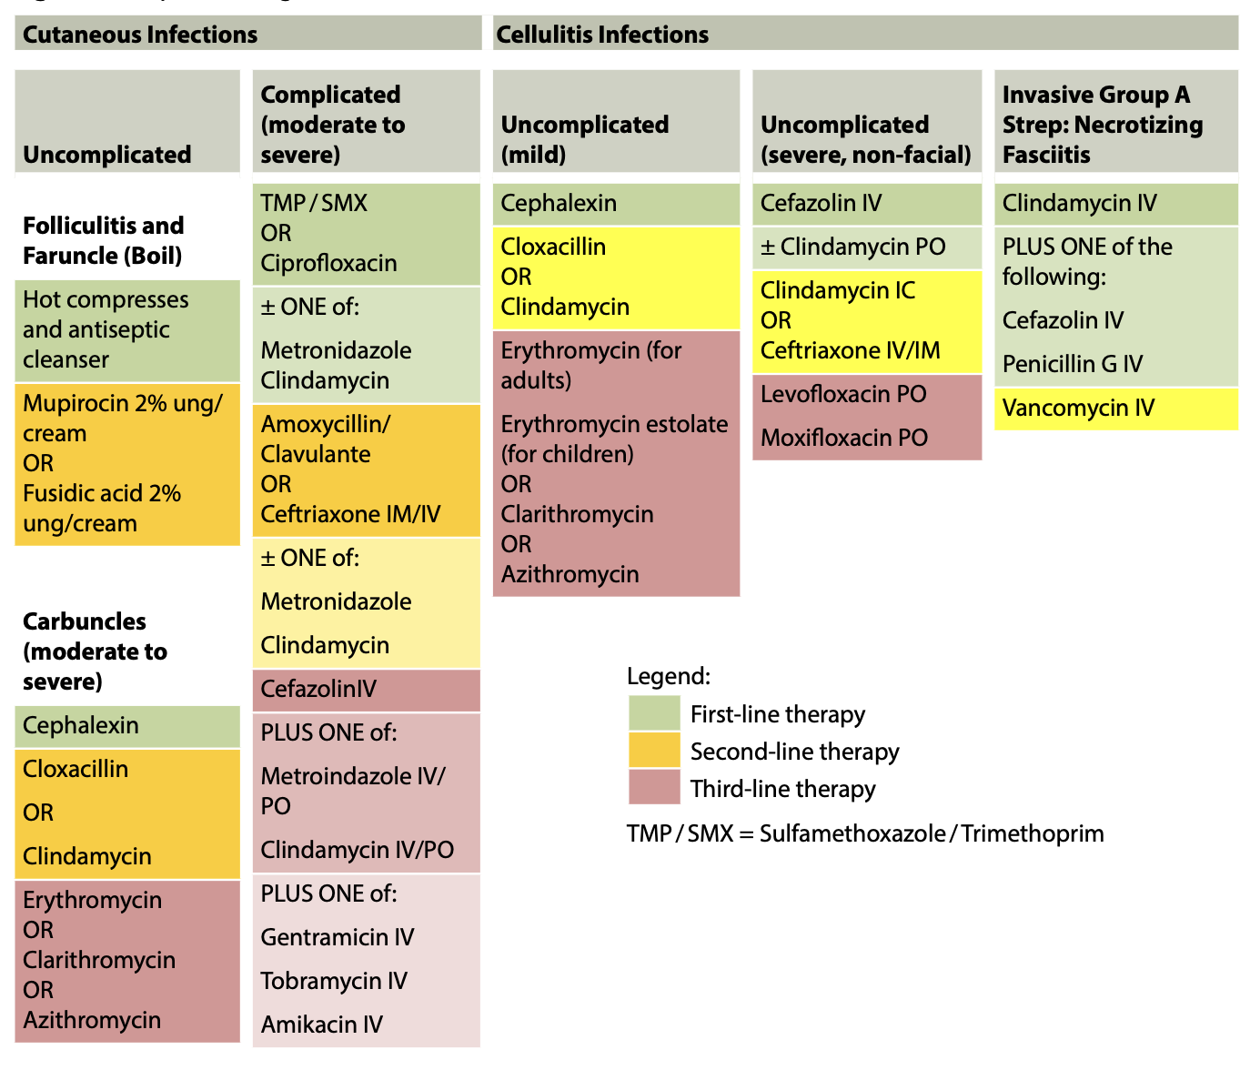

Cutaneous Infections - Complicated (e.g. perirectal abscess, decubitus ulcer)
Def’n | Complicated infections include perirectal abscesses and decubitus (pressure) ulcers. Usually polymicrobial
Non-pharmacological options | - Local care may be adequate if there is no S/S of systemic infx or extensive ulceration  - I&D and debridement
Pharmacological Therapy
NOE: Avoid topical antibx therapy and R/O osteomyelitis
Duration: 7-14 d
Drug/Dose | Indication | Adverse fx (AE) and Drug interactions (DI) | Contraindications & special considerations
1st Line Therapies: TMP/SMX OR Ciprofloxacin +/- flagyl and clinda
TMP/SMX 1-2 DS tabs BID | Use for suspected MRSA (suspect in areas where MRSA is commonly isolated or in pts with prior antibx use or hospital admisions)
Ciprofloxacin  500-750 mg BID | Use if Pseudomonas is present (in which case avoid TMP/SMX)
+/- ONE OF THE FOLLOWING
Metronidazole  500mg BID | If Anaerobes are present, add one of these
Clindamycin 300-450mg QID
2nd Line Therapies
Amoxiclav ALONE 500mg TID or 875mg BID | Amoxiclav covers anaerobes and can be used alone.  Ceftriaxone doesn’t cover anaerobes thus req. Flagyl or clinda if anaerobes a concern
Ceftriaxone IM/IV

+/- Metronidazole or Clindamycin

Cellulitis (Mild)
Def’n | Mild cellulitis is a common bacterial skin infection that affects the deeper layers of the skin (dermis) and the underlying tissue. It usually presents with redness, swelling, warmth, and tenderness in the affected area. In mild cases, the symptoms are generally limited to a small, localized area, and there may be no fever or systemic signs of infection. The most common cause is Streptococcus or Staphylococcus bacteria entering through a break in the skin, such as a cut, scrape, or insect bite. Mild cellulitis is typically treated with oral antibiotics and good wound care.
Therapeutic goals | N/A
Algorithm | N/A
Non-pharmacological options | N/A
Education/counseling | N/A
Pharmacological Therapy
Drug/Dose | Indication | Adverse fx (AE) and Drug interactions (DI) | Contraindications & special considerations
1st Line Therapies
Cephalexin  500mg QID for 5 days  Children:  50-100 mg/kg/day  divided q6h | Mild cellulitis, non life GAS infection | AEs:  DIs: | If origin unclear use cephalexin
Cefadroxil 500 mg BID or 1 g daily for 5 days  Children: 30mg/kg/day divided BID or once daily(Max: 2g/day) | Mild cellulitis, non life GAS infection
2nd Line Therapies
Cloxacillin500 mg QID for 5 days  Children:50 mg/kg/day divided q6h | Mild cellulitis, non life threatening. S. Saureus infection
Notes | Mild cellulitis, non life threatening. S. Saureus infection
Considerations | Treatment considerations:  - Group A Strep: Penicillin V or amoxicillin may be used. For Staphylococcus aureus, cloxacillin is first-line. If the organism is unclear, cephalexin is recommended. A 5-day treatment duration is suggested. Elevation of the affected area is helpful.  - CA-MRSA: For community-associated MRSA, trimethoprim-sulfamethoxazole (TMP-SMX) or doxycycline is effective. Cloxacillin, cephalosporins, and amoxicillin-clavulanate are not effective. In adults over 70 kg or with a BMI ≥40 kg/m², consider 2 DS TMP-SMX tabs twice daily if renal function is normal.  - Empiric MRSA Coverage: Empiric coverage for CA-MRSA should be considered in areas with high MRSA prevalence (>10-15%) or in patients with recent hospitalizations (last 12 months) or purulent drainage without a drainable abscess.  - Alternative treatment: Consider clindamycin for patients with multiple drug allergies or side effects to other treatment
Referral
Other notes | Conditions that may masquerade as infectious cellulitis include: vascular disorders (superficial and DVT); primary dermatological conditions (e.g., contact dermatitis, insect bites, drug reactions); rheumatic disorders (gouty arthritis); malignant disorders; foreign body reaction (e.g., metallic implant, silicone injections or mesh intolerance)

Cellulitis- Severe (Non-Fascial)
Def’n | See Cellulitis (mild).
Therapeutic goals
Algorithm | N/A
Non-pharmacological options | N/A
Education/counseling | N/A
Pharmacological Therapy
Drug/Dose | Indication | Adverse fx (AE) and Drug interactions (DI) | Contraindications & special considerations
1st Line Therapies
Cefazolin IV  1-2 g q8h  Children:  100 mg/kg/day  divided q8h | Severe cellulitis, not in the face, due to:  S. aureus or  Group A Strep  Group C Strep  Group G Strep  Group F Strep | AEs:  DIs:
2nd Line Therapies
Amoxicillin/  Clavulanate  500 mg TID or  875 mg BID  Children:  40 mg/kg/day  amoxicillin divided q8 | Severe cellulitis, not in the face, due to:  S. aureus or  Group A Strep  Group C Strep  Group G Strep  Group F Strep
2nd Line Therapies
Ceftriaxone IV  1-2 g q24h  Children:  75 mg/kg/day  divided q12h-q24h  (Maximum: 2 g/day) | Give in penicillin allergy
Notes
Monitoring | See cellulitis-mild.
Referral
Other notes | If anaerobes are an issue, consider adding metronidazole or clindamycin (if multiple-drug allergies.

Cellulitis: Facial
Def’n
Therapeutic goals
Algorithm
Non-pharmacological options
Education/counseling
Pharmacological Therapy
Drug/Dose | Indication | Adverse fx (AE) and Drug interactions (DI) | Contraindications & special considerations
1st Line Therapies
Adult:  Cefazolin IV: 1-2g q8h  Ceftriaxone IM/IV: 1-2  Q24h  Children:  Cefuroxime IV:  100-150 mg/kg/day q8h  Ceftriaxone IV:  75mg/kg/day q12-q24h (maximum 2g/day) | Group A Strep  S. aureus  Group A Strep  S. aureus  H. influenzae | AEs:  DIs:
2nd Line Therapies
Adult:  Clindamycin IV/PO: PO: 300-450mg QID  IV: 600mg q8h  Amoxicillin/ Clavulanate:  500mg TID or 875mg BID  Children:  amoxicillin/ clavulanate:  40 mg/kg/day TID | Group A Strep  S. aureus  Group A Strep  S. aureus  H. influenzae
3rd Line Therapies
Adult:
Vancomycin IV: 1g Q12h
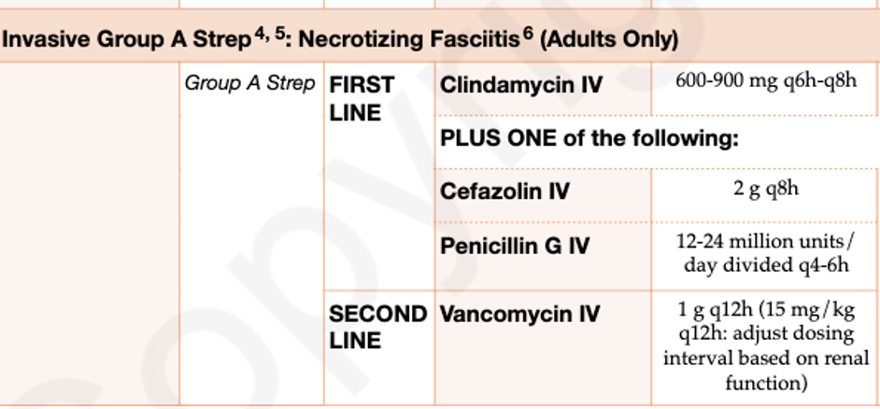
Notes
Monitoring | -Patient can be in outpatient setting and reassessed q24h or until parental therapy is no longer required
Referral
Other notes | -consult infectious disease if MRSA suspected  -use ceftriaxone if cellulitis is secondary to sinusitis  -cephalexin 500mg QID x 7-10 days can be used for outpatient management of mild facial cellulitis when H. influenzae is ruled out.  -reportable to the local medical officer of health.  -Treatment for a minimum of 10 days  -dosing regimes for polymicrobial infections caused by organisms other than group A strep will differ but include vanco or linezoid plus pip/taz or a carbapenem.  -prophylaxis of contacts use cephalexin 250 mg PO QID x 10 days  -IVIG considered if shock like syndrome is present  -surgery is used to treat necrotizing fasciitis

Cellulitis – Special Considerations: Diabetic Foot (Mild-Moderate)
Def’n | Cellulitis in diabetic population caused by S. aureus, GAS, GBS, Enterococci
Therapeutic goals
Algorithm | Mild: local skin infection involving only subcutaneous tissue (2 of the following: local swelling or induration; erythema <=2 cm; warmth; tenderness or pain; purulent discharge)  Moderate: local skin infection with erythema >2 cm or involving deeper than SC; no systemic signs (temp, HR, RR, WBC)  Tissue samples by curettage or biopsy  If anaerobes (necrotic tissue or foul smell) then metronidazole or clindamycin added
Non-pharmacological options
Education/counseling
Pharmacological Therapy Duration 1-2 weeks
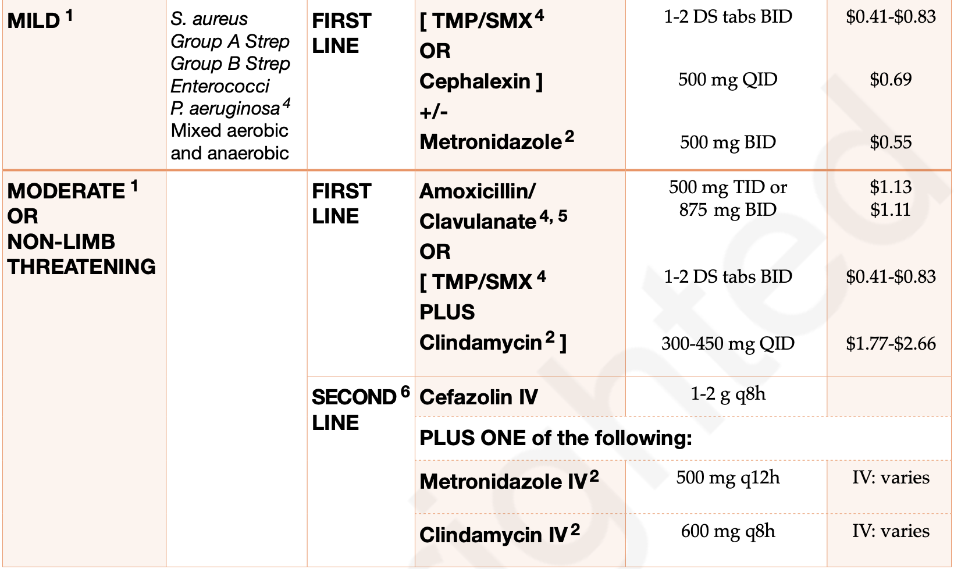
Notes
Monitoring | **Diabetics have decreased oral absorption due to gastric neuropathies- IV abx if 2-4 days no improvement  **Monitor kidney function; get kidney function BW prior to prescribing antibx (from class)
Referral
Other notes | -MRSA treatment when prior abx use or hospital admissions over last 6-12 months; TMP/SMX and doxycycline;  -TMP/SMX and amoxi/clav not used for pseudomonas (warm climate, wet feet, failed treatment, - ciprofloxacin instead  -If anaerobes are suspected (foul odour or necrotic tissue), metronidazole or clindamycin should be added to cover anaerobes

Cellulitis – Special Considerations: Diabetic Foot (severe)
Def’n | Severe or limb-threatening cellulitis of a diabetic foot.  Severe - evidenced by systemic toxicity (elevated fever, HR, RR, WBC), deep tissue involvement or spreading erythema >2cm
Therapeutic goals | N/A
Algorithm | N/A
Non-pharmacological options | N/A
Education/counseling | N/A
Pharmacological Therapy
Drug/Dose | Indication | Adverse fx (AE) and Drug interactions (DI) | Contraindications & special considerations
1st Line Therapies - Duration of therapy 14-28 days. If bone involvement, between 4-12 weeks generally required (consult osteomyelitis guideline).
Ceftriaxone 1-2g IM/IV Q24H | Severe or limb threatening cellulitis of diabetic foot.  Probable organisms: S. Aureus, GAS, Group B Strep, Enterococci, P. Aeruginosa, Mixed aerobic and anaerobic | AEs:  DIs:
Cefotaxime 1-2g IV Q8H
ANY ONE of the above PLUS ONE of the following:
Metronidazole 500mg PO BID
Clindamycin 300-450mg PO QID
2nd Line Therapies
Ciprofloxacin 750mg PO BID or 400mg IV Q12H
PLUS ONE of the following: (same drugs as above but slightly different dosing)
Metronidazole 500mg PO/IV Q12H
Clindamycin 300-450mg PO QID or 600mg IV Q8H
Notes
Monitoring | Blood cultures should be taken. Consider admission to hospital.
Referral
Other notes | Anti-infective guidelines fineprint:  - Pathogens: Most non-limb threatening or mild infections are monomicrobial involving gram positive bacteria only (e.g. S. Aureus, Streptococci) whereas severe infx are usually polymicrobial involving anaerobes  - MRSA: Empiric coverage for MRSA should be considered in areas where MRSA is commonly isolated or in patients with prior antibiotic use or hospital admissions over last 6-12 month. TMP/SMX and doxycycline are active against CA-MRSA whereas cloxacillin, all cephalosporins and AM/CL are not  - Pseudomonas consideration: If it’s known that Pseudomonas is present, the specific agent is determined by susceptibility results. Risk factors for pseudomonas- warm climate, frequent exposure of foot to water, tx failure with antibx therapy that has not activity against P. aeruginosa, or severe diabetic foot infection

MRSA
Def’n | MRSA is a resistant form of Staphylococcus aureus bacteria, dangerous for its resistance to common antibiotics. It can cause skin and other infections. There are two strains: CA-MRSA (community-acquired) affecting healthy individuals outside hospitals and not hospitalized in 12 months, and HA-MRSA (healthcare-acquired) affecting patients in healthcare settings.
Therapeutic goals | - Eradicate the infection.  - Prevent the spread of MRSA.  - Reduce complications, recurrence, and transmission to others.  - Use appropriate antibiotics based on susceptibility testing
Algorithm | - Diagnose through clinical examination and possible culture for confirmation.  - Identify whether the strain is CA-MRSA or HA-MRSA.  - Start empiric therapy based on the local prevalence of resistant strains.  - Adjust therapy once culture and sensitivity results are available.
Non-pharmacological options | - Hand hygiene: Prevent transmission via frequent handwashing.  - Environmental cleaning: Use hospital-grade disinfectants.  - Wound care: Use barrier precautions like gloves, masks, and gowns for open wounds.  - Patient isolation (if needed): Isolate in clinic or hospital settings to prevent spread and book MRSA patients at the end of the clinic day and educate office staff about reducing MRSA spread.
Education/counseling | - Emphasize hand hygiene, avoiding shared personal items (towels, razors).  - Discuss proper wound care and environmental cleaning.  - Educate on the risks of MRSA transmission and how to protect family members.  - Inform about judicious use of antibiotics to prevent resistance.  - Encourage patients to inform other healthcare providers about their MRSA status.
Notes
Monitoring
Referral | Referral to infectious disease specialists if the infection is recurrent, does not improve with standard treatment, or if resistance patterns are unclear.
Other notes | - HAMRSA: Most common growth sites include: anterior nares, axilla, groin, perineum, rectum, skin ulcers, IV sites, indwelling catheters, tracheostomy and feeding tubes.  - Colonized individuals may transmit MRSA, however decolonization is not recommended in community settings because patients may become re-colonized when treatment stops and repeated decolonization for chronic carriers will contribute to the emergence of resistant organisms.  - MRSA colonization: Decolonization is generally not recommended outside healthcare settings unless there is a recurrent infection or family transmission. Decolonization for colonized individuals should be reserved for exceptional cases to prevent resistance

Community-acquired MRSA
Def’n | Community-acquired methicillin-resistant Staphylococcus aureus (CA-MRSA) is commonly associated with skin and soft tissue infections, such as cellulitis and abscesses. It can also lead to more severe conditions, including necrotizing pneumonia, septic shock, and bone or joint infections. Screening for nasopharyngeal or other site carriage is not recommended, and decolonization therapy is generally discouraged due to the risk of creating even more resistant strains.
Therapeutic goals | When to Suspect CA-MRSA: Consider CA-MRSA in the following cases:  - Any patient with a skin or soft tissue infection in a community where more than 10-15% of S. aureus isolates are MRSA.  - Patients from high-risk groups, such as athletes in contact sports, those who are institutionalized, incarcerated, homeless, injection drug users, or individuals with HIV or malnutrition.  - Patients who have not responded to treatment with β-lactam antibiotics.  - Individuals with recent antimicrobial therapy, especially broad-spectrum, within the past 6 months.  - Those with invasive procedures or devices (e.g., dialysis, indwelling catheters), advanced age, or children under 2 years.
Algorithm | Management:  - Culture any lesion suspected to be caused by MRSA. Even minor lesions should be cultured in high-risk patients or when β-lactam therapy has failed.  - Minimize antimicrobial therapy where possible. In areas endemic with CA-MRSA, β-lactams (such as cephalexin) remain an appropriate first-line empiric treatment for mild skin and soft tissue infections. Cephalexin 500 mg QID may be used alongside TMP/SMX or doxycycline.  - The treatment duration for MRSA-related skin and soft tissue infections typically ranges from 5 to 14 days, depending on severity and clinical response
Non-pharmacological options | Judicious use of antibiotics; hand hygiene; not sharing personal care items (e.g., towels, soap); early recognition, containment and management of infections if they do occur.
Education/counseling
Pharmacological Therapy
Drug/Dose | Indication | Adverse fx (AE) and Drug interactions (DI) | Contraindications & special considerations
1st Line Therapies
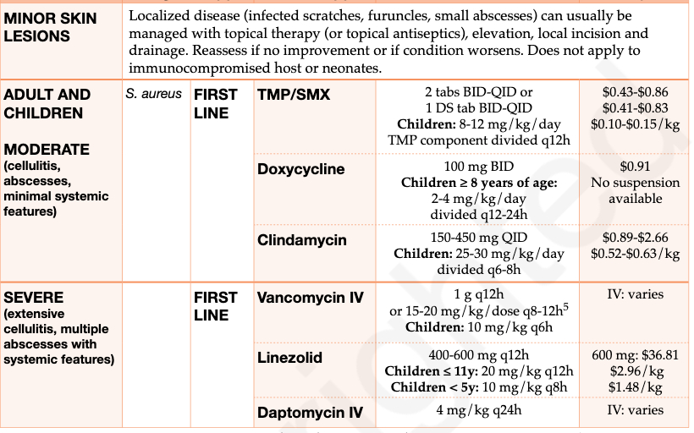
Notes
Monitoring
Referral
Other notes | For Critically Ill Patients: In critically ill patients with suspected or confirmed MRSA infections, a vancomycin loading dose (20-35 mg/kg) may be administered. Dosing should be based on actual body weight, not exceeding 3,000 mg, with subsequent doses adjusted according to AUC-guided serum concentration monitoring (Rybak, 2020).

Bites: Cat, Dog, Wild Animal and Human
Therapeutic goals | Treat infx
Algorithm | N/A
Non-pharmacological options | -All wounds should be thoroughly cleaned, irrigated (NS or povidone-iodine) and debrided.
Education/counseling | N/A
Pharmacological Therapy
Duration of therapy:
For human and animal bites 7-14 d (or longer if there’s bone or joint involvement)
If child-child bites and high risk (puncture, to face, hands, feet, genitalia, more than a superficial abrasion) then give abx as prophylaxis for 3-5 days
Drug/Dose | Indication | Adverse fx (AE) and Drug interactions (DI) | Contraindications & special considerations
1st Line Therapies
Amoxicillin/Clavulanate  500mg TID or 875mg BID  Children: 40mg/kg/day amoxicillin divided Q8H | Mild Infx from a bite | AEs:  DIs:
Ceftriaxone IM/IV 1-2g Q24h  Children: 50-100mg/kg/day Q24h  +/-  Metronidazole500mg BID (esp if human bite) | Moderate-Severe infx from a bite |  | Metronidazole important for human bites since anaerobic coverage is required
2nd Line Therapies
Doxycycline 100mg BID first day then 100mg daily  Children >8yo: 2-4mg/kg/day Q12H first day then half dose Q24h | Mild Invfx from a bite
Ceftriaxone IM/IV 1-2g Q24h  Children: 50-100mg/kg Q24h | Mild Invfx from a bite
Piperacillin/tazobactam IV 3g Q6H  Children: 200-300mg/kg/day divided Q8H | Moderate-severe infx from bite
If allergic to B-lactam antibiotics
[TMP/SX PO/IV 4-5 mg/kg/day divided Q6-12H  OR  Ciprofloxacin 500mg BID]  +/-  [Metronidazole 500mg BID  OR  Clindamycin 300-450mg QID] | If allergic to B-lactam antibx
Notes
Monitoring | -Worsening infx
Referral | -Public health if rabies suspected
Other notes | Animal bite considerations:  1.Antibx prophylaxis: recommended for high-risk wounds such as: deep punctures, wounds to the face/hands/upper limbs/other joints/cartilaginous structures; those inflicted through unprovoked attacks or wild animals  -Cat wounds have a high risk of infx (80%) d/t deeper puncture wounds; dogs have 3-28% infection rate  2. Rabies:If potentially exposed to rabies (e.g. wild or domestic animal bite), report to local public health office and refer to local immunization guidelines for rabies prophylaxis and tetanus  - Risk factors for rabies: stray/wild animal, unprovoked attack, bites  - Incubation period of rabies for head/neck bites are short d/t proximity to brain and thus immediate rabies prophylaxis may be indicated  Pediatric bites: child bites child  -Consider prophylactic antibx if there’s moderate-severe tissue damage, deep puncture wounds or bites to the face/hand/foot/genitals that are more than simple superficial abrasions  -Give HBV vaccine to non-immune child if biter or bitten has known HBV  If child-child and status unknown no need to test blood if low risk  Adult bites: adult bites adult  -Assess for risks of bloodborne pathogen transmission and treat appropriately
LYME | If they meet ALL 4 criteria administer 200mg doxy once to adults (4mg/kg once to peds). If they dont meet the criteria monitor for 30 days and if S/S then administer same meds:  - Tick has been removed within the past 72 hours  - Tick bite occurred in a higher risk area where blacklegged ticks have been identified.  - Tick was likely attached for 24 hours or more  - Doxycycline is not contraindicated (e.g. allergy).
TETANUS | 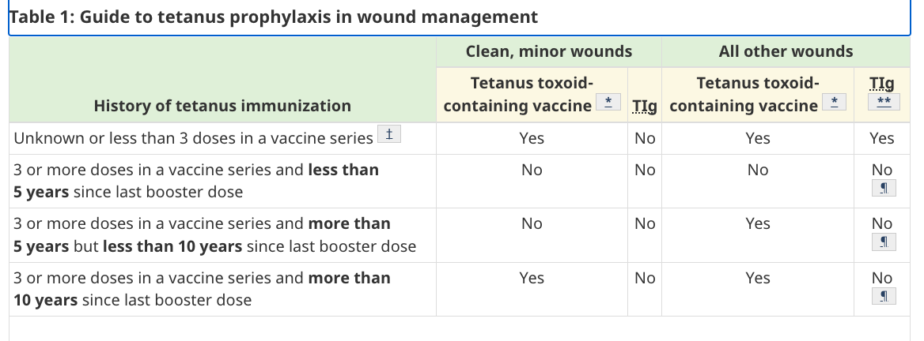
RABIES | - Only mammals can carry rabies, must break the skin and usually mucus must contact the human from the animal (except for bats, any physical contact = should vaccinate)  - If youre in the same room as a bat and asleep then wake up then no need to vaccinate (assuming you didnt disturb the bat). If you're erratic and freaking out you'll increase likelihood of making contact and need vaccine  - For any bite from a wild animal initiate rabies rPEP and then test the animal (if possible). If results are negative then d/c rPEP  - For dogs see if the dog can be observed/tracked for 10 days. If a dog has no S/S for 10 days then no rPEP is needed.  - Immediate cleaning of the wound with soap and water is the most effective procedure in the prevention of rabies. Flushing for approximately 15 minutes is suggested. Suturing the wound should be avoided.  - rPEP in a previously unvaccinated person: rabies immune globulin on the first day of post-exposure prophylaxis (Day 0) and rabies vaccination on Days 0, 3, 7 and 14.  - rPEP in those who are immunocompromised or taking antimalarial drugs: an additional dose is provided on Day 28.  - rPEP in a person who was previously vaccinated: only two doses of rabies vaccine on Days 0 and 3. No rabies immune globulin is required.

Herpes Simplex Virus-Mucocutaneous
Def’n
Therapeutic goals
Algorithm
Non-pharmacological options
Education/counseling
Pharmacological Therapy
Drug/Dose | Indication | Adverse fx (AE) and Drug interactions (DI) | Contraindications & special considerations
1st Line Therapies
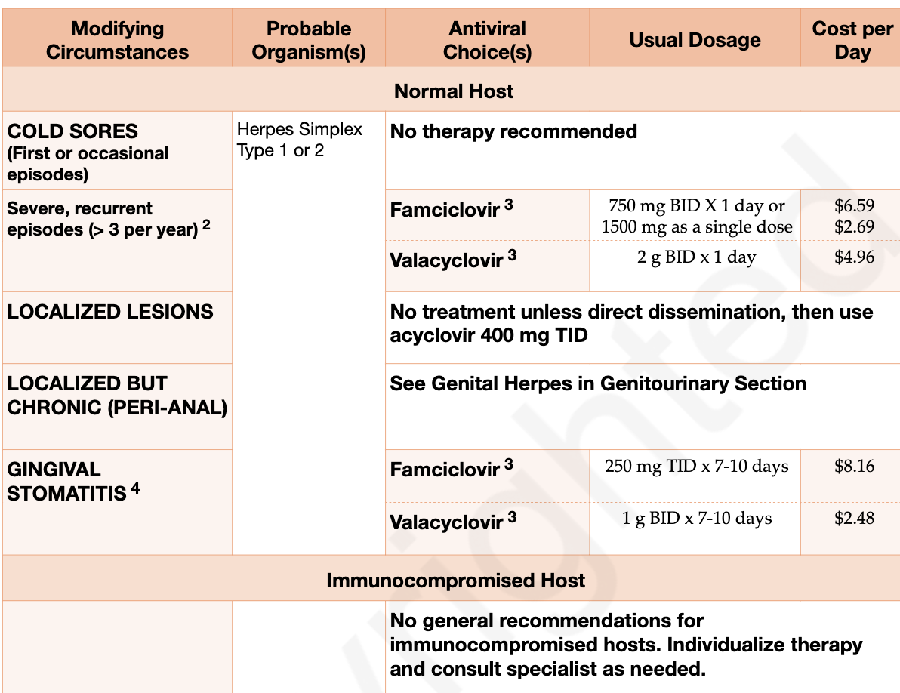

Gingival Stomatitis: PEDS acyclovir 15mg/kg to a maximum of 200mg five times daily for seven days.
2nd Line Therapies
acyclovir 400mg BID  (PEDS acyclovir 10mg/kg/dose BID to maximum of 400mg daily)  -famciclovir 250mg BID and  -valacyclovir 250mg BID, 500 mg daily or 1G daily | in adults or children with over 6 recurrences/year |  | Valacyclovir, flucoinonide, famiclovir should be started during prodromal stage of presentation
Notes
Monitoring
Referral
Other notes | -topical treatments must be started during prodromal stage during pain/tingling/burning

Warts- common, plantar, anogenital
Def’n | Caused by HPV infection, anogenital warts are caused by HPV 6 and 11.  -commonly occurs on the hands.  -plantar warts are found on soles of the feet and are more difficult to treat. -anogenital warts found on genitals or anus
Therapeutic goals | Prevent reactivation by continuing therapy for 2-3 months minimum  Treating wart early to increase treatment success and decrease transmission
Algorithm
Non-pharmacological options | -Soaking and debriding a hand and foot wart to increase penetration of topical therapy, silver duct tape over top can increase clearance  -Apply for six days/ week, soak and debride on day 7
Education/counseling | -Gardasil 9 vaccine can decrease risk of anogenital warts  -salicylic acid combination with cryo inform to skin salicylic acid on days when receiving cryo to decrease pain and irritation
Pharmacological Therapy
Drug/Dose | Indication | Adverse fx (AE) and Drug interactions (DI) | Contraindications & special considerations
1st Line Therapies
Salicylic acid- OTC  -Compound W-  -Dr.scholl’s-  -Soluver-  -Apply liquid/gel once or twice daily  -plaster/disc trim to site and apply q48hrs | Use for 12 weeks  -use higher strength (40%) unless patient has sensitive skin then use lower strength.  -liquid has better accuracy for application vs gel | AEs: minor skin irritation, hypo or hyper pigmentation  DIs: | Do not put on areas of poor healing ex. Neuropathic feet
Cryotherapy-  -Liquid Nitrogen: apply q 2 weeks max of 6 treatments,  -Nitrous Oxide- OTC  -Dimethyl Ether Propane- OTC | -benefits seen after 4 applications  OTC cryotherapy:  -arch of foot- apply 10-20 seconds  -plantar warts - apply 40 seconds | AEs: pain, blistering, soreness, scarring skin irritation, pigment alteration in darker skin type.  DIs: | -increasing aggression of treatment by increasing frequency  -avoid areas of difficult skin healing
Anogenital Warts:  -podophyllotoxin condyline  BID x 3 days, off x 4 days. Max 4 weeks  Imoquimod  Apply 3 times a week at HS and wash with soap next AM. max 16 weeks  Cryotherapy  Used for solitary genital warts or in pregnancy but PAINFUL | Apply only to lesion and do not occlude. | AEs:  erythema/skin irritation, pain, ulcers ulcers, flaking, dryness
For reluctant warts:  -use PO therapy for numerous warts such as high dose oral zinc.  -bleomycin intralesional q2wks for wart to slough off  -surgical excision |  | bleomycin:  -AEs:  Intense pain and tissue necrosis  *cant use during pregnancy
2nd Line Therapies
Blistering Agents:  Over 12 yr: apply to wart and surrounding 1mm with wooden stick q 2 weeks, occlude for 8hr  Children over 3 years or adults:  Apply to wart and surround 1-3mm with a wooden stick for q2wk, occlude for 24hr  -Cantharidin + SA + Podophyllin  -Cantharidin OTC  PEDS: cantharidin alone preferred | -use for plantar warts, high cure rates after 2 week application, | AEs: pain, minor skin irritation, lymphangitis, potential hypo-hyper pigmentation, bleeding from blistering,  DIs: | -apply thin layer allow few seconds to dry then cover with dressing  -consider abx if lyses of blister occurs  -avoid in areas of poor healing or areas where skin is irritated or inflamed  -toxic if ingested!!
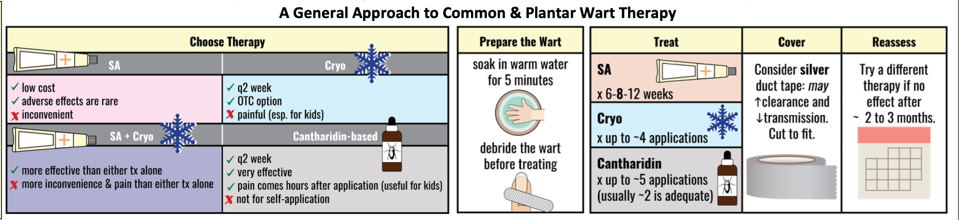
Notes
Monitoring
Referral | Surgical removal if warts are reluctant
Other notes

Head Lice
Def’n | Dx based on presence of live lice.
Therapeutic goals | Eradication of lice and nits (their eggs)
Non-pharmacological options | -Household treatments (e.g. mayonnaise) are NOT effective  -Wash clothes/sheets in hot water and dry in dryer +/- vacuum carpet/furniture
Education/counseling | All of the following are critical for success:  - Proper application technique  - A second treatment is required for all lice products in ~9 days to ensure nit eradication after they’ve hatched but before they’re mature enough to lay eggs  - Nitpicking  Note: re-treating too early can lead to tx failure as some nits will not have hatched yet (time to hatch 6-9 d)  OK to return to school/work after 1st tx
Pharmacological Therapy
Drug/Dose |  | Adverse fx (AE) and Drug interactions (DI)
1st Line Therapies
All 1st line tx have similar efficacy and should cure lice in 2 weeks; if failure, try another 1st line tx.
Note: longer hair requires more product like shampoo
Permethrin 1% creme rinse  (Insecticide) |  | AEs: tingling, skin irritation, rash, itch  Contraindication: allergy to chrysanthemum
Pyrethrins/Piperonyl Butoxide 0.33/3% shampoo  (Insecticide) |  | AEs: skin irritation, localized burning, itch  Contraindication: allergy to ragweed or chrysanthemum plant
Isopropyl Myristate 50% sol’n  (not insecticide;dissolves lice exo-skeleton) |  | AEs skin irritation, rash tingling, itch  DIs skin
Dimethicone 50% spray  (not insecticide; suffocates lice) |  | AEs skin irritation and eye irritation
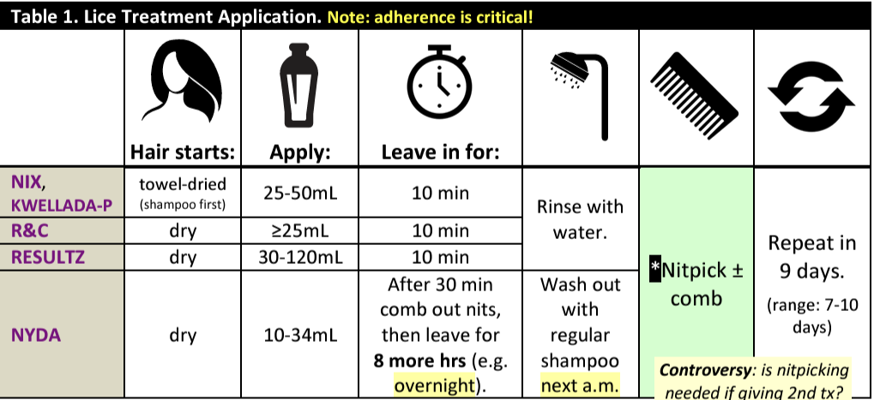
Notes - N/A

Scabies
Def’n | Caused by itch mites that burrow under skin; transmitted via skin-skin contact. Dx via visual inspection of burrows and skin scrapings.
Therapeutic goals | N/A
Algorithm | N/A
Non-pharmacological options | Non-pharm mgmt essential. Wash sheets/clothing in hot water and dry in hot dryer. Place items that can’t be machine washed in sealed bag for 1 wk
Education/counseling | -Ok to return to school/work one day after tx  -Itchiness should resolve after 1 week of tx
Pharmacological Therapy
Drug/Dose |  | Adverse fx (AE) and Drug interactions (DI)
1st Line Therapies

Permethrin 5% cream/lotion - massage into all skin areas from neck down to soles of feet incl fingernails and genitalia, leave on 8-14 hrs (overnight) then wash off. Second application often recommended 7-10d later. |  | AEs: scalp irritation, rash, tingling, pruritus, edema, erythema
2nd Line Therapies
Crotamiton 10% cream - massage into all skin areas from neck down to soles of feet, incl fingernails/genitalia. Repeat in 24h; wash off 48 after last application. |  | AEs: local irritation, contact dermatitis, pruritus, skin rash, hypersensitivity rxn
Notes - N/A

Varicella Zoster Virus (Shingles)
Def’n | -painful vesicular lesions limited to a dermatome and one side of body
Therapeutic goals | -reduce pain, resolve without scaring
Algorithm
Non-pharmacological options | OTC pain medications, calamine lotion
Education/counseling | Isolation to prevent transmission  Vaccine (Shingrix) 2 doses 2-6 months apart for >50 years of age
Pharmacological Therapy
Drug/Dose | Indication | Adverse fx (AE) and Drug interactions (DI) | Contraindications & special considerations
1st Line Therapies
Famciclovir  500mg TID x 7 days | >11 y/o, >50 y/o, disseminated or severe, non-truncal involvement  -Initiate within 72 hours of rash onset | AEs: headache, nausea  renal impairment (adequate hydration) | Can be started up to 7 days after rash onset if severe or complications
Valacyclovir  1g TID x 7 days | -Initiate within 72 hours of rash onset
2nd Line Therapies
Acyclovir  800mg 5x daily x7days | -Initiate within 72 hours of rash onset | Adjusted for low creatinine clearance | IV for immune compromised
Notes
Monitoring | Renal function (all anti-virals impact kidney function. Monitor renal function and may need to adjust dosing)
Referral | Specialist if pregnant
Other notes | Immunocompetent children under 12 do not require antivirals unless dissemination  Avoid steroids

Chicken Pox (Treatment and Post-exposure Prevention)
Def’n | -temp, cough, tiredness followed by itchy rash with small blisters that dry and scab day 2-4
Therapeutic goals | -reduce lesion number and time to crusting
Algorithm
Non-pharmacological options | -calamine lotion, cool showers/compress, oatmeal in bath  -antihistamine  -acetaminophen (NO Ibuprofen or naproxen as increases risk of serious skin infection; NO ASA because of Reye syndrome)
Education/counseling | -avoid scratching (nails short), loose clothing,
Pharmacological Therapy
Drug/Dose | Indication | Adverse fx (AE) and Drug interactions (DI) | Contraindications & special considerations
1st Line Therapies- ADULT
Famciclovir  500mg TID 5-7 days |  | AEs: headache, nausea  renal impairment (adequate hydration) | *initiate within 24 hours of onset of rash
Valacyclovir 5-7 days  1g TID |  |  | *initiate within 24 hours of onset of rash
2nd Line Therapies- ADULT
Acyclovir  20mg/kg/dose QID |  |  | During Pregnancy and immunocompromised
Prevention - for those who have not had chickenpox or vaccine previously
Chickenpox Vaccine | Within 72 hours of exposure (up to 5 days) |  | Contraindicated in pregnancy
VariZIG (Varicella Zoster Immunoglobulin) | Given for significant exposure. Give within 96h up to 10 days |  | Safe for pregnancy, neonates, and immunocompromised
Notes
Monitoring
Referral
Other notes | - Pregnancy is serious issue, can cause death if haven’t been exposed previously  - No good evidence to support antiviral therapy in otherwise healthy adults and children, although it can reduce lesion number and time to full crusting at best. Benefit increases in immunocompromised patients and those with noncomitant skin or pulmonary conditions  Special populations:  -CHILDREN: treatment not recommended routinely  -PREGNANCY: tx is acyclovir 10mg/kg IV Q8H or 20mg/kg PO QID  - Varicella zoster immunoglobulin should be considered in pregnant women who are non-immune, varicella-zoster IgG antibody negative, and who have had significant exposure within last 4 days  -IMMUNOCOMPROMISED: Acyclovir 10mg/kg IV Q8H (Adults) or 500mg/m^2 Q8H (Children)

Onychomycosis (nail fungus)
Def’n | -nail thickening, discolouration and separation from nail bed
Therapeutic goals
Algorithm | 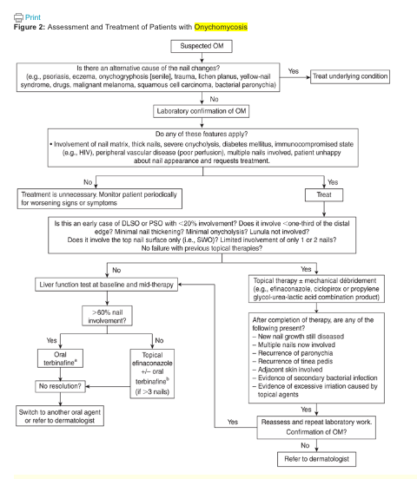Toenail: dermatophytes; fingernail: yeast
Non-pharmacological options
Education/counseling | -wear shoes in communal areas
Pharmacological Therapy
Drug/Dose | Indication | Adverse fx (AE) and Drug interactions (DI) | Contraindications & special considerations
1st Line Therapies
Terbinafine  250mg daily X12 weeks | Culture or microscopic confirmation prior to treatment** | AEs: hepatic failure  nausea/vomiting | -baseline liver function prior to starting treatment
2nd Line Therapies
Itraconazole
250mg BID (6 weeks for hand, 12 weeks for toes)
Topical
Nail lacquer
Penlac or Emitrix/Jublia
1-2 drops/nail daily x48 weeks
Notes
Monitoring
Referral
Other notes

Oral Candidiasis
Def’n | -white plaques on oral mucosa (pseudomembranous) or erythema without plaques (atrophic)
Therapeutic goals | -eradicate candida albicans; reduce infection
Algorithm
Non-pharmacological options
Education/counseling | -no smoking, rinse after inhaled steroids, dentures/poor oral hygiene
Pharmacological Therapy
Drug/Dose | Indication | Adverse fx (AE) and Drug interactions (DI) | Contraindications & special considerations
1st Line Therapies
Nystatin oral suspension  400-600,000 U QID x7 days or >2 days after improved | Mild disease | AEs:Nausea, vomiting, diarrhea
Fluconazole  100-200mg daily x7-14 days or >2 days after improved | Topical treatment ineffective; moderate to severe disease | AEs:abdo pain, Nausea, vomiting, diarrhea  DIs: All CYP (statins, benzos, calcium channel blockers, warfarin)
Notes
Monitoring
Referral
Other notes

Common Fungal Skin Infections
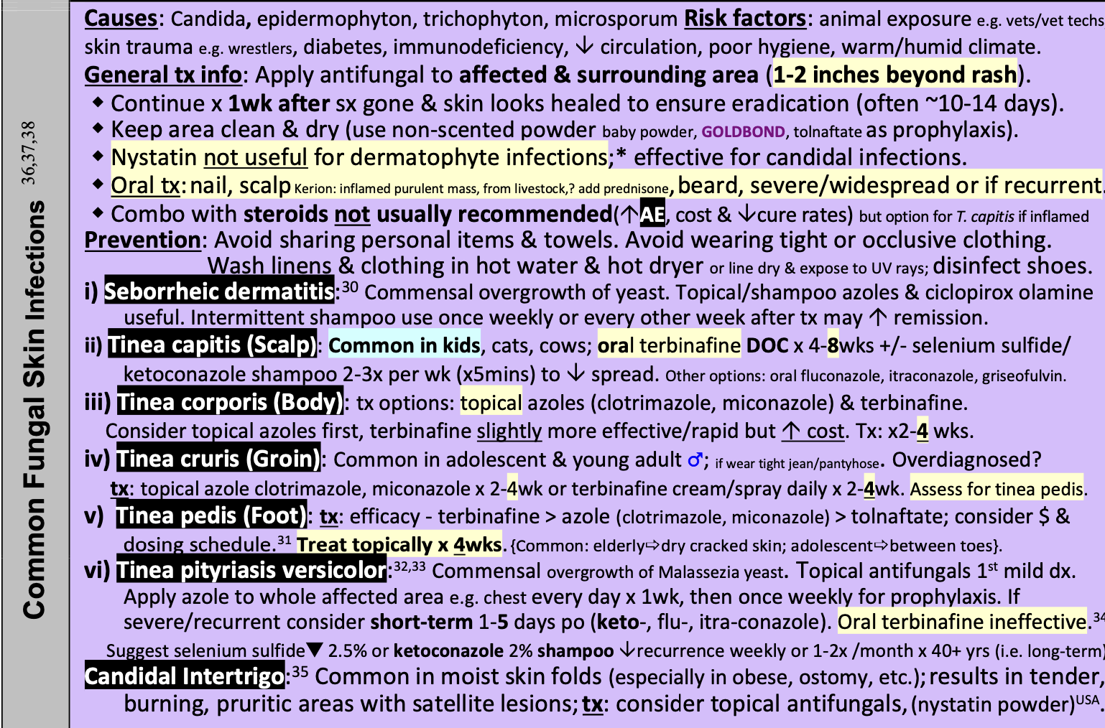

WEEK 5: DERMATOLOGY PART II

ACNE
Def’n | Mild acne (comedonal): <20 comedones, or <15 inflammatory papules, or <30 lesions  Mild-moderate (papulopustular): 15-20 papules and pustules with comedones, cysts are rare, total lesion count 30-125  Severe: primary nodules and cysts, or comedones, papules and pustules or total lesion > 124, scarring
Therapeutic goals | Prevent scarring
Algorithm | 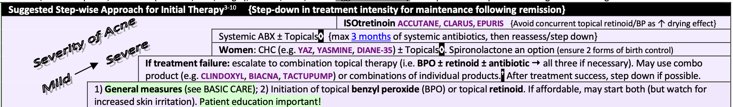
Non-pharmacological options | -Diet: avoid high fat, sugar, dairy  -Tea tree oil
Education/counseling | BASIC CARE: (first line of treatment)  -Avoid excessive skin care  -Avoid stress, astringents, scrubs, toners  -Use oil free makeup  -Avoid picking/touching/squeezing lesions  -Shaving- shave lightly, only once and follow grain of hair growth  -Wash face-once a day, no more than twice a day with water and soapless cleanser (cetaphil, spectro jel, cerave)  -avoid sunlight and use non-comedogenic sunscreen  -oily skin: use solution or gel, dry skin: use cream or lotions
Pharmacological Therapy
Drug/Dose | Indication | Adverse fx (AE) and Drug interactions (DI) | Contraindications & special considerations
1st Line Pharmacological Topical Therapies for mild-moderate acne
Benzoyl peroxide (BPO)  (antibacterial/  keratolytic)  -ex. Panoxyl, oxy vanishing, proactive solution, cerave gel  -apply to entire affected area QHS or BID | First line for mild-moderate acne as individual therapy | AEs: irritation, dryness, peeling, erythema, burning, pruritis, can bleach clothing, severe allergic rxn and contact dermatitis  -if irritation occurs: decrease concentration, potency, frequency  DIs:skin irritation or drying effect- concomitant topical medication, abrasive soaps and cleansers, cosmetics, (any product with high concentration of isotretinoin, lime, alcohol, astringers, spices).  -can inactivate retinoids and antibiotic | -Advice to use at night to avoid staining  -acne may get worse for first 2-4 weeks  -if acne is moderate-severe combine with other drugs
Retinoid  Differin  Retina-A  Steiva-A  Vit, A acid  Tazorac  Aklief  Apply pea size amount qhs apply initially apply q 2-3 nights to decrease adverse effects | First line for mild-moderate comedonal (black/white heads)  -decreases non inflammatory and inflammatory lesions  -decreases wrinkles and scars | AEs: skin irritation (red, dry, burning), photosensitivity  -contact allergy  -eczema/sunburn  -caution: pregnancy, increased risk if >20%, skin lesion  DIs: combination with antibiotics does not prevent resistance | Clinical worsening can occur in first 2-4 weeks  -maximal response time at 12 weeks  -increased photosensitivity use sunscreen  -ensure skin is dry before applying  -titrate: start at low strength every other night  Once get desired response decrease frequency
Moderate to Severe Acne
Antibiotics  Clindamycin  Erythromycin | Treatment for moderate-severe acne, most effective for inflammatory lesions stop when no further inflammation  -most effective when used in combination with BPO or topical retinoids (combining with BPO prevents bacterial resistance) | AEs: erythema, peeling, itching, dryness and burning  Serious: pseudomembranous colitis  DIs: | -Response time 8-12 weeks  -contraindications with previous colitis, ulcerative colitis, pseudomembranous colitis, regional enteritis
Combinations  -increased efficacy for combination  -Benzamycin (combo BPO and erythromycin).  -benzaclin, clindoxyl (BPO + CLI) | Moderate to severe acne  -once inflammation settles try stopping antibiotic | AEs:  DIs: | -response 2-4 weeks
Systemic Acne Therapies
Oral antibiotics  Tetracycline 250mg cap  (initially 500 mg BID  Maintenance: 250-500 mg daily)  Doxycycline 100mg cap  -100mg daily (ac best)  Minocycline 50,100mg cap  -(initial 100mg daily, maintenance 50 mg daily) | -Targets cutibacterium acne  -Moderate to severe acne on chest/back/shoulder  -used if topical combination have failed or are not tolerated  -tetracycline must be taken on empty stomach due to decreased absorption with food  -tetracycline cant be taken before sleep due to pill potentially lodging in esophagus | AEs:GI upset, vaginal candidiasis, photosensitivity, hyperpigmentation, lightheadedness, dizziness, vertigo, drowsiness, fatigue  -rare azotemia, pseudotumor cerebri, lupus, autoimmune hepatitis and hypersensitivity  DIs: Decreased GI absorption: irone, aluminum, calcium, magnesium, elevated INR for warfarin, decreased oral contraceptive effectivness, isotretinoin can cause intracranial HTN/hemorrhage | -recommended to do “pulse therapy” take po antibiotic for 3-4 months with topical therapy then topical therapy alone.  -combine with BPO to decrease antibiotic resistance  Contraindications: in pregnancy, children under 8 years, renal or hepatic dysfunction
Erythromycin  (initial 500mg BID, maintenance 250-500mg daily) | -Erythromycin second line due to increased resistance and GI effect | AEs  GI upset, NVD, jaundice  DIs:inhibits CYP1A2 and 3A4, increases levels of carbamazepine,, cyclosporin, theophyline, warfarin
Combined Hormonal Contraceptives
Tri Cyclen  Alesse  Yasmin  Yaz | Anti-androgenic effect due to estrogen increase  -used for women with moderate to severe acne + seborrhea and hirsutism/ alopecia / late onset acne | AEs  Bleeding, headache, hepatotoxicity, VTE  DIs:antibiotics can decrease efficacy | Response time is 3-6 months  -worsening of symptoms at the beginning of cycle  -progesterone only pills can worsen acne
Oral Retinoid
Isotretinoin  Accutane (10 or 40mg cap)  Clarus (10mg or 40mg)  Epuris (10,20,30,40mg caps)  Absorbica (8,16,24,32mg cap)  Initial:  0.5mg/kg/day cc divided daily-BID x4wks  Maintenance:  1mg/kg/d cc x3-7 months.38 Max: 2mg/kg/d.  Total course: 120-150mg/kg ** optimal dose must be at this dose to prevent recurrence  E.g. 60kg (40mg caps)  -40mg daily x 4wks;  40 & 80mg alternating  -daily x 4 months  Total course = 130mg/kg | Most effective acne treatment but has significant AE  Use for severe nodulocystic acne/ scarring, significant psychological distress | AEs  Dry skin and mucous membrane, hair loss, rash/red face, aches, elevated lipids and LFT, increased sun sensitivity, decreased night vision, depression and suicide  DIs:  -combined hormonal contraceptives, methotrexate, vitamin A  -avoid other acne topical during therapy due to dryness  -increased absorption with high fat meats | -response time is 3 months  -may see initial flare for first two months  -pregnancy test: twice prior to initial dose, within 11 days prior to initiating, monthly, one month after discontinuation  -start first dose 2-3 days after first menstrual cycle  -need to use 2 contraceptive forms
Spironolactone  Aldactone 25mg, 100mg tab  25-200mg daily | Anti adrenergic  Used for women over 18 when other treatment have been ineffective or not tolerated | AEs:  Menstrual irregularity, mild GI upset, headache, elevated potassium, gynecomastia, breast tenderness, avoid if poor kidney function!  DIs: | -Response time is 3-6months
Notes
Monitoring | CBC, LFT, anti nuclear factor, pregnancy test, mood
Referral
Other notes | Potency of drug: solution > gel>cream/lotion

Topical Corticosteroids
Def’n | Topical steroids used for:  psoriasis, vitiligo, eczema, atopic dermatitis, phimosis, acute radiation dermatitis, lichen sclerosus
Therapeutic goals
Algorithm | 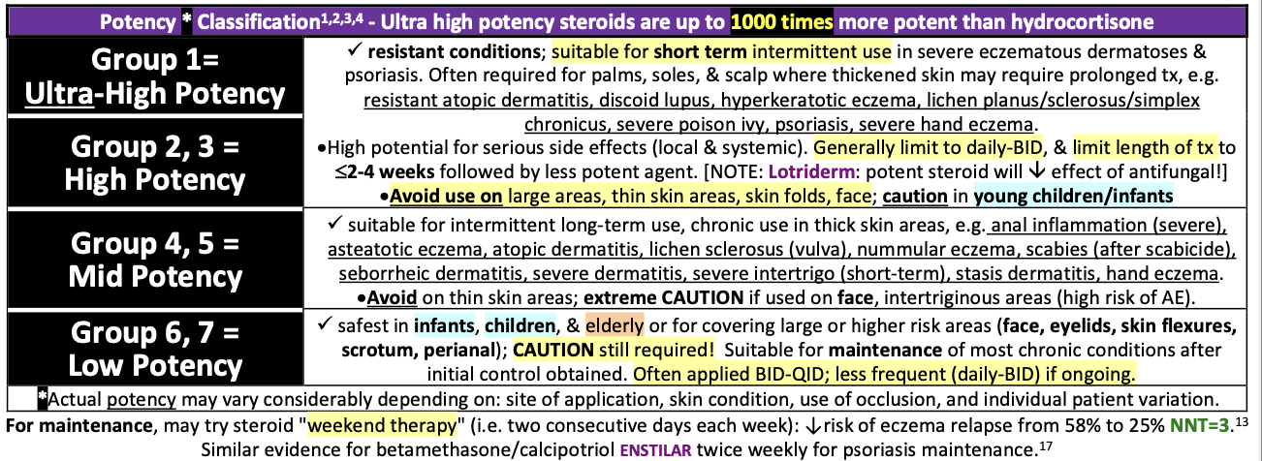
Non-pharmacological options
Education/counseling
Pharmacological Therapy
Drug/Dose | Indication | Adverse fx (AE) and Drug interactions (DI) | Contraindications & special considerations
Topical Steroid | -Ultra potent agents: max 50g/week, apply daily or BID  -High potency agents: use for resistant skin conditions and for thick skin areas (avoid using on face and thin skin areas)  -Low potency agents: use prn and on thin skin areas in elderly, young children, infants for long term use | AEs:  Skin atrophy, acne, telangiectasis, irreversible striae with prolonged use,  Use on eyelids increases risk of glaucoma and cataracts  -adrenal suppression  -children- increased risk of osteoporosis  DIs: | Pregnancy: use lowest potency for shortest duration due to increased risk of fetal growth restriction
Non-steroid emollients  Aveeno, cerave, eucerin, glaxal base, vaseline,hydrous emulsifying ointment, lubiderm, nicotinamide, | Apply emollient after bathing twice daily to improve eczema
Non-steroid  Tacrolimus:  (Calcineurin inhibitor)  Ointment use BID  Use 0.03% over 2yr  Use 0.1% over 16yr  Pimecrolimus  Calcineurin inhibitor 1% cream BID  Crisaborole  2% ointment BID  Over 3months for mild-moderate atopic dermatitis  Roflumilast  0.3% cream over 12 years for plaque psoriasis |  | AEs:  -Burn/itch, flushing post alcohol  -Risk of skin cancer
Creams: cause less occlusion for non-acute/wet lesions, intertriginous areas
Clobetasol propionate (Dermovate) 0.05%  -supplied as 15,50,454g  Betamethasone dipropionate (lotriderm, 1% clotrimzole)  0.05%  Supplied as 15,50,450g  Betamethasone valerate 0.1%, 0.05%  Hydrocortisone  2.5%, 1%, 0.5%  Daily QID | Potency score of 1  Potency score of 3  Potency score of 5  Potency score of 7 | AEs:  DIs:
Ointments→ more occlusive, greasy, more effective on dry scaly or hyperkeratinized skin areas, palms and soles
Clobetasol Propionate 0.05% (Dermovate)  Supplied as 15, 50g  Betamethasone dipropionate 0.05%  (Dirprosone, Topison)  Hydrocortisone 1% or 0.5%  Daily QID | Potency score of 1  Potency score of 2  Potency score of 7
Gels → non-occlusive, non-greasy, quick drying, and do not leave residue, useful on scalp or
hairy areas, irritating
Betamethasone diproprinate 0.05% + calcipotriol 50ug/g (dovobet)  Desoximetasone 0.05% (topicort)  Fluocinonide 0.05% (lyderm, lidex) | Potency score of 2 or 3  Potency score 2  Potency score 2
Lotions/Solutions → less occlusive than creams useful for axilla, foot, groin, hairy areas, acute weeping lesions
Clobetasol propionate 0.05% (scalp), 0.05%  Betamethasone dipropionate 0.05% lotion  Betamethasone valerate 0.1% scalp, 0.1% lotion, 0.05% lotion | Potency score of 1  Potency score 3, 4, 5  Potency score 5,6
Foams → quickly and easily spread, good for hairy areas, alcohol may burn if present
Betamethasone valerate 0.12%  Betamethasone dipropionate 0.5mg/g/calcipotriol  Clobetasol 0.05% | Potency score of 3,4  Moderate to severe psoriasis over 18yr  Potency score of 3,4  Psoriasis vulgaris over 18 yr  Potency score of 1  Moderate to severe atopic dermatitis over 12 years
Patch → max 30 day use less or equal 5 patches/day, apply every day wait 30min between remove and re-apply can be cut
Betamethasone Volerate 2.25mg | Potency score 3, 4  Mild to moderate knee/elbow psoriasis
Notes
Monitoring | Monitor for skin irritation and burning
Referral
Other notes

Treatment guide to common skin conditions
Pharmacological Therapy
Drug/Dose | Indication | Adverse fx (AE) and Drug interactions (DI) | Contraindications & special considerations
Dermatitis, Atopic
Step 1:  General Treatment Measures:  -avoid contact with irritants or trigger factors  -avoid wool or nylon clothing  -wash clothing in soap vs detergent, double rinse/vinegar  -limit use of soap to axilla, feet and groin |  | AEs:  DIs:
Step 2:

-colloidal oatmeal bath products
-lanolin-free water miscible bath oil
-intensive skin hydration therapy
-”soapless” cleansers for sensitive skin
Step 3:  -oral antihistamine (first generation) QHS  -topical hydrocortisone 0.5%  Apply OD-TID  Use cream during the day and ointment at night. | Used for sedation and relief of itching  For inflammation, useful in relieving itching, short courses of higher potency topical steroids are required for initial control, lower potency and frequency required for maintenance
Step 4  Prescription topical corticosteroids  -use lowest potency steroid that is effective and wean to twice weekly  -Topical/ oral anti-staphylococcal  (fusidic acid, mupirocin,  cloxacillin, macrolides, clindamycin) | -decreases bacterial load
Dry Skin
Step 1: General Treatment Measures

-use cool air humidifiers
-lower house temperature (min perspiration)
-avoid frequent or prolonged baths (limit two times a week)
-limit use of soap to axilla, feet and groin
-apply lubricant emollients such as petrolatum to damp skin

Step 2:  -colloidal oatmeal bath  -water miscible bath oil  -humectants: urea, lactic acid, phospholipid | -emollients: water retaining properties that are used in replacing natural skin oils (petrolatum, mineral oil, lanolin)  -humectants: water attracting properties to draw water into skin (glycerin, urea, lactic acid, lecithin)
Step 3:  -oral antihistamine for sedation and relief of itching  -give at bedtime and day time as required  -no more than 2 week course | -help relieve itchy skin  -first generation preferred  -second generation for urticaria | AEs:  Causes drowsiness, GI disturbances, paradoxical excitability and nervousness
Psoriasis
Step 1:  -non pharmacological measures (general health issues)  -moisturizers (will not clear skin but will decrease itching)  -coal tar (tegrin shampoo)  -anthralin  -Vit D3  -Topical Retinoid Therapy  -Sunshine  -Salicylic acid  -Bath additives (tar solutions, oils, oatmeal, epson salts) | -coal tar: anti-inflammatory and antipruritic  -anthralin: topical compound used to treat psoriasis.  -salicylic acid: keratolytic action helps remove psoriasis scales  -bath additives:soothing to itchy skin and help lock in moisture | AEs:  Folliculitis, acne, photosensitivity  AEs:  Burn normal skin around lesions, stain skin and clothing
Step 2:

-phototherapy UVB

-photochemotherapy (Psoralen + UVA)

-combination therapies
Step 3:

-Methotrexate

-oral retinoids (etretinate)

-Cyclosporin

-Rotational Therapies
Notes
Monitoring
Referral
Other notes

Rosacea
Def’n | Chronic, inflammatory, cutaneous vascular disorder. Initially characterized by erythema, flushing, and telangiectasia of central face then can progress to persistent erythema and presence of papules and pustules
Therapeutic goals | Increase awareness of triggers for rosacea outbreaks and how to avoid them; reduce erythema, flushing, telangiectasia and inflammatory lesions; improve appearance of skin when it’s affecting QOL; reduce # and severity of recurrences of cutaneous and ocular rosacea
Algorithm | 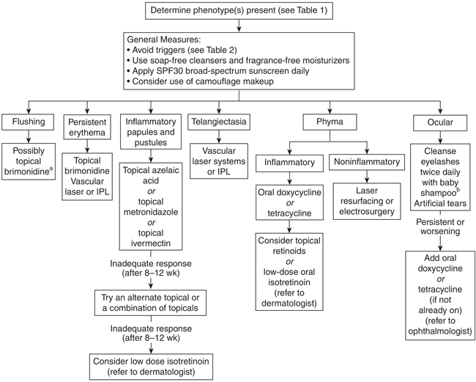
Non-pharmacological options | -Avoid triggers that can worsen rosacea (e.g. sunlight, heat, wind, exercise, hot beverages, spicy foods, alcohol, certain meds like vasodilators)  -Use high SPF sunscreen  -General skin care for sensitive skin  -Eyelid hygiene for ocular rosacea
Education/counseling | -Educate that following tx for erythema (particularly with brimonidine), telangiectases may appear more pronounced because the redness surrounding them has been reduced  -
Pharmacological Therapy -Note: CPS didn’t specify 1st/2nd line
Drug/Dose | Indication | Adverse fx (AE) and Drug interactions (DI) | Contraindications & special considerations
Topical therapies
Ivermectin 1% topical cream - apply daily | Inflammatory papules and pustules  Duration: 8-12 wks | AEs:Dry skin, pruritus, skin-burning sensation  DIs:
Azelaic acid 15% gel applied BID | Inflammatory papules and pustules  Duration: 8-12 wks | AEs:Initial mild, transient burning, tingling or stinging, pruritus, scaling, contact dermatitis
Metronidazole cream BID x9 wks | Inflammatory papules and pustules  Duration: 8-12 wks | AEs:Local irritation
Brimonidine tartrate 0.33% gel | Flushing and persistent erythema | AEs:Erythema, flushing, skin burning sensation, contact dermatitis, HA
Systemic therapies
Doxycycline 100mg daily x12 wks | Phyma (swelling or masses typically in advanced rosacea);  Also for ocular rosacea | AEs:GI fx, yeast overgrowth, photosensitivity
Tetracycline 500mg BID x2 wks then 500mg daily until rosacea controlled then 250mg daily x3-4 wks |  | AEs:GI fx, yeast overgrowth, photosensitivity
Isotretinoin (accutane) 0.2-0.3mg/kg/day x3-4 months | If inadequate response to topical therapies for inflammatory papules/pustules, can try low-dose isotretinoin and refer to derm | AEs:Teratogenicity, cheilitis, dry skin
Notes
Monitoring
Referral | -Pts with persistent or severe ocular involvement should be referred to ophthalmologist  -If pt requires accutane, refer to derm
Other notes | -Rosacea is often underdiagnosed in pt with dark skin  -Avoid topical corticosteroids (can precipitate or worsen rosacea)

Atopic Dermatitis (Eczema)
Def’n | Chronic, recurring inflammatory disorder of skin characterized by ill-defined patches of erythema, scale, and excoriations d/t abnormal skin barrier function and inability to maintain adequate hydration
Therapeutic goals | -Relieve generalized dry skin and pruritus  -Treat patches of dermatitis to reduce inflammation and pruritus and reduce risk of secondary infx  -Prevent flares caused by environmental irritants  -Promptly treat complications of AD such as secondary bacterial or viral infx
Algorithm | 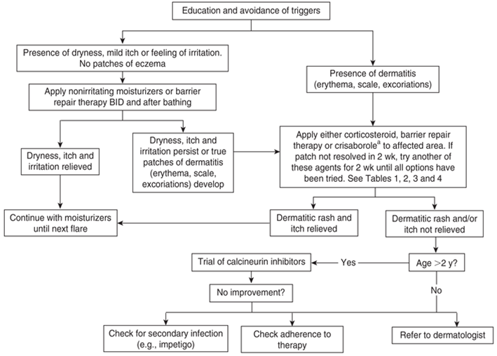
Non-pharmacological options | - Avoid triggers (environmental irritants, soaps, certain foods etc.)  - Sweat, stress and overheating increase itching  - Skin moisturizers once daily to help seal in moisture (first-line therapy for prevention of flares and treatment of minimal irritation and itch)  o E.g. petroleum jelly
Education/counseling | Prevention:  - Daily moisturizer application in infants at risk might reduce the risk of developing AD  - Maternal use of probiotics during pregnancy and breastfeeding may help reduce development of AD in the child  Education: inform pt that they have a chronic, recurring condition that can be controlled not cured
Pharmacological Therapy
Drug/Dose | Indication | Adverse fx (AE) and Drug interactions (DI) | Contraindications & special considerations
1st Line Therapies – If non-pharm/moisturizer/trigger avoidance is not working > try either corticosteroid, barrier repair therapy, or crisaborole
Duration: 2 wks
If not resolved, try another of these agents (trial 2 weeks each) until all options have been tried.
Barrier Repair Therapy  E.g. Ceramides, Cerave cream | Presence of dermatitis (erythema, scale, excoriations), dryness, itch or persistent irritation
Topical Corticosteroid  Low potency – face, eyelids, intertriginous folds (areas of body with thin skin)  Medium potency – body (trunk, extremities), and scalp  High Potency - palms and soles- thick skin |  | AEs: Striae, telangiectasia, atrophy, purpura | Choice will depend on area of skin (low-med-high potency).  Vehicle also important (e.g. lotion vs solution vs gel) - ointments are considered more potent and more occlusive and contain less preservatives.  Patches of dermatitis resistant to tx despite good adherence may req. a short course of more potent corticosteroid
Crisaborole topical (phosphodiesterase 4 inhibitor – topical anti-inflammatory)
2nd Line Therapies – if above options not working, and age >2yo, try calcineurin inhibitor.
If still not working> check adherence or underlying secondary infx
Calcineurin Inhibitors Topical  E.g. tacrolimus cream, pimecrolimus cream |  | AE: skin irritation  C/I: <2 yo or immunocompromised
Notes
Monitoring | Secondary skin infections are common with AD (e.g. impetigo). Monitor for such and treat appropriately
Referral | Derm:  - If 2nd line therapy not working and pt is adherent and no underlying cause (e.g. secondary infx) identified  - If 1st line therapy not working and patient <2 yo
Other notes | -Most common skin condition in pregnancy. Best to maximize non-pharmacologic approaches like moisturizers and avoid triggers. Topical corticosteroids are main tx.  -Ointments are less irritating and penetrate better than creams or lotions

Atopic, Contact and Stasis Dermatitis
Def’n | Atopic dermatitis - chronic, relapsing pruritic inflammatory skin disease caused by mucocutaneous barrier dysfunction (See above table for more detail on atopic dermatitis therapies)  Contact dermatitis- inflammatory skin disease caused by exposure to allergens and irritants (e.g. plants, latex, metals, meds, preservatives)  Stasis dermatitis - inflammation of the skin of lower legs caused by chronic venous insufficiency resulting in erythema, edema, pigmentation and ulceration. Chronic stasis results in scaling, discoloration, lichenification and accompanied by edema d/t venous disease. Pigmentation also present d/t dermal extravasation of RBCs following small venule rupture.  - 80% of patients with chronic stasis dermatitis are at risk of contact dermatitis - inciting agents are often topical meds/ointments so only applied topical meds considered essential as these patients are readily sensitized
Therapeutic goals | Eliminate individual triggers/irritants/allergens  Restore barrier function  Provide symptomatic relief while decreasing skin lesions  Implement proactive measures focusing on preventing or decreasing flares
Algorithm | N/A
Non-pharmacological options | For atopic/contact derm:  - Moisturizers* very important as dryness initiates or exacerbates symptoms  - Wet dressings can be applied as a compress (for drying of weeping/wet skin) or as a soak (for hydration of dry skin)Colloidal oatmeal baths  - Soapless cleansers  - Coal tar: anti-inflammatory; can reduce need for corticosteroids  Stasis Derm:  - Non-sensitizing moisturizers  - Bedrest/elevation to reduce edema  - Wet dressings can be applied as a compress (for drying of weeping/wet skin) or as a soak (for hydration of dry skin)  After dermatitis is healing, compression stockings to prevent edema
Education/counseling | -Avoid triggers  -Bathe regularly to remove allergens from skin  -Avoid bath salts (can cause itching/redness on sensitive skin)
Pharmacological Therapy
Drug/Dose | Indication | Adverse fx (AE) and Drug interactions (DI) | Contraindications & special considerations
1st Line Therapies - treatment is pretty much the same as atopic dermatitis table (see above). Moisturizers and topical corticosteroids are key - choice of steroid depends on area affected (see atopic derm table above).
Topical corticosteroids | 1st line therapy for all types of dermatitis. | AEs: Cutaneous atrophy | For stasis dermatitis - Higher potency corticosteroids should be avoided d/t risk of cutaneous atrophy which may lead to ulceration  For other types of dermatitis, the choice of corticosteroid will depend on area of body affected (see atopic derm table)
Moisturizers | 1st line therapy for all types of dermatitis.
Barrier repair products (ceramides/cholesterol/free fatty acids like EpiCeram)
Other treatment options
Systemic corticosteroids for severe, acute cases (e.g. extensive poison ivy/oak)
Topical calcineurin inhibitors (e.g. Tacrolimus ointment) | For treatment of corticosteroid-resistant allergic contact dermatitis | AEs: Local irritation
Oral antihistamines | To relieve itching. 1st gen anti-histamines can also promote sleep.
Notes
Monitoring | -Acute dermatitis: should see inflammation decrease by 50% within 7-10 days  -Chronic dermatitis: should see inflammation improve by 4-8 weeks  -Physical examination for cutaneous side fx is recommended during long-term potent corticosteroid therapy.  -Consider the potential for both topical and systemic side fx including possible HPA axis suppression.
Referral | N/A
Other notes | -Avoid topical anti-histamines. They are strong contact sensitizers and d/t the ionization that occurs topically, they’re not efficacious when applied to normal skin.  -1st gen oral anti-histamines can be used to promote sleep (cause drowsiness)

Psoriasis
Def’n | -chronic, immune-mediated skin disease with markedly increased epidermal cellular turnover; plaque psoriasis accounts for 80% of cases  -inflamed, thickened (hyperkeratosis), well-demarcated plaques with silvery scale (scalp, extensor elbow, knees, sacral area and nails-pitting, yellowing, lifting)
Therapeutic goals | -improve appearance and symptoms (increase quality of life); achieve long-term control
Algorithm | 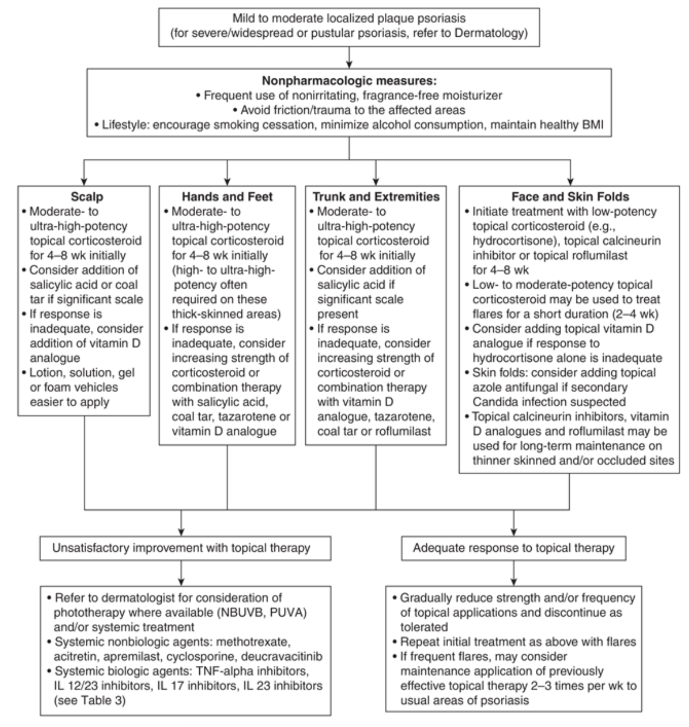
Non-pharmacological options | -fragrance free, nonirritating moisturizer; ointments and creams more beneficial than lotions are thicker and therefore more hydrating and barrier providing  -phototherapy  -reduce friction (loose clothing)
Education/counseling | -smoking and excessive alcohol increase severity  -obesity increases severity- maintain healthy weight  -screening for comorbidities associated with psoriasis- cardiovascular disease, HTN, obesity, hyperlipidemia, depression, diabetes)
Pharmacological Therapy
Drug/Dose | Indication | Adverse fx (AE) and Drug interactions (DI) | Contraindications & special considerations
1st Line Therapies- topical corticosteroid
Hydrocortisone 1-2.5% BID-TID | Low-potency, flexures and face | AEs: striae, telangiectasia, atrophy, purpura, suppression of HPA axis
Betamethasone valerate 0.05% daily-BID | Medium potency, trunk & extremities, scalp | AEs: striae, telangiectasia, atrophy, purpura, suppression of HPA axis
Clobetasol propionate 0.05% BID | high potency, palms, soles of feet | AEs: striae, telangiectasia, atrophy, purpura, suppression of HPA axis
2nd Line Therapies
Add in salicylic acid or coal tar
Then vit D analogues (dovonex)
Notes
Monitoring | Improve in 1-2 months of treatment but life-long condition
Referral
Other notes | Systemic nonbiologic agents (methotrexate) or biologic agents (TNFalpha inhibitors)

Diaper Dermatitis (Diaper Rash)
Def’n | -area specific contact dermatitis, irritant or allergic (usually irritant from exposure to urine/feces); mostly referring to children but can be caused by incontinence in older adults;
Therapeutic goals | -relief of symptoms, resolution of dermatitis, prevention of complications (infections-candida, staph, strep), prevention of recurrence
Algorithm
Non-pharmacological options | -breast feeding reduces acidity and amount of feces compared to formula fed  -bath every 2 days and use moisturizer, don’t bathe daily  -disposable diapers and frequent changes; avoid wipes with alcohol  Air dry, absorptives, antifungals, anti-inflammatories  Barrier products - avoid powders (d/t risk of inadvertent inhalation)  Cleansing, compressing  - Clean gently with water and use hypoallergic wipes  - Compress with wet dressings if there’s oozing/crusting with acute inflammation  Diapers – use disposable diapers with absorbent material are better than reusable cloth diapers, change q3-4hrs, dont double diaper  Education – about preventing and tx
Education/counseling
Pharmacological Therapy
Drug/Dose | Indication | Adverse fx (AE) and Drug interactions (DI) | Contraindications & special considerations
1st Line Therapies
Barrier products  Petroleum  Zinc oxide 10-20% | Treatment and prevention
2nd Line Therapies
Topical antifungal- miconazole (BID) or clotrimazole (BID) | Present for 3+ days
Topical corticosteroid  E.g. Hydrocort 0.5-1% for short periods (1-2 wks only) | For DD that is predominantly anti-inflammatory
Notes
Monitoring
Referral
Other notes

PPTs on Ulcers
Venous Ulcer Treatment:
-long healing time, approx 30% unhealed at 24 weeks
-predictors for not healing = living alone, compression level <30 mm Hg, pressure ulcer scale for healing (PUSH) score >10, area reduction of <25% in 2 weeks, calf-muscle dysfunction
-Compression: venous insufficiency and/or lymphedema is life long use; compression therapy reduce ambulatory venous pressure; Compression improves calf-muscle pump function and decreased reflux in incompetent veins
- compression bandaging systems- used to treat active VLUs and reducing edema
  - Short stretch bandages (SSB)- muscle movement against rigid system, pressure is generated and distributed equally along lower leg; better for pain, massage effect with walking; examples Coban
  - Long stretch- multicomponent and more effective than those composed of inelastic; bulky and can reduce ROM
- compression garments- used once edema reduced- prevent recurrence of VLUs; more patients heal with high compression stocking systems than SSB
- compression devices-used to treat active VLUs and reducing edema
  - Intermittent pneumatic compression reduce lower limb edema in VLUs and lymphedema
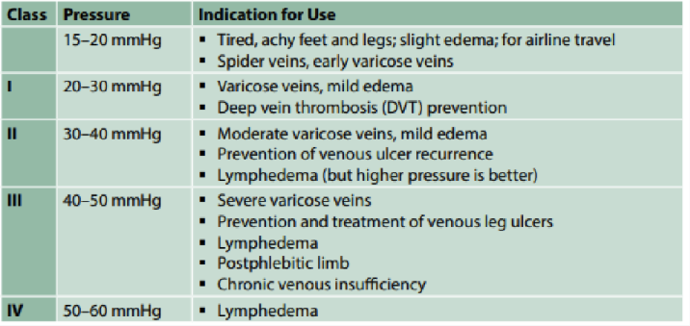
-Health Teaching:
- Decrease venous pressure by less standing, less sitting (walk each hour), walk daily to strengthen calf muscle, leg exercises, compression stockings, elevate feet above heart
-Recurrence is high- 70%; affordable life-long system use; affordable, comfortable, easy to apply, non-allergenic, able to fit into shoes

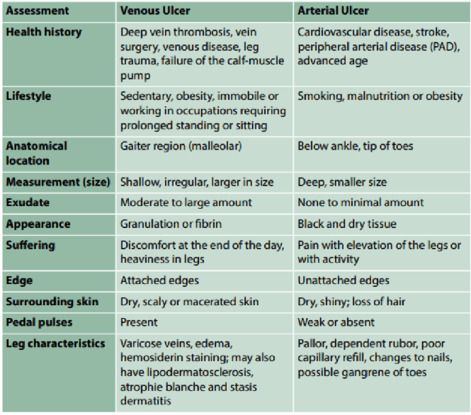

Arterial Ulcer Treatment:
Adequate perfusion indicates sufficient blood flow to support tissue viability and wound healing; treatment goal is reducing cardiovascular risk and claudication
Achieved through:
-lower LDL-C <2.0
-lower BP > 50 years SBP <120, DM <130/80, other <140/90
-Antiplatelet/antithrombotic:
1st line- ASA 75-325 mg daily
2nd line- clopidogrel 75mg daily
Claudication- pentoxifylline 400mg TID + statins
-Critical limb-threatening ischemia (CLTI)
-diagnostic imaging to diagnose and identify vessels (Computed Tomographic angiography- CTA)
-contraindicated normal post exercise ABPI
-Revascularization optimal treatment and through balloon angioplasty, stent, atherectomy, thrombolysis, laser
-Acute Limb Ischemia (ALI)
-urgent revascularization through heparin and analgesics
-chronic ischemia is amputation after failed revascularization, lack of suitable target arteries, severe patient comorbidities, poor functional status, extensive gangrene/infection & limb preservation not possible
-Surgical Treatment
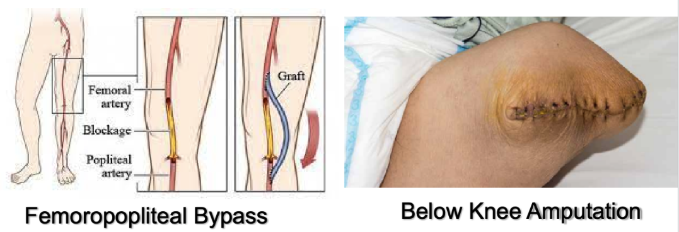
-Health Teaching:
Smoking Cessation
Control Blood Glucose Levels (A1C >7 increased risk of micro and cardiovascular complications)
Control blood pressure
Assess feet
Exercise-risk reduction
Diet- low saturated fat
-Arterial Disease: 6 Ps
Pain, Pallor, pulselessness, paresthesia, paralysis, poikilothermia (polar)
-Compression:
Limited evidence; lower extremity edema barrier to wound healing, accurate blood flow determined prior to compression by vascular, lower levels of compression (ABPI >0.50 to <0.80), avoid compression if ABPI <0.50, after revascularization procedure adequate blood flow (lower compression, 18-30 mmHg after lower bypass to manage edema)

Diabetic Foot Ulcer Treatment:
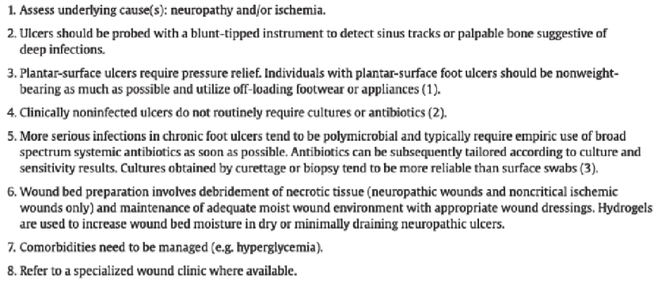
*foot care and callus removal by qualified health care provider; offloading devices to aleviate pressure to promote healing of ulcers

PREVENTION:
- Patient Education
- Foot skin and toenail care
- Protective footwear
- Protective surgeries
Diagnostics:
- Glucose control- HbA1C q3months
- Renal:
  - albumin/creatinine ratio from first morning urine sample, normal <2 mg/mmol
  - Glomerular filtration rate from serum blood, calculation using creatinine test, age, body size and gender, normal >60 ml/min
- Dyslipidemia: fasting lipid levels, TC, HDL, TG, LDL </=2 mmol/L
- Coronary Artery Disease: ECG baseline and q2years
Referrals Required:
- Dietician
- Diabetic Wellness
- Orthotics- offloading
- Foot care

Week 6/7: Cardiology

HTN Treatment Guidelines and Med info
Indications for starting therapy | 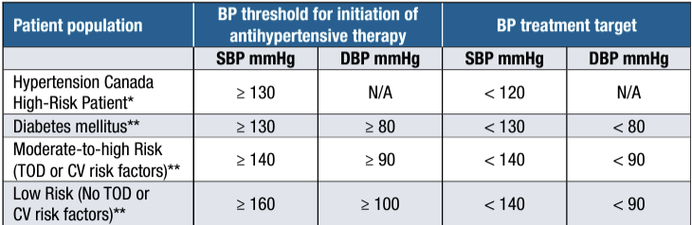
Algorithm | Choice of therapy  - Monotherapy choices: See chart below- All of these are recommended as effective first-line treatment in all adults with uncomplicated hypertension without compelling indications for specific agents.  - Multitherapy: additional HTN drugs should be used if target BP levels are not achieved with standard dose monotherapy.  - Recommended combos: (diuretic or CCB) + (ACE inhibitor or ARB)  - Do NOT combine ACE inhibitor and ARB  - Try to replace multiple anti-hypertensive agents with single pill combination therapy (SPC). Either monotherapy or SPC should be considered for initial anti-hypertensive therapy  - Resistant HTN: defined as BP above target despite >3 BP drugs at optimal doses. Typically, a combo of RAAS blocker, CCB, and diuretic are used to ensure that different mechanisms for increases in BP are blocked. If this combo fails, the pt may have resistant HTN  - Accurate office and out of office BP measurement essential  - R/O other potential causes before diagnosing true resistant HTN such as non-adherence, white coat syndrome, and secondary HTN  - If diagnosed with resistant HTN, refer to HTN specialist  - Treating HTN in assoc. With renovascular disease: pts with HTN attributable to atherosclerotic renal artery stenosis should be primarily medically managed because renal angioplasty and stenting offers no benefit over optimal medical therapy alone
Non-pharmacological options | Health Behaviour Management  - Reduce ETOH to reduce BP and prevent HTN (there is no ‘safe’ limit for ETOH consumption)  - Physical exercise, weight reduction, diet (fruits, veg, low fat dairy, whole grains, protein from plant sources), reduce sodium intake toward 2000mg, increase dietary potassium to reduce BP, manage stress  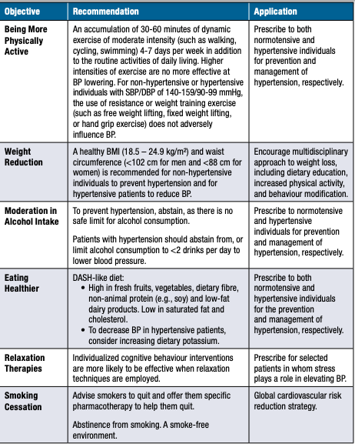

Pharmacological Therapy
ANY of the following meds are effective first-line treatments for someone without any indications for a specific med. Specific indications to recommend a particular class are in the “specific indications” column; if a patient doesn’t fit these indications, they can have any of these drugs as first line
 | Specific Indications | Mechanism | A/E and DI | Contraindications
Thiazide/Thiazide-like Diuretics  E.g.  -Indapamide  -HCTz  -Chlorthalidone | -First choice among equals initial or add-on  -Diabetes  -Isolated systolic HTN | Act on nephron to increase sodium excretion and urine volume -> reducing blood vol. and thus BP | Indapamide:  AE: H/A, dizziness  HCTZ and Chlorthalidone: low doses well tolerated  A/E: hypokalemia, hyponatremia, hypomagnesemia, pancreatitis, sexual dysfunction  DI: Digoxin (increases toxicity if K low), increases Lithium level, NSAID, steroid | -Hyponatremia  -Symptomatic gout  -Sulfa allergy (cross-reactivity NOT proven)  -Anuria
Calcium channel blockers (CCB)  2 classes of CCBS:  1)Dihydropyridines (DHPs):  -Amlodipine  -Felodipine  -Nifedipine  2)Non-Dihydropyridines (Non-DHPs):  -Diltiazem  -Verapamil | -Diabetes  -Isolated systolic HTN | Cardiac muscle contraction relies on influx of calcium. Calcium channel blockers inhibit inward movement of calcium in heart and vascular smooth muscle > vasodilation | AE: dizzy, HA, rash, flushing, constipation, periph edema, tachycardia or bradycardia | -Systolic BP<90  -Recent MI with pulm edema  -peripheral edema  -Sick sinus syndrome  -2nd or 3rd degree AV block  -Systolic Dysfunction/HF
Angiotensin Receptor Blocker (ARB)  E.g.  -Irbesartan  -Valsartan  -Losartan  -Telmisartan | -Diabetes  -CV risk factors  -Kidney disease  -Isolated systolic HTN | Blocks angiotensin II.  Angiotensin II causes vasoconstriction. Also triggers adrenal glands to release aldosterone and ADH > increasing Na and water reabsorption (retention) and potassium excretion  Thus ACE inhibitors and ARBs increase vasodilation, increase water and salt excretion, and increase potassium | AE:  -Well tolerated in general but fatigue, HA, rash, low BP, hyperkalemia, acute renal failure  In general, less AE than ACE-I  DI:  -Increases lithium  -Telmisartan: increases digoxin levels | -Pregnancy; caution required in prescribing to women of child bearing potential  -Angioedema hx  -Bilateral artery stenosis  -ACE-I less effective in black people?
Angiotensin converting enzyme inhibitor (ACE-I)  E.g.  -Lisinopril  -Ramipril  -Catopril | -Diabetes  -CV risk factors  -Kidney disease |  | AE:  -Cough, loss of taste,rash, HA, dizziness, low BP, fatigue, hyperkalemia, angioedema, acute renal failure, hepatotoxicity,  DI  -Potassium sparing diuretics (d/t increased K), increases lithium levels, decreases effectiveness of NSAIDs, and increases potassium
Beta-Blocker  E.g.  Bisoprolol, metoprolol, atenolol, propanolol | -Recent MI (in combo with ACE-I or ARB but ACE-I is better) | Blocks B-1 adrenergic receptors > inhibiting release of catecholamines (stress hormones epi and norepi) | AE:  -Fatigue, insomnia, vivid dreams, decreased HR, impotence, decreased exercise tolerance, dizzy, cold extremities, bronchospasm, increased tension HA, decreased HDL, hallucinations, depression  -Worsens: PAD, HF, Raynauds  -Sudden withdraw: exacerbate Angina/MI | -Severe asthma  -2nd or 3rd degree heart block  -Severe bradycardia  -Uncompensated HF  - Severe PAD
General recommended multitherapy combos:  ACE-I + CCB (grade A evidence)  Or  ARB + CCB (Grade B)  Or  ACE-I or ARB + Thiazide/thiazide-like Diuretic (Grade B) | -Diabetics who require multi-therapy: ACE-I + CCB  -Stroke: ACE-I + Diuretic  -CVD requiring multi-therapy: ACE-I + CCB  -Recent MI: ACE-I + B-Blocker
Notes
Monitoring | -If initiating therapy, F/U Q1-2 months until readings on 2 consecutive visits are below target.  -When target BP achieved F/U Q3-6 months
Referral | Resistant HTN should be referred to HTN specialist (unable to meet target BP despite >3 meds)

Geriatric HTN
Therapeutic goals | Guidelines disagree on BP target for older adults. Individualize targets. In general:  - Consider aggressive target (e.g. <140) for:  - Overall healthy  - Mild cognitive impairment  - High CV risk  - If meds are well tolerated  - Consider less aggressive target (e.g. 140-150) for:  - Frail, Long-term care, Limited life expectancy  - Low CV risk  - High risk of adverse effects (e.g. falls) or have difficulty tolerating meds
Algorithm | - Start low - initial lower doses (<½ dose of a younger adult). Assess tolerability of new drug/dose within 3-7 days (e.g. any falls?)  - Go slow - gradually decrease BP over weeks to months to minimize risk of ischemic symptoms;  - Rule of thumb Increase dose by <50-100% Q4 weeks to desired effect  - Monitor BP and other parameters (BW etc.) after 1-2 weeks, with any dose change, and periodically (e.g. Q6-12 months)
Non-pharmacological options | Diet, exercise, lifestyle mods
Education/counseling
Pharmacological Therapy
Drug/Dose | Indication | Adverse fx (AE) and Drug interactions (DI) | Contraindications & special considerations
1st Line Therapies
ACE-I/ARBs | 1st line for older adults with uncomplicated HTN (NOT african ancestry), DM, CAD, Post-MI, HF, Renal disease, or LVH |  | Monitor SCr and K+ when starting, after a dose change, and after 1-2 weeks of stable therapy
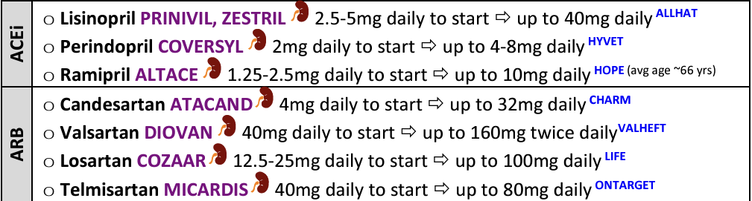
Thiazide/thiazide like diuretics | 1st line for most older adults with uncomplicated HTN, diabetes with normal kidney function, LVH or isolated systolic HTN  1st line add-on option for HTN with renal disease and proteinuria |  | Monitor baseline serum electrolytes (K, Na, Mg, Cl, Ca, Po4), blood glucose, lipids, uric acid, Cr, urea  Monitor lytes and SCr within 1-2 weeks of starting or changing dose and more frequently in people with renal insufficiency
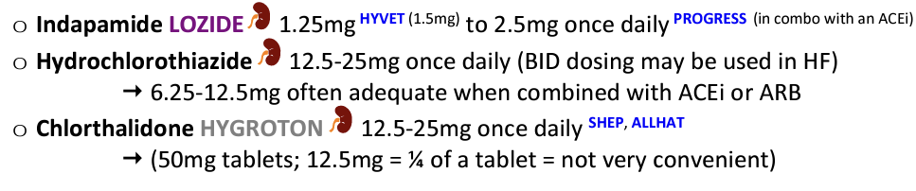
CCB | All long acting CCBs can be considered for treating uncomplicated HTN and HTN in LVH or stable angina | AE: Orthostatic hypotension, periph edema (edema can be reduced by combining CCB with ACEi or ARB)
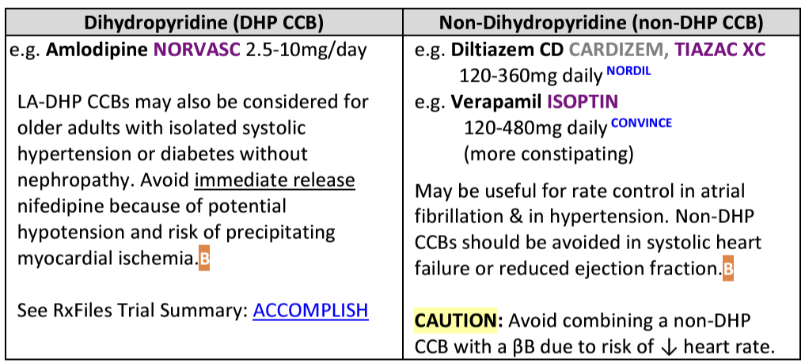
DHP- more peripheral vasodilation, better for straight HTN
Non-DHP- better for improving heart function, ie. heart failure, DM, afib
2nd Line Therapies
Beta-Blockers | Not used as 1st line monotherapy in >60 yo but may be used in <60  Indications incl: post MI, Afib, stable angina, ACS, or those requiring polytherapy to control BP  Cardioselective b-blockers (bisoprolol and metoprolol) better for older adults with asthma, COPD, diabetes, and for treating high BP in HF | AE: Fatigue, cognitive impairment, confusion
Notes
Monitoring | -Older adults are more sensitive to antihypertensive side fx (dizziness, falls)  -Monitor for orthostatic hypotension to reduce risk of falls  -Rule of thumb Increase dose by <50-100% Q4 weeks to desired effect  -Monitor BP and other parameters (BW like electrolytes for diuretics) after 1-2 weeks, with any dose change, and periodically (e.g. Q6-12 months)

Dyslipidemia Guideline 2021
Dyslipidemia Who to Screen
-men over 40  -women over 40 (postmenopausal)  -earlier if south Asian or indigenous | -all patients with any of the following:  -atherosclerosis, AAA, DM, arterial hypertension, smoking, family history of premature CVD/ dyslipidemia, CKD, obesity (BMI over 30), inflammatory diseases, HIV infection, erectile dysfunction, COPD, HTN during pregnancy
Recommendation
-non-fasting lipid and lipoprotein performed in adults whos screening is part of a risk assessment
-triglycerides over 1.5, non-HDL-C or ApoB should be used instead of LDL-C
-history of triglycerides levels over 4.5 lipid and lipoprotein levels should be measured fasting
-if do not fast: change in non-HDL, decrease in LDL and small increase in triglycerdies
Coronary Artery Calcium (CAC) Measurement- Recommendation
-CAC-screening should done using computed tomography imaging for asymptomatic over 40 years and FRS 10-20%,
-do not do computed tomography for high risk, patients receiving statins, asymptomatic, low risk
-low risk if family history of premature acute cardiovascular disease or known genetic causes of acute coronary vascular disease
Lipoprotein Measurement Recommendation
-we recommend measuring lipoprotein level once in a person’s lifetime for initial lipid screening
-level of lipoprotein being greater than 50mg/dl need more intensive health behaviour modification
Risk Assessment for Primary Prevention
-we recommend that a CV risk assessment be completed every five years for men and women ages 40 to 75 using the Framingham Risk score (FSC) or Cardiovascular Life expectancy model (CLEM)
-repeat q 5years for FRS less than 5% or every year for FRS over 5%
-older patients that are high risk a discussion about statin therapy in overall management should be completed
-if triglyceride levels are over 1.5mmol/L, non-HDL or ApoB should be used instead of LDL-C as the preferred lipid parameter for screening.
When to consider pharmacological treatment in risk management?
-statin therapy for high- risk conditions (atherosclerosis, AAA, DM, CKD, LDL over 5.0)
-use high-intensity statin therapy + modification in health behavior for all secondary prevention CVD patients, use the maximally tolerated dose.gfg
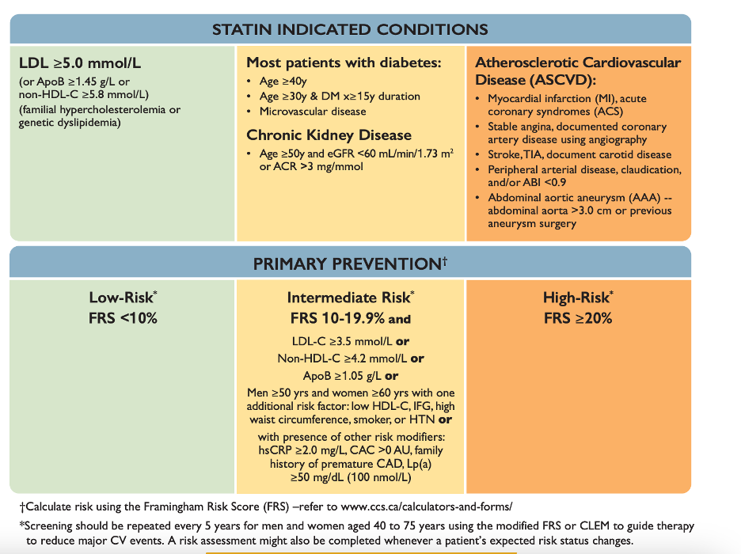
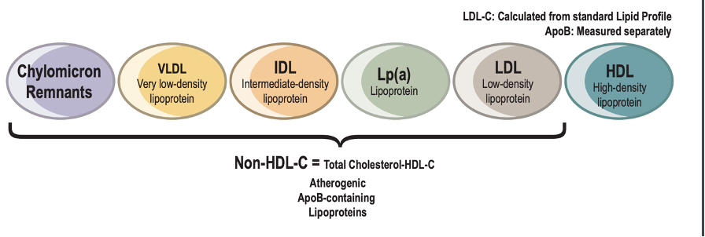
Treatment of CKD
-treatment with statin/ezetimibe combination to reduce CVD events in adults over 50 years with CKD not being treated with dialysis or kidney transplant.
-do not start lipid lowering therapy in adults with dialysis dependent CKD
- suggest lipid-lowering therapy be continued in adults already receiving it at the time of dialysis initiation
-Sugest statin in kidney transplant pts

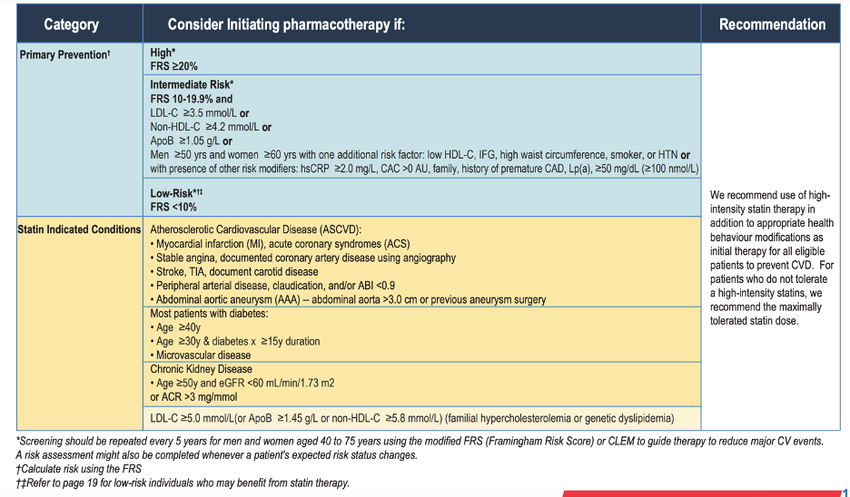
Adverse Effects of Statins
-all statin associated symptoms should be evaluated by observing the cessation and re-initiation to identify a tolerated dose
-do not use vitamins, minerals or supplements for symptoms of myalgia
-statins have many adverse effects ensure that the benefits outweigh the risks
-patients must continue diet, weight and exercise interventions to facilitate achievement of lipid goals
Non-Statin Therapy
-intensifying lipid therapy through PCSK9 inhibitors with or without the use of ezetimibe
-the largest PCSK9 inhibitor therapy is in patients who have LDL remaining over 1.8, HDL over 2.4 or ApoB over 0.7 while receiving the maximum tolerated dose
-intensify lipid-lowering therapy with ezetimibe/PCSK9 inhibitor for patients whos LDL remains over 1.8 while receiving the maximally tolerated statin dose.
-use PCSK9 inhibitor to lower LDL-C levels in patients with genetic predisposition to high cholesterol and no atherosclerotic disease whose LDL remains over 2.5 or less than 50% reduction from baseline, or ApoB over 0.85 or non-HDL over 3.2 despite max statin therapy
-use PCSK9 inhibitor for genetic predisposed and atherosclerosis whose LDL remains above 1.8 with maximum tolerated statin and with or without ezetimibe.
-use icosapent ethyl to decrease the risk of CVD in atherosclerotic patients, or patients with DM who have triglyceride levels of 1.5-5.6 despite using max tolerated statin dose
-if using ezetimibe therapy and LDL levels remain above target bile acid sequestrants should be considered
-do not combine niacin or fibrates with statin for CVD prevention if pts achieved LDL target 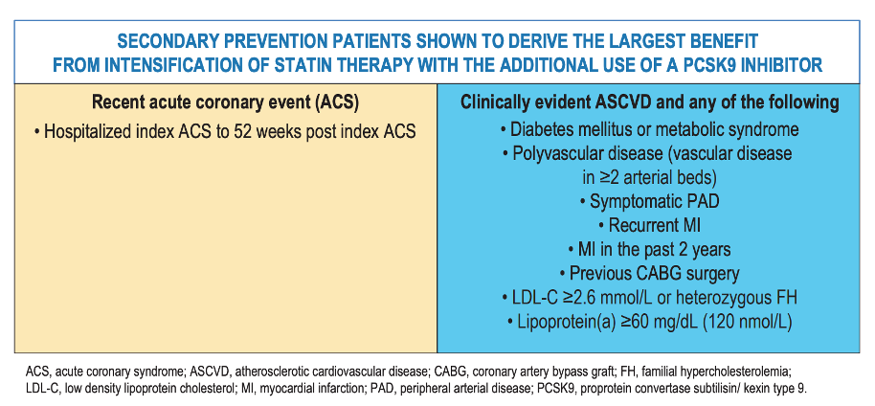
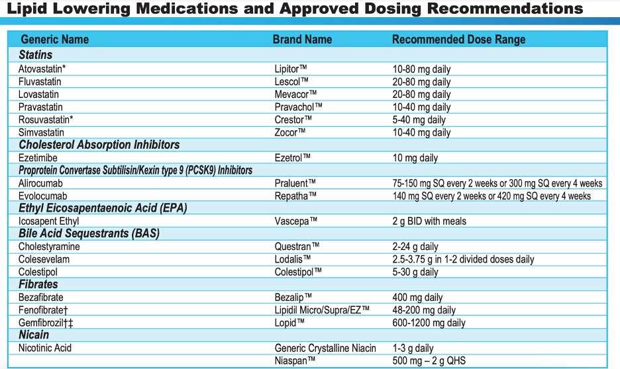
Non-Pharmacological Interventions

Smoking Cessation
Diet
-all pts should adopt Mediterranean diet
-adherence to diet most important factor
-Portfolio Diet
-DASH diet, low glycemic index/glycemic load dietary pattern, plant based dietary pattern, diet high in nuts legumes, olive oil, fruits and vegetables, total fiber, whole grains
-dietary modifications can augment drug therapy with statins- shown benefits in BP and lipoproteins
-do not recommend the use of OTC omega-3 polyunsaturated fatty acid supplements to reduce CVD risk, can use it for high triglyceride levels
Exercise
-adults should have 150 min of moderate- to-vigorous intensity aerobic exercise, in bouts of ten min or more to reduce CVD risk
-more than one day a week to forty min/day plus 1 hour/week of intensive exercise
Facilitators for Change
-recommend combining low-risk lifestyle behavior including: healthy body weight, regular physical exercise, moderate alcohol consumption, moderate sleep duration for maximal CVD risk reduction
-healthy weight BMI 18.5 to 25, waist circumference of under 88cm for women or 95 to 102 cm for men
-moderate alcohol consumptions of less than 12-14g/month
-moderate sleep is 6-8 hours/night
-
Treatment Approach for patients with Statin

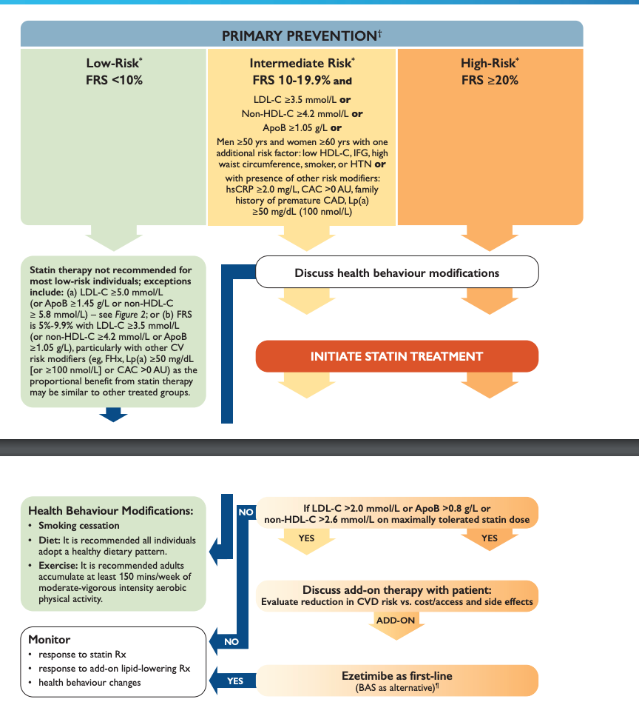
*Screening should be repeated every 5 years for men and women aged 40 to 75 years using the modified FRS or CLEM to guide therapy to reduce major CV events. A risk assessment might also be completed whenever a patient’s expected risk status changes
-the above is the treatment approach for patients without a statin indicated condition!

-below is the treatment for statin indicated conditions: all documented Atherosclerotic conditions, other high risk primary prevention conditions in the absence of atherosclerosis such as: DM or CKD
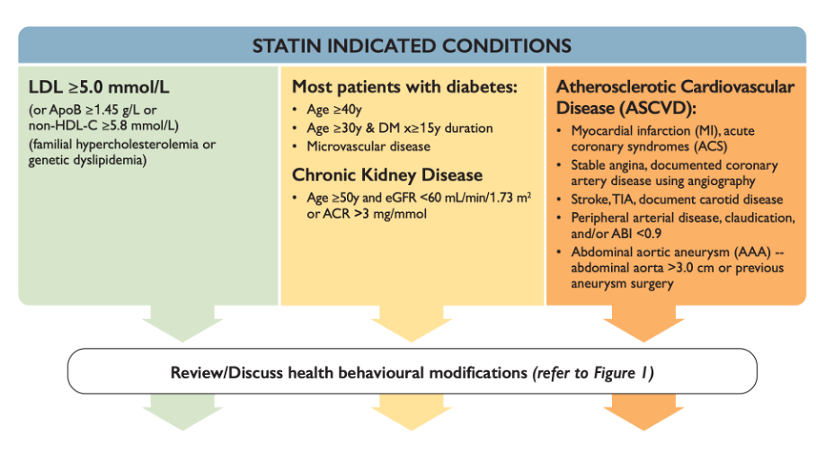
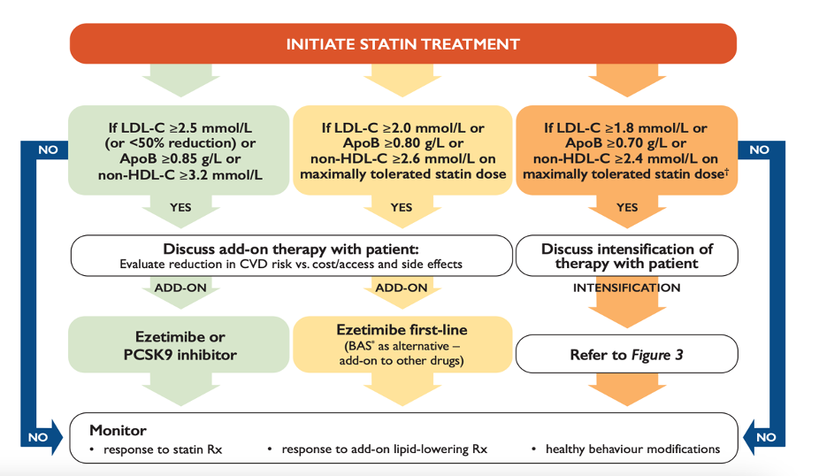

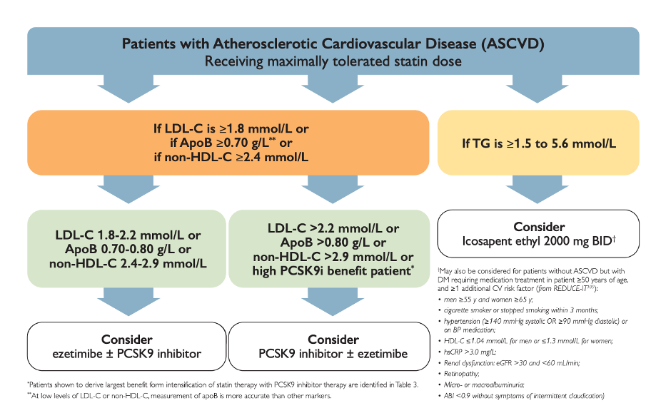
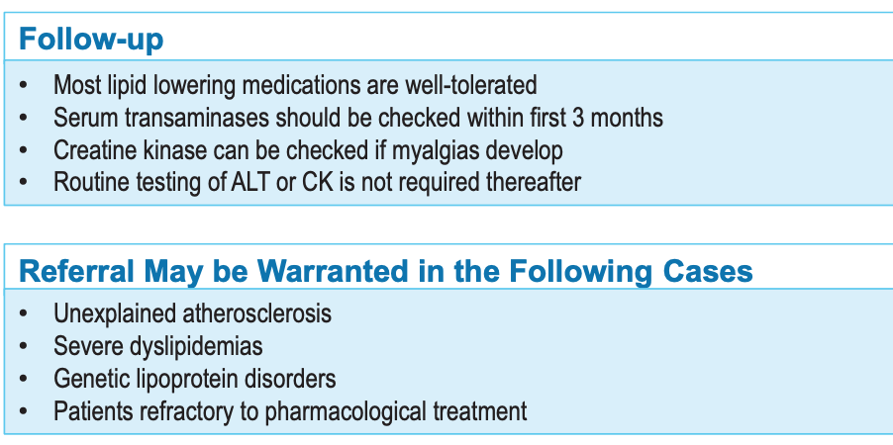

Lipid Lowering Agents (Rx files)
Def’n | Low risk (10 year CVD risk <10%)  Intermediate risk (10 year CVD Risk 10-19.9%)  High Risk (10 year CVD risk greater or equal to 20%)
Therapeutic goals
Algorithm | Low risk: change in life style- smoking cessation, diet, exercise  Intermediate risk: statin moderate intensity if:  (LDL greater or equal to 3.5 or non-HDL greater or equal 4.2, ApoB greater or equal 1.05 or  male over 50 or female over 60 plus one additional factor low HDL-C high waist circumference, impaired FG, smoker HTN)  High Risk: treat with high intensity statin, statin induced conditions (AAA, atherosclerosis, DM, CKD, LDL over 5)  -when statin is initiated no repeat lipid testing, no baseline CK/ALT unless clinically indicated  -secondary prevention: if need more treatment can add on ezetimibe or PCSK9
Non-pharmacological options
Education/counseling
Pharmacological Therapy
Drug/Dose | Indication | Adverse fx (AE) and Drug interactions (DI) | Contraindications & special considerations
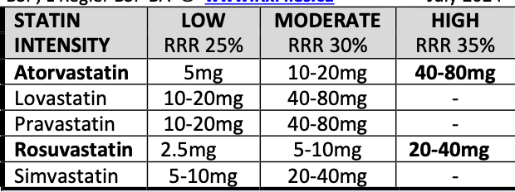
1st Line Therapies (STATINS)
-Atorvastatin  (decrease LDL by 35-60%)  Primary prevention:  10mg po HS  20mg Hs or 40-80mg/hs | -Decrease LDL/ atherosclerosis/CVD/ stroke | AEs: generally tolerated better than other agents, need to decrease AE change dose  -upper GI bleed, headache, rash, sleep problems  -neuropathy, lupus like symptoms, impotence,  -increased risk of hemorrhagic stroke, DM, pancreatitis  -elevate LFT, concern if ALT three times more, increase LFT occurs with dose  -cataracts, myopathy  -small chance of rhabdomyolysis  *** cant use if you have active liver diagnosis, or excessive alcohol intake or pregnancy  DIs:  Increase effect of digoxin, warfarin  Increase toxicity with HMG, grapefruit juice  Decreases effect of HMG | -routine monitoring for LFT, CK is NOT indicated  -monitor LFT- 0,3,6,12 months and annually only if high dose!  -LDL initial test non-fasting LDL  -then fasting lipids 4-12 weeks after statin initiation and dose adjustments  -q 3-12 months after as needed
-Fluvastatin  (decrease LDL by 20-35%)  20mg po HS  40mg Po HS  40mg Po BID with meals | -Decrease LDL/ atherosclerosis/ CVD/ stroke
-Lovastatin  (decrease LDL by 25-40%)  Primary prevention: 20-40mg PO HS  40mg PO BID with meals to increase absorption | -Decrease LDL/ atherosclerosis/ CVD triglycerides and increase HDL
-Pravastatin  (decrease LDL by 20-35%)  20mg po HS  Primary and secondary prevention:  40mg PO Hs | Decrease LDL/ atherosclerosi/ CVD/ stroke  -use if pregnant
Rosuvastatin  (decrease LDL by 40-65%)  Primary prevention:  20mg Po Daily  Asian-10mg daily  40mg Po daily/hs | -Decrease LDL/ atherosclerosis/ CVD  -use if pregnant  -increase dose level if asian
-Simvastatin (decrease LDL by 35-50%)  -20-40mg Po Hs secondary  -40mg hs secondary  -80mg po hs | -Decrease LDL/ atherosclerosis/ CVD/ stroke  -increase muscle AE at doses over 40mg/d
2nd Line Therapies
(add on tx options to maximally tolerated statin to further reduce CV risk, or address LDL/lipid thresholds)
Ezetimibe  10mg daily when added to statin can also lower statin dose! | -lowers LDL (when added to statin)  -increases HDL  -decreases triglycerides | Contraindication:: hepatic liver  -Monitor LFT  DI: increased levels by fibrates and cyclosporin  -resin interferes with absorption
Allirocumab  Evolocumab  PCSK9 Inhibitors  -75-150mg subcut q 2weeks - 300mg q 4 weeks  -140mg sbucut q 2weeks - 420mg q 4weeks | -lowers LDL  -increases HDL  -decreases triglycerides  -add to statin decrease CV events | AEs:  Injection site pain/swelling/bruising, influenza like pharyngitis, itch, allergic rxn | If severe decrease in HDL stop fibrate!!
Bezafibrate  Secondary prevention:  400mg po daily | -lowers LDL  -increases HDL  -decreases triglycerides | AEs:  Commonly Gi upset, rash and abdominal pain  -rare: headache, pruritus, dizzy, drowsy, decreased renal function , increase LFT, myopathy, increase pancreatitis, impotence, increased gallstones  Contraindications:  Hepatic, gallbladder, renal diagnosis, smoking  DI:  -Increased toxicity/levels with (colchicine, cyclosporine, enzalutamide, MAOI, furosemide)  -decreased effect by: cholestyramine and colestipol  -increased effect:  Warfarin, chlorpropamide, enzalutamide, furosemide, homocysteine, pioglitazone etc. | Monitor:  CBC, Cr, Glucose, LFT
Fenofibrate  200mg daily  160mg daily | -lowers LDL  -increases HDL  -decreases triglycerides |  | Monitor:  CBC, Cr, Glucose, LFT
Gemfibrozil  300mg PO BID ac  600mg BID ac (primary and secondary prevention) | -lowers LDL  -increases HDL  -decreases triglycerides |  | Monitor:  CBC, Cr, Glucose, LFT
Nictotinic acid  Start 50-100mg BID-TID (increase weekly by 100mg/week to increase tolerability)  1500mg PO BID- primary intervention  1g PO TID secondary prevention | -lowers LDL  -increases HDL  -decreases triglycerides  2g niacin/day helps HDL and TG but only higher doses affect LDL  NICOTINAMIDE NOT EFFECTIVE | AE:  Common flushing, dry eyes, pruritus, GI upset, rash, increased LFT, increased uric acid, increased glucose, macular edema  Contraindications:  Peptic ulcer diagnosis, chronic liver disease, DM, gout  DI:  With HMG increase myopathy | Monitor:  LFT, glucose, uric acid
Icosapent ethyl  2G po BID with food | -lowers  -increases HDL  -decreases triglycerides | AE:  Afib, peripheral edema, bleeding, MSK pain.arthralgia, constipation, gout  Contraindication: hypersensitivity reaction to fish/shellfish  DI:  Increased risk of bleeding with antithrombotics
Notes
Monitoring | Baseline Lab Monitoring: non-fasting lipid panel FBG, A1c, creatinine, GFR, TSH, LFT, ApoB, urine ACR.  Repeat bloodwork within 3 months to assess liver enzyme (ALT) and lipids. Assess CK if myalgia develops
Referral
Other notes

Geri Dyslipidemia (Rx files)
Def’n | Primary Prevention: delays and prevents the first CV event  Secondary Prevention: delays and prevents another CV event
Therapeutic goals | Reduce LDL and CV events  There is no benefit with statin use over age of 75 risk benefit analysis must be done.  Cholesterol levels are not related to mortality rates in ages 70-90
Algorithm | Statin is first choice, can add on ezetimibe and PCSK9 for more risk reduction
Non-pharmacological options | exercise/activity  Weight loss  Smoking cessation
Education/counseling | Lifestyle modification
Older adult differences | -less evidence that cholesterol lowering has a benefit in older adults  -little evidence that statin lower mortality rates in older adults  -older adults may be more susceptible to adverse effects of statin  -older adults have a higher risk of drug interactions with statin due to polypharmacy  Patient is already on a statin:  -a patient that is on a statin it should not be stopped because once the patient turns 75 as continuing a statin that the patient is already on has the benefit of decreasing major CV events  -could be harm if discontinuing statin  -can lower the dose if needed  Stop if: more harm than benefit,  Low- moderate-high intensity of statin  -Statin may cause more harm in older adults  -high intensity statins lower the risk of CV events more than low intensity in high risk individuals, no difference in mortality, may increase risk of advers events  -older adults can tolerate high doses  -atorvastatin levels have been shown to be higher in older adults due to reduced renal function and drug interactions  Primary Prevention  -Primary prevention benefit seen 65-75 years, not much benefit seen over 75 years of age.  -diminished benefit of reducing major adverse cardiac event with the use of statins.  -do not use lipid testing and assessment of risk using a CVD calculator for over age of 75  -do not use statin primary prevention of statin for over age of 75 little benefit seen  -do not stop or reduce statin once patient turns 75, if they are already on it  Secondary prevention:  -statin can be beneficial- but risks and benefits must be discussed
Pharmacological Therapy
Drug/Dose | Indication | Adverse fx (AE) and Drug interactions (DI) | Contraindications & special considerations
1st Line Therapies
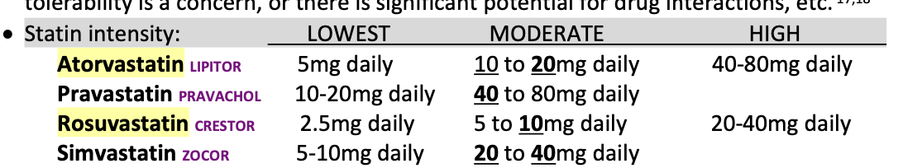
Potency highest to lowest: rosuvastatin, atorvastatin, simvastatin, lovastatin, pravastatin, fluvastatin
Statin |  | AEs:  -greater chance of myopathy in older adults, may have to reduce dose or add ezetimibe  -small chance of increased hepatic transaminase  -increased risk of AKI with higher potency  -diabetes new onset can occur with higher intensity statins.  DIs: (increased risk of rhabdomyolysis and myopathy)  -amiodarone, -antifungals,  -calcineurin inhibitors (cyclosporine/tacrolimus),  -calcium channel blockers  -colchicine  -danazol, dronedarone  -fibric acid derivatives  -grapefruit juice  -macrolide antibiotic  -mTOR inhibitor  -niacin  -protease inhibitor  -telithromycin  -ticagrelor  -warfarin  -rifampin
2nd Line Therapies
Ezetimibe | If added to a statin can decrease CV events
Proprotein convertase subtilisin/kexin type 9 (PCSK9) inhibitor  Evolocumab: 140mg subcut q 2 weeks or 420mg subcut monthly  Alirocumab:  Icosapent | When added with statin  Shown to reduce risk of CV death, MI, stroke, hospitalization  When added to a statin reduced risk of CV death, MI, stroke  Lowered CV events, | increased harm of A-fib, peripheral edema, serious bleeding
Fibrates | Used preventively in patients who have high triglycerides-induced pancreatitis  -not found to be more effective when combined with statin
Niacin | No benefit
Notes
Monitoring
Referral
Other notes

Framingham Risk Score (FRS)- 10 yr estimate of CVD Risk

https://ccs.ca/wp-content/uploads/2024/04/FRS_eng_2024_FNL2-1.pdf
Step 1: calculate risk factors for age, HDL-C, total cholesterol, SBP, SMoker, Diabetes
Step 2: Use total points to determine risk based on gender & identify treatment recommendations from chart below
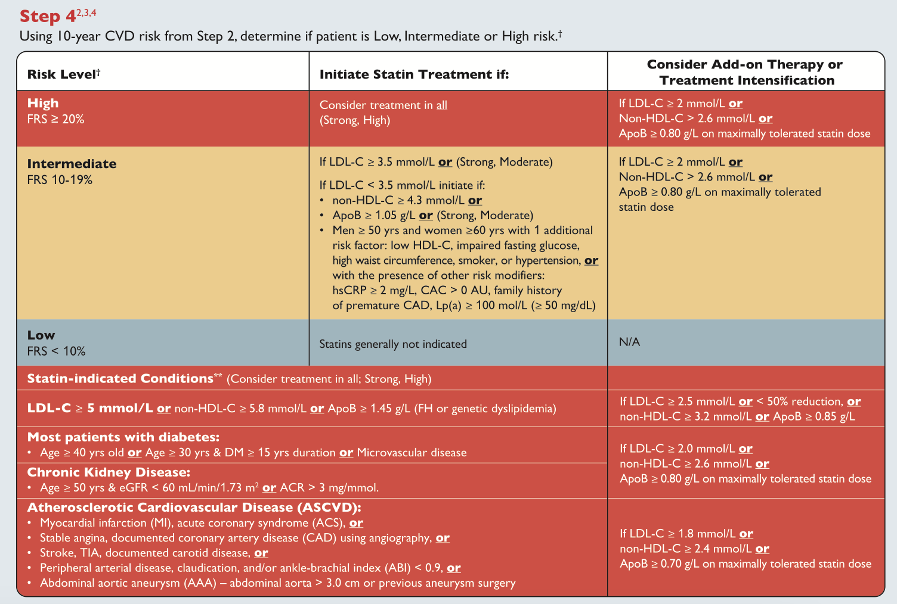

Oral Antiplatelets
Pharmacological Therapy
Drug/Dose | Indication | Adverse fx (AE) and Drug interactions (DI) | Contraindications & special considerations
ASA 81MG Daily | Secondary prevention CV hx (MI, PVD), stroke/TIA or PAD  Other: mechanical heart valve | Bleeds, fatigue, GI upset, | Bleeding disorder, NSAID allergy, children with other symptoms = reyes,
Clopidogrel (Plavix) 75mg daily or LD 300mg to 600mg x1 dose | Secondary prevention MI, PCI, stroke/TIA, vascular death with MI, stroke or PAD; ACS+ ASA  Alternative to ASA when allergy | AE: GI upset, GI bleed  DI: SSRIs increase bleeding risk; omeprazole, esomeprazole and morphine decrease effectiveness | Active bleeding, liver impairment
Ticagrelor (Brilinta)  ACS= 180mg LD then 90mg BID  MI>1 year or CAD + T2DM + PCI = 60mg BID | Secondary prevention + ASA: ACS, stroke/TIA, hx MI >1 year prior | AE: bleeding, dyspnea, bradyarrhythmia, increase uric acid  DI: cyclosporine, grapefruit increase; CYP3A4 inducers reduce | Active bleeding, IC hemorrhage, hepatic impairment, CYP3A4 inhibitors (ketoconazole, clarithromycin)

Oral Anticoagulants
Pharmacological Therapy
Drug/Dose | Indication | Adverse fx (AE) and Drug interactions (DI)  DI ALL: antiplatelets, NSAIDs, SSRIs/SNRIs, ginger, ginkgo and garlic | Contraindications & special considerations  CI ALL: PREGNANCY  Active bleeding, falls >295/yr; extreme weights
Warfarin (Coumadin)  ½ life 6-72hrs  Dose tot target INR based on condition  Inhibits Vit K dep clotting factors | A fib, stroke prevention, stable CAD/PAD, VTE prophylaxis and treatment, | AE: intracranial bleed, alopecia  DI: many (amiodarone, abx, antiepileptics) | Okay in pregnancy after 1st trimester  Check INR 4-6 days after starting or changing dose  Antidote vit K
Dabigatran (Pradaxa)  ½ life 12-17hrs  110mg (Elderly)- 150mg BID based on condition  Thrombin inhibitor | Afib, stroke prevention, VTE prophylaxis and treatment | AE:GI bleed, dyspepsia  DI: azoles; rifampin, dronedarone; simva/lovastatin increase bleed risk (use rosuvastatin), not with antacid, verapamil or quinidine | CrCl<30, prosthetic heart valve  Antidote idarucizumab
Rivaroxaban (Xarelto)  ½ life 9hrs  Factor Xa inhibitor | A fib(20mg daily), stroke prevention (15mg + clopi), stable CAD/PAD (2.5mg BID + ASA), VTE prophylaxis (10mg daily) and treatment (15 mg BID x3wks then 20mg daily x3-6m), | AE: GI bleed, menorrhagia, pruritus, syncope, raise LFTs  DI:p-gp inhibitors (cyclosporine, ketconazole, quinidine verapamil) increase bleed risk; P-gp inducers decrease efficacy (carbamazepine, phenytoin, rifampin, St. John’s Wort) | CI: Factor Xa inhibitors (pregnancy, hepatic disease)  Strong inhibitors of 3A4 and P-gp (ritonavir, ketoconazole)  CrCl<15  Antidote ondexxya
Apixaban (Eliquis)  ½ life 8-14hrs  Factor Xa inhibitor | Afib(5mg BID, 2.5mg BID if elderly), stroke prevention, VTE prophylaxis (2.5mg BID), treatment (20mg BID x7d, then 5mg BID x3-6m) and prevention (2.5mg BID) | AE: menorrhagia  DI:p-gp inhibitors (cyclosporine, ketconazole, quinidine verapamil) increase bleed risk; P-gp inducers decrease efficacy (carbamazepine, phenytoin, rifampin, St. John’s Wort) | CI: Factor Xa inhibitors (pregnancy, hepatic disease)  Strong inhibitors of 3A4 and P-gp (ritonavir, ketoconazole)  CrCl<15  Antidote ondexxya
Edoxaban (Lixiana)  ½ life 10-14hrs  CrCl 15-50 use 30mg daily  Factor Xa inhibitor | Afib (60mg daily; 30mg if CrCl 30-50, <60kg), stroke prevention (60mg daily + clop 75mg), VTE treatment only (LWMH x 5-10days then 30mg daily 3-6m) | AE:GI bleed, menorrhagia,  DI: p-gp inhibitors (cyclosporine, ketconazole, quinidine verapamil) increase bleed risk; P-gp inducers decrease efficacy (carbamazepine, phenytoin, rifampin, St. John’s Wort)  reduce dose to 30mg daily if on cyclosprine, erythromycin, ketoconazole, quinidine | CrCl<15  Antidote ondexxya

Warfarin Tips and Dosing Nomograms
Indications | Stroke prevention in afib, heart valve disease/replacement, venous thromboembolism
Therapeutic Goals | Target INR is 2.5 (acceptable range 2-3) for most people; for mechanical mitral valve replacement, target INR is 3 (range 2.5-3.5 acceptable)
Management Pearls | -Remember that today’s INR is from warfarin dose 4-5 days ago  -Can extend frequency of monitoring up to Q12 weeks in medically less complex patients who have had stable INRs for >3 mos  -In patients maintained on warfarin, don’t adjust dose based on an asymptomatic, single unexplained out of range INR (<0.5 +/- target range); recheck in 1-2 weeks  -If concomitant use of a drug that alters INR cannot be avoided, increase INR monitoring and reactively (NOT proactively) adjust dose in response
Algorithm | Collect INR on Day 1 if no baseline is available. Use one of the following regimens when starting warfarin:  Option 1: Warfarin 2-3 mg po daily x2 days, day 3 INR, subsequent doses based on INRs  - Indications: higher bleed risk, elderly, debilitated, malnourished, HF, liver disease, on INR increasing meds etc.  Option 2: Warfarin 5 mg po daily x2 days, day 3 INR, subsequent doses based on INRs  - Indications: most commonly used  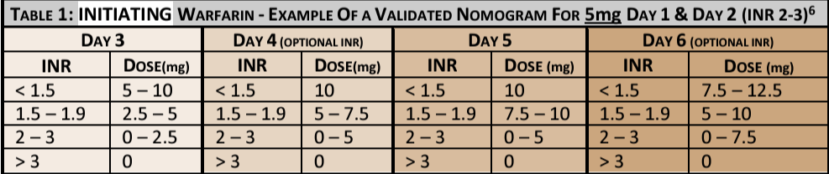  Option 3: Warfarin 10 mg po daily x2 days, day 3 INR, subsequent doses based on INRs  - Indications: younger, low blood risk  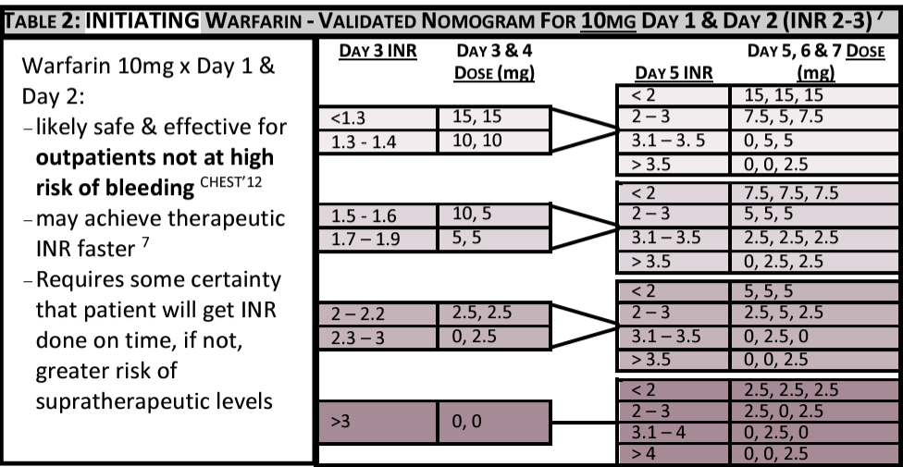
Monitoring | Generally:  - Week 1: baseline, day 3 and 5  - Week 2: 2 INRs  - Then Q weekly INRs until stable x 2 weeks  - Then Q 2 weeks until stable x 1 month  - Then Monthly INRs until stable x 3 months  - Then Q 12 weeks (3 months)  If dose changes: check INR weekly until stable  If starting, stopping or changing the dose of an interacting drug: Check INR in 4-6 days after the change  Managing Sub-Supratherapeutic INRs:  - Factors that may increase INR: acute illness, ETOH  - Factors that may decrease INR: edema, increased vitamin K intake, physical activity  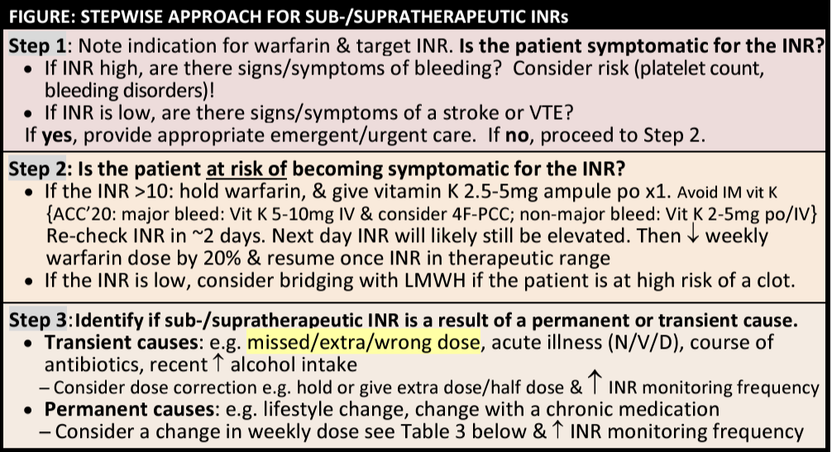  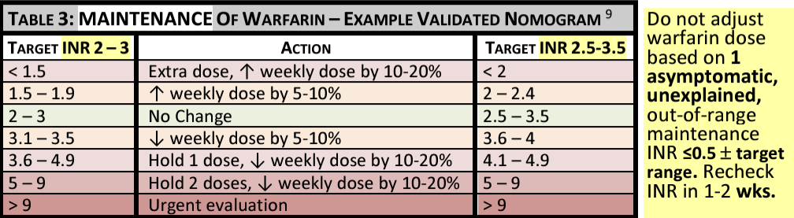
Drug Interactions | Drug interactions  - Interactions that cause a change in INR: e.g. amiodarone, antiepileptics, antimicrobials, corticosteroids, levothyroxine  - If combo cannot be avoided, increase INR monitoring and reactively adjust dose in response  - Interactions that increase risk of bleed or clot without affecting INR: e.g. NSAIDs, antiplatelets, hormone therapy  Food interactions: continue diet as usual, do not avoid certain foods. Encourage consistent vitamin K intake. If making a big diet change (e..g garden season, new diet), increase INR monitoring and adjust doses as needed  Herbal interactions: Many!! Licorice, anise, borage, ginger, ginkgo biloba, nettle, and much more

Atrial Fibrillation
Def’n | Chronic, recurrent and progressive condition
Algorithm | 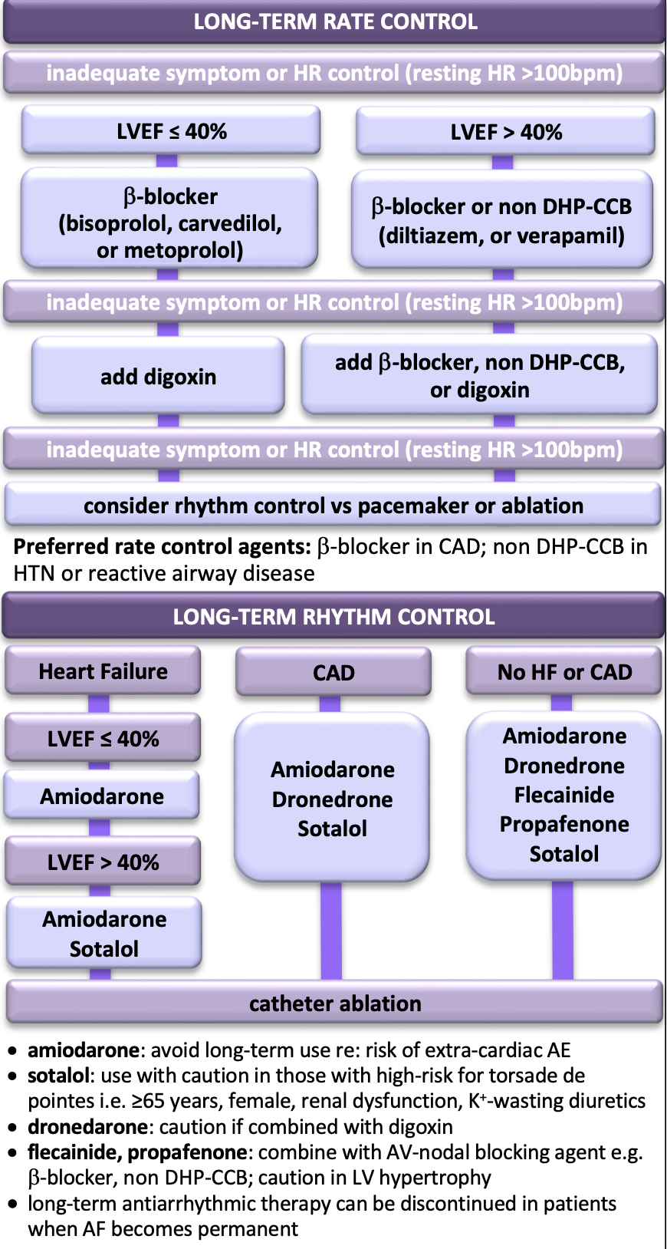
Pharmacological Therapy
Drug/Dose | Indication | Adverse fx (AE) and Drug interactions (DI) | Contraindications & special considerations
1st Line Therapies for Stroke Prevention
Anticoagulants/  antiplatelets if meet criteria:  CHADS2- >1 = oral anticoagulants  CHADS2- 0 <65 = antiplatelet | CHA2DS2-VASc score males 1+, females 2+ = oral anticoagulants  Bleeding risk- >3 then high risk and consider alternatives to anticoag | Dabigatran (150mg BID, 110mg BID for elderly), Rivaroxaban (20mg daily, 15 mg if reduced CrCl), Apixaban (5mg BIG, 2.5mg if elderly), Edoxaban (60mg daily, 30 if reduced CrCl) | SEE INFO ABOVE IN ORAL ANTICOAGULANTS/  ANTIPLATELETS for all CI, AE, DI
1st Line Therapies for Rate/Rhythm Control
Beta Blockers  Bisoprolol 2.5mg-10mg daily  MEtoprolol 25-200mg BID (100-200mg SR daily) | Initial therapy | AE: low BP/HR, dizziness, fatigue, sex dysf  DI: amiodarone, CCB, digoxin, antidiabetics, NSAIDs, | CI: severe asthma, HB with pacemaker, bradycardia, SBP<85, PAD  *atenolol associated with increased mortality
2nd line is nondihdropyridine Calcium Channel Blockers (Diltiazem, Verapamil) | Other: Digoxin (0.125-0.25mg) | Class III- amiodarone, dronedarone, sotalol- LAST RESORT SHORT TIME FRAME

Non-valvular Atrial Fibrillation: Anticoagulation
Comparing different meds to warfarin***
Category | Warfarin | Dabigatran (Pradaxa) | Rivaroxaban (Xarelto) | Apixaban (Eliquis) | Edoxaban (Lixiana/Savaysa)
Stroke/ Embolism | Baseline | Better at reducing stroke risk compared to warfarin | Better at reducing stroke risk, but only for certain doses | Better at reducing stroke risk | Better at reducing stroke risk but less effective in certain high-risk patients
Intracranial Hemorrhage | Baseline | Better – Lower risk than warfarin | Better – Lower risk than warfarin | Better – Lower risk than warfarin | Better – Lower risk than warfarin
Major GI Bleed | Baseline | Worse – Higher GI bleed risk compared to warfarin | Worse – Higher GI bleed risk | Better – Lower GI bleed risk than warfarin | Similar than warfarin
Major Bleed | Baseline | Similar to warfarin | Similar to warfarin | Better – Lower bleeding risk than warfarin | Better – Lower bleeding risk than warfarin
Discontinuation Rates | Baseline | Worse – Higher discontinuation rate than warfarin | Similar – No difference compared to warfarin | Better – Lower discontinuation rate than warfarin | Similar – No difference compared to warfarin
Renal Function (CrCl) | No specific restriction | Worse – Contraindicated if CrCl < 30 mL/min | Worse – Limited data, avoid if CrCl < 15 mL/min | Worse – Limited data, avoid if CrCl < 15 mL/min | Worse – Limited data for CrCl < 15 mL/min
Half-Life Pros/Cons  Longer – Requires regular monitoring |  | Shorter – Faster onset and offset but needs twice daily dosing | Shorter – Once daily dosing, faster onset and offset | Shorter – Twice daily dosing, faster onset and offset | Shorter – Once daily dosing, faster onset and offset
 |  | ***Be aware with a shorter half life that means earlier loss of anticoagulation so more doses which may lead to adherence issues/noncompliance…however this also means that with a shorter half life anticoagulation is achieved faster and bleeding stops faster when needed
Bleed management reversal agent | Vitamin K, PCC | Idarucizumab (Praxbind) | Andexanet alfa
Drug Interactions | Many HOWEVER few interactions are absolutely contraindicated | Better – Fewer interactions than warfarin however MUST avoid P-glycoprotein inhibitor and CYP3A4
Other Considerations | Requires regular INR monitoring, bleeding risk and dietary restrictions | Avoid if CrCl < 30 mL/min; may cause stomach upset/dyspepsia; increases MI risk |  | Evidence shows decrease in mortality
Cost | $15 however indirect cost of INR monitoring/time to travel | Worse – Higher cost at $98 g | Worse – Higher cost at $35 g | Worse – Higher cost at $37 g | Worse – Higher cost at $107

Summary
- Effectiveness: All DOACs (Dabigatran, Rivaroxaban, Apixaban, and Edoxaban) generally offer a better stroke prevention rate than warfarin.
- Safety: DOACs are associated with lower risks of intracranial hemorrhage. Apixaban and Edoxaban also tend to have a lower overall bleeding risk, including GI bleeds, while Dabigatran and Rivaroxaban may have a higher risk for GI bleeds.
- Convenience: DOACs don’t require regular blood monitoring, have fewer drug and dietary interactions, and generally have shorter half-lives, making them easier to manage in most cases.
- Cost: Warfarin is more affordable but comes with additional costs and effort due to regular INR monitoring, while DOACs are more expensive but offer easier management and fewer dietary restrictions.
- Apixaban is generally the most favorable balance of effectiveness and safety, especially for patients with a high bleeding risk, though cost and individual patient factors like renal function will affect the choice.

Venous Thromboembolism- VTE (includes PE, DVT)
Def’n | 3rd most common cardiovascular disorder
Therapeutic goals | Prevent thrombus extension, recurrence, death
Algorithm | Direct oral anticoagulants (DOAC) can treat VTE. If parenteral required then LMWH preferred.  Treatment Duration: 1st occurrence with transient risk is 3 months; unprovoked or irreversible risk factors then can be indefinite treatment;  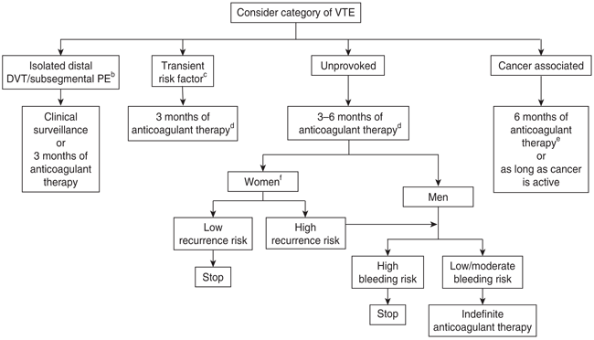
Non-pharmacological options | DVT: early ambulation, elevating swollen leg; elastic stockings (dec edema but not risk of DVT)  PE: oxygen, IV fluids, vasopressors if hypotensive
Education/counseling
VTE Pharmacological Therapy
Drug/Dose | Indication | Adverse fx (AE) and Drug interactions (DI) | Contraindications & special considerations
Treatment and Prophylaxis
Low molecular weight heparins: | Dalteparin (100U/kg BID SC or 200U/kg Q24H)  Enoxaparin (1mg/kg BID SC or 1.5 mg/kg Q24H SC)  Nadroparin 86U/Kg BID SC or 171U/kg Q24H SC)  tinzaparin(175 U/kg Q24H SC) | AEs: HIT  DIs: | Pregnancy- LMWH, UFH if not available
DOACs: | Apixaban (10mg BID x7d then 5mg BID 3-6m; prophylaxis of 2.5mg BID) | Rivaroxaban (15mg BID x3wk then 20mg daily 3-6m; 10-20mg daily for prophylaxis) | Dabigatran and edoxaban require parenteral anticoagulant prior to use for treatment
Prophylaxis ONLY
Unfractionated heparin | IV infusion- 80U/Kg bolus then 18U/kg/hr adjusted to meet aPTT |  | Hospitalized generally
ASA | 81mg f28d after dalteparin/rivaroxaban following surgery
Notes
Monitoring | Thrombosis consult; regular monitoring
Summary | Treatment of Venous Thromboembolism (VTE)  Pharmacological Treatment:  - Direct Oral Anticoagulants (DOACs)  - LMWH (low-molecular-weight heparin) is often used in combination with oral anticoagulants.  - Unfractionated heprin  - Warfarin can be used, but requires monitoring of INR and overlaps with parenteral anticoagulants for 5 days.  - Thrombolytics (may be used in severe cases (life/limb-threatening VTE), but only when bleeding risk is manageable.  Duration of Therapy:  - 3 months for first-time VTE due to transient risk factors; indefinite for unprovoked VTE or high recurrence risk. See algorithm above  Prophylaxis of Venous Thromboembolism (VTE)  Nonpharmacologic Measures:  - Graduated compression stockings and intermittent pneumatic compression can reduce VTE risk, especially in high-bleeding-risk surgeries.  - Inferior vena cava filters may be considered if anticoagulation fails or is contraindicated.  Pharmacological Prevention:  - DOACs especially post-hip/knee surgery.  - LMWH or unfractioned heprin for surgical/prolonged immobilization cases.  - Aspirin may be used after initial LMWH for some surgeries.  - Fondaparinux for high-risk orthopedic surgeries.  Duration of Prophylaxis:  - Typically 10-14 days post-surgery or during hospitalization; extended if high risk or early discharge (e.g., orthopedic surgeries, cancer patients).

Raynaud Phenomenon
Def’n | -blanching of digits when exposed to cold; white to blue to red colour changes of the skin
Therapeutic goals | -reduce frequency/severity, decrease symptoms, prevent deterioration, heal lesions
Algorithm | 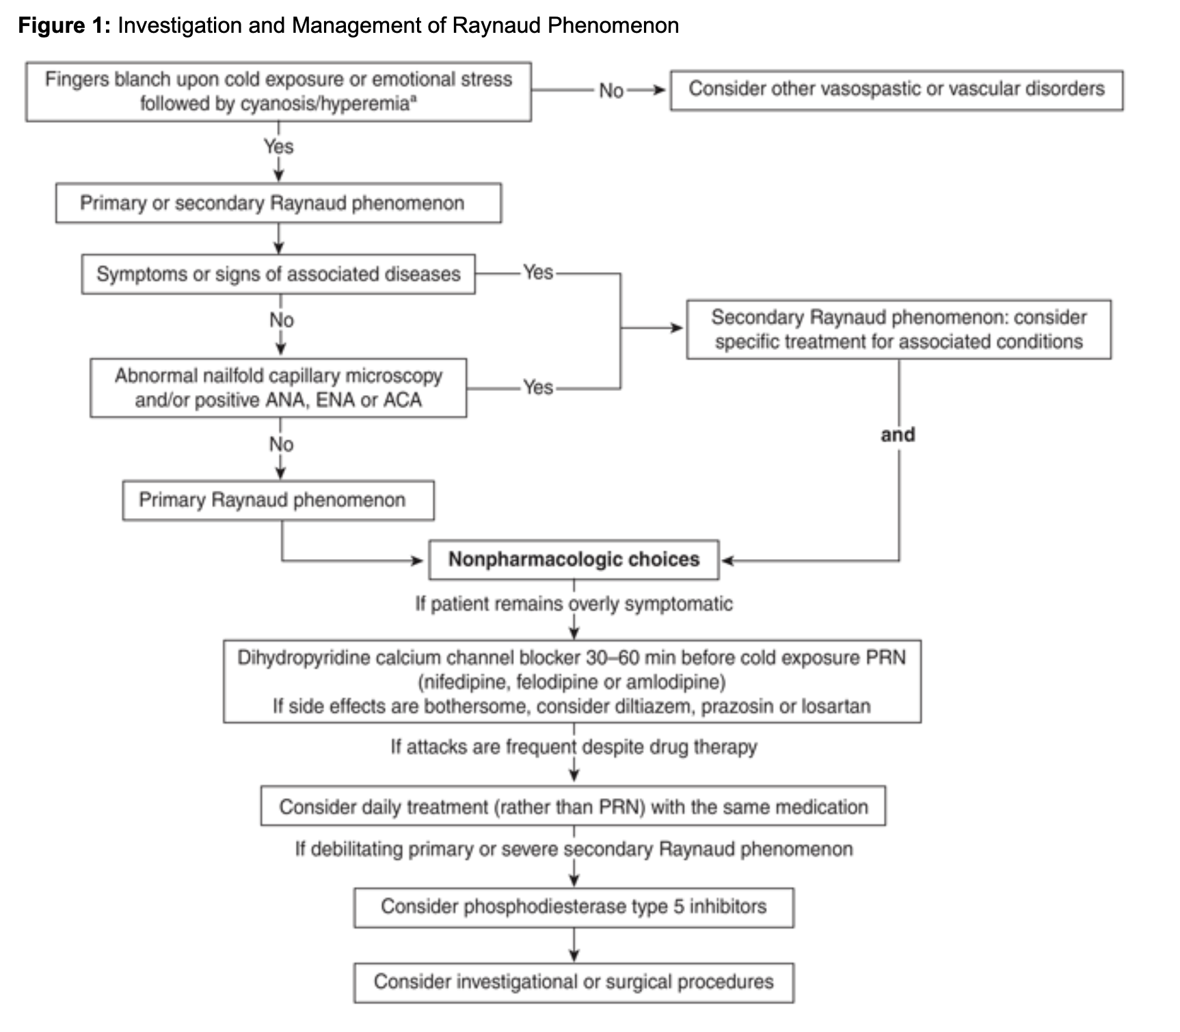
Non-pharmacological options | **meds only 40-60% effective- these need to be utilized**  -minimize cold exposures, avoid vasoconstricting meds (beta blockers), warming exercises (swinging arms), dress warmly, stop smoking, avoid vibrating tolls
Education/counseling | -induced by stress
Pharmacological Therapy
Drug/Dose | Indication | Adverse fx (AE) and Drug interactions (DI) | Contraindications & special considerations
1st Line Therapies
Dihydropyridines calcium channel blockers  Nifedipine 30mg PO 30-60min before cold exposure  (felodipine and amlodipine also work) | Take daily if required | AEs: tachycardia, flushing, headache, dizziness, orthostatic hypotension, edema, gingival hyperplasia  DIs: | -nif not legal in canada for pregnancy, ok for breastfeeding
2nd Line Therapies
Diltiazem (180-240mg 60-90mins before), prazosin (1-2mg BID daily), losartan (ARB, 50mg daily)) | If AEs above are bothersome | Syncope, hypotension
Phosphodiesterase type 5 inhibitors  Sildenafil, tadalafil | If above options didn’t work | hypotension
Notes
Monitoring | Treating symptoms not condition
Referral | Vascular if surgeries required for ulcers

Intermittent Claudication
Def’n | -limping or lameness caused by PAD narrowing lower limb blood vessels
Therapeutic goals | -improve mobility, QOL, increase walking distance, prevent associated cardiovascular events
Algorithm | 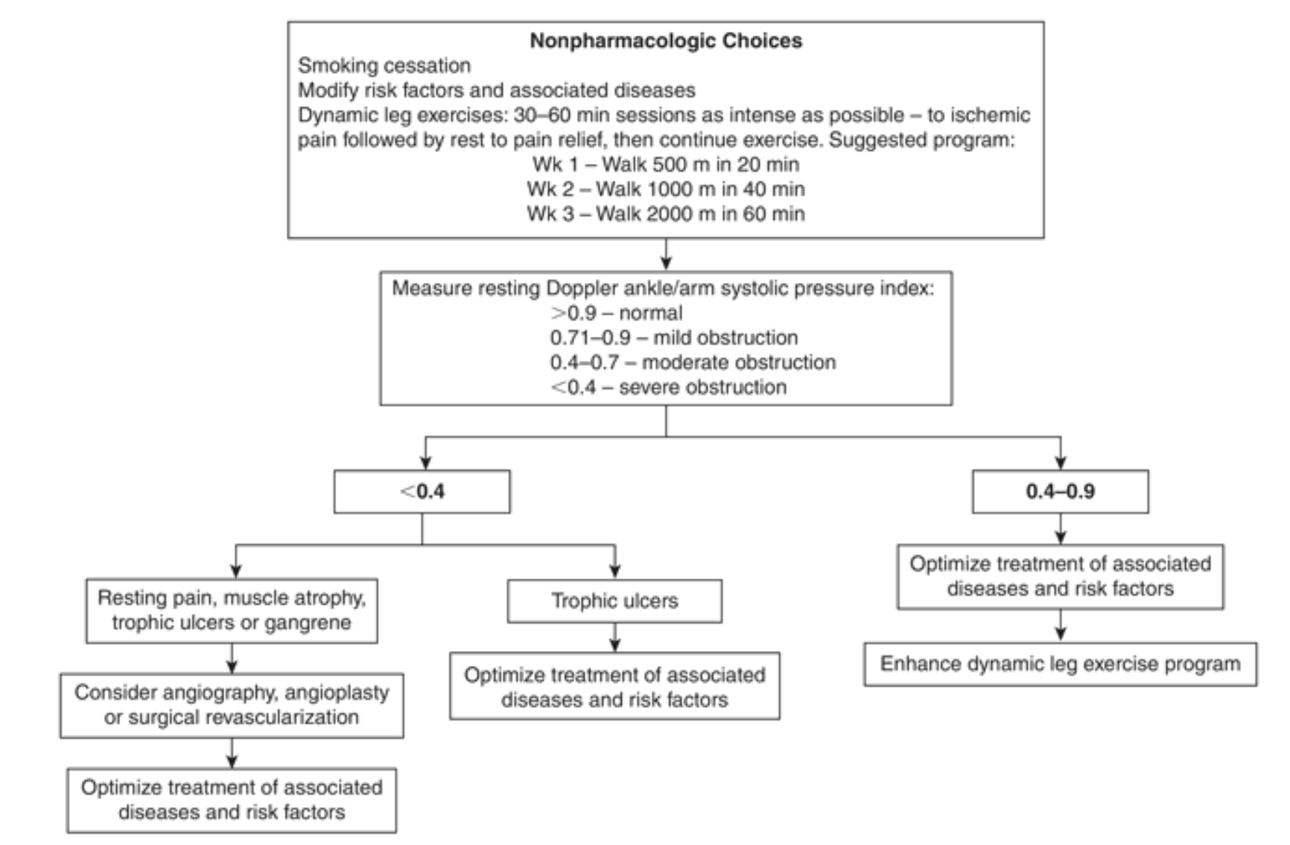
Non-pharmacological options | Discontinue smoking, exercise- regular, dynamic,
Education/counseling | Antithrombotic therapy is NOT recommended for isolated asymptomatic lower extremity PAD
Pharmacological Therapy
Drug/Dose | Indication | Adverse fx (AE) and Drug interactions (DI) | Contraindications & special considerations
1st Line Therapies
Rivaroxaban 2.5mg BID with ASA 80-100mg daily as per COMPASS TRIAL | Symptomatic lower extremity PAD at high risk for ischemic events | AEs:R- bleeding  DIs:R- strong inhibitors of CYP3A4 and Pgp | CrCl<30
ASA (75-325mg) or clopidogrel 75mg | Symptomatic lower extremity PAD at high bleeding risk | AEs: A- bleeding, GI upset  C- rash, diarrhea, bleeding
Notes
Referral | Vascular, if required

Prevention Infective Endocarditis- Prophylaxis
Def’n | Recommend ONLY for:  Prosthetic heart valves or prosthetic material used for cardiac repair  Previous bacterial endocarditis (even in the absence of heart disease)  Unrepaired cyanotic congenital heart disease (includes palliative shunts and conduits)  During the first 6 months after complete repair of a congenital heart defect with prosthetic materials/device  Repaired congenital heart disease with residual defects that inhibit endothelialization  Cardiac transplant recipients who develop cardiac valvulopathy
Algorithm | Oral regimens are more convenient and safer  Only use parenteral if unable to take or absorb oral  IM avoid in anticoagulation therapy patients  Antibiotics should be administered 30-60 minutes prior to the procedure. If antibiotic prophylaxis is inadvertently not administered prior to the dental procedure it may be given up to two hours after the procedure
Pharmacological Therapy
Drug/Dose | Children | Adverse fx (AE) and Drug interactions (DI) | Contraindications & special considerations
Dental (all procedures) & Upper Respiratory Procedures (tonsils, bronchoscopy, etc)
***
Dental: All dental procedures that involve manipulation of gingival tissue of the periapical region of teeth or perforation of the oral mucosa.
Respiratory: Tonsillectomy or adenoidectomy, surgical operations involving respiratory mucosa, bronchoscopy, invasive treatment of established infection
1st- Amoxicillin 2g 30-60 min pre-procedure; if missed can be given up to 2 hours post procedure | Children: 50mg/kg | AEs:allergy  DIs: | Penicillin allergy
2nd- Cephalexin 2g  Doxycycline 100mg | 50mg/kg  < 45kg 2.2mg/kg; >45kg 100mg
Parenteral
1st- Ampicillin 2g IM or IV 30-60 mins pre-procedure  Cefazolin 1 g IM or IV given 30-60 minutes pre-procedure  Children: 50 mg/kg IM or IV  Ceftriaxone 1g IM or IV given 30-60 minutes before procedure Children: 50mg/kg MI or IV | 50mg/kg IM/IV
GI and GU Procedures ABX PROPHYLAXIS NOT INDICATED
Skin- abx prophylaxis reasonable for procedures on infected skin, skin structures, or musculoskeletal tissue only for high risk pts

Stable Angina
Def’n | -squeezing discomfort felt in chest caused by myocardial ischemia
Therapeutic goals | -increase QOL, decrease/prevent, improve exercise intolerance
Algorithm | 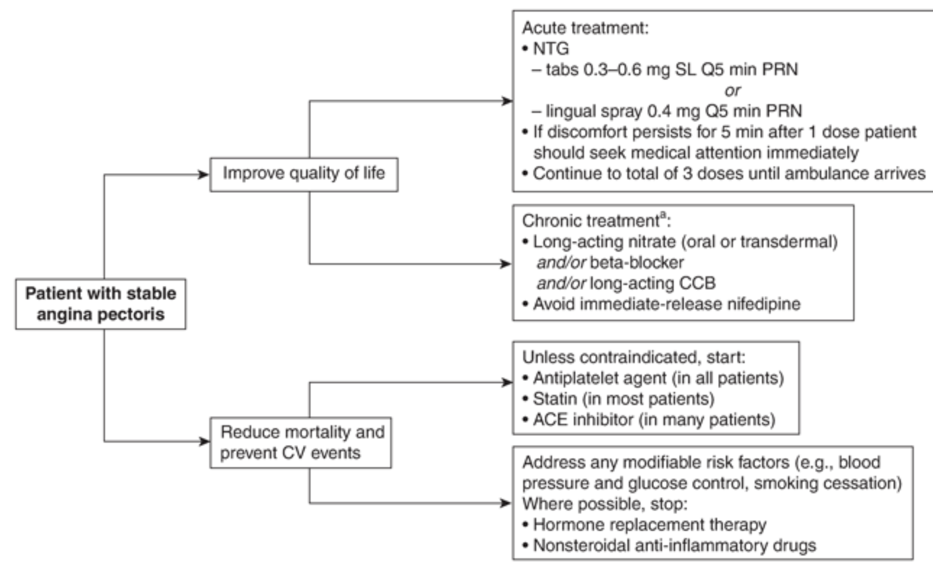
Non-pharmacological options | Aggressive lifestyle intervention- aerobic exercise, heart healthy diet, quit smoking, minimize alcohol, stress management  Revascularization- PCI
Education/counseling
Pharmacological Therapy
Drug/Dose | Indication | Adverse fx (AE) and Drug interactions (DI) | Contraindications & special considerations
Nitrate- nitroglycerin
Sublingual spray (0.4mg PRN q5m, call ambulance if not improved, max 3 doses)  Tablet (0.3-0.6mg SL PRN q5m) | Acute treatment Improve quality of life | AEs:headache, tachycardia, hypotension, syncope, dizziness, flushing  DIs:fatal hypotension with sildenafil, tadalafil, vardenafil
Transdermal patch | Chronic treatment; improve quality of life | AEs:headache, tachycardia, hypotension, syncope, dizziness, flushing  DIs:fatal hypotension with sildenafil, tadalafil, vardenafil | *10-12 hr free daily to prevent tolerance
Beta Blocker- decrease HR, contractility, BP (afterload)
Bisoprolol 2.5mg daily  Metoprolol 50mg/day (regular doses BID, SR once daily)  Atenolol 25mg/day | Chronic treatment; improve quality of life | Fatigue, hypotension, bradycardia (especially with nondi CCBs) | Avoid abrupt withdrawal  C/I: Asthma and Heart Blocks. Even cardioselective (beta-1 selective) meds are contraindicated in asthma because there’s still a chance it can cause bronchoconstriction (although non-selective is def worse- like propanolol)
Calcium Channel Blocker
Nondihydropyridines:  Verapamil SR- 180mg/day  Diltiazem 120mg/day | Chronic treatment; improve quality of life; decrease myocardial oxygen demand by lowering heart rate, contractility and blood pressure | -headaches, dizziness, bradycardia, heart block  +constipation for verap  DI: CYP3A4 substrate, azoles, macrolides | *caution in HF patients or heart block without pacemaker
Dihydropyridines:  Amlodipine 2.5mg/day  Nifedipine 30mg/day | Chronic treatment; improve quality of life; arterial dilation | -ankle edema, flushing, headache, hypotension, tachycardia  DI: CYP3A4 substrate, azoles, grapefruit
Antiplatelet Agent  ASA 80-325mg OR  Clopidogrel 75mg if ASA allergy | all patients for reduced mortality and prevent CV events | Nausea, vomiting, GI bleeding  Diarrhea, bleeding
Statin  Atorvastatin 80mg  Reduce LDL to <2 or 50% drop | most patients for reduced mortality and prevent CV events;
ACE Inhibitor  Ramipril 10mg daily | Many patients for reduced mortality and prevent CV events; decreasing sympathetic adrenergic transmission, reducing blood pressure and afterload, and improving coronary flow reserve

Syncope
Def’n | -transient loss of consciousness associated with an inability to maintain postural tone, rapid and spontaneous recovery, and the absence of clinical features specific for another form of transient loss of consciousness
Therapeutic goals | -remove reversible causes (diarrhea, medications, alcohol), treat arrhythmias and obstructive causes,
Algorithm | 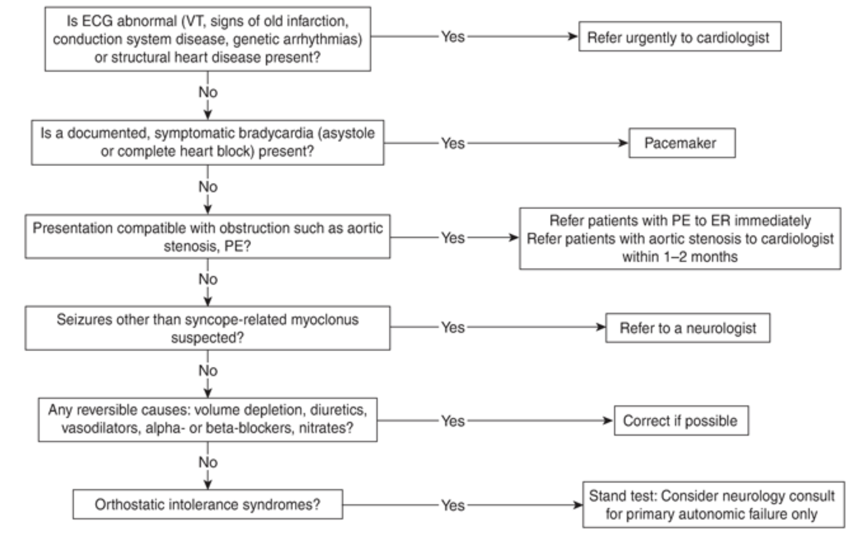
Non-pharmacological options | Salt pills, fluid retention
Pharmacological Therapy
Drug/Dose | Indication | Adverse fx (AE) and Drug interactions (DI) | Contraindications & special considerations
1st- Sodium Chloride (salt tablets) 3-5g elemental NA daily | y | AEs: gastric upset, fluid retention  DIs:diuretics | *fluid retention can precipitate HF
Mineralocorticoids-  Fludrocortisone 0.2mg daily | Vasovagal, orthostatic, | AEs:edema, supine hypertension, hypokalemia, eczema  DIs:diuretics
Alpha-agonists-  Midodrine 2.5mg-5mg TID, none after 5pm | Vasovagal,orthostatic,increase venous return | AEs:Supine hypertension, shivering  DIs:digoxin | Check supine BP
SSRI-  Paroxetine | Vasovagal (rare),
Acetylcholinesterase inhibitor-  pyridostigmine | orthostatic

Canadian Cardiovascular Society Guidelines on Fitness to Drive
Here’s a summary of the key recommendations from the CCS 2023 Fitness to Drive Guidelines:
General Principles:
- Risk of Harm:
  - Private drivers: Allowed up to a 22% annual risk of sudden cardiac incapacitation (SCI).
  - Commercial drivers: Restricted to a 1% annual SCI risk.
- Driving Eligibility:
  - Decisions depend on symptom burden (e.g., NYHA class), LVEF, and condition-specific risks.
  - Recovery times post-cardiac events or procedures are specified to ensure safety.

Condition-Specific Highlights:
1. Coronary Artery Disease (CAD):
- Post-myocardial infarction (MI):
  - LVEF ≤ 40%: Private driving after 1 month; commercial after 3 months.
  - LVEF > 40%: Private driving after 2 weeks; commercial after 1 month.
- Unstable angina (no MI): Private driving after 48 hours; commercial after 7 days.
2. Valvular Heart Disease:
- Aortic Stenosis (NYHA Class I-II):
  - No restrictions for private drivers; commercial allowed only if LVEF ≥ 50%.
- Post-valve replacement (e.g., TAVR or SAVR):
  - Private driving after 1 month; commercial after 3 months.
3. Heart Failure (HF):
- NYHA Class IV or receiving inotropes: Disqualified for all driving.
- NYHA Class I-II:
  - Private driving allowed; commercial restricted if LVEF < 30%.
- NYHA Class III:
  - Private driving allowed; commercial disqualified.
4. Implanted Devices (e.g., ICDs, LVADs):
- Implantable Cardioverter Defibrillators (ICDs):
  - Private driving allowed 3 months post-implant (secondary prevention).
  - Commercial driving usually disqualified.
- Left Ventricular Assist Devices (LVADs):
  - Private driving after 2 months if NYHA Class I-II; commercial disqualified.
5. Syncope:
- Unexplained Syncope:
  - No driving for 3 months after event unless resolved and low-risk.
- Resolved Syncope:
  - Private driving allowed after thorough evaluation.
6. Inherited Arrhythmias:
- Long QT Syndrome (LQTS):
  - Private driving allowed if well-controlled on beta-blockers.
  - Commercial disqualified for high-risk cases or recent syncope.
- Hypertrophic Cardiomyopathy (HCM):
  - No restrictions for low-risk individuals; high-risk cases require 3 months symptom-free.

Practical Recommendations:
- Physicians: Legally required to report unfit drivers in most Canadian provinces.
- Assessment Tools: Use LVEF, NYHA class, and specific event rates for decisions.
These guidelines aim to ensure safety while balancing independence for patients.

Smoking Cessation
Algorithm | 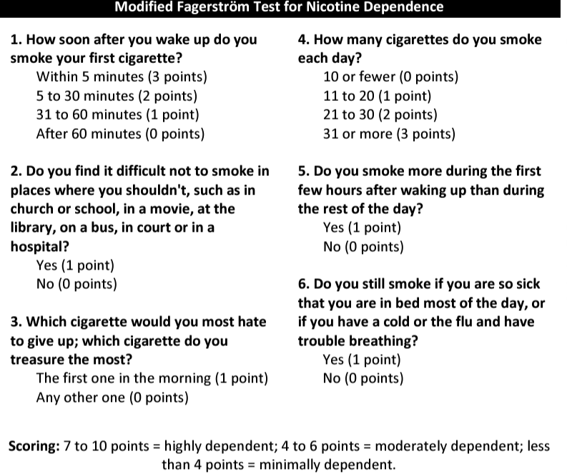
Education/counseling | - Quit smoking advice from a clinician, even brief can increase cessation by 30%  - Some attempt 10x before quitting  - Smoking is the leading cause of preventable death. Smokers die on average 10-17 years younger than non-smokers and 50% of long-term smokers die prematurely (cancer, heart, stroke and lung disease); quitting decreases mortality by 36%  5 A’s of smoking cessation/tobacco treatment:  - Ask about tobacco use every visit  - Advise to quit  - Assess willingness to quit  - Assist implement plan  - Arrange follow-up and cessation counseling
Pharmacological Therapy
1st line is NRT, varenicline, or buproprion
Drug/Dose | Indication | Adverse fx (AE) and Drug interactions (DI) | Contraindications & special considerations
Nicotine Replacement Therapy (NRT)
- Combining NRT forms (e.g. patch + gum) may increase efficacy.
- May smoke with NRT (but may increase AEs).
- Individualize dose - increase if withdrawal, decrease if AE
- Effectiveness may depend on co-interventions and/or highly motivated patients
- Pregnancy: nicotine patch vs smoking assoc with decreased risk of prematurity and small for gestational age infants. Encourage smoking cessation and NRT tapering to decrease exposure
Nicotine patch  7, 14, 21mg available | 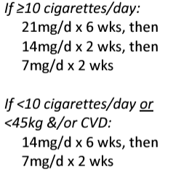  Start 1-4 weeks before quit date  Patch is best NRT option for patients with CVD (results in fewer CV events compared to other NRT options) | AEs: Skin irritation, headache, insomnia, nightmares (if worn at night- remove patch if needed)  DIs: | CI: eczema
Nicotine gum  2, 4mg available | 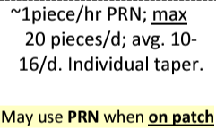 | AEs: cough, throat irritation, nausea,  DIs: coffee, acidic beverages impair absorption. Space by >15min | CI: dental problems, TMJ syndrome, not advised for high risk cardiac patients (consider patch instead)
Nicotine lozenge  1, 2, 4mg lozenges | 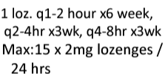 | AE: sore gums, teeth, throat; hiccups, heartburn/indigestion | CI: not advised for cardiac patients
Nicotine oral inhaler/spray | 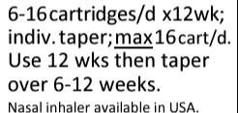  Quick delivery convenient for severe cravings | AE: throat irritation, cough, rhinitis, dyspepsia | CI: not advised for cardiac patients
Antidepressants can also be used to help quit smoking. Can combine with NRT
Bupropion | 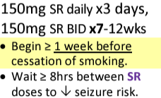 | AE: 9% D/C due to AE. Insomnia, agitation, seizure, aggression, decreased appetite, N/V, tremor, dry mouth | CI: personal/family hx of seizures, increased risk of seizures, head trauma, patients on MAO inhibitors within 14 days
Varenicline; can combine with NRT
Varenicline  (nicotine receptor partial agonist - provides some stimulation of nicotine receptors while also blocking nicotine from concurrent smoking) | 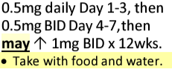  Set quit date 1-2 weeks after starting | AE: nausea, sleep/dream, aggression, taste disturbance, high CBG  DI: increased nausea with NRT | CI: end stage renal? Epilepsy? Suicidal?
Notes
Monitoring
Referral | If no response in 4 weeks, reassess
Other notes

Post-myocardial infarction
Def’n | Patients who have had STEMIs or NSTEMIS are at substantial risk for subsequent major CV event
Therapeutic goals | Restore quality of life and prevent progression of disease and repeat infarction.  Target modifiable risk factors for secondary prevention. Monitor for potential arrhythmias
Algorithm | 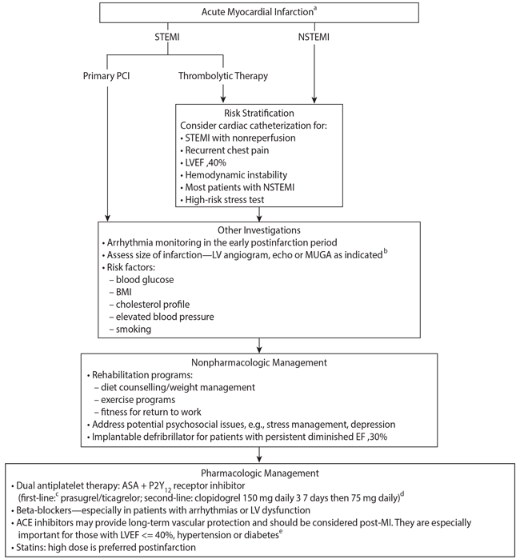
Non-pharmacological options | -Coronary angiography should be considered in most patients after MI  -Target weight goal BMI 18.5-25- regular exercise, 30-45 min of moderate aerobic activity 3-4x/week  -Counseling to manage significant psychosocial issues (anxiety, social support)
Education/counseling
Pharmacological Therapy
Secondary prevention with several classes of drugs independently reduces incidence of major adverse cardiovascular events by ~25%.
Drug/Dose | Indication | Adverse fx (AE) and Drug interactions (DI) | Contraindications & special considerations
Consider in ALL post-MI patients. Cumulative risk reduction if all 4 of the following drugs are used is 75%
1. Dual antiplatelet therapy:  Low dose ASA + P2Y12 receptor inhibitor (ticagrelor [1st line], clopidogrel [2nd line])  Duration: at least 1 year after MI in patients with low bleeding risk THEN just ASA indefinitely | Inhibition of PLT required to maintain vessel patency and prevent reinfarction. | AEs:  ASA - N/V/, GI hemorrhage, tinnitus, vertigo, hypersensitivity  Ticagrelor- increased risk of bleeding, bradycardia, HA, nausea  Clopidogrel - rash, purpura, diarrhea, bleeding  DIs: caution with NSAIDs (for all anti-PLTs)
2. Beta-blocker  Start within a few days of infarction and titrate dose to achieve HR <70bpm | Reduces reinfarction and prevention of ventricular arrhythmias after MI | AE: Fatigue, bradycardia, reduced exercise capacity, HA< impotence, vivid dreams  DI: bradycardia with digoxin or non-DHPS CCBs. Cardidepressant effect with non-DHPS CCBs, anti-arrhythmics, anesthetics
3. Lipid lowering agent  High dose statin (e.g. atorvastatin 80mg or rosuvastatin 40mg).  Duration: forever  Dose: highest dose tolerated | Lower lipid levels and help stabilize plaque, preventing future rupture | AE: GI disturbances, sleep disturbances, HA, rash, myalgia (+/- CK levels), increased CK and aminotransferase levels, myopathy, rhabdomyolysis (rare) | Target LDL-C <1.8  .
4. ACE inhibitor  Can use ARB instead of ACEI if not well tolerated | Should be used in all MI patients especially those with LV dysfunction, HTN or DM. | AE: dry cough, hyperkalemia, angioedema  DI: elevated lithium levels | CI: significant renal dysfunction, hyperkalemia
Notes
Monitoring | N/A (not specifically discussed in this CPS article)
Referral | N/A
Other notes | N/A

Geri RX Files- Chronic Coronary Disease In Older Adults
Couldn’t find this specific RX files doc. The closest one I could find was “Cardiology Considerations in Older Adults” which is what i’ve summarized here
- Lifetime risk of experiencing a coronary event at age 70 is 35% (men) and 24% (women), increasing to 89% (men) and 92% (women) by age 80
- De-escalation/de-prescribing of therapies should be considered for older population, especially frail patients, as CV meds have lots of AE which are more pronounced in older population; shared decision-making re: preferences, QOL, and values to balance risks vs benefits

Dyslipidemia
- In secondary prevention, statins may be recommended regardless of age
- Lipid testing and CV risk calculation offers little for age>75 and not recommended
- In primary prevention age >75, it’s reasonable to offer statins for those whose overall health status is good; statin role/benefit less certain with higher age (>80) and frailty

Chronic coronary disease (CCD)
Ischemic Heart Disease
- Influenza vaccine assoc with reduced risk of MI, change in CHF prognosis, and cardiovascular death in 65 yo+

HF with reduced EF
- Consider combo of ACEI or ARB + B-blocker + MRA (mineralocorticoid receptor antagonist) and SGLT2i (sodium/glucose cotransporter 2 inhibitor) for early use in HFrEF as the new therapeutic standard (quadruple therapy)

Anti-PLT and Anti-coagulants
- ASA in primary prevention: ASA should not be used in most patients regardless of diabetes, age, or sex. Risk of major bleeding >70 yo
- Shortened dual antiplatelet therapy (DAPT) of 1-3 months (as opposed to 1 year which was prev recommended in other guideline) for some PCI may reduce major bleeding without affecting efficacy
  - DAPT of 1-3 months and step down to single antiplatelet therapy > appropriate for those with high bleed risk undergoing PCI for ACS
  - High bleeding risk (HBR) includes any 2 of:
    - age >75, eGFR 30-59, long-term NSAID or steroid use, any previous stroke etc.
Afib
- Under-dosing direct oral anticoags (DOAC) is common and doesn’t meaningfully reduce bleeds; it does increase hospitalization, thrombotic events and death
- Despite fall risk, frailty or advanced age, benefits of oral anti-coags outweigh risks
- Apixaban is the preferred DOAC in most older adults d/t lower bleed risk

RX Files Heart Failure with Reduced Ejection Fraction (HFrEF: Treatment Overview)
PEARLS
-Heart failure mortality rates are high (50% die within five years of diagnosis)

Quadruple therapy (ARNI or ACE or ARB + HF beta blocker + MRA + SGLT2):

-Goal is to decrease risk of death and hospitalizations and improve symptoms.
-Start quadruple therapy at low dose and tirtate q 1-4 weeks to max tolerated dose.

Optimizing therapy beyond ACE/ARB + HF beta blocker further reduces risk of death/ hospitalizations/ improves S&S:

-adding on medications such as spironolactone, ramipril or enalapril, dapagliflozin

Monitor:
-serum creatinine, BUN, eGFR, potassium, BP when starting ACE/ARB/ARNI/MRA
-reasonable to see: increase creatinine 30%, potassium over 5.5, asymptomatic SBP 90-100 mmHG, DBP: 50 to 60 mmHG.
-patients need to monitor their own weight, fluid and potassium intake

Initial Workup
Common symptoms:

-dyspnea, weight gain, edema, fatigue, orthopnea, paroxysmal nocturnal dyspnea, weakness, exercise intolerance, cough, abdominal distention, nocturia, cool extremities
Investigations:

-CXR, ECG, blood work (CBC, electrolytes, renal and thyroid function, glucose, BNP, urinalysis).
-if NTproBNP over 125pg/mL or BNP over 50pg/mL order ECHO and intensify medications such as: ACE, ARB, HF beta blocker
How is HF Classified
Left Ventricular Ejection fraction (LVEF):

-HF with reduced EF (HFrEF): LVEF ≤40%
-HF mildly reduced EF (HFmrEF): LVEF 41-49%
-HF with preserved EF (HFpEF): LVEF ≥50%
-HF with improved EF (HFimpEF):
baseline LVEF ≤40%, a ≥10% ↑ from baseline, and second measurement of LVEF >40%

NYHA class I: no symptoms
NYHA class II: symptoms with ordinary activity
NYHA class III: symptoms with < ordinary activity
NYHA class IV: symptoms at rest or minimal activity
Management of HF with LVEF greater 40% (HFmrEF/ HFpEF)
-medications decrease hospitalizations but NOT mortality
-use diuretics for congestion
-manage risk factors ex. HTN, DM, AF
-look at LVEF trends (ie. less events if EF increasing)
-consider SGLT2 (empagliflozin, dapagliflozin)
-consider candesartan, spironolactone, entresto
Management of HF with improved EF
-risk of relapse when HF therapy is stopped therefore continue HF therapy unless not tolerated
Life style
-weight- advice client to check weight every morning, nude after voiding
-report (gain more than two pounds in two days or more than five pounds a week)
-fluid intake- limit to 1.5 to 2L/day
-Salt intake- limit to 2-3g salt/day, if advanced HF or increased fluid less than 2g salt/day
-potassium- avoid high potassium
-exercise- after stress test** improve exercise capacity, at least 15m min/day of moderate intensity.

Medical Management
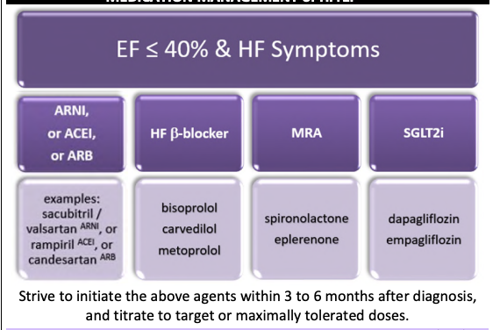
Ways to Optimize HrEF Therapy
Congestion | -use diuretics- for congestion at any stage  -adjust diuretic to euvolemic state  -combine diuretic if fluid retention (eg. lasix with metolazone)  -optimize HFrEF quadruple therapy
SR and HR over 70-77 | -add ivabradine or digoxin to decrease hospitalizations
Black | -add hydralazine + nitrate to patients with NYHA III-IV
Worsening HF | -optimize HFrEF quadruple therapy  -add vericiguat to decrease hospitalizations
A-fib | -add digoxin or amiodarone
De-novo HF | -start quadruple therapy urgently (consider starting in pairs)
Frailty | -decrease risk of hypotension and falls by starting with low doses and titrate slowly (q2-4 weeks)  -rise slowly from supine to standing  -separate administration and cardiac rehab
Severe HF Symptoms | Refer to cardiologist  Acute HF → ER  Chronic HF → interdisciplinary HF clinic

RXFILES-Heart Failure Medication when Patient is Sick (2020)
If patient is sick and experiencing vomiting/ diarrhea/fever

Assess for Dehydration:
-weak/ tired
-dizzy/ light headed
-confused/ trouble focusing
-thirsty, dry mouth
-cool, clammy skin
-less urine

Educate:

-hydrate up to 2L of fluid/day
-limit caffeine
-watch sodium
-weigh daily
-check BP and HR twice/ day
-consult provider if weight up or down by more than 1.5 kg over two days or BP low

Medications stop when sick and restart when feeling well:
- Diuretics (lasix, metolazone)
- Ace inhibitors (ramipril)
- Angiotensin receptor blocker (valsartan)
- Sacubitril-valsartan
- Spironolactone or eplernone
- SGLT2 inhibitor (dapagliflozin, empagliflozin) → go to ER if having abdominal pain, severe vomit, drowsy
- Metformin, glyburide, gliclazide
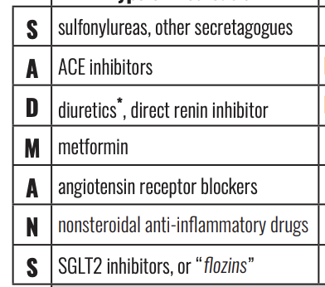 (2018)
For cough and cold:
-avoid anti-inflammatory (ibuprofen,motrin)
-avoid decongestants containing pseudoephedrine or phenylephrine
-avoid aspirin for pain or fever (only okay to take daily dose for CV protection)
-instead use tylenol and saline rinses

Rx Files Furosemide Sliding scale for HF outpatients
Furosemide

-furosemide helps manage congestion symptoms (SOB, weight gain, swelling)
-furosemide does not decrease the risk of mortality
-furosemide can limit the effect of other heart medications.

-should be titrated to the minimum effective dose to maintain euvolemia

-adjust dose so that: there's a decreased risk of volume depletion and reduce risk of volume overload
-patient’s can adjust their own doses after being educated.

-Goal of Euvolemia:
-dry weight=ideal weight without extra fluid accumulation/congestion

-Range of lasix:
-no lasix → PRN only → low dose daily → high BID dose with or without metolazone

Considerations for assessing & managing hypovolemia/volume depletion and maintaining euvolemia

Considerations |  | Medication adjustments
-pt experiencing hypovolemia without worsening HF symptoms:  -(postural hypotension drop more than SBP 20 or DBP 10mmHG/HR increase over 30 Bpm)..  -weight stable or low  -pt presenting with: weak, tired, cold, clammy, low urine output |  | First Reduce or Hold Diuretics  -if patient is on metolazone → reduce or hold for 2-3 days prior to adjusting furosemide  -if not on metolazone → reduce lasix in 20-40 mg increments and hold for 2-3 days  -if on ARNI or SGLT2i was recently started → reduce furosemide by 30-50%  -if patient is on spironolactone only hold if pt has hyperkalemia  Then R/A in 2-3 days  -r/a S&S of hypovolemia and HF and blood work  -if still hypovolemic and no HF symptoms → reduce lasix by another 20-40 mg increments.  -euvolemic and no HF symptoms→ continue to hold current diuretics and monitor for HF symptoms  -if mild HF symptoms→ restart diuretic at same or lower dose or monitor and restart if symptoms worsen
-Does their bloodwork suggest they are dry?
-decline in renal function
-serum creatinine/BUN ratio less
than 12
-high potassium
-BNP lower

-patient taking more diuretics than prescribed:

patient is drinking less than 1.5 - 2L of fluid/day: encourage to drink up to 1.5-2L/day

-if patient has acute illness and has fluid loss: NVD hold SADMANS medication until pt is well

Considerations for Assessing and Managing Hypervolemia/overload with a goal of achieving Euvolemia
Considerations |  | Medication Adjustments
Patient experiencing S&S of congestion:  -pt present with elevated JVD, pulmonary crackles, edema, S3 sounds  -increase weight of over two pounds in two days or five pounds in a week  -worsening: edema, SOB, weakness, orthopnea, dyspnea, cough  Educate pt:  -daily weight taken after urinating and without clothes.  -edema on ankles is normal at the end of the day elevate feet before bed. |  | 1st start or increase diuretic  -if pt is not on furosemide → start furosemide 20 to 40mg PO OD  -if pt is on furosemide → increase oral dose by 20mg to 40mg  Ex. lasix 20mg increase to 40mg  2nd , R/A in 2-7 days  -R/A HF symptoms and blood work  -if dry weight not achieved or HF symptoms continue → increase lasix by another 20 to 40 mg increments  -if more than 2 increases of lasix does not provide relief,consider adding metalozone 2.5mg daily for 3 days  -if dry weight achieved and HF symptoms resolved:  -reduce to previous dose  -if hypervolemia recurs then maintain the higher dose  -higher doses may be required in CKD  -If potassium is trending too low → start and titrate ACE, ARB, ARNI, MRA and start potassium supplements
BW showing congestion:

-Increase in BNP over thirty percent
-or is the pt having concurrent illness such as (Afib, pneumonia, anemia, COPD) that can give similar S&S.

Pt taking less diuretic than prescribed

Educate pt:
-if avoiding lasix because of incontinence when go outside then only take diuretic once are back home
-if avoiding lasix because of nocturia take diuretic no later than mid-afternoon
Pt taking more than 2L of fluid/day or too much salt:

Educate pt:
-drink less than 2L/day and less 2g of salt/day
Pt taking medications that can exacerbate HF:
-ex. NacL, COXIB, corticosteroids, androgens, estrogens
-if so stop them
-BB can increase fluid retention when recently started

Week 8: Respiratory

Asthma (MUMS Respiratory Guidelines & RX Files Meds)
Acute exacerbations:
- Deal with precipitating cause
- SABA, SAMA, ICS/LABA (fast on-set), systemic corticosteroids as req.
- Oxygen supplementation PRN
Def’n | Asthma is characterized by paroxysmal or persistent symptoms of dyspnea, chest tightness, wheezing, sputum production, and cough assoc. With variable airflow limitation and airway hyper-responsiveness to endogenous and exogenous stimuli. Most common pediatric disease
Therapeutic goals | Achieve well controlled asthma, Improve health status and QOL, reduce exacerbations, hospitalizations, morbidity, and premature mortality. Symptoms of asthma are reversible and preventable  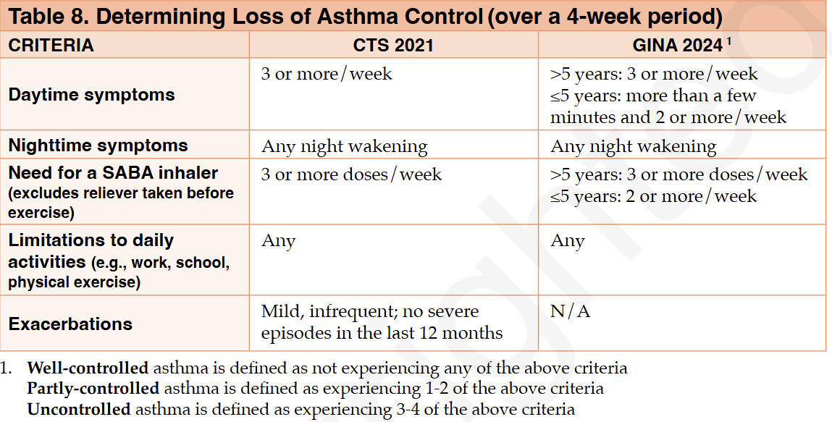
Algorithm  (From MUMS respiratory guideline) | 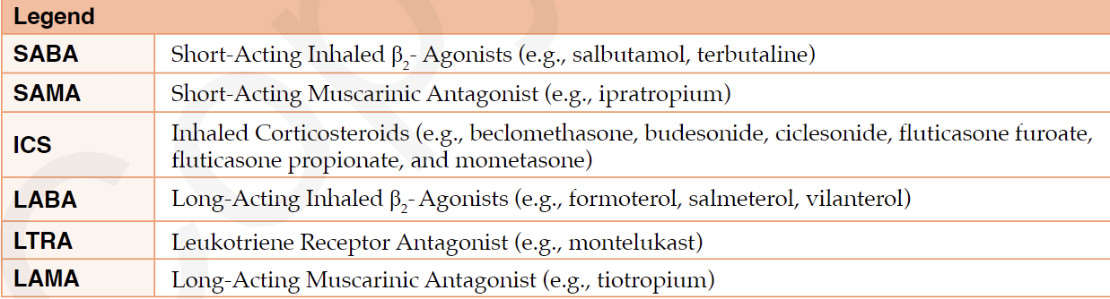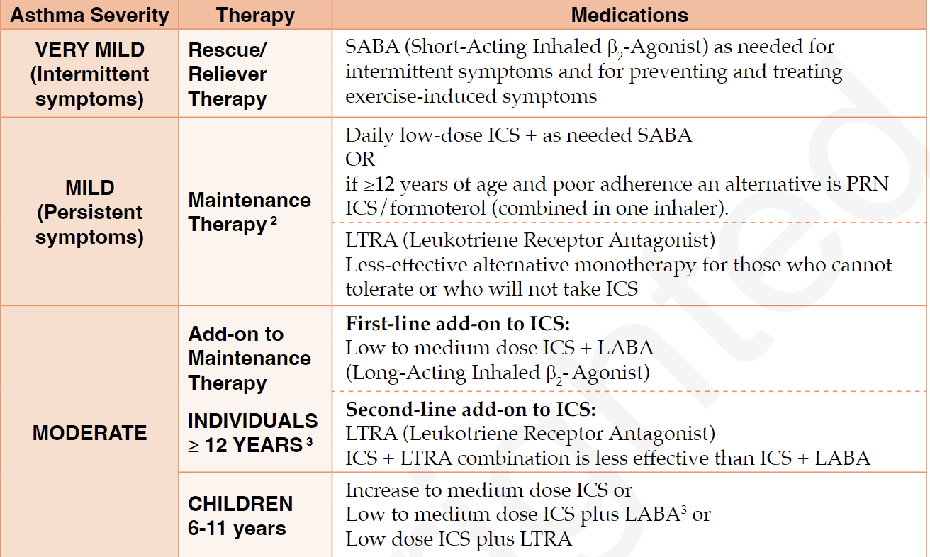  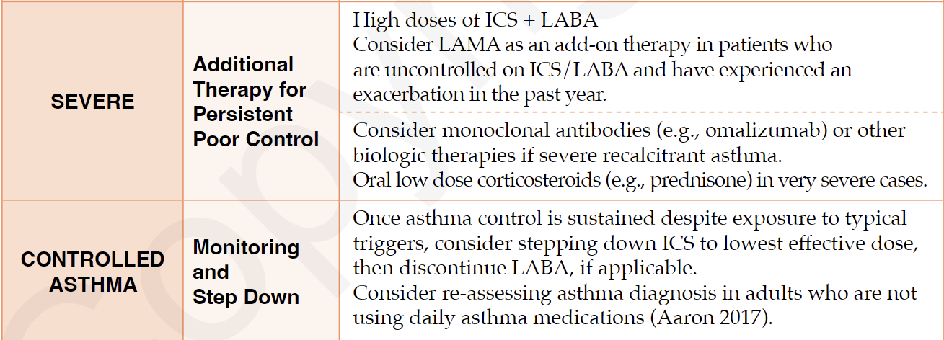
Non-pharmacological options | Prevention:  - Minimize exposure to allergens (e.g. environmental, medications etc.) and triggers (e.g. resp infections like colds/flus, tobacco, cannabis)  - Smoking cessation (asthma patients who smoke have poorer response to asthma meds and worse lung function)  - Immunization - important to get influenza and pneumococcal vaccines to reduce risk of influenza and pneumococcal disease complications  - Develop an asthma action plan - written plan for medication self-adjustment and should document med requirements for symptom relief
Education/counseling | - Proper inhaler technique (prime inhaler x4 sprays), recognizing and controlling triggers and allergens, how to recognize asthma exacerbations and when to seek medical tx  - Patients using MDI inhalers should be encouraged to use a spacer device to increase drug delivery to lungs and decrease need for hand-breath coordination and reduce local AEs (e.g. thrush)  - Decrease AEs (e.g. oral thrush) by using a spacer and rinsing mouth  - To prevent exercise induced symptoms, can prophylactically take 2 puffs of ventolin 15-30 min prior to exercise (1 puff if <12yo)
Pharmacological Therapy (RX Files)
Drug/Dose | Indication | Adverse fx (AE) and Drug interactions (DI) | Contraindications & special considerations
Step 1: Initial Therapy - choose 1 of the following 4 options. Individualize choice; may switch between options
Inhaled Corticosteroid Daily maintenance  - SABA PRN (rescue)  Low dose preferred (similar efficacy and fewer AEs)  E.g. Budesonide (Pulmicort) 100mcg daily  Other examples: Beclomethasone, fluticasone, mometasone | Preferred guideline choice for most patients  Provides superior asthma control compared to PRN ICS formoterol and better reduction in exacerbations compared to PRN SABA alone | AEs: oral thrush, hoarseness  DIs: 3A4 inhibitors may increase gluticasone, mometasone, and budesonide levels | Decrease AEs by using a spacer and rinsing mouth  Pregnancy: Budesonide preferred
ICS/Formoterol PRN  >12 yo only  I.e. Symbicort (budesonide/formoterol) | Useful if non-adherence to daily ICS since it only needs to be taken when symptomatic  No SABA as part of regimen so prevents risk of SABA overuse | AEs: Tremor | This is a type of ICS/LABA combo (Formoterol is a long-acting bronchodilator aka LABA)
Short-Acting Beta Agonist (SABA) PRN ALONE  E.g Salbutamol, terbutaline  From MUMS:  >12 yo: 1-2 inhalations Q4-6H PRN  4-11 yo: 1 inhalation Q4-6H PRN | Suitable if very mild asthma  (If reliever PRN use does not NOT exceed 2 doses/week and lower exacerbation risk) | AEs: tremor, tachycardia | Escalate to daily ICS if there’s a risk of asthma exacerbation (e.g. poorly controlled asthma, current smoker, hx of exacerbations) or overuse (>2 SABA refills/yr)
Montelukast Daily maintenance  - SABA PRN  E.g. Singulair | 2nd line tx option: Inferior to daily ICS for asthma control. Consider if CS nonadherence or if concomitant allergic rhinitis | AEs: HA
Step 2: Escalate Therapy R/A adherence, inhaler technique, environmental control, and comorbidities before escalating therapy
6-11 yo: increase to medium-dose ICS (e.g. Budesonide 400mcg [med dose] instead of 100mcg [low dose])
>12 yo: switch to ICS/LABA combo
Step 3: Escalate Therapy R/A adherence, inhaler technique, environmental control, and comorbidities before escalating therapy
6-11 yo: ICS/LABA combo
- Alternative: switch to ICS + montelukast
>12 yo: switch to triple therapy (LAMA + LABA + ICS)
- Alternative: add montelukast (either to ICS-LABA or to LAMA/LABA/ICS)
Step 4: Severe Asthma - refer to specialist, R/A adherence, inhaler technique etc.
Tx options: High-dose ICS + LABA
Consider adding LAMA (spiriva) in pts uncontrolled with ICS/LABA
Monoclonal antibodies for severe recalcitrant asthma
Oral corticosteroids for severe cases
Asthma Exacerbations
From RX Files:
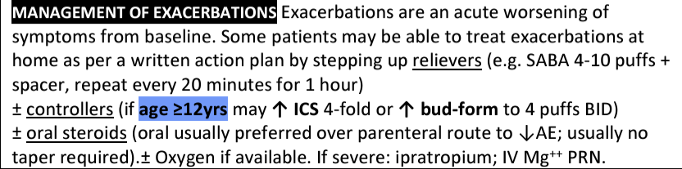
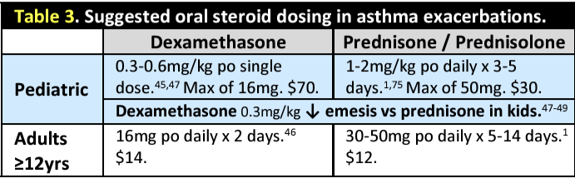
From MUMS: Asthma Exacerbations
- SABA for symptomatic relief Q4H; if needed more frequently seek medical attention
- Systemic corticosteroids for moderate-severe exacerbations or for those who fail to respond to a SABA
- Ipratropium (SAMA) may be added to SABA in moderate-to-severe exacerbations
- Oxygen PRN
Notes
Monitoring | - Assess symptom control over past 4 weeks and if asthma control not adequate, reassess compliance, inhaler technique, and procedures to eliminate allergens/triggers before modifying treatment  - Refilling a reliever more than twice/year is a flag for uncontrolled asthma
Referral | ED if exacerbation not relieved with ventolin
Other notes | Pregnancy- asthma is most common resp disorder complicating pregnancy and assoc. With adverse maternal and perinatal outcomes; asthma often worsens in pregnancy  - Pharm is the same  Clinical Pearls:  - Before adjusting therapy, check adherence, inhaler technique, environmental control, and comorbidities (~50% of pts non-adherent)  Escalating therapy: escalate tx as req. To achieve asthma control. Consider stepping down (e.g. decrease ICS dose by 25-50%) if pt stable >3 months to find lowest effective dose

Asthma Summerized
Severity | Symptoms | Medications | Additional Details
Very Mild (Intermittent) | Symptoms < 2 days/week, < 2 nights/month | SABA (Short-Acting Beta-Agonist) as needed for relief, such as salbutamol or albuterol. | - No regular daily medication needed.  - Used only when symptoms occur, e.g., exercise-induced symptoms.
Mild (Persistent) | Symptoms > 2 days/week, 3-4 nights/month | Low-dose ICS daily for inflammation control.  Consider LTRA as monotherapy if cannot tolerate ICS.  SABA as needed (PRN). | If ≥12 years of age and poor adherence an alternative is PRN ICS/formoterol (combined in 1 inhaler)
Moderate (Persistent) | Symptoms daily or every other day | - low-med dose ICS + LABA (combination for daily maintenance).  - low-med dose ICS+LTRA as second line but must be over 12 years.  - SABA as needed (PRN). | - LTRA is added only if pt is older than 12 years.  If 6-11 consider: increase to medium dose ISC, Low-med ISC+LABA or low dose ISC+LTRA
Severe (Persistent) | Continuous symptoms with frequent exacerbations | - High-dose ICS + LABA.  Add LAMA if symptoms are not controlled/exacerbation in past year.  Consider oral corticosteroids or monoclonal antibodies for further control.  SABA for acute symptoms. | - LAMA (Long-Acting Muscarinic Antagonist) is added to ICS + LABA for further bronchodilation in case of poor control.  - Biologic therapy or oral corticosteroids may be needed.
Controlled Asthma | Minimal symptoms, rare nighttime awakenings | Continue ICS or ICS + LABA at a lower dose.  Goal is to d/c LABA and have ISC+SABA as needed. | - When asthma is controlled, you may reduce medication doses over time to prevent over-treatment.  - Regular monitoring to avoid relapse.

COPD (MUMS Respiratory Guidelines & RX Files Meds)
Def’n | Chronic, progressive disorder characterized by partially reversible airway limitation, systemic manifestations, and increasing frequency and severity of exacerbations. Chronic bronchitis and emphysema both occur in COPD and both may be present in absence of airflow limitation and the dx of COPD. These terms should not be used to define and manage COPD.
Therapeutic goals | - Prevent further lung damage and disease progression (smoking cessation, immunization)  - Optimize current lung function and improve symptoms (education, pulm rehab, oxygen, surgical approaches)  - Long-term: reduce mortality, improve exercise tolerance and overall health status
Algorithm | 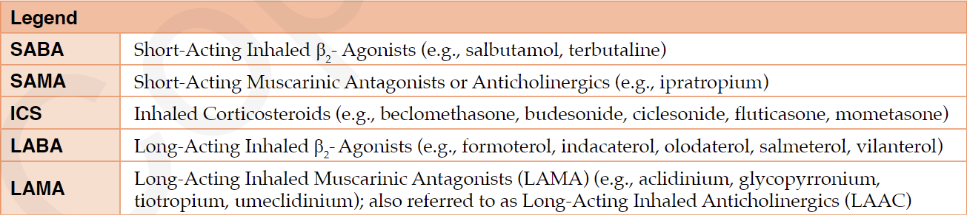  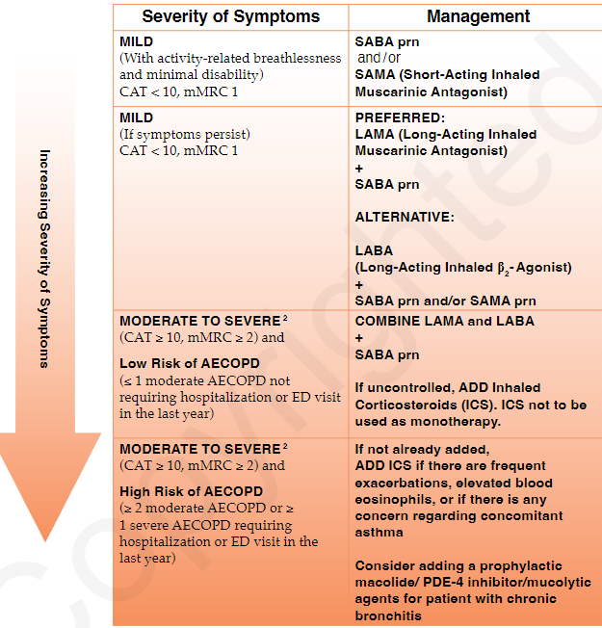  *Note: CAT score = COPD assessment test; it’s a 8-item pt questionnaire that measures impact of COPD on pt’s health status. Not actually in the guideline  MMRC = modified medical research council dyspnea scale; used to classify severity of COPD  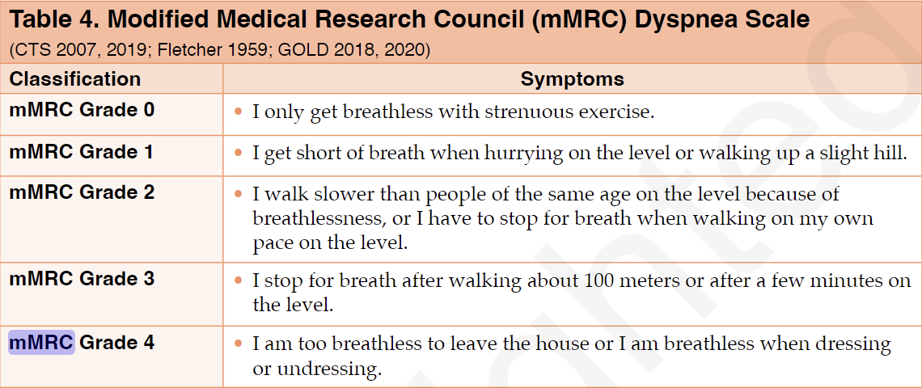
Non-pharmacological options | - Pulmonary rehabilitation (incl. Exercise training, psychosocial support, nutritional counseling)  - Exercise  - Education and case management  - Nutrition  - Psychosocial support  - Oxygen: long-term O2 therapy reduces mortality and increases life expectancy of COPD patient with chronic hypoxemia. Indications for long-term O2 incl:  - All pts with stable COPD on optimal doses of meds with PaO2 <55 or SaO2<88%  - COPD pts with PaO2 <60mmHg or SaO2 88-90% with concomitant bilat ankle edema, cor pulmonale, RT sided HF, pulm HTN, altered mentation  - NOT INDICATED FOR PTS UNWILLING TO STOP SMOKING  - Surgery to reduce lung volume or lung transplant
Education/counseling | - Proper inhaler techniques (50% unable to demonstrate proper inhaler technique - reassess at every visit)  - Adherence to meds (50% nonadherent)  - Smoking cessation  - Immunizations (to prevent exacerbations):  - Influenza annually  - Pneumococcal: all adults >65 yo
Pharmacological Therapy (RX Files)
Drug/Dose | Indication | Adverse fx (AE) and Drug interactions (DI) | Contraindications & special considerations
Step 1: Choose a short-acting bronchodilator (SAMA, SABA, or combo)
Short-acting muscarinic antagonist (SAMA)  i.e. Ipratropium (Atrovent)  40 mcg (2 puffs) TID-QID | Mild COPD or as PRN add-on to LAMAs/LABAs  Improves COPD symptoms but does not reduce exacerbations | AEs: same as LAMA; dry mouth, cough, constipation, urinary retention, HA | Anticholinergic - works by binding non-selectively to pulmonary muscarinic receptors, reducing smooth muscle contractions;
Short Acting Beta2 agonist (SABA)  Salbutamol 1-2 puffs QID PRN  Terbutaline 1 puff QID PRN |  | AEs: tremor, nervousness, tachycardia, QT prolongation, HA | Sympathomimetic - Binds to B2 pulm receptors, increasing cAMP to relax bronchial smooth muscle
Combo SABA + SAMA

Combivent (Ipratropium + salbutamol) 1 puff QID PRN
Step 2: Long-acting bronchodilator (LAMA or LABA - both are first line but often LAMAs are used first)
Long Acting Muscarinic Antagonist (LAMA)  E.g. Tiotropium respimat 2 puffs daily | Mod-severe COPD or use after SABA +/- SAMA failure  Reduces exacerbations. | AEs: same as SAMA; dry mouth, cough, constipation, urinary retention, HA | Anticholinergic -same mechanism as SAMAs but slower to dissociate from M3 receptors, making it last longer
Long Acting Beta Agonist (LABA)  E.g. Formoterol turbuhaler 6-12 mcg inhaled BID |  |  | Sympathomimetic - same mechanism as SABAs but slower to dissociate from pulm receptors, making it last longer
Step 3: Dual Therapy (LAMA + LABA) - e.g. Duaklir, inspiolto
Step 4: Triple Therapy (LAMA + LABA/ICS)
Combo Inhaled corticosteroid (ICS)/LABA  Symbicort (Budesonide/ Formoterol) turbuhaler 2 puffs BID  Advair  (Fluticasone/Salmeterol) 1 puff BID | ICS typically added last in COPD d/t AEs  Ensure pt is also on a LAMA for triple therapy | Inhaled Corticosteroids AE: pneumonia risk, fractures
Notes
Monitoring | Escale therapy PRN to control symptoms and exacerbations but always check inhaler technique first
Referral | Severe AECOPD
Other notes | From MUMS:  Oral Corticosteroids - long term use not recommended d/t AE; only required for acute exacerbations  Inhaled corticosteroids (ICS)- not recommended as monotherapy; typically added last due to AEs (increased PNA risk, fractures). In pts with FEV1<60%, regular tx improves symptoms, lung function, quality of life, and frequency of exacerbations - consider for patients with more advanced COPD who have 2+ exacerbations/year despite LABA/LAMA therapy

Acute Bronchitis
Def’n | 90% of acute bronchitis is viral; all children cases are viral
Algorithm | Rule out pneumonia (abnormal VS, chest examination)  Children: if child is breathless and/or experiencing tachypnea consider pneumonia
Non-pharmacological options | Prevention: reduction of risk factors (smoking cessation and avoidance of second hand smoke)  Increase hydration and humidity for cough management
Education/counseling | Cough lasts 1-3 wks and can be with or without phlegm  Corticosteroid NOT recommended  No lozenges, no cough suppression
VIRAL DO NOT GIVE ABX for CHILD or ADULT
Drug/Dose | Indication | Adverse fx (AE) and Drug interactions (DI) | Contraindications & special considerations
Antitussive | Cough Suppression
Inhaled Bronchodilators | Cough, wheeze, airflow obstruction
Notes
Other notes | Cough and cold medications not recommended in pediatric population

Acute Exacerbations of Chronic Bronchitis or COPD
Def’n | Worsening of baseline symptoms (cough, sputum and dyspnea)
Therapeutic goals | -symptom relief, prevent loss of function that would lead to hospitalization  Pharmacological Goals:  - Decrease work of breathing (bronchodilators)  - Reduce airway inflammation (short term course systemic corticosteroid)  - Reduce bacteria in lower airways (abx therapy)  - Treat any accompanying hypoxemia (oxygen therapy)
Algorithm | If have at least 2 of these increased symptoms would benefit from abx:  - dyspnea  - Sputum volume  - Sputum purulence  COPD patient with green sputum and increased dyspnea or cough should get abx  50% of AEs are noninfectious (exposure to allergen/ irritants)
Non-pharmacological options | -remove from irritants (dust, pollutants, first and second hand smoke)  -Spirometry (done during exacerbation free periods for baseline) is good measure of exacerbation and treatment response  -adequate hydration
Education/counseling | Smoking cessation  Appropriate doses of bronchodilators  Prevention of AEs is critical component of management  Low dose theophylline, expectorant or cough suppression agents have no benefit  Influenza and pneumococcal vaccinations once recovered
Pharmacological Therapy **relapse within 3 months requires alternative class**
Mild/Moderate exacerbation duration 5 days
Severe exacerbation duration 7-10 days
Drug/Dose | Indication | Adverse fx (AE) and Drug interactions (DI) | Contraindications & special considerations
Simple Low Risk Patients: CB-mild to moderate impairment of lung function (FEV1>50% predicted), 3 or less AE/year, no significant cardiac disease
1st:
Amoxicillin 500mg TID
Doxycycline 100mg BID first day then 100mg daily
2nd:
Clarithromycin 500mg BID
Complicated High Risk Patients: poor underlying lung function FEV1<50% and significant cardiac disease and/or 4 + exacerbations per year; OR use supplemental O2, chronic use of oral steroid, abx use in past 3 months
1st: Amoxi/Clav 500mg TID or 875mg BID
2nd:
Levofloxacin 500mg daily x7D OR 750mg daily x5D
****RESERVED FOR SEVERE
P. aeruginosa risk (very poor underlying lung function (FEV1 <35% predicted), or multiple risk factors including frequent exacerbations, chronic oral steroid use
Ciprofloxacin 500-750mg BID
Moderate to Severe exacerbation COPD (in outpatients and hospitalized)
As per Gillian add if: SpO2<95%, decreased A/E, SOBOE, maxing out inhalers
Systemic oral corticosteroid: Prednisone 25-50mg daily x7-10D OR 40 mg daily x5D (only need to taper if on longer than 2 week duration as per Gillian)

Pneumonia-Adult
Def’n | Pneumonia caused by S. pneumoniae H. influenzae Gram -ve bacilli S. aureus Legionella spp. C. pneumoniae
Therapeutic goals | N/A
Algorithm | N/A
Non-pharmacological options
Education/counseling
Pharmacological Therapy
Drug/Dose | Indication | Adverse fx (AE) and Drug interactions (DI) | Contraindications & special considerations
Outpatient WITHOUT comorbidities/modifying factors
1st Line Therapies
Amoxicillin 1 g TID for 5-14 days |  | AEs:  DIs:
2nd Line Therapies
Doxy 100 mg BID for 5-14 days

Azithromycin 500 mg daily on first day then 250 mg daily x 4 days or 500 mg daily x 3 day
Clarithromycin 500 mg BID or 1000 mg (extended release) once daily for 5-14 days

Outpatient WITH comorbidities/modifying factors
1st Line Therapies
Amoxicillin/ Clavulanate 500 mg TID or 875 mg BID for 5-14 days  * effective against 90-95% of S. pneumoniae and may be considered for patients over 50 years, where Mycoplasma infection is less likely.* | USE ANYONE OF THESE 3 BETA LACTAM AGENTS PLUS ONE OF THE FOLLOWING → | Doxycycline 100 mg BID | *Consider a macrolide for suspected atypical organisms (e.g., Legionella) or severe penicillin allergy. Resistance to clarithromycin was 23% in 2015. The risk of resistance is higher with longer-acting macrolides like azithromycin.*  *Fluoroquinolones should be reserved for treatment failures, comorbidities with recent antibiotic use, or highly drug-resistant pneumococcal or Legionella infections, due to concerns about resistance and C. difficile-associated disease.*
Cefuroxime 500 mg BID for 5-14 days |  | Azithromycin 4 500 mg daily on first day then 250 mg daily x 4 days
Cefprozil 500 mg BID for 5-14 days |  | Clarithromycin 500 mg BID or 1000 mg (extended release) once daily
2nd Line Therapies
Levofloxacin 5 750 mg once daily x 5 day**
Moxifloxacin 5 400 mg once daily for 5-14 days
Notes
Notes | - The CRB-65 score can guide hospitalization decisions for patients based on confusion, respiratory rate, blood pressure, and age. A score of 3+ requires urgent admission; a score of 0-1 suggests home treatment may be appropriate.  - Routine Cultures: Routine sputum and blood cultures are not recommended unless there is severe disease or treatment for MRSA or Pseudomonas aeruginosa is involved.  - Fluoroquinolones should be reserved for treatment failures or when other risk factors (e.g., recent antibiotic use, allergies) are present due to concerns about resistance and C. difficile.  - Macrolide Resistance: Resistance in S. pneumoniae in Canada has increased, and the risk is higher with longer-acting macrolides like azithromycin.  - Review antibiotic history within the past 3 months and consider selecting a different class if there's significant exposure. In regions with high macrolide-resistant S. pneumoniae (>25%), alternative agents should be considered even in patients without comorbidities.  - Therapy lasts 5-14 days, but shorter courses (minimum 5 days) are equally effective in ambulatory patients. Patients should be afebrile and clinically stable for 48-72 hours before discontinuing therapy. Azithromycin 500 mg may be used for 3 days in certain outpatients.  - Comorbidities/Modifying Factors: Conditions like recent hospitalization, chronic disease (heart, lung, liver, renal), diabetes, malignancies, asplenia, immunosuppression, and age >65 years should guide treatment decisions. Do not routinely offer a glucocorticosteroid to patients with CAP unless they have other conditions for which glucocorticosteroid treatment is indicated (  - Macrolide Use: Consider a macrolide for suspected atypical organisms (e.g., Legionella) or severe penicillin allergy. Resistance to clarithromycin was 23% in 2015. The risk of resistance is higher with longer-acting macrolides like azithromycin.  - Aspiration Pneumonia: Consider aspiration pneumonia in patients with swallowing difficulties or impaired consciousness. Treatment typically involves amoxicillin or amoxicillin/clavulanate. Routine anaerobic coverage is not recommended unless there are high-risk features (e.g., dental disease, putrid sputum, or suspected lung abscess/empyema).

Pneumonia- Long-Term Care: Mild to Moderate
Def’n | Pneumonia caused by S. pneumoniae H. influenzae Gram -ve bacilli S. aureus Legionella spp. C. pneumoniae
Pharmacological Therapy
Drug/Dose | Indication | Adverse fx (AE) and Drug interactions (DI) | Contraindications & special considerations
1st Line Therapies
Amoxicillin 1 g TID for 5-8 days | USE ANYONE OF THESE BETA LACTAM MEDICATIONS PLUS ONE OF THE FOLLOWING → | Doxycycline 100 mg BID
Amoxicillin/ Clavulanate 500 mg TID or 875 mg BID for 5-8 days |  | Azithromycin 4 500 mg daily on first day then 250 mg daily x 4 days
Cefuroxime 500 mg BID for 5-8 days |  | Clarithromycin 4 500 mg BID or 1000 mg (extended release) once daily
Cefprozil 500 mg BID for 5-8 days
2nd Line Therapies
Levofloxacin 750 mg once daily x 5 days
Moxifloxacin 400 mg once daily for 5-8 days
Notes
Notes | Antibiotic Duration in Nursing Home Patients: Pneumonia in nursing home patients should be treated for 5-8 days. Treatment duration may need to be extended in cases of poor clinical response, medical instability, or infection with Pseudomonas aeruginosa. Broader antibiotic coverage is reserved for severe illness or multidrug-resistant pathogen risks.  Risk of Fluoroquinolone Resistance: Patients from nursing homes or those with recent hospital exposure have a higher likelihood of infection with fluoroquinolone-resistant pathogens. Fluoroquinolone monotherapy is not recommended in regions where there is significant resistance (e.g., 4% resistance to levofloxacin in nursing home residents with pneumococcal disease).  Macrolide Use for Atypical Organisms: A macrolide can be considered for suspected atypical organisms (e.g., Legionella) or in patients with severe penicillin allergy. S. pneumoniae resistance to clarithromycin was 23% in 2015. Resistance is more likely with longer-acting macrolides, such as azithromycin.  Higher Risk with Azithromycin Use: Previous use of azithromycin carries a higher risk of resistance compared to other macrolides, making it important to consider this when selecting treatment options.

Pneumonia- Adult: Requiring Hospitalization (non-ICU)
Def’n
Therapeutic goals
Algorithm | When determining whether to hospitalize a patient with community-acquired pneumonia (CAP), severity of illness scores can be used to identify those who may be suitable for outpatient treatment. Common criteria used in this decision include:  - The CRB-65 or PSI/PORT score help quantify the severity of illness. CRB-65 is a simplified version that evaluates:  - Confusion (new onset disorientation),  - Respiratory rate (≥ 30 breaths per minute),  - Blood pressure (SBP < 90 mmHg or DBP < 60 mmHg),  - Age (≥ 65 years).  - Score Interpretation:  - CRB-65 Score ≥ 3: Urgent hospitalization is recommended due to a higher risk of mortality.  - CRB-65 Score of 2: A same-day assessment in secondary care is advised to determine the best course of action.  - CRB-65 Score of 0-1: Outpatient treatment may be appropriate based on clinical judgment and available support.  - Supplement with Subjective Factors: In addition to the severity score, consider:  - The patient's reliability to take oral medications,  - The availability of outpatient support (e.g., access to healthcare, caregiver assistance, proximity to hospital),  - Any social circumstances that could impact care (e.g., living situation, cognitive or physical ability).
Non-pharmacological options
Education/counseling
Pharmacological Therapy
Drug/Dose | Indication | Adverse fx (AE) and Drug interactions (DI) | Contraindications & special considerations
PATIENT ON MEDICAL WARD (Community-acquired or Long-Term Care)
1st Line Therapies
Cefotaxime IV 1-2 g q8h | USE ANYONE OF THESE BETA LACTAM MEDICATIONS PLUS ONE OF THE FOLLOWING → | Doxycycline 100mg PO/IV q12h
Ceftriaxone IV 1-2 g q24h |  | Azithromycin 500mg PO/IV q24h
 |  | Clarithromycin 500mg PO/IV q12h
2nd Line Therapies
Levofloxacin PO/IV 3 750mg PO/IV q24h
Moxifloxacin PO/IV 3 400mg PO/IV q24h
Notes
Notes | - CRB-65 Severity Score: This score helps determine the need for hospitalization based on the following criteria: confusion, respiratory rate (≥ 30 breaths/min), low blood pressure (< 90 SBP or < 60 DBP), and age ≥ 65 years.  - Score ≥ 3: Urgent admission required.  - Score 2: Same-day secondary care assessment needed.  - Score 0-1: Home treatment may be appropriate, depending on clinical judgment and support availability.  - Hospitalized Patients & Oral Antibiotics: Patients who are hemodynamically stable, have a functioning GI tract, and can tolerate oral medications can be treated with oral antibiotics. Step-down from IV to oral therapy should be considered when possible. Avoid glucocorticosteroids unless specifically indicated.  - Fluoroquinolone Resistance in Nursing Home Patients: Nursing home residents or those with recent hospital exposure are at higher risk of fluoroquinolone-resistant pathogens. Fluoroquinolones should be reserved for severe β-lactam allergies.  - Antiviral Therapy: Antiviral treatment (e.g., oseltamivir) is recommended for CAP patients testing positive for influenza, especially in hospitalized individuals, regardless of the illness duration before diagnosis.

Pneumonia- Children: Outpatients & Hospitalized
Def’n
Therapeutic goals
Algorithm
Non-pharmacological options
Education/counseling
Pharmacological Therapy
Drug/Dose | Indication | Adverse fx (AE) and Drug interactions (DI) | Contraindications & special considerations
OUTPATIENT
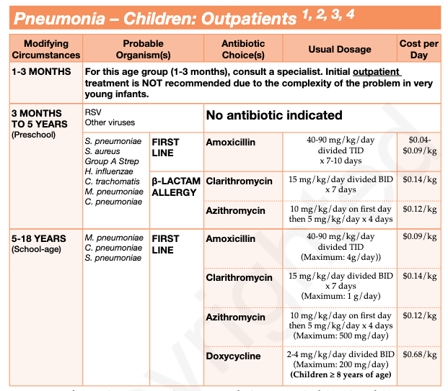
HOSPITALIZED
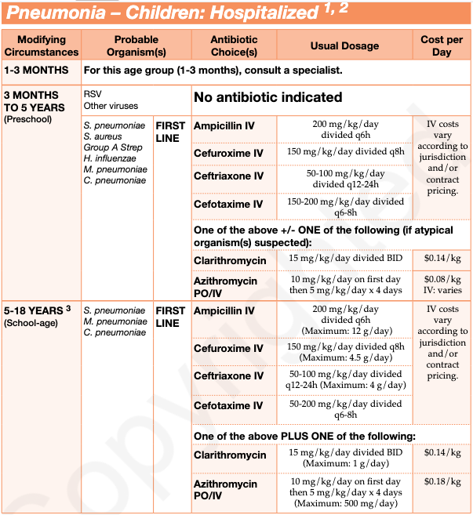
Notes
Monitoring | Under 5 years: viruses are the most common cause  Between 3months-18 years: If bacterial Streptococcus pneumoniae is the leading bacterial, with Haemophilus influenzae type b becoming less common due to widespread vaccination.  If over 5 years of age, Mycoplasma pneumoniae and Chlamydia pneumoniae should be considered, especially when clinical presentation suggests atypical pneumonia. In these cases, macrolide antibiotics are often recommended.  - Viral vs. Bacterial Pneumonia: Viral pneumonia tends to have a more gradual improvement, while bacterial pneumonia typically shows clinical improvement within 48 hours of treatment. If non-severe bacterial pneumonia, 5-day course of abx is needed, while hospitalized children usually require 7-10 days of treatment.  - Hospitalization Criteria: While most pediatric cases of pneumonia can be managed in an outpatient setting, infants under 6 months may require hospital admission due to the need for more supportive care.  - Hospitalization is recommended for children with pneumonia if they are:  - Less than one month old.  - Presenting with a toxic appearance.  - Showing signs of severe respiratory distress or compromise (grunting, nasal flaring, apnea, hypoxemia).  - Dehydrated or vomiting with inadequate oral intake.  - Unresponsive or intolerant to oral antimicrobial therapy.  - Immunocompromised.  - Chest Radiography: Routine chest X-rays are discouraged in children with wheezing but without fever, as radiography in these cases may not be clinically useful.  - Antibiotic Use: When selecting antibiotics, review any antibiotics prescribed in the previous 3 months. If a child has been exposed to a particular class of antibiotics, it’s important to consider an alternative class to reduce resistance.****  - Add vancomycin or linezolid to the antibiotic regimen if MRSA is suspected.  - If influenza is suspected, consider prompt treatment with neuraminidase inhibitors (e.g., oseltamivir, zanamivir). Antiviral treatment is beneficial, especially in hospitalized or moderately to severely ill children, and may prevent secondary bacterial infections.
Referral
Other notes

Pneumonia- Community Acquired
Education/counseling | -Review abx history and if use in previous 3 months choose different class  -for aspiration pneumonia amoxicillin or amoxi/clav  -consider macrolide for atypical organisms (ie. azithromycin)  -Do not offer glucocorticosteroid treatment
Pharmacological Therapy
Patients should be treated for a minimum of 5 days, be
afebrile for 48-72 hours, and otherwise clinically stable before discontinuing therapy, can go up to 14 days
Drug/Dose | Indication | Adverse fx (AE) and Drug interactions (DI) | Contraindications & special considerations
Outpatient WITHOUT comorbidities/modifying factors (hospitalization last 3 months and/or chronic heart, lung, liver or renal disease, DM, alcoholism, malignancies, immunosuppression, >65yo)
1st: Amoxicillin 1g TID
2nd: Doxycycline 100mg BID
Outpatient WITH comorbidities/modifying factors (hospitalization last 3 months and/or chronic heart, lung, liver or renal disease, DM, alcoholism, malignancies, immunosuppression, >65yo)
1st: Amoxi/Clav 500mg TID or 875mg BID
PLUS
Doxycycline 100mg BID
2nd: Levofloxacin 750mg x5D

Asthma & COPD Inhalational Devices
Device | Description | Pros | Cons
MDI (Metered Dose Inhaler)  (ex. Flovent, ventolin, Qvar)  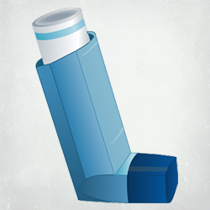 | Delivers aerosolized medication as a fast spray (~0.2 sec). | - Suitable for all ages  - Can be used with spacers for children or elderly  - Can be used with mechanical ventilation (in ICU)  -Low inspiratory flow ≈ 20L/min required | - Requires coordination of hand and breath  - Needs a spacer for better use  - Contains greenhouse gases  -NO dose counter  -Requires priming (will waste some doses).
Respimat  (ex. Spiriva, combivent)  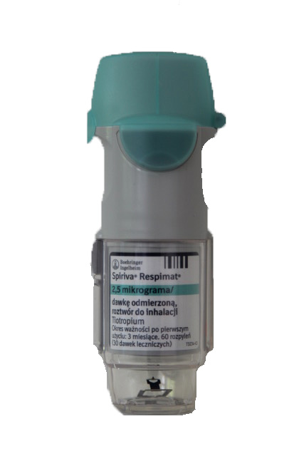 | Uses a spring to deliver a slower mist (~1.5 sec). | - Slower mist is easier to inhale  - Dose counter for monitoring doses  -Low inspiratory flow ≈ 20L/min required | - Requires priming and strength to use  - Not approved for children  -Incorrect rate of inhalation may result in cough
Handihaler / Breezhaler / Aerolizer  (ex. spiriva)  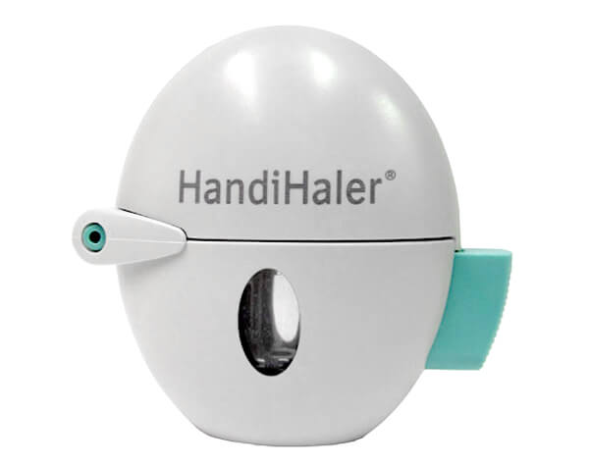 | Capsules are pierced, releasing powder that is inhaled. | - No hand-breath coordination required  - Dose counter for each capsule  - No priming needed  -Rattling or whirring is heard if the capsule's contents are inhaled correctly. Can look to view empty capsules  -Low inspiratory effort needed | - Multi-step loading process and needs dexterity to load (not food for arthritis/Parkinsons)  - Capsules can be swallowed by accident or inhaled if periced more than once
Turbuhaler  (i.e. pulmicort, symbicort)  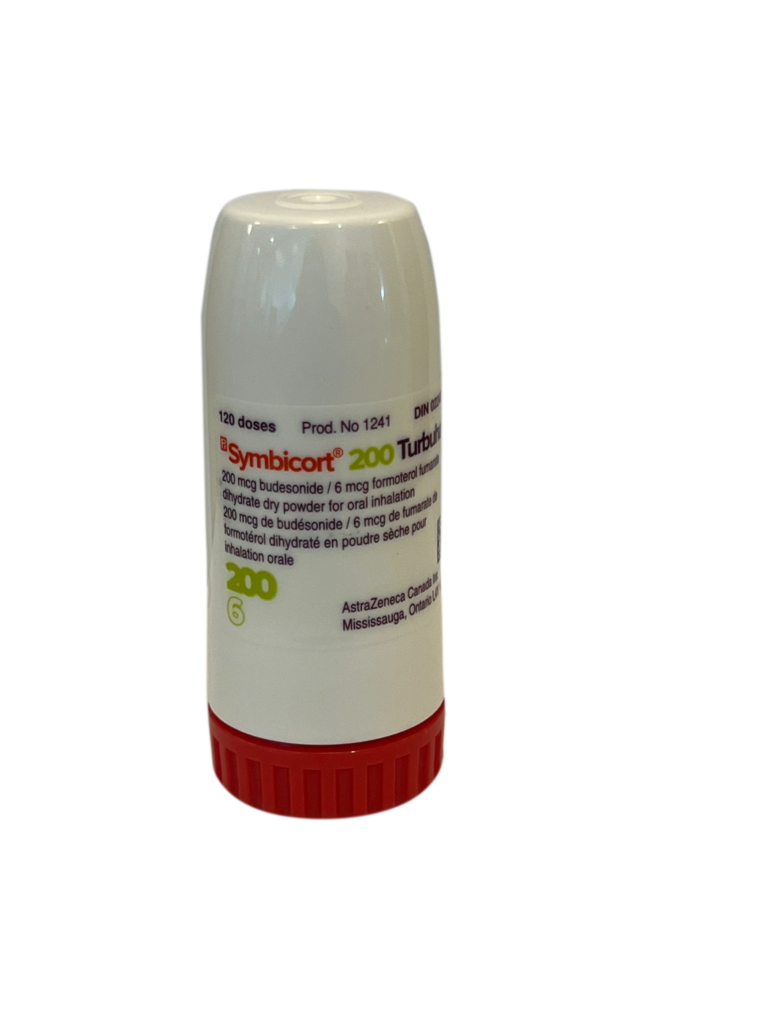 | Dry powder inhaler with a reservoir inside. | - One step to open & load  - Breath-actuated (reduces hand-breath coordination)  - Dose counter (every 2nd dose numbered)  -Dose is not lost when twisted multiple times  -Red mark when empty | - Requires high inspiratory flow  - Dose counter may not show all doses  -When empty, remaining desiccant can still be heard - pts may think there are doses left -Humidity/moisture (e.g. exhaling into device, storing in bathroom) can clump drug in reservoir  -Requires sharp, forceful inhalation of breath (not effective if < 5 years old, or some COPD patients with severe symptoms)  -Require high flow rates. -Tipping device before inhalation (e.g. upside down) can lose the dose
RespiClick  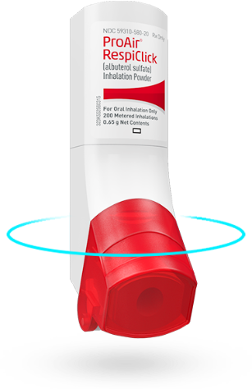 | Breath-actuated dry powder inhaler. | - Simple one-step use  - Dose counter available  - No need for high inspiratory flow  -The dose counter turns red with 20 doses left  -High rate of correct use after one instruction. | - Requires full opening to load the dose  - Device may expire after a month of opening  -Requires sharp, forceful inhalation of breath (not effective if < 5 years old, or some COPD patients with severe symptoms)  -Require high flow rates. -Tipping device before inhalation (e.g. upside down) can lose the dose
Twisthaler  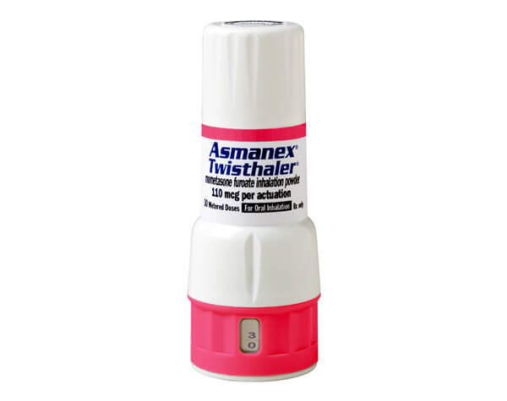 | Breath-actuated dry powder inhaler with a reservoir. | - Clear dose counter  - Locks when empty  - One-step to load dose | - Requires high inspiratory flow  - Device must be closed properly to load next dose (must hear an audible "click")  -Requires sharp, forceful inhalation of breath (not effective if < 5 years old, or some COPD patients with severe symptoms)  -Require high flow rates. -Tipping device before inhalation (e.g. upside down) can lose the dose
Diskus / Inhub  (ex. Flovent, ventolin)  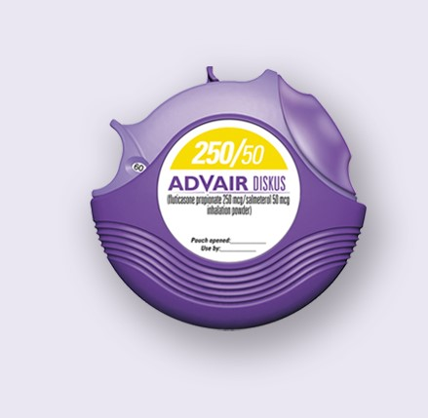 | Dry powder inhaler with single-dose blister packs. | - Simple to use, one-button press to load dose  - Clear dose counter | - May be difficult for patients with low inspiratory flow  - Expire faster once opened  -Requires sharp, forceful inhalation of breath (not effective if < 5 years old, or some COPD patients with severe symptoms)  -Require high flow rates. -Tipping device before inhalation (e.g. upside down) can lose the dose
Genuair  (ex. Tudorza)  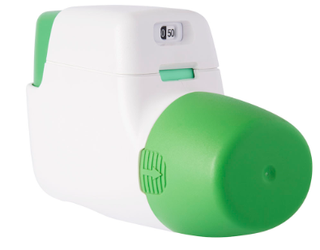 | Breath-actuated dry powder inhaler. | - Clear visual (color change) and auditory (click) confirmation  - Dose counter available  -One button press to load dose  -Every 10th dose is numbered | -Some patients may experience a bitter taste with aclidinium  -Requires sharp, forceful inhalation of breath (not effective if < 5 years old, or some COPD patients with severe symptoms)  -Require high flow rates. -Tipping device before inhalation (e.g. upside down) can lose the dose
Ellipta  (ex. Breo, incruse, trelegy)  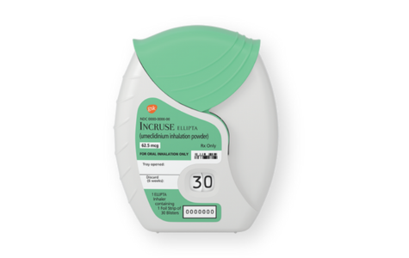 | Dry powder inhaler with blister doses. | - Large dose counter  - One-step use, no complex loading  - Suitable for most patients  -Most people prefer this one  -Dose counter with remaining doses in large numbers | - Short expiration after opening (6 weeks)  - Must hear an audible click to confirm dose loading  -Requires sharp, forceful inhalation of breath (not effective if < 5 years old, or some COPD patients with severe symptoms)  -Require high flow rates. -Tipping device before inhalation (e.g. upside down) can lose the dose
Summary:
- MDI: Requires hand-breath coordination but is versatile for all ages.
- Respimat: Slower mist with easier inhalation but requires priming.
- Handihaler: No coordination needed but has a complex loading process.
- Turbuhaler: Breath-actuated but requires high inspiratory flow.
- RespiClick: Simple one-step activation with dose counter, but needs full opening.
- Twisthaler: Easy to use but high flow required.
- Diskus/Inhub: Easy one-button press, but not suitable for patients with low breath strength.
- Genuair: Visual and audible feedback, but requires full dose loading.
- Ellipta: Very simple, large dose counter, but has a shorter expiry after opening.
Notes from Class: MDI better for children, DPI better for adults as requires coordination of breathing/following instructions; DPI better for environment

Canadian Tuberculosis Standards 8th Edition
Chapter 5: Treatment of TB- principles of drug therapy in TB disease & therapeutic regimens for drug-susceptible disease
Chapter 6: TB preventive tx in adults- Table 1: summary of recommended tx for latent TB infx
Chapter 9: table 4
Algorithm | 1.2 Principles of Drug Therapy in TB DIsease  First-line drug therapy:  - Drug therapy in TB is given in 2 phases:  - Intensive phase (2 months)- 3 or 4 drugs used in combo to rapidly kill TB organisms and prevent selection of drug-resistant organisms  - Frequency: daily dosing  - Continuation phase - minimum of 2 effective drugs are used and tx duration varies depending on the drug regimen, adherence, and risk of relapse  - Frequency: can be intermittent (thrice weekly) in select circumstances under directly observed therapy but daily dosing still preferred when possible
Education/counseling | Why multidrug therapy? TB disease includes a large number of TB bacilli and drug resistance to any individual drug is likely; However resistance to 3 drugs is highly unlikely which is why do this
Pharmacological Therapy
Drug/Dose | Indication |  | AEs
Standard 6 Month Treatment Regimen for SUSPECTED Drug Susceptible TB
Isoniazid  Adult: 5mg/g  Peds: 10mg/kg  (max 300mg) | Step 1: Initial Phase  Take these 4 drugs daily for 2 months | Step 2: Continuation Phase  Take these 3 drugs daily for 4 months | AEs:Mild liver transaminase elevation, hepatitis, gastritis, peripheral neuropathy, hypersensitivity
Rifampin  Adult: 10mg/kg  Peds: 15 mg/kg  (max 600 mg for peds, no max for adults) | Step 1: Initial Phase  Take these 4 drugs daily for 2 months |  | AEs:Orange discoloration of secretions, vomiting, hepatitis, flu-like illness
Ethambutol  Adult: 15mg/kg  Peds: 20mg/kg  (max dose 1600mg) | Step 1: Initial Phase  Take these 4 drugs daily for 2 months |  | AEs:GI disturbance, optic neuritis with decreased visual acuity and decreased red-green color discrimination
Pyrazinamide  Peds: 35 mg/kg (max 2g) | Step 1: Initial Phase  Take these 4 drugs daily for 2 months |  | AEs:hepatotoxicity, hyperuricemia, arthralgia
Standard 6 Month Treatment Regimen for KNOWN drug susceptible TB
Isoniazid | Step 1: Initial Phase  Take these 3 drugs daily for 2 months | Step 2: Continuation Phase  Take these 2 drugs daily for 4 months
Rifampin | Step 1: Initial Phase  Take these 3 drugs daily for 2 months
Pyrazinamide | Step 1: Initial Phase  Take these 3 drugs daily for 2 months
Treatment Regimens for LATENT TB infection
Isoniazid 15mg/kg (max 900mg)  AND  Rifapentine  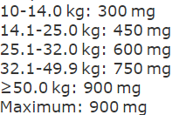  Once weekly x12 weeks (12 doses) | 1st Line Regimens:  A. Isoniazid and rifapentin  Or  B. rifampin alone
Rifampin alone 10mg/kg (max 600mg)

Daily x4 months (120 doses)
Izoniazid 5mg/kg (max 300mg)  Daily x9 months (270 doses) | 2nd Line Regimen
Notes
Referral | Use of adjunctive corticosteroids - requires consultation with a TB expert
Other notes | Intermittent therapy (regimens that include doses taken 3 times per week) should only be used in combination with direct observed therapy (DOT). If self-administered, intermittent therapy should not be used and drugs should be administered daily.

Week 9: GI

Constipation
Def’n | Unsatisfactory defecation d/t infrequent stools +/- difficult or incomplete stool passage; subjective and symptom based.  Types of constipation:  Primary Constipation:  - Normal transit (~60%): normal frequency but stool is hard or difficult to pass  - Mgmt: lifestyle & laxatives  - Pelvic floor dysfunction (~25%): pelvic floor or external anal sphincter cannot relax - may be accompanied with anal fissures and/or hemorrhoids  - Mgmt: pelvic floor retraining; suppositories or enemas may be preferred over laxatives  - Slow transit (~15%): infrequent bowel movements  - Mgmt: lifestyle and laxatives  Can have both pelvic floor and slow transit  Secondary constipation -  - Meds (NSAIDs, opioids, anticholinergics like antipsychotics, anticonvulsants, antidepressants etc.)  - Diseases or conditions (cancers, endocrine, GI, neurologic, psychologic)  - Decrease dose or switch to another agent  - Manage reversible causes
Therapeutic goals | Chronic constipation - goal is regular BM after 1 month of tx  Opioid use - goal is a BM at least Q3 days
Algorithm | 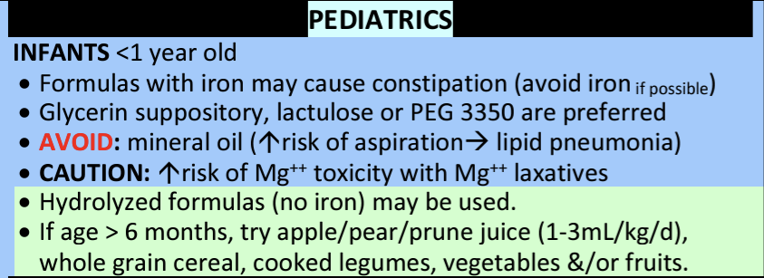  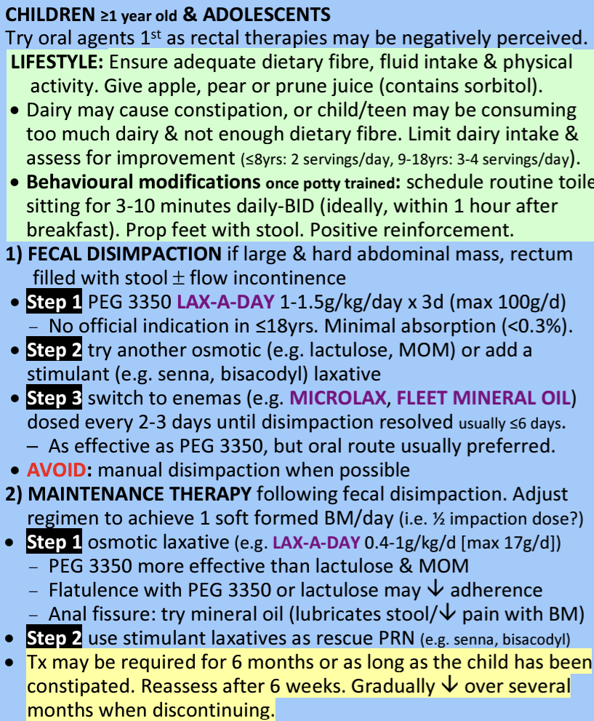  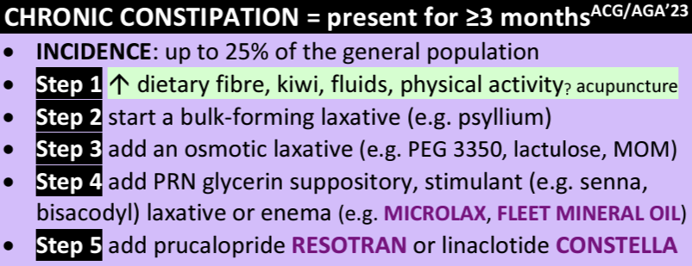  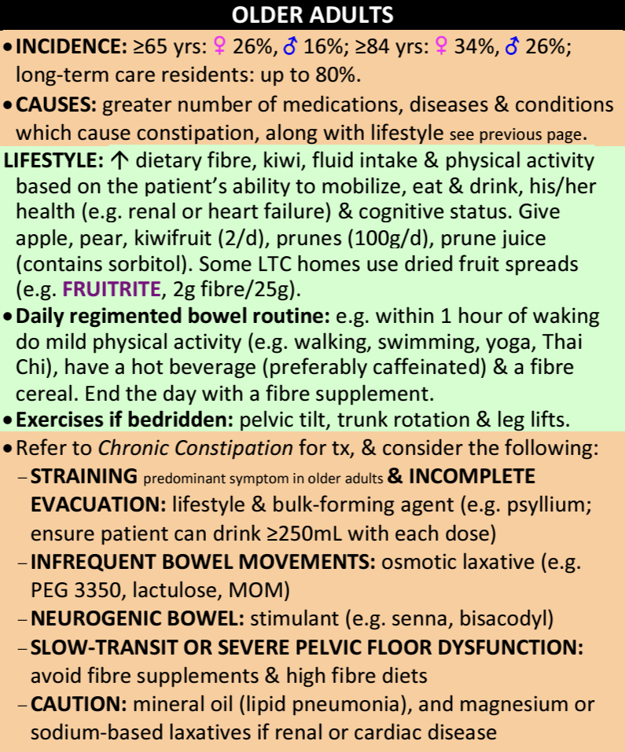  OPIOID INDUCED CONSTIPATION (Case Study)  - Constipation is 2nd most common opioid AE and for cancer patients, it's the most common opioid AE (incidence up to 90%)  - Goal: non-forced BM Q3 days but individualize  Step 1: Prevention  - Start a stimulant laxative +/- stool softener when an opioid is started (e.g. Senna 1-2 tab PO HS)  - Increase dietary fibre, fluid intake, and physical activity  Step 2: Treatment:  - If no BM after 3 d, treat  - Increase dose of preventative laxative until max dose achieved or admin. Is no longer practical  OR  - Add an osmotic laxative (e.g. PEG, lactulose)  Step 3: If no success, R/O fecal impaction & bowel obstruction  - R/A potential causes & treat if reversible  - Try rectal therapies (suppository, enema, manual disimpaction) AND adjust scheduled laxative regimen by increasing dose(s) +/- adding a scheduled laxative with a different mechanism of action  - NOTE: avoid bulk forming laxatives in cancer/palliative patients if fluid intake is low and rectal manipulation if thrombocytopenic or neutropenic d/t bleeding and infx risks  Step 4: if mod-severe constipation persists:  - Non-cancer: Consider naloxegol  - Palliative: add methylnaltrexone (Relistor)  - These are both opioid receptor antagonists
Non-pharmacological options/Education | - 3 F’s: Fibre, Fluid, Fitness (Increase fibre intake by 5g/week to minimize bloating/flatulence- recommended daily intake is 20-35g; ensure adequate hydration; physical activity)  - Implement a regular toileting routine (dedicate and allow time for BMs, don’t ignore urge to defecate)  - Travelling: constipation more common than diarrhea d/t dehydration, altered diet, less activity
Pharmacological Therapy
Class of Agent | (Generic& Trade names) | Mechanism of Action | AE, CI, Precautions | Admin Instructions/Dose
Bulk-forming Agents  Onset: 12-72 h | Psyllium (metamucil  Inulin (Benefibre)  Guar Gum (Benefibre)  Calcium Polycarbophil (Prodiem) | Improves stool weight and consistency by increasing stool fluid content | AE: flatulence, bloating, titrate slowly to minimize  CI: fluid restricted, dehydrated, dysphagia, esophageal strictures | Must take with >250mL of water/juice to prevent fecal impaction & esophageal obstruction  E.g. Psyllium (Metamucil)  Adult: 3.4-6.8g PO daily-TID (max 30 g/day)  Ped (6-12yo): 1.7-3.4g po daily-TID (max 15g/day)
Osmotics | Polyethylene glycol (PEG 3350)  Onset: 48-96h  Lactulose  Onset: 24-48h  Sorbitol  Onset: PO 34-48H and PR: 5-15 min  Glycerin suppository  Onset: 15-60 min  Magnesium Hydroxide (milk of Magnesia)  Onset: 0.5-6H | Poorly absorbed sugars which are broken down by colonic bacteria, osmotically draw fluid into the lumen and stimulate peristalsis | AE: nausea, abdo discomfort, flatulence  CI: bowel obstruction (PEG), galactose free diet (lactulose), cardiac or renal impairment (Sorbital and magnesium hydroxide), anal fissures/fistulas/hhemorrhoids/proctitis (glycerin) | Dilute in water, juice, or soda  E.g. PEG  Adult: 17g PO daily  Not approved for <18 yo
Lubricants  Onset: PO 6-8H and PR 2-15min | Mineral Oil enema or oral liquid (Fleet Mineral Oil) | Lubricates GI tract to aid stool passage & slow reabsorption of water from GI tract | AE: lipid pneumonia, perianal pruritus if incontinent  DI: docusate (increases absorption of mineral oil); may decrease absorption of oral contraceptives, digoxin, and possibly fat soluble vitamins A, D, E, and K; may increase anticoag effect d/t decreased Vit K  Caution: Not for chronic use b/c it impedes vitamin/mineral absorption  CI: infants, bedridden, dysphagic patients (risk of aspiration) | Oral  To increase adherence, mix with fruit juice or carbonated beverages and chill to decrease viscosity  Adult: 15-45mL PO HS while sitting up  Peds 6-12 yo: 10-25mL po HS while sitting up  PR (enema):  Adult: 60-150mL daily or PRN  Ped 2-12 yo: 30-60mL daily or PRN
Stimulants | Bisacodyl (dulcolax)  Onset: PO 6-12H and PR: 15-60min  Sennosides (senokot)  Onset: 6-12H | Alter colonic electrolyte transport, increase intraluminal fluids, stimulate myenteric plexus and induces peristalsis | CI:  Bisacodyl- abdo pain with N/V, acute IBD, appendicitis, ileus, galactose or fructose intolerance, GI obstruction, severe dehydration, tartrazine allergy  Senna- GI obstruction, stenosis, atony, appendicitis, IBD, abdo pain of unknown origin, severe dehydration with water and electrolyte depletion  AEs: abdo pain, diarrhea, hypokalemia,  Caution: tolerance may occur with slow transit constipation (rare) | Bisacodyl- Do not crush, chew, or break EC tablets. Space milk, antacids, H2 blockers, and PPIs by 1 hour  Adult: 5-10mg po HS or 10mg supp PR (Max 30mg/day)  Ped: 5mg (PO for 3-12 yo or PR for >1month to 2 yr)
Stool Softeners | Docusate Sodium (Colace)  Onset: 12-72H | Reduces stool surface tension, increasing fluid penetration into stool - NOT AS EFFECTIVE A OTHER AGENTS | CI: acute abdo pain, N/V  AE: well tolerated | Adult: 100mg PO BID
Notes
Monitoring | Long-term use: may result in malabsorption, dehydration, and fecal incontinence  Discontinuing chronic laxative use: gradually taper over 3-4 wks; optimize non-pharms; use osmotic laxatives PRN until bowel pattern is normalized

Traveller’s Diarrhea – Treatment and Prevention
Def’n
Therapeutic goals
Algorithm
Non-pharmacological options
Education/counseling
Pharmacological Therapy
Drug/Dose | Indication | Adverse fx (AE) and Drug interactions (DI) | Contraindications & special considerations
MILD TO MODERATE DIARRHEA (Diarrhea is tolerable, not distressing and doesn’t interfere with plans. No blood or fever)
Loperamide 4 mg STAT, then 2 mg after each loose stool (Maximum: 16 mg/day) Children: see below | Enterotoxigenic  E.coli (ETEC) Campylobacter Salmonella  Shigella Viruses Protozoa (e.g., Giardia) | AEs:  DIs:
Bismuth subsalicylate (Pepto Bismol) 2 tabs or 30 mL, repeat q30 minutes as needed (Maximum: 8 doses/day) (Prevention: 2 tabs or 30 mL QID with meals and in evening) Children: see below |  | Makes tongue black, stools black
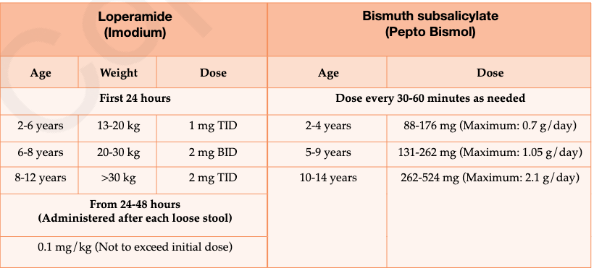
MODERATE (Diarrhea is distressing or interferes with planned activities, no blood or fever) TO SEVERE (Diarrhea is incapacitating or completely prevents planned activities OR dysentery present
First Line
Norfloxacin  800 mg single dose or 400 mg BID for 1-3 days (Prevention: 400 mg daily) |  |  | Prophylaxis should only be used in patients at high risk of the complications of diarrheal illness (e.g., immunocompromised people or people who have significant medical comorbidities).  Drugs taken for prevention should be started on the first day in the area of risk and continued for 1 or 2 days after returning home, to a maximum of 3 weeks total. If possible, one dose can be given initially and patient response evaluated over the following 12-24 hours. If diarrhea is improved, then the antibiotic can be discontinued, otherwise therapy can be continued for up to 3 days. Consult product monographs for children’s dosing
Ciprofloxacin 6 750 mg single dose or 500 mg BID for 1-3 days (Prevention: 500 mg daily)
Levofloxacin 500 mg daily for 1-3 days (Prevention: 500 mg daily)

1000 mg single dose
Azithromycin 1 g single dose or 500 mg daily for 1-3 days Children: 10 mg/kg/day for 3 days | Indonesia/Thailand/ India/ Nepal  Drug of choice for children; used as prophylaxis for high risk
Rifaximin 8 550 mg daily (Prevention: 200 mg TID for 3 days

Notes
Monitoring
Referral
Other notes | - Prevention Tips:  - Follow the rule: "Boil it, cook it, peel it, or forget it."  - Avoid raw or undercooked meats, seafood, unpasteurized dairy, tap water, ice, cold sauces, leafy greens, or food from street vendors (unless served hot).  - Practice good hand hygiene.  - Mild Cases:  - Mild diarrhea often resolves in 24 hours with fluids and anti-diarrheal agents.  - Persistent symptoms (over two weeks after returning) need medical follow-up.  - Prophylaxis for High-Risk Travelers:  - Only high-risk travelers (immunocompromised or with major health issues) should use preventive drugs.  - Start the drug on the first day of travel; continue until 1–2 days after returning, but no more than three weeks.  - Fluid Replacement:  - For mild dehydration, drink carbonated drinks, juices, or purified water.  - Moderate diarrhea: use electrolyte solutions.  - Severe cases (especially in children): use solutions like Pedialyte or a mix of salt, bicarbonate, potassium chloride, and glucose in safe water.  - Probiotics and Vaccines:  - Evidence on probiotics (e.g., Lactobacillus GG, Saccharomyces boulardii) is promising but inconclusive.  - Vaccines (e.g., Dukoral) offer limited benefit and are typically reserved for high-risk travelers.  - Avoiding Certain Treatments:  - Do not use anti-diarrheal agents if there is high fever or bloody diarrhea.  - For bacterial infections (like Shigella, Salmonella, Campylobacter), anti-diarrheal agents should be paired with antibiotics if used at all.  - Medication for Children:  - Avoid fluoroquinolones; consider azithromycin or ciprofloxacin only when necessary.  - Azithromycin is preferred in regions with quinolone resistance and is generally the safer option for children.  - Special Considerations:  - Avoid bismuth subsalicylate in children under 12 and people with certain health conditions (aspirin allergy, renal issues, on anticoagulants).  - Parasites:  - The most common parasitic cause is Giardia; recommended treatment is metronidazole (250 mg TID or 500 mg BID for 5–7 days).

C.Diff
Def’n
Therapeutic goals
Algorithm | N/A
Non-pharmacological options | - Prevention:  - Limit antibiotic use, especially clindamycin, extended-spectrum cephalosporins, and fluoroquinolones, which increase CDI risk.  - Avoid proton pump inhibitors (PPIs) when possible, as they’re associated with a higher CDI risk and recurrence.  - Handwashing with soap and water is essential, as alcohol-based sanitizers don’t kill C. difficile spores. Clean surfaces with hospital-grade disinfectants or bleach.  - Isolation precautions in private rooms or cohort settings should be taken until at least 48 hours after diarrhea stops.
Education/counseling | Currently, probiotics are not recommended for CDI prevention, particularly in patients on antibiotics, though they may benefit some GI issues. Probiotics can be risky for immunosuppressed or critically ill patients.
Pharmacological Therapy
Drug/Dose | Indication | Adverse fx (AE) and Drug interactions (DI) | Contraindications & special considerations
MILD TO MODERATE WBC < 15 x 109/L and SCr < 1.5 x baseline (or SCr < 133 umol/L)
Vancomycin - ORAL 125 mg orally QID for 10-14 days  Children: 40 mg/kg/day orally divided TID-QID x 10-14 days (Maximum 2 g/day) |  | AEs:  DIs:
Metronidazole - ORAL 500 mg TID or 250 mg QID (if 500 mg not tolerated) for 10-14 days
Children: 15-30 mg/kg/day orally divided TID-QID x 10 days (Maximum: 2 g/day)
Fidaxomicin 200 mg BID for 10 day

SEVERE AND UNCOMPLICATED WBC ≥ 15 x 109/L or SCr ≥ 1.5 x baseline (or SCr ≥ 133 umol/L)
Vancomycin - ORAL 125 mg orally QID for 10-14 days
Children: 40 mg/kg/day orally divided TID-QID x 10-14 days (Maximum: 2 g/day)
Fidaxomicin 200 mg BID for 10 days
FIRST RECURRENCE
Vancomycin 125 mg orally QID x 10-14 days
OR
Orally in a tapered and pulsed regimen (e.g., 125 mg po QID for 14 days; TID for 7 days; BID for 7 days; once daily for 7 days, and then every 2 or 3 days for 2–8 weeks)
Fidaxomicin 200 mg orally BID x 10 days

Alternate dosing for subsequent or recurrent: 200 mg BID x5 days, followed by every other day for 20 day
SECOND OR SUBSEQUENT RECURRENCES
Vancomycin orally in a tapered and pulsed regimen (e.g., 125 mg po QID for 14 days; TID for 7 days; BID for 7 days; once daily for 7 days, and then every 2 or 3 days for 2–8 weeks)  OR  125 mg orally QID x 10 days followed by rifaximin 400 mg TID x 20 days |  |  | Fecal Microbiota Transplantation (FMT): Consider FMT after at least two CDI recurrences for those not responding to other treatments
Fidaxomicin 200 mg orally BID x 10 days

Alternate dosing for subsequent or recurrent: 200 mg BID x5 days, followed by every other day for 20 days
Notes
Monitoring
Referral
Other notes | Symptoms and Diagnosis:  - Symptoms generally begin within 2 weeks of antibiotic use but can appear sooner or up to 6 weeks later. Common signs include watery stools (3+ in 24 hours), cramps, fever, nausea, and dehydration.  - Diagnosis is based on symptoms, recent antibiotic use, and toxin tests.  Treatment:  - Stop the antibiotic causing CDI, if possible. Fluid and electrolyte management may be sufficient for mild cases.  - Do not use antidiarrheals or opiates due to the risk of toxic megacolon.  - For severe cases, oral vancomycin is preferred; if ileus is present, vancomycin may be administered rectally.  - Fidaxomicin is preferred over vancomycin for adult patients due to lower recurrence rates, but is not approved for patients under 18.

Helicobacter pylori infection -MUMS
Therapeutic goals | -don’t treat asymptomatic
Algorithm | -diagnose with Urea Breath test, unless endoscopy indicated for another reason
Education/counseling | -stop NSAIDs, stop smoking, minimize use of alcohol  Take for 14 days
Pharmacological Therapy
Drug/Dose | Indication | Adverse fx (AE) and Drug interactions (DI) | Contraindications & special considerations
Quadruple Therapy x 14 days
Proton Pump Inhibitor  Lansoprazole 30mg  Omeprazole 20mg  Pantoprazole 40mg  Rabeprazole 20mg  Esomprazole 20mg  BID x14 days | Substitute ranitidine 150mg BID if PPI intolerant | See chart below
Bismuth subsalicylate 262 or 524 mg QID |  | Avoid if renal impairment (CrCl<30), increases risk of bleeding in pregnancy
Metronidazole 500mg TID-QID | Mild resistance | No alcohol while taking and for 48 hours after to avoid reaction
Tetracycline 500mg QID | Has no resistance noted
OR all 4 below x 14 days
PPI above BID | Metronidazole 500mg BID | Clarithromycin 500mg BID | Amoxicillin 1g BID
Triple Therapy x 14 days
PPI BID, Amoxicillin 1g BID, Calrithromycin 500mg BID
OR
PPI BID, metronidazole 500mg BID, Clarithromycin 500mg BID
Notes
Monitoring | -F/U confirm eradication no earlier than one month after completion IF COMPLICATED
Other notes | Treatment failure due to noncompliance; resistance occurring  Pregnancy- triple therapy PPI, metronidazole and amoxicillin

GI Acid Suppression Medication Overview (RXFiles-evidence, tips and pearls, geri and comparison chart)
Def’n | Happens with age, medications, etc.
Algorithm | 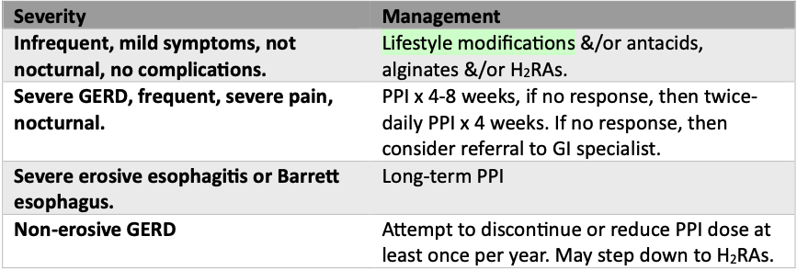
RED FLAGS | Vomiting persistent >7 days; bleeding that leads to anemia/melena; abdominal mass or unexplained weight loss; dysphagia (*Prompt endoscopy)  Others: jaundice, gastric/ovarian CA history, prior ulcer, risk factors for Barretts
Non-pharmacological options | Diet- decrease foods that worsen symptoms, smaller meals, chew well, avoid lying down within 2-3 hrs after eating, avoid tight clothes  Elevate head of bed, sleep in left lateral position  Exercise and weight loss, moderate alcohol use and smoking cessation
Education/counseling | NSAIDs responsible for majority of PUD and gastric ulcers; use lowest dose shortest duration
Pharmacological Therapy
OTC- Antacids- mild GERD <3x/week, short duration and low intensity
Alginates (Gaviscon) 2-4 tsp QID after meals and at bedtime | Calcium Carbonate (TUMS) 200-400mg PRN | Magnesium-aluminum hydroxide (MAALOX) 15-60ml QID 1 hour after meals and at bedtime  AE: constipation, salt overload, aluminum toxicity
FIRST LINE moderate/severe and erosive-
Proton Pump Inhibitors (more efficacious than H2RA)
*reassess therapy at 8 weeks, stop/taper if able or trial 1 other PPI
Long term therapy for barrett’s, esophagitis, GI bleed risk tailor dose and frequency to control symptoms; Can use for NSAID GI Ulcer prophylaxis
Take 30 minutes before breakfast on an empty stomach with water to enhance absorption
NEED TO TAPER IF ON LONG TERM, otherwise rebound issues
Omeprazole, Rabeprazole, Esomeprazole  20mg daily | Dexlansoprazole, lansoprazole 30mg daily | Pantoprazole 40mg daily
AE: constipation, diarrhea, dizziness, headache, nausea, pruritis, somnolence, sweating
Longterm AEs: C. diff, enteric infections, liver disease, bacterial peritonitis, bone fractures, hypomagnesium, vit B12 deficiency, T2DM, kidney disease
DI: decrease drug absorption low pH-dependent (ca carbonate, iron, -tinib, -conazole, thyroxine; increase dig and tacrolimus; **pantoprazole and rabeprazole least interactions
H2RAs not for NSAID GI Ulcer prophylaxis- mild GERD <3x/week of short duration and low intensity; duodenal ulcer = 4-8weeks; gastric ulcer 8 weeks
**avoid in geriatrics at risk for delirium
Cimetidine 600mg BID DI- the most | Famotidine (Pepcid) 20mg BID *preferred | Nizatidine 150mg BID | Ranitidine (Zantac) 150mg BID *preferred
AE: diaarrhea, constipation, headache, fatigue, confusion (elderly and renal impaired)
DI: cimetidine TONS (avoid in elderly)
Space antacid by 30-60minutes
Misoprostol- treatment/prevention NSAID-induced gastroduodenal ulcers and duodenal ulcers caused by peptic ulcer disease 200mcg BID-QID with food x4-8weeks
AE: GI upset, diarrhea
Pregnancy-Calcium carbonate (TUMS), alginate antacids preferred, ranitidine, omeprazole preferred;
Lactation- calcium carbonate, alginate antacids preferred; famotidine, pantoprazole, ranitidine
Other options if <60 not responding:
domperidone 10mg TID, max 30mg/day AE: QT prolongation
Metoclopramide 5-20mg TID-QID; avoid in parkinson’s
Amitriptyline 10-100mg HS, avoid in dementia, glaucoma

Inflammatory Bowel Disease (eCPS)- Crohn’s Disease and Ulcerative Colitis
Def’n | CD- any part of GI tract  UC- restricted to colon
Therapeutic goals | Induce and maintain clinical and endoscopic remission  Improve nutritional status and growth  Prevent development of colon cancer
Non-pharmacological options | -smoking cessation  -surgery
Algorithm | 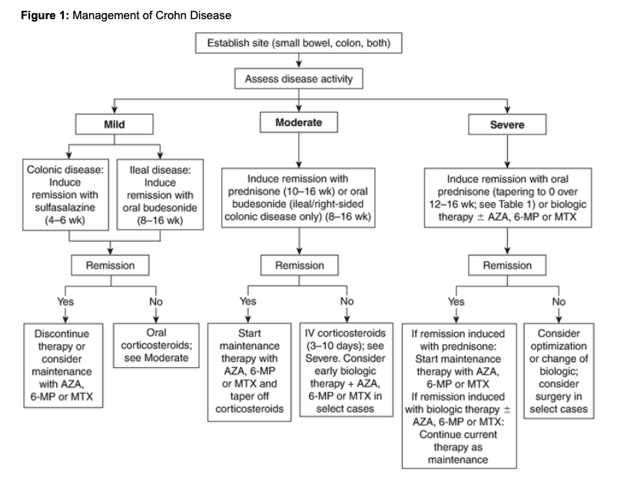  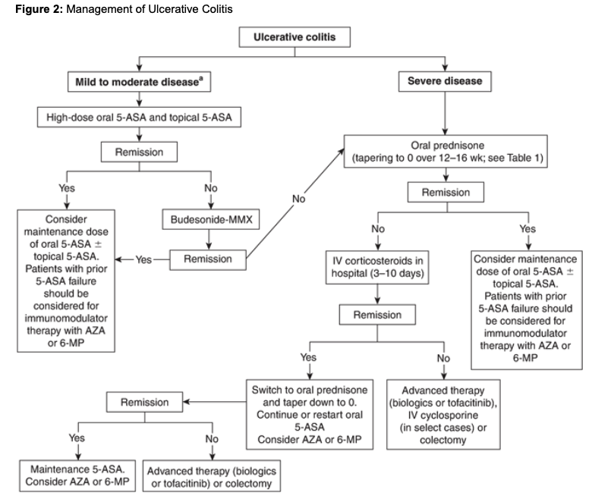
Pharmacological Therapy
Aminosalicylates-5-aminosalicylic acid (5-ASA)
Salofalk/Pentasa- small bowel and colon
Sulfasalazine/olsalazine/asacol-colon
AE: abdo pain, cramps, diarrhea, HA, N/V, rash; DI: myelosuppression,renal with NSAIDs/azathioprine
Corticosteroids- exacerbations
Prednisone 40-60mg/day-severe AE: osteoporosis with long=term therapy
Budesonide mild-moderate
AE: acne, glucose intolerance, weight gain, HTN, hypokalemia, osteoporosis,
Immunomodulators- refractory; monotherapy to induce remission in CD
Azathioprine
6-mercaptopurine (6-MP)
Methotrexate- CD
AE: nausea, stomatitis, GI discomfort, diarrhea, anorexia, bone marrow suppression, opportunistic infections, melanoma, DI: inhibit warfarin, neutropenia with ACEI
Biologic response modifiers
Anti-tumor necrosis factor-alpha therapies- adalimumab
Anti-integrin therapies- natalizumab
AE: N, reaction at injection site, TB, infections, URTI; CI: live vaccines
Antibiotics- 2-4wk course CD
Metronidazole
Ciprofloxacin
CI: alcohol; AE: neuropathy with long term use
Antidiarrheals
Avoid in severe disease = toxic megacolon
Loperamide
Opioid Analgesics
Decrease GI motility; chronic use = narcotic bowel syndrome
Codeine- pain control and decreasing bowel movements

Irritable Bowel Syndrome (IBS)- RXFiles/eCPS
Def’n | -abdo pain associated with defecation and altered bowel habits
Therapeutic goals | -diagnose based on ROME IV score:  Recurrent abdominal pain ≥1 day/week in the last 3 months associated with 2 or more of the following criteria:  - Related to defecation  - Associated with a change in frequency of stool  - Associated with a change in form (appearance) of stool  Symptom onset should be at least 6 months prior to diagnosis.
Algorithm | 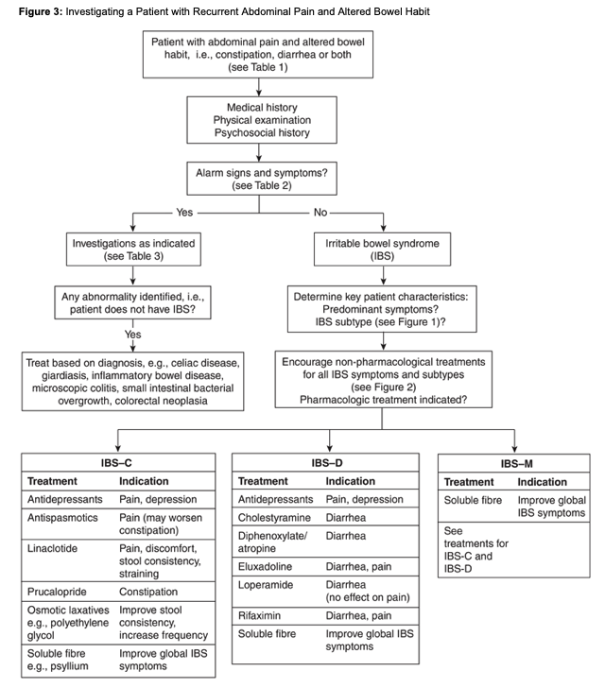
Non-pharmacological options | Diet: gluten free, low FODMAPs, fibre  Probiotics/ fecal transplants- Multiflor, align, HMF forte, pregnancy care probiotic, ultraflor balance, activia,  IBS-D- bio-k+  Prebiotics  Psychological therapies- CBT, hypnosis, mindfulness  Lifestyle interventions: exercise, reduce caffeine/alcohol
Pharmacological Therapy
Drug/Dose | Indication | Adverse fx (AE) and Drug interactions (DI) | Contraindications & special considerations
IBS-Constipation Predominant
1st LINE: Water-soluble fibre increase stool frequency; safe in pregnancy
Psyllium (metamucil) 1 serving AE: abdo pain, bloating, flatulence, cramps, bad taste; CI: obstruction, impaction; DI: lithium, carbamazepine
Calcium Polycarbophil (Prodiem) 2 caps daily-QID, 8 caps max AE: abdo pain, bloating, epigastric fullness, flatulence; SI: obstruction, impaction; DI: tetracyclines
Osmotic Laxatives Increase frequency and improve consistency
polyethylene glycol 17g in 250ml water daily to BID AE: abdo pain, bloating, increase mg; CI: obstruction, renal impaired; DI: mg, quinolones, tetracyclines
lactulose (not preferred due to excessive gas)
Magnesium Hydroxide
(Not available in Canada) Lubiprostone- prostaglandin derivative and selective chloride channel activator; relieves bloating, frequency, consistency
guanylate cyclase C agonist
Linaclotide- AE: diarrhea, abdo pain, rectal bleed; CI: <6;
(not available in Canada) Plecanatide AE: diarrhea, HA, UTI; CI: avoid 6-18 yrs; DI: none
Antispasmodics- pain, relax smooth muscle
Dicyclomine 40mg QID AE: sweating, constipation, nausea, dry mouth, dizziness, blurred vision tachyarhythmia, apnea, dyspnea; CI: obstruction, GERD,; DI:
Pinaverium 100mg TID AE: epigastric pain, constipation, N/V/D, heartburn;
Trimebutine 200mg TID AE: epigastric pain, dyspepsia, diarrhea, constipation; DI: cisapride
IBS-Diarrhea Predominant
Water-soluble Fibre
Mu-opiopid receptor agonist slow transit, reduce fluid sectretion
1st LINE Loperamide (imodium) 2-4mg daily-BID PRN Max 16mg/day AE: dry mouth, cramps, anorexia, N/V, flatulence; CI: abdo pain, enerocolitis, dysentery DI: P-gp inh (gemfibrozil)
Diphenoxylate (Lomotil)-atropine, caution in elderly as cumulative anticholinergic effects
bile acid malabsorption
Cholestyramine 4g q12h AE: nausea
colesevelam- 3.75 g powder daily
Antibitoics: diarrhea and pain relief
Rifaximin 550mg TID PO x14D AE: diarrhea, nausea; DI: warfarin/BC inactivated
IBS- Mixed Pattern
Antidepressants- reduce abdo pain
Tricyclic antidepressants- amitriptyline, despiramine- increase colon transit, more effective diarrhea AE: anticholinergic, dry mouth, drowsiness; CI: constipation
SSRIs- fluoxetine, paroxetine, citalopram

Colic (eCPS) **FOCUS ON PARENT’S MENTAL HEALTH**
Def’n | -functional GI disorder in infancy
Therapeutic goals | -decrease frequency/duration of crying episodes  -ensure infant is feeding well to maintain hydration & weight gain  -decrease discomfort and fussiness after feeds  -ensure infant is falling asleep and staying asleep  -minimize caregiver stress and frustration, strengthen coping strategies
Algorithm | 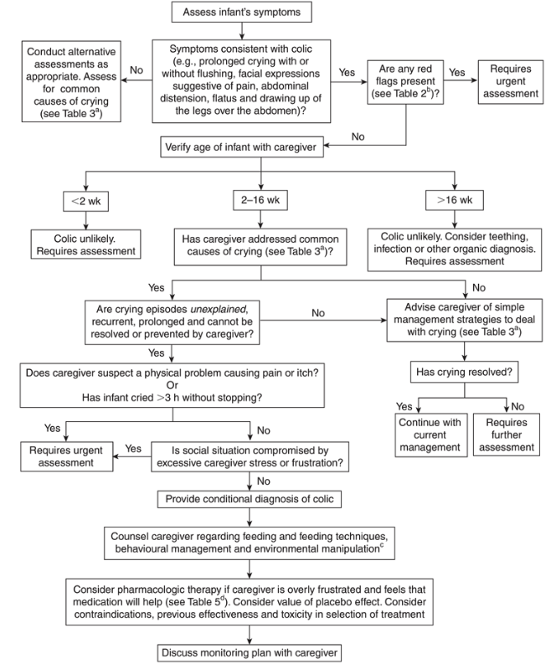
Non-pharmacological options  MAIN TREATMENT | Manage Crying:  Hunger- increase feeding frequency  GERD- smaller quantities, more often; burp ever 5-10 mins of feeding or 30-60ml; hold more upright and remain upright following feeding  Overheated- remove layers  Need for attention/physical contact- cuddle  Sleep- dark, quiet room, avoid stimulation/arousal  Cry when left alone- stimulation
Education/counseling | -resolves by 5 months; presents around 2 weeks, persisting to 6 weeks and gradually improving after  -keep a colic diary to better understand triggers
Red Flags | Fever (<3 months) or lethargy; weight loss/dehydration/failure to thrive; diarrhea/blood-streaked/mucus stools; frequent regurgitation/vomiting/abdominal distension; extreme or high pitched crying; parental mood disorders (anxiety or depression); maternal drug ingestion; >5 months; lack or predictable diurnal rhythm; family hx of migraine or atopy
Pharmacological Therapy
Drug/Dose | Indication | Adverse fx (AE) and Drug interactions (DI) | Contraindications & special considerations
Physical Methods
Gentle pressure on abdomen, massage | Pull legs up and arch back and push legs back and forth (bicycle motion) | Warm baths
Dietary Manipulation (NOT OVERLY HELPFUL AND TIME CONSUMING)
Encourage breastfeeding, empty one breast.feed | Eliminate allergenic foods (dairy, eggs, wheat, etc), cabbage, broccoli, caffeine, citrus fruit and chocolate | Hypoallergenic formula may or may not help and more expensive
Natural Health Products
Probiotics- lactobacillus reuteri BioGaia 5 drops once daily | Sucrose- 12-24% solution (make own)
Prescription
Simethicone (Ovol, Infacol) 20-40mg PO with each feed | Science not supportive but placebo is huge for parent’s mental health and if they have benefits and want something prescribed then prescribe it
Notes
Monitoring | Monitor excessive crying, post-feed discomfort/fussiness, dehydration, fever, sleep, parent anxiety/stress
Referral | MH counseling for parent

Dyspepsia and GERD (eCPS)
Def’n | Dyspepsia- epigastric pain >1 month; Caused by peptic ulcer disease, reflux, cancer, crohn’s, hypothyroid, food intolerance, medications (amiodarone, antibiotics, NSAIDs) **test for H. Pylori first  GERD- no predominant symptom, acid regurgitation, heartburn, epigastric pain, nausea, dysphagia
Therapeutic goals | -reduce or eliminate symptoms  -induce healing of damaged mucosa  -prevent barrett esophagus, cancer  -identify worsening symptoms and red flags
Algorithm | 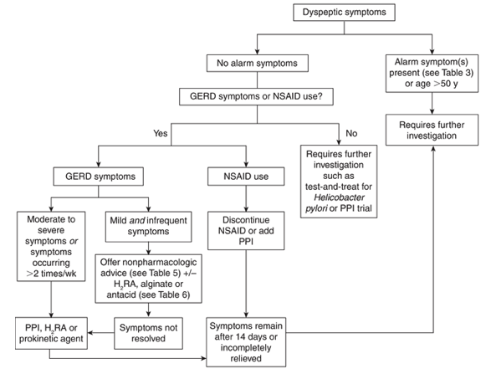  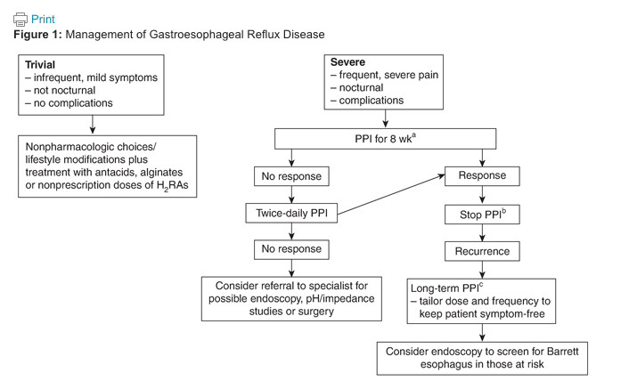
 | Dyspepsia | GERD
Non-pharmacological options | -avoid foods that precipitate events, avoid lying down after eating, reduce body weight, quit smoking, avoid alcohol intake, avoid caffeine, eat smaller, more frequent meals  Reduce stress, benign nature | Stop drugs (anticholinergics, CCB, beta-agonists, nicotine, opioids), no smoking, lose weight, diet (no fatty foods, chocolate, onions, coffee, alcohol, carbonated drinks), avoid exercising or bending on full stomach, avoid large meals, avoid lying down after eating  -Hiatus hernia, pregnancy, stress and anxiety don’t help
Treatment summary |  | Mild: lifestyle, dietary changes and OTC antacid, intermittent PPI, H2RA
Education/counseling
Pharmacological Therapy
Antacids
Gaviscon 10-20ml PC and HS PRN | Calcium Carbonate (Tums) 500-1500mg per day divided doses PRN  Milk of Magnesia >12 650-1300mg per day in 4 divided doses PRN | AEs:constipation, hypophosphate, end stage renal disease leads to dementia  Diarrhea for milk of magnesium  DIs:decrease fluoroquinolone and tetracycline abx
H2-reeptor antagonists -Empiric therapy with an H₂RA for 4–8 weeks may be beneficial to treat the symptoms of functional dyspepsia.
Cimetidine 800mg daily  AE: Diarrhea, constipation, headache, fatigue  DI: increases serum concentration of may drugs (antidepressants) | Famotidine (Pepcid) >12 y/o 10-20mg BID PRN max 40mg/day  AE: headache, dizziness  DI: don’t take with antacids | Ranitidine (Zantac) >16 y/o  75-150mg BID PRN max 300mg daily  AE: headache, nausea, vomiting, diarhea  DI: don’t take with antacids
Proton Pump Inhibitors- Patients with moderate to severe or frequent symptoms of GERD (occurring >2 times per week) can be treated with an 8-week course of PPIs,​ and empiric therapy with a PPI for 4–8 weeks may be used to treat the symptoms of functional dyspepsia
Rabeprazole 10-20mg daily 30 mins before food  AE: headache, nausea, diarrhea, rash  DI: decrease ampicillin absorption, don’t take with sucralfate, increases tacrolimus, unsure about clopidogral, digoxin levels may increase | Lansoprazole (Prevacid) 15-30mg once daily 30 mins before food  Pantoprazole magnesium (tecta) 40mg daily 30 mins before food  Pantoprazole sodium (pantoloc) 20-40mg daily 30 mins before food  AE: headache, nausea, diarrhea, rash  DI: decrease ampicillin absorption, don’t take with sucralfate, increases tacrolimus | Esomeprazole (NExium) 20-40mg daily 30 mins before food  Omeprazole (Losec) 20-40mg daily 30 mins before food  AE: headache, nausea, diarrhea, rash  DI: inhibits CYP2C19- changing levels of drug in system (diazepam, digoxin), celexa
Notes
Monitoring | Symptoms persist >2 weeks, worsening symptoms, recurrent many times a year further investigation

Drug Use during Pregnancy (eCPS)
Drugs of Choice
Antihistamines, citalopram/escitalopram, IHCS, inhaled bronchodilator, topical corticosteroids (little as possible), cephalosporins, lamotrigine, quetiapine, bulk-forming agents, soluble and non-soluble fibre, antacids, alginic acid, omeprazole, ranitidine, levetiracetam, acetaminophen, acyclovir, valacyclovir, IV labetalol/hydralazine, 5-aminosalicylic acid, azathioprine, beta blockers, nifedipine, diclectin, clotrimazole vaginally, nystatin vaginally
DO NOT USE TERATOGENIC
ACEIs, carbamazepine, coumarin anticoagulants, ethanol, folic acid antagonists, phenytoin, lithium, misoprostol, retinoids, tetracyclines, thalidomide, topiramate, valproic acid

Probiotics (Rx chart)
Antibiotic-Associated Diarrhea Prevention | Visbiome, Bio-K, Culturelle, florastor, align  Kids: Culturelle, florastor kids  Continue 3 days after abx use
Irritable Bowel Syndrome | Possibly effective  Multiflor, align, HMF forte, pregnancy care probiotic, ultraflor balance, activia,  IBS-D- bio-k+
Colic | L. reuteri- Biogaia
C. Diff Prevention | Insufficient data, maybe Florastor  Pediatrics- S. boulardii
Ulcerative Colitis | Increase remission rate- Mutaflor, Visbiome
Mixed Evidence | Vulvovaginitis candidiasis, BV, UTIs, Crohn’s, H. Pylori,
INEFFECTIVE TREATING | Acute Pancreatitis  Eczema  Kids: Infectious diarrhea, inflammatory bowel disease, food allergies, atopic disease

Nausea and Vomiting (symptom management) (RX files)
Algorithm | 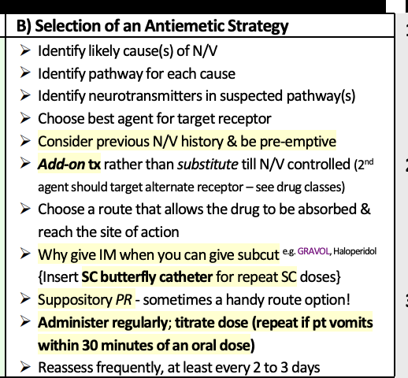
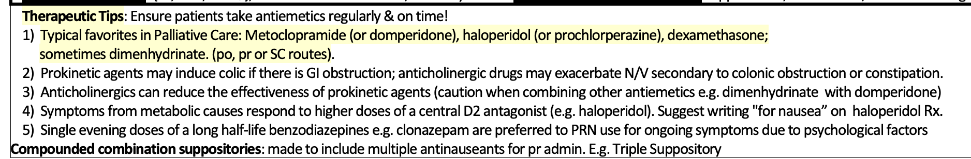
Non-pharmacological options | 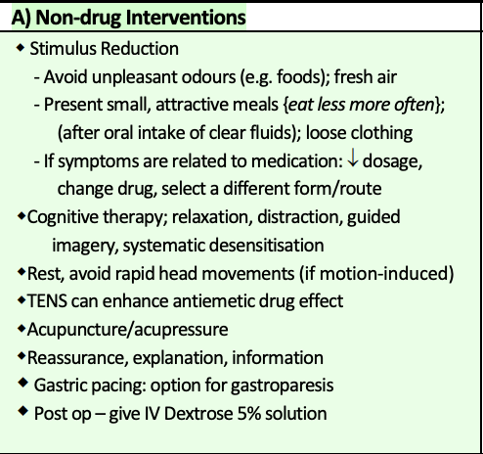
Pregnancy NV | If prenatal vitamin increases nausea:  - take with snack at night, take folic acid alone, limit iron if possible
Pregnancy NV | -1st line:  Pyridoxine (Vitamin B6) 10-25mg TID-QID or Diclectin (doxylamine/pyridoxine)
Pregnancy NV | -Dimenhydrinate: 50-100mg PO/PR q4-6hr:  likely no teratogenicity  -use with caution in late pregnancy (oxytocic effect: increases uterine activity which can cause premature labour
Pregnancy NV | Other: less safety data: metoclopramide, phenothiazine, ondansetron, dexamethasone
Pregnancy NV | P6 acupressure: wristband, (eg. Sea-band) -likely safe needs more research
Pregnancy NV | GInger Root: Dose 250mg-1g QID and post op NV  AE: GI upset, mouth irritation, increased fibrinolysis vaginal spotting  Come as tab, cap, fresh
Cannaboid Hyperemesis Syndrome | If having severe recurrent NV from chronic cannabis use  -D/C cannabis use  -hot shower/bath  -capsaicin crm to abdo OTC  -Dopa agonist (ie. haldol)
Post-operative NV | -al equally effective: aprepitant, dexamethasone, granistron, ondansetron, ramosetron, fosiprepetent, droperidol  -Dimenhydrinate: effective for NV  Prevention: ondansetron, dexamethasone most effective  Greater risk of NV post op can also use: halopierdol, dimenhydrinate, scopolamine, meoclopramide
Chemotherapy induced NV | 5-HT3A agents, similar PO or IV
Pediatric Population | 1.viral gastroenteritis: self limiting treat with hydration primary treatment  -ondansetron: decrease vomiting but can increase diarrhea  -chemotherapy induced N/V (CINV):  2. Ondansetron:  -High-Very high NV: ondansetron 5mg/m^2 IV or PO, pre-chemo q12hr afterwards  -pre- chemo and q8h PLUS dexamethasone 4.5-8mg/m^2  -pre-chemo PO/IV less 10min and Q12-24hr there after  -Moderate NV: ondansetron 5mg/m^2 (max 8mg( IV or PO), pre chemo and q12hr there after.  -low NV: ondansetron 3mg/m^2 (max 8mg) IV or po x 1 pre-chemo  -minimal NV: no trt  -breakthrough NV management: lorazepam, ondansetron, dexamethasone (granisetron 20ug/kg/dose IV pre and q12 hr pre and q12hr, metoclopramide and nabilone)  3.Ondansetron PO dose per BSA: eg less 0.3m^2 → 1mg, 0.3-0.6m^2 → 2mg.
Drug Classes- Overview (combine for severe/refractory cases)
Dopamine (D2) Antagonist  -haloperidol, metoclopramide, domperidone | -act as chemoreceptor trigger zone (CTZ)  -halopierdol: has a high central potency on CTZ  -metoclopramide and domperidone: have central antidopaminergic activity and antagonize dopamine in gut. Can reverse gastroparesis via serotonin antagonism  -metaclopramide: crosses the BBB causing CNS AE, Extra pyramidal symptoms, tardive dyskinesia  -domperidone: maintains activity and does not cross the BBB to cause CNS AE.
Phenothiazine  -prochlorperazine, prmethazine, chlorpromazine  -atypical anti psychotic | -weaker central D2 antagonists with variable effects at other CTZ, gut and vomiting center  -AE: significant anticholinergic effects especially sedation and dry mouth, EPS symptoms, anticholinergic and hypotensive, hypotension, blood dyscrasia, cholestatic jaundice
(Seratonin (5-HT3) Antagonists)  -ondansetron, granisetron, dolasetron | -acts centrally CTZ and peripherally (vagus nerves in GI)  -Do Not reverse nausea mediated by dopamine pathways (eg. opioid induced)  -generally well tolerated low rates of side effects  AE: headache, constipation, rare, prolonged QT interval with dolasetron
1st generation antihistamines (H1 antagonists)  -dimenhydrinate, diphenhydramine, cyclizine | -antagonize both histamine H1 and muscarinic cholinergic (Ach) receptors  -exert central antiemetic effects  -can be effective for various causes  -better than benzodiazepine for acute vertigo  -AE: drowsiness and dry mouth are common side effects
Anticholinergic (M1 antagonists)  -scopolamine patch | -little central antiemetic effect useful in prevention and treatment of motion sickness  -primarily reduces GI peristalsis and decreases exocrine secretions  -caution in elderly has a strong anticholinergic effect  -AE: dry mouth use oral balance gel, sedation, blurred vision
Benzodiazepines  -lorazepam, clonazepam, diazepam | -have no direct antiemetic effect  -may be useful as adjunctive therapy for post-chemo NV  -used to reduce anxiety when symptoms are related to psychological factors
Corticosteroids  -dexamethason | -preferred for severe refractory NV and in combination with 5-HT3-A for chemo induced NV prevention and treatment  -high doses used as primary intervention for nausea due to increased ICP, bowel obstruction  -manages refractory NV to unknown origin and delayed NV
Somatostatin Analogues  -octreotide | -decreased peristalsis and gastric secretions through inhibition of growth, thyroid stimulating and adrenocorticotropic hormone
Neurokinin-1 Receptor Antagonist  Aprepitant, fosaprepitant | -active centrally and peripherally  -used with steroids and 5HT3 drugs for moderate/highly emetogenic regimes  -DI: aprepitant may increase levels of drugs metabolized by CYP3A4 chemo agents, pimozide, decreases levels of drugs  -rolapitant varubi 90mg tab/IV.  AE: neutropenia, hiccups, decreased appetite, dizziness, allergic reaction
Education/counseling
Pharmacological Therapy
Drug/Dose | Indication | Adverse fx (AE) and Drug interactions (DI) | Contraindications & special considerations
1st Line Therapies
Chemically induced NV  Often combos | Halopierdol  0.5-2mg q6-12hr  Po/SC/IM  Post op NV: 1mg  Chemo induced NV: PRN | AEs: sedation, EPS, agitation, restlessness, increased QT
Chemically induced NV  Often combos | Prochlorperazine  5-10mg q6-8hr po/pr  Post-op NV: 5-10mg  CINV: PRN | AEs: sedation, EPS, hypotension, dry mouth, blurred vision
Chemically induced NV  Often combos | Pamidronate  30-60-90mg IV x 1 over 2hrs | AEs: GI, gastric pain/GERD, diarrhea, NV, hypocalemia, HTN
Chemically induced NV  Often combos | Ondansetron  4-8mg q12hr x 3 dose PO/IV  Post op NV: 2-4MG IV, 4MG po 1hr pre-op max 16mg  CINV:8-16mg 1 hr pre op | AEs: Headache, malaise, constipation  Serious AE: anaphylaxis, bronchospasm, dysrhythmia, 5HT syndrome.  Useful pre-chemo/procedure for first 24hr  -not effective after NV occurs  Post op NV: more effective for vomiting than nausea  -can add dexamethasone to 5-HT3 antagonist to increase effectiveness
Chemically induced NV  Often combos | Nabilone  0.5-1-2mg po daily BID | AEs: sedation, ataxia, dizziness, euphoria, hypo and hypertension, dry mouth
GI/Dysmotility | Domperidone (motilium)  5-10-20mg po TID-QID AC.  Chemo induced NV: 20mg po QID ac and HS | AEs: diarrhea, abdominal cramps, may increase pain if GI obstruction, increased risk of falls, increased risk of stroke, galactorrhea, gynecomastia, increased QT over 30mg/day, increased EPS
GI/Dysmotility | Metoclopramide  50-10-20mg TID-QID  PO-IV-SC ac or 3-6mg/hr continuous SC  Chemo induced NV: PRN, 10-20mg  Post op NV:10mg IV | AEs: diarrhea, abdominal cramps, may increase pain if GI obstruction, increased risk of falls, increased risk of stroke, EPS-akathisia, mild sedation, increased prolactin, dyskinesia  Serious: dysrhythmia, NMS, EPS
GI/Dysmotility | Dexamethason  4-8mg BID-QID PO/IM/SC | AEs: mood change, increased appetite/energy, increased glucose, increased GI AE
GI/Dysmotility | Octreotide  50-150mcg BID-TID sC | AEs: pain at injection site, diarrhea, nausea
Increased ICP | Dexamethasone  4-8mg BID-QID PO/IV/SC  Postop NV: 8mg IV | AEs: mood changes, increased appetite, hyperglycemia, increased energy, hypertension  Pregnancy: avoid corticosteroid in first 10 weeks if possible due to oral cleft
Sensory/psych Anticaptory | Lorazepam (ativan)  0.5-1mg q6hr prn PO/SL/SC  chemo induced NV: 0.5-1mg PO/SL pre chemo | AEs: sedation, confusion, falls in elderly  Advantages: SL option, short acting  Peds: 0.025-0.05 mg/kg/dose po/IV/sL  Max 4mg/dose
Sensory/psych Anticaptory | Clonazepam  0.25-0.5mg PO BID-TID | AEs: sedation, confusion, falls in elderly
Sensory/psych Anticaptory | Diazepam  5-10mg HS Po/Pr | AEs: sedation, confusion, falls in elderly
Motion Related | Dimenhydrinate  25-50-100mg q4-6hr prn  po/pr/sc/IM  Post-op NV: 25-100mg  12.5025mg q6-8hr, 25-50mg q6-8hr | AEs: sedation, dry mouth,
Motion Related | Scopolamine  0.3-0.6mg q3-6hr prn sc  1 patch q 72hr  Post-op NV: patch 4hr until onset | AEs: sedation, blurred vision, dizziness, urinary retention,
Motion Related | Betahistine:  16-24mg po BID prn | AEs: skiing rash, GI , headache
Cyclic Vomiting Syndrome | Supportive tx,  PPI, TCA  Migraine prevention  PEDS: ondansetron
Unknown cause | Dexamethasone, dimenhydrinate
Pregnancy  Peak nausea at 9 wks resolved by 20wks | Step 1: {Pyridoxine 10-25mg TID-QID} ± {DoxylamineDICLECTIN 1 tab am, 1 tab afternoon, 2 tab HS Max 8/day)}  Doxylamine: H1 blocker; AE: drowsiness, ACh, DI: CNS depressant/herbs can add Folic Acid 5mg/d  Step 2:  Dimenhydrinate (GRAVOL) 50-100mg q4-6hr po/pr,  Promethazine (PHENERGAN) 12.5-25mg q4-6hr po/pr  Options/add-on tx.  If dehydrated, give hydration tx (IV fluid, IV vitamins, IV dimenhydrinate 50mg/mL q4-6h)  Step 3:  (in order of fetal safety; Safest → least safest)  chlorpromazine 10-25mg q4-6hr po or 50-100mg q6-8hr pr; → prochlorperazine 5-10mg q6hr po/pr; promethazine po; →  metoclopramide 5-10mg q8hr SC/IM/po; →  ondansetron 4-8mg q12hr po.  Step 4:  IV meds, NG tube.  Lifestyle/Herbal: meal/drink size, frequent nibble, biscuit before rising;  GERD tx;  P6 acupressure  Ginger

Dehydration in Children (CPS)
Def’n | Newborns and young children have a higher water content than adolescents and adults  More prone to water, sodium, potassium loss during illness!!
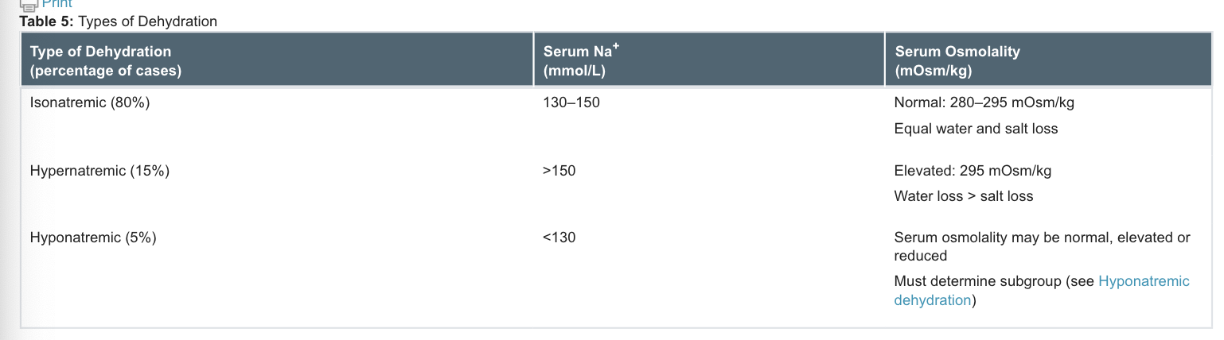

Isonatremic dehydration:
-is the most common form of dehydration, with loss of both K​⁺ and Na​⁺. K​⁺ can be added to the IV mixture following establishment of urinary output.
-K​⁺ administration should not normally exceed 4 mmol/kg/day.​Higher K​⁺ concentrations can be used in life-threatening hypokalemia.
Hypernatremic dehydration:
- usually develops slowly and is corrected slowly to prevent cerebral edema and seizures. Shock is treated aggressively by administering IV NaCl 0.9% until urinary output is re-established, then NaCl 0.45% + 5% dextrose in water (D5W) is used to correct dehydration states and restore Na​⁺ to normal levels.
-The goal of therapy is to reduce serum Na​⁺ by 10–15 mmol/L/day and to restore hydration to normal in no less than 48 hours. If the serum concentration drops rapidly (>10–15 mmol/L/day or >1 mmol/L every 2 hours), change the IV solution to NaCl 0.9% + D5W.
Hyponatremic dehydration is classified into 3 subgroups:
- Excessive water
- Na​⁺ depletion
- Factitious lowering of serum Na​⁺ concentration due to increased glucose, electrolytes, lipids and proteins
-Symptomatic hyponatremia:
- is usually related to the degree of serum Na​⁺ depletion.
-Children with serum Na​⁺ >120 mmol/L rarely demonstrate any clinical manifestations. When serum Na​⁺ drops below 120 mmol/L, neurologic manifestations (e.g., seizures) are common.
-Children who are symptomatic require aggressive replacement using hypertonic saline (NaCl 3%) to achieve a serum Na​⁺ >125 mmol/L.
-Hyponatremia correction should be carried out carefully and monitored closely. Correction should occur quickly until serum Na​⁺ is >125 mmol/L. The remaining correction above 125 mmol/L should occur over 8 hours. In general, 2–4 mL/kg of NaCl 3% is given at a rate of 1–3 mL/kg/hour. Serum sodium will increase by approximately 5 mmol/L for every 6 mL/kg of NaCl 3%.
Serum Na​⁺ deficit can be calculated as follows:
Na​⁺ deficit (mmol) = [Na​⁺ desired – Na​⁺ actual (mmol/L)] × body weight (kg) × total body water (L/kg)
After the initial elevation of Na​⁺ to >125 mmol/L, the remaining deficit can be replaced over 24–48 hours in asymptomatic children.
Remember that children who are dehydrated and have ongoing fluid losses need to have those fluid losses replaced. Those replacements need to be considered in addition to their estimated deficit plus maintenance fluids. The replacement of ongoing fluid losses usually occurs in a ratio of 1 mL of replacement to each 1 mL of fluid lost.​When determining fluid loss and its need for replacement, consider excessive loss secondary to high urinary output in a patient with diabetes, nasogastric losses, or excessive ongoing vomiting and/or diarrhea. Adjust fluid for electrolyte losses as well.​The replacement fluids suggested are based on the author’s practice, although other fluid replacement strategies for children have been proposed
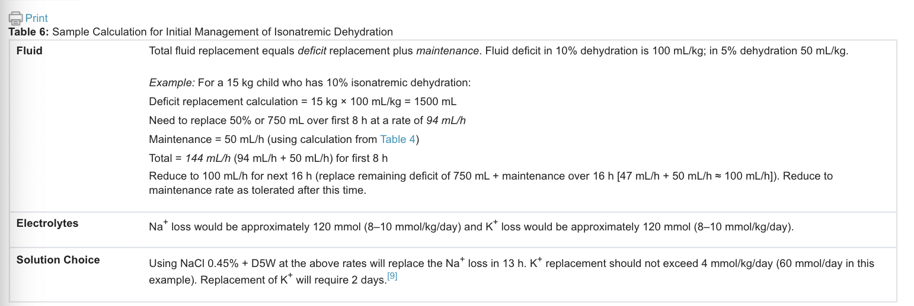
Therapeutic goals | -treat shock/impending shock  -treat dehydration using an appropriate fluid and route  -treat electrolyte imbalances  -prevent complications (seizures or edema)  -provide education to family members to help prevent recurrence
Algorithm | 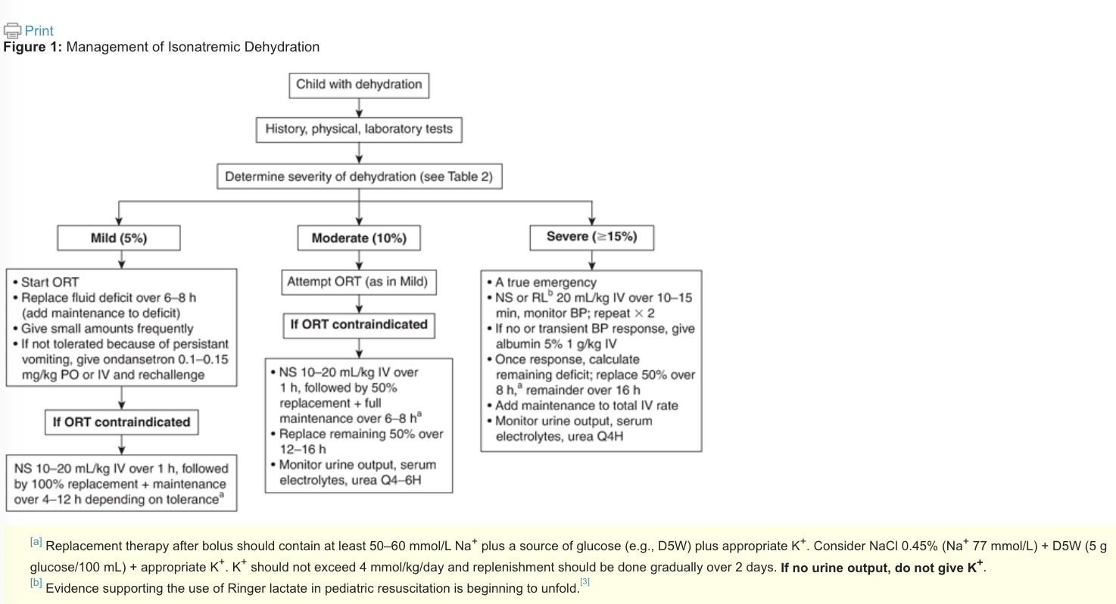
Therapeutic Tips | - Absolute indications for admission to hospital are:  - shock  - hypo-/hypernatremia  - intractable vomiting/diarrhea  - altered sensorium  - Possible indications for admission to hospital are:  - serum HCO₃ <15 mmol/L at onset of therapy  - poor response to oral replacement therapy and ongoing requirement for IV therapy  - Clinical signs of dehydration are often not present until at least 5% of a child's body weight is lost.  - Depending on the clinical situation, consider measuring serum electrolytes before, at the time of and after starting IV fluids.
Pharmacological Therapy
Drug/Dose | Indication | Adverse fx (AE) and Drug interactions (DI) | Contraindications & special considerations
1st Line Therapies
IV rehydration therapy | -Replace fluid deficits and maintain normal hydration. | AEs:  DIs:
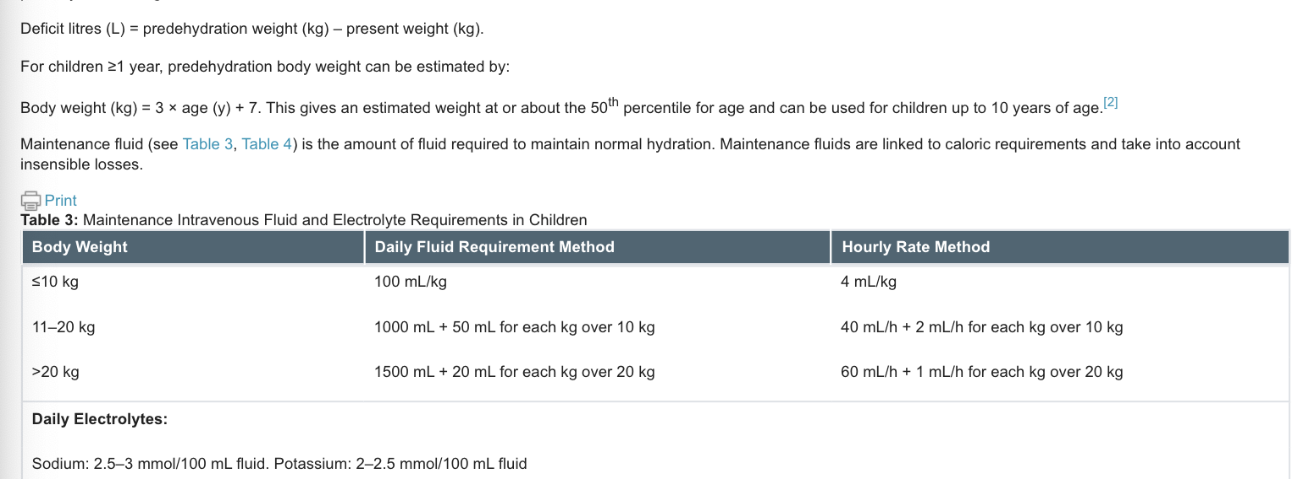

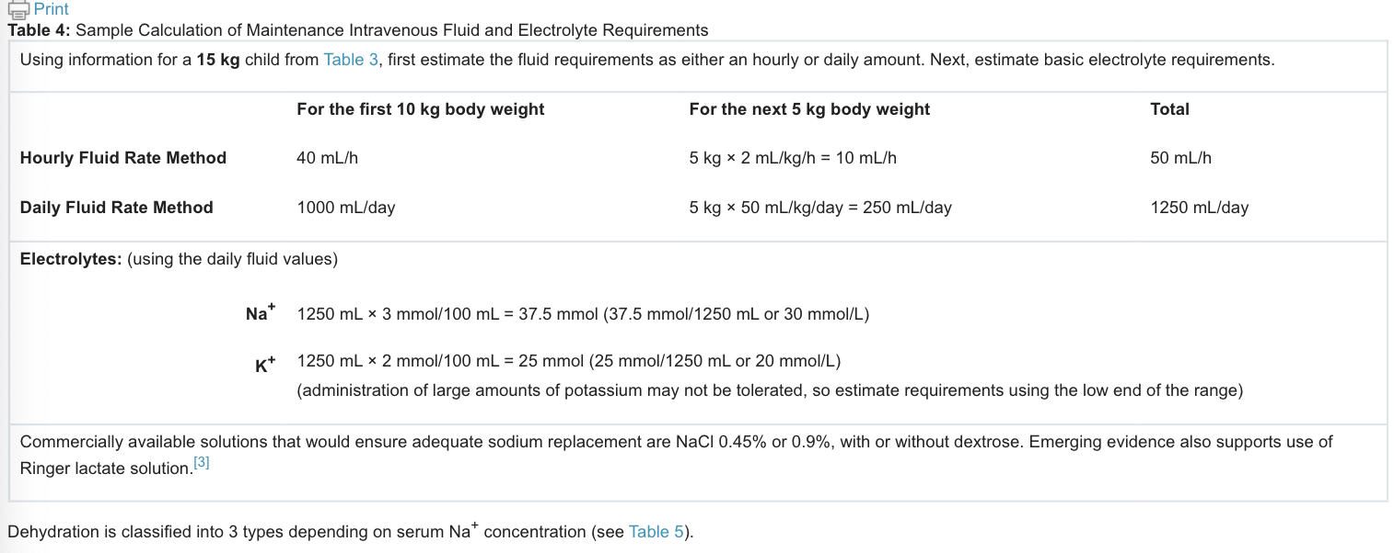

Oral Rehydration Therapy
-Oral rehydration is the treatment of choice in children with mild to moderate dehydration.
-Oral rehydration can be used in all types of dehydration as long as hypo- and hypernatremic dehydration are not present.
-The fluid deficit is calculated and the rate of replacement is based upon the degree of dehydration.
-mild to moderate dehydration, the rate of replacement is 50 mL/kg over the first 4 hours;
-moderately to severely dehydrated, the rate of replacement is 100 mL/kg over the first 4 hours. -the rehydration phase may last from 4–12 hours after the first 4 hours start to replace the remainder of the deficit over the next 6–8 hours.
-The fluid should be a balanced electrolyte solution ideal solutions for oral replacement therapy contain Na​⁺ 45–75 mmol/L, K​⁺ 20 mmol/L and glucose 20–24 g/L; 100–150 mL/kg/day is given to the child.
- impossible to determine how much fluid is being consumed during breastfeeding, so breastfeeding should be held during rehydration.
-Once oral rehydration is complete, infants older than 6 months of age can return to breastfeeding or formula. In infants less than 6 months restart the child on breast milk or half-strength formula
-Children started on IV fluid replacement therapy should be switched to oral replacement therapy as soon as feasible since it is equally effective and linked to a shorter hospital stay.
⁻If oral replacement therapy is not tolerated, switch to nasogastric tubes.
-Contraindications: protracted vomiting despite small, frequent feeding, severe dehydration with shock-like state, impaired consciousness, paralytic ileus, monosaccharide malabsorption.
-Antiemetics can be used such as ondansetron :
Dose of ondansetron: 8–14 kg = 2 mg, 15–30 kg = 4 mg, >30 kg = 6–8 mg, side effect include diarrhea.
Oral rehydration should begin 15–30 minutes following administration of ondansetron.​

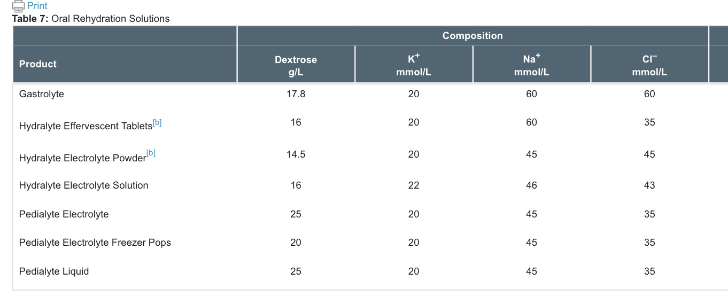

Notes
Monitoring | Sodium, potassium, chloride, urea, creatinine, glucose, bicarbonate, blood gases, urinalysis  Urine output
Referral | Hospital admission if: shock, hypo-/hypernatremia, intractable vomiting/diarrhea, altered sensorium possibly if serum HCO₃ <15 mmol/L at onset of therapy or poor response to oral replacement therapy and ongoing requirement for IV therapy.

Diarrhea (CPS)
Def’n | Loose watery bowel movements  -Diarrhea may be defined as acute (<14 days in duration), persistent (14–30 days in duration) or chronic (>30 days in duration).​
Therapeutic goals | -Reduce symptoms and improve stool frequency or consistency to improve quality of life  -Prevent and treat complications, e.g., dehydration, electrolyte depletion, nutrient malabsorption, hemorrhoids, rectal prolapse  -Remove or eradicate the cause of diarrhea where possible
Algorithm | 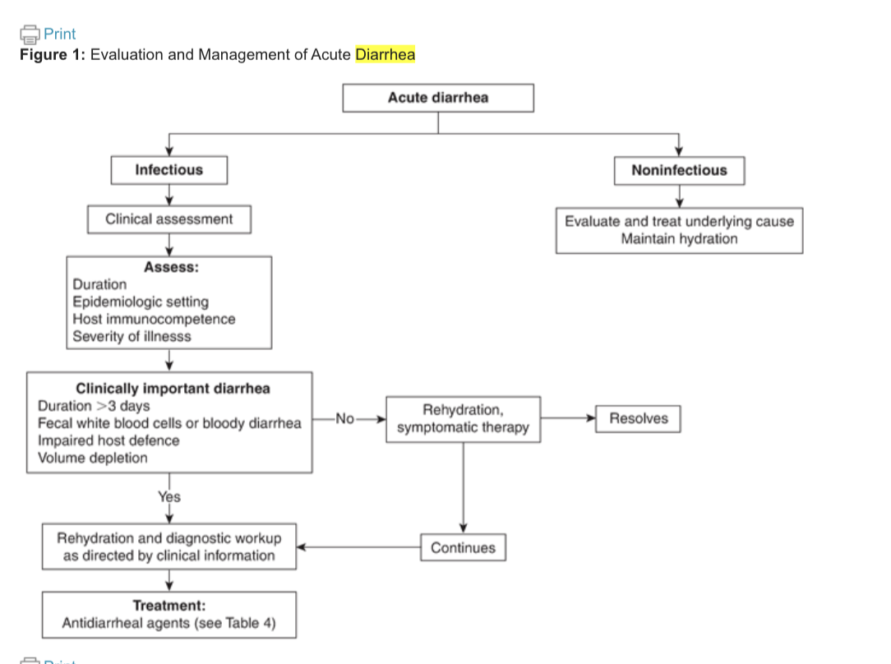  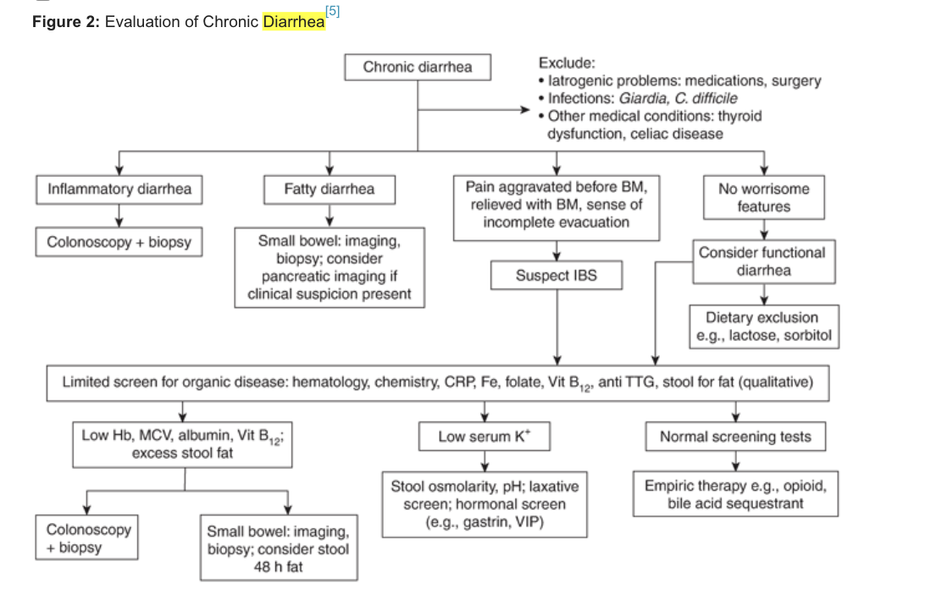  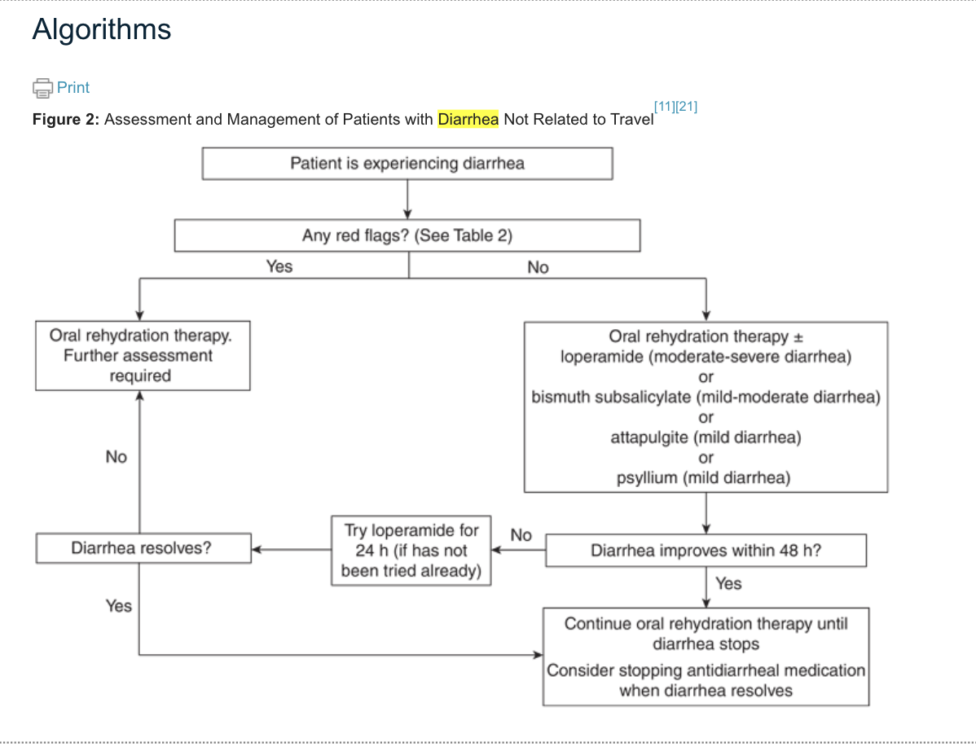
Non-pharmacological options | -drink enough fluids and electrolytes  -oral rehydration solutions (mixture of water and salt)  -discontinue medications that cause diarrhea  -stop eating poorly absorbed carbohydrates, beverages and foots containing fructose, lactose-containing dairy products  -once bowel movements have subsided start a bland diet that is low fat, low carbohydrate including, for example, bananas, rice, unsweetened applesauce, clear soup).  -oral rehydration therapy  -Prevent C. difficile spread: practicing good hand hygiene and isolating patients in hospital settings until symptom-free for 48 h post initiation of treatment, wearing protective clothing gowns and gloves.
Education/counseling | -Patients must understand the importance of a balanced electrolyte oral rehydration solution in preventing and treating dehydration.  -Breast feeding should be continued during children episodes of diarrhea  Seek medical assistance in children if younger than 6 months or:  - They have vomiting that lasts longer than 4–6 hours, or  - They show any of these signs of dehydration:  - dry mouth or tongue  - no tears when they cry  - less than 4 wet diapers in 24 hours  - their eyes or soft spot are sunken  - they are irritable or have low energy  Seek medical assistance if have:  - A high fever over 38.5°C.  - A bowel movement that has blood or black  - Diarrhea that lasts longer than 2 days  - Severe pain in your belly  - More than 6 bowel movements in 1 day  - Vomiting  - Signs of dehydration (very thirsty, weak or lightheaded, dry mouth or tongue, not urinating as often as usual).
Acute Diarrhea  Infectious Diarrhea | -oral rehydration therapy (ORT)  Bismuth subsalicylate: treat acute diarrhea, used for gastric ulcers, adverse effects: hypercalcemia, hypercalcuria, bismuth related encephalopathy  Opioids (codeine, diphenoxylate, loperamide): an effective antimotility agents for acute and chronic diarrhea. Antimotility should not be used in diarrhea caused by microorganisms as stasis can increase infection.  Codeine: causes sedation and analgesia.  Diphenoxylate and loperamide: have fewer side effects  Probiotics: not enough studies to recommend
C-diff | Management of C-diff: consists of preventing spread, implementing supportive measures, hospitalization.  Vancomycin and fidaxomicin: used for initial episodes of C-diff  Metronidazole: non severe C-diff  -Relapse:  -first relapse should treated with first line therapy,  - second relapse treat with tapered or pulsated vancomycin oral, standard dose is followed by rifaximin or fidaxomicin  -third recurrence fecal microbiota transplantation (FMT) (done through colonoscopy or oral capsule)  Bexlotoxumab: use for recurrent CDI, human monoclonal antibody against C-diff.
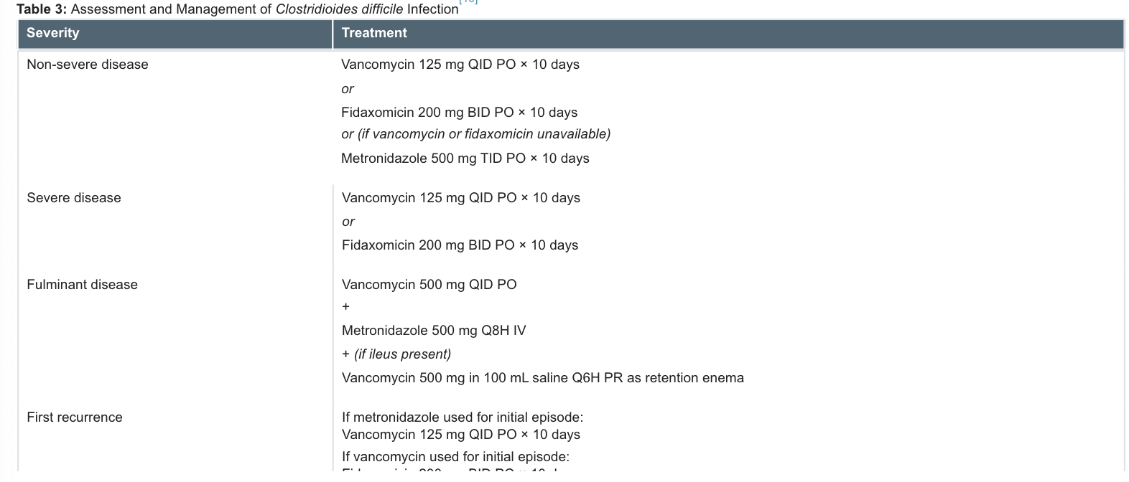

Chronic Diarrhea | Hydrophilic Bulking Agents:  Cholestyramine resin: treats bile acid- induced diarrhea  Alpha2-adrenergic Agonists:  Clonidine: is effective for diarrhea in IBS, opioid withdrawal and diabetic autonomic neuropathy. A/E:sedation, dry mouth, orthostatic hypotension  Somatostatin Analogues:  Octreotide help with diarrhea caused by neuroendocrine tumours, ileostomy, short bowel syndrome, diabetic neuropathy, chemo, HIV
Pregnancy and Breastfeeding | Bulk forming agents (psyllium)- are first choice in treating diarrhea in pregnancy.  Loperamide: second line for treatment of diarrhea in severe cases.  Diphenoxylate/atropine contraindicated in pregnancy!!  Bismuth subsalicylate: avoided during pregnancy
Pharmacological Therapy
Drug/Dose | Indication | Adverse fx (AE) and Drug interactions (DI) | Contraindications & special considerations
1st Line Therapies
Oral Rehydration Therapy (ORT) | -should be started as soon as diarrhea begins and until it is less frequent  -used to prevent dehydration and electrolyte loss  -have a balanced sodium to glucose ratio (excess sodium or glucose can aggravate diarrhea).  -ex. Gastrolyte, pedialyte or homemade: 2.5mL of salt and 6 teaspoons 30mL of sugar to 4cups 1L of water.  -contraindicated in: protracted vomiting despite small frequent feeding, worsening diarrhea and cant keep up with losses, stupor or coma, intestinal ileus  CHRIS WAS OBSESSED WITH THIS SO CHART SO IT MAY HAVE BEEN AN EXAM QUESTION IN THE PAST??  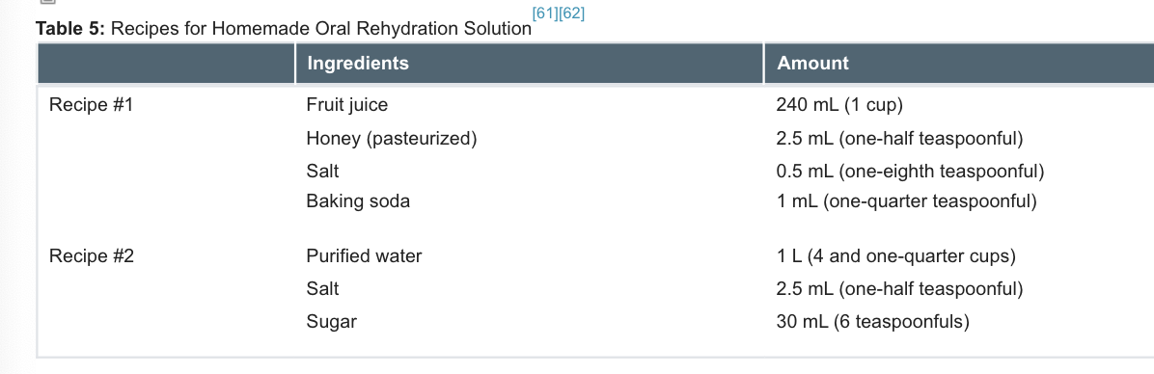  Children:  -Breastfeeding should be continued during diarrhea and ORT can be offered, ORT should be offered as soon as diarrhea begins and until diarrhea is less frequent.  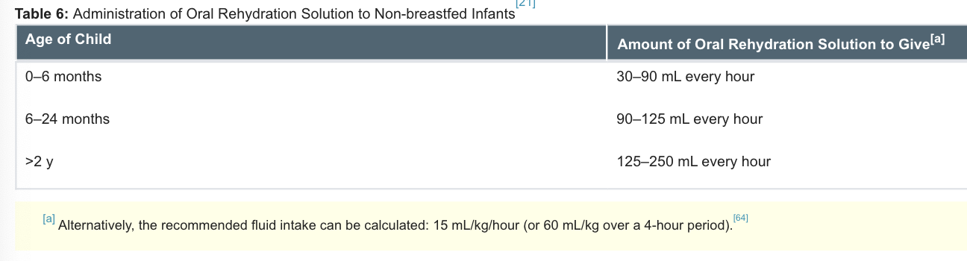  Oral rehydration solution (ORS) should be given to a child with a cup or bottle, solution can be given with a medicine dropper or spoon (15mL every 10-15 min until vomit stops)  If vomit does not stop after 4-6hr child should undergo further assessment  -start refeeding in 6hr of starting ORS.  -if child is formula fed refeed with small frequent feeding if diarrhea persists for 2 days switch to soy or lactose free  -if child is older can resume normal diet after 24-48 hrs  -hypo-osmolar is more effective than iso-osmolar solutions due to (shorter period of diarrhea, less stool output and less maintenance therapy)**  -In addition to hypo-osmolar ORS, recommend supplementation with zinc 20 mg daily for 10–14 days for infants >6 months of age and 10 mg per day for infants <6 months of age. (Zinc supplementation decreases both the severity and the duration of acute or persistent diarrhea in children).  -half-diluted apple juice followed by preferred fluids can be considered for children with mild gastroenteritis and minimal dehydration  -prompt rehydration is essential to avoid damage to vital organs in elderly.
Clonidine  0.1-0.3mg BID PO | Alpha2-adrenergic agonists  Used in treatment of opioid withdrawal and diabetic autonomic neuropathy | AEs:centrally mediated sedation, hypotension  DIs:additive effect with drugs that cause hypotension
Flidaxomicin  200mg BID PO x 10 days | Antibacterial Agents  Used in treatment of C-diff | AEs:constipation, nausea, rash, vomiting  DI
Metronidazole  500mg TID PO x 10 days | Antibacterial Agents  Used in treatment of C-diff | AEs:nausea, headache, anorexia, dry mouth, metallic taste in mouth  DIs:can potentiate warfarin monitor INR, avoid alcohol
Vancomycin  125mg QID PO x 10 days | Antibacterial Agents | AEs:Bitter taste, nausea, vomiting, stomatitis, chills, drug fever, eosinophilia
Psyllium hydrophilic mucilloid (metamucil)  1 teaspoon (5-6g) q12h PO | Hydrophilic Bulking Agents | AEs:inhales can have allergic reactions, cramping, and flatulence. Esophageal obstructions can occur if not enough fluids  DIs: can interfere with absorption of carbamazepine and lithium | Do not combine with laxatives  Separate administration of other medications by 2h  Contraindicated in patients with dysphagia
Bismuth subsalicylate with calcium carbonate (Pepto-Bismol)  2 tabs q 30min PO max 8 doses/day  Or 30mL q 30min PO | Intestinal Adsorbant  Used to treat chronic idiopathic diarrhea with a reduction in stool weight and frequency | AEs:salicylate toxicity, black tongue, black stool,tinnitus bismuth-induced, encephalopathy  DIs: decreased absorption of fluoroquinolones, doxycycline, tetracycline. Avoid patients taking anticoagulants, methotrexate, probenecid, salicylatees
Codeine  30-60mg q4hr PRN PO | Opioids | AEs:sedation, nausea, tolerance- addictive  DIs: additive CNS depression with CNS depressant
Loperamide  2mg PO after each loose bowel movement (maximum of 16mg/day) | opioid | AEs:sedation, nausea, abdominal cramps, discomfort, drowsiness, dizziness, dry mouth, skin rash | Opiate-like CNS effects have been observed in children <3 y of age.  -Do not use in children <3 y of age or in those who are malnourished, moderately or severely dehydrated, systemically ill, or with bloody diarrhea.  Use with caution in children <12 y of age.  Discontinue if symptoms persist longer than 48 h.  Monitor patients with hepatic dysfunction for signs of CNS toxicity.
Cholestyramine resin  4g Q12h PO | Resin  Used in treatment of bile acid-induced diarrhea | AEs:nausea, fat-soluble vitamin deficiency with long term use, constipation  DIs: administer other meds at least 1hr before or 4-6hr after | Take with fluids
Octretide acetate  50-500mcg Q12h SC | Somastostain Analogues  Used in treatment of diarrhea due to chemotherapy, short bowel syndrome, neuroendocrine tumors, AIDS, chronic diarrhea not responding to treatment. | AEs:pain at injection site, nausea, mild diarrhea  DIs: Hypoglycemia or hyperglycemia
Notes
Monitoring | 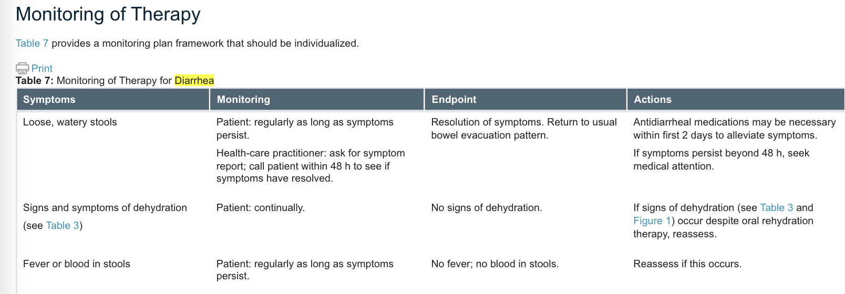
Referral
Other notes | - if working with food service, daycare, employee, health care with diarrhea, and have direct patient contact should be tested for parasitic and bacterial pathogens.  - If suspect an endemic diarrheal disease outbreak should report their concern to public health authorities and work with them to initiate appropriate diagnostic testing to identify the pathogen and define the extent of the outbreak.

Managing Proton Pump Inhibitor Use in Older Adults
https://cep.health/media/uploaded/CEP_PPIs_20210305.pdf

https://deprescribing.org/wp-content/uploads/2018/08/ppi-deprescribing-algorithm_2018_En.pdf
Tool designed to help HCPs assess and discuss pros/cons of PPI use in pts >65
Chronic use of PPIs has become problematic and rampant. Older adults more susceptible to AEs d/t comorbidities and when PPIs are used too long, they can contribute to polypharmacy related AEs, med errors, DIs, ED visits and hospitalizations

Risks and Benefits
Potential risks from long-term (>1 year) use:
- Hip fracture
- C diff infx
- Acute interstitial nephritis
- Community acq. PNA
- Low Mg
- B12 deficiency

Benefits of short-term use:
- GERD, prevention of NSAID associated peptic ulcer, reflux esophagitis, functional dyspepsia, H pylori assoc peptic ulcer recurrence

Identifying Pts
HCPs should discuss patient use of PPIs when a patient:
- Is >65yo
- Comes in for a rx renewal or refill
- Has had a recent hospitalization
- Has had a recent med reconciliation
- Is admitted to LTC
- Complains of side fx (HA, N/V/D, rash)
- On meds that don’t match their active medical concerns

SECTION A: Algorithm
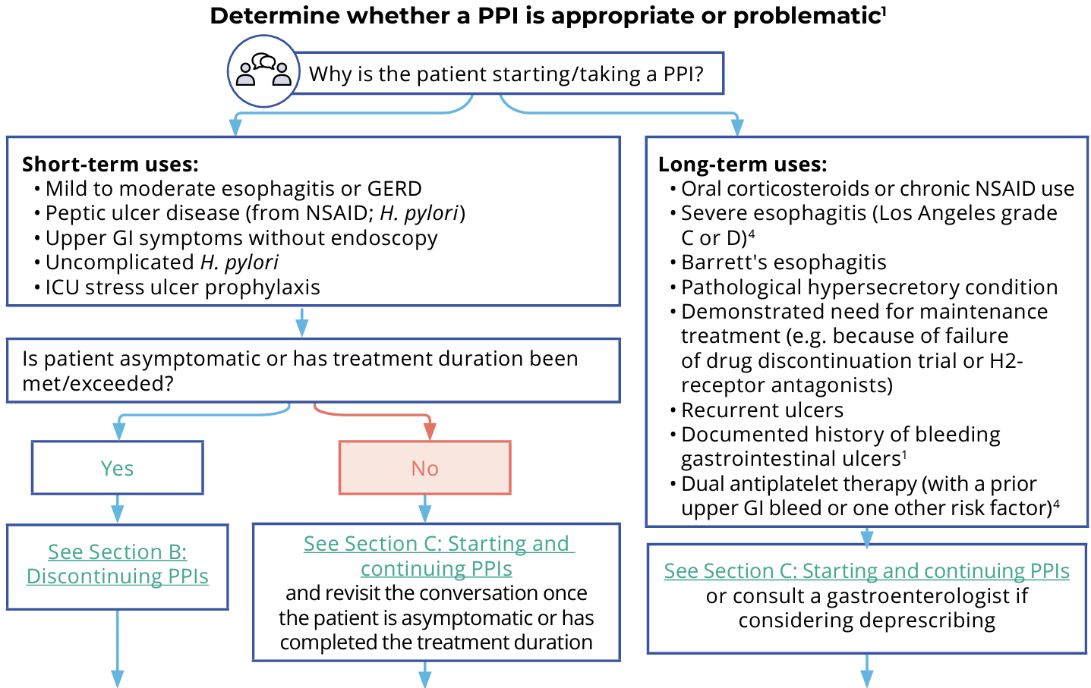
SECTION B: Tapering/Discontinuing PPIs
- Before tapering- ensure lifestyle changes and alternative therapies are implemented to reduce risk of relapse symptoms
- Plan the taper- no evidence to support one tapering approach to another, it’s based on pt preference and what plan seems most tolerable
- Engage pts in developing a clear plan for tapering- when are their symptoms most severe? Customize their plan
- Establish method of tapering: ensure the ODB covers the doses you plan to use during tapering and if not, consider alternate day dosing or switching to another PPI
- Potential tapering methods:
- Reduce dose from BID to daily
- Reduce from daily to every other day
- Stop PPI and replace with H2 blocker
- Reduce dose to PRN
- Include a note in Rx to inform pharmacist of tapering plan and consult pharm if pill splitting is necessary
- Initiate taper and monitor
- Initiate plan
- F/U in 4-12 wks to report any relapse symptoms: heartburn, reflux, sore throat, coughing, abdo pain
- If pt experiencing withdrawal and/or rebound acid reflux > suggest non-pharm and non-PPI alternatives to lessen symptoms (ex. Tums, H2RA)
- If still not tolerating > re-implement PPI > if symptoms still continuing > test for H pylori and consult GI
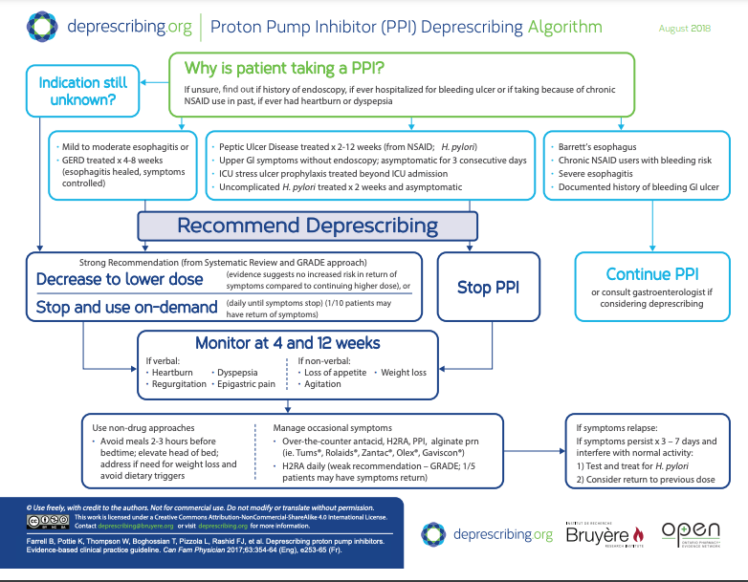
SECTION C: Starting and Continuing PPIs
Important info to collect before starting a PPI:
- Pre-existing conditions that require a GI referral: dysphagia, GI bleeding/anemia, recurrent vomiting, weight loss, odynophagia
- Dietary patterns and triggers (e.g. ETOH, caffeine)
- All prescribed and OTC meds
- Hx of prev non-pharm and pharm alternatives tried - an adequate trial is approx 6-8 wks
- Hx of adverse events

Tips for safe PPI prescribing:
- Limit Rx to 2-8 wks
- Discuss tapering plan before prescribing a PPI
- Consult with GI before concomitantly administering anti-secretory agents d/t marked reduction in acid inhibitory fx
- F/U in 4-8 weeks

Chronic use of PPIs
- Conditions that may require long-term PPI use: barrett’s esophagus, chronic oral corticosteroids or chronic NSAID use, esophagitis, hx bleeding GI ulcers, dual antiplatelet therapy (with a prior UGIB or one other risk factor)

SECTION D: Alternatives to PPIs
Non-Pharm:
- Elevate HOB
- Diet: increase fibre, avoid chocolate/ETOH/caffeine/acidic juices/large fatty meals/spicy feet/peppermint; choose smaller quantities and ebay slowly
- Weight loss
- Less evidence for these: avoid lying down 2-3h after you eat, avoid tight clothes, smoking cessation

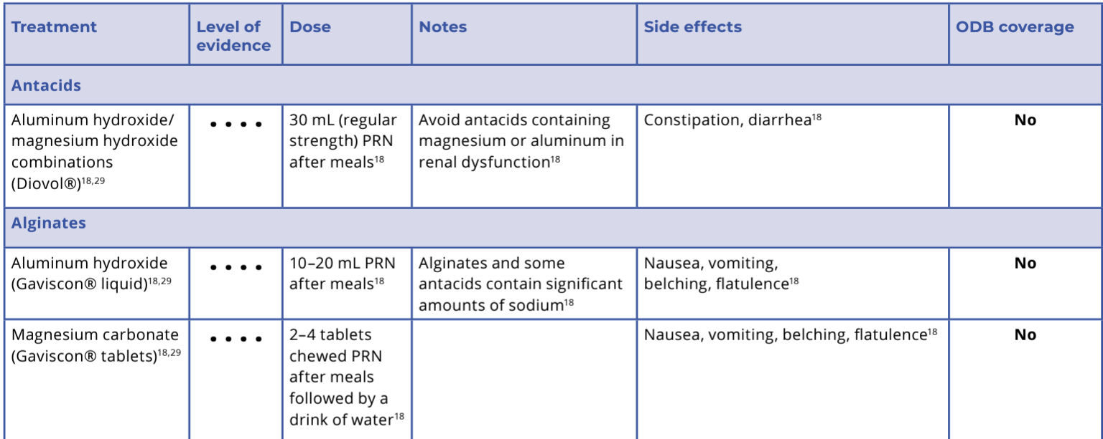
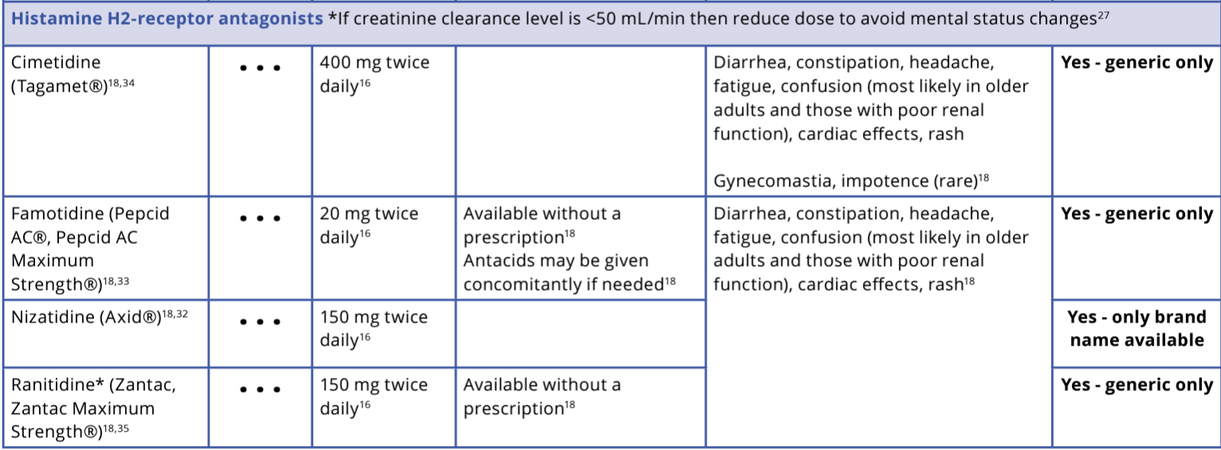

Other alternatives (not as effective but can relieve minor symptoms of heartburn/reflux): pepto bismol, calcium carbonate like tums, magnesium hydroxide)

Hepatitis B/C
https://www.catie.ca/hepatitis-b
https://www.catie.ca/hepatitis-c-an-in-depth-guide/hepatitis-c-treatment
HEP B

1. Acute Hepatitis B:
- Self-limiting in most cases: Typically resolves within six months without specific treatment.
- Supportive care: Treat severe symptoms like fatigue or nausea; antiviral therapy is rarely needed.
- Monitoring: Blood tests six months post-diagnosis confirm if the virus has been cleared.

2. Chronic Hepatitis B:
- Treatment Goals: Reduce viral replication to prevent liver damage, cirrhosis, and liver cancer.
- Therapy Options:
  - Interferon-based injections (e.g. Pegylated interferon-alpha): Weekly, for specific cases.
    - Limited efficacy (best for young pts with less advanced liver disease)
    - AE: flu like symptoms, depression, cytopenias
  - Antiviral pills (nucleos(t)ide analogues): Daily, tailored to patient needs.
    - 1st line - Entecavir, Tenofovir oral once daily, long-term or lifelong duration
- Monitoring: Lifelong liver function tests and viral load checks.

3. Prevention and Post-Exposure:
- Vaccination:
  - Universal vaccination for infants and high-risk groups (e.g., healthcare workers, people from high-prevalence regions).
  - Routine three-dose vaccination for infants as per local immunization schedules.
- Perinatal Prevention:
  - Screen all pregnant individuals.
  - Administer hepatitis B immunoglobulin (HBIG) and the first vaccine dose to newborns within 12 hours of birth.
  - Continue vaccination schedule to prevent chronic infection.
- Post-Exposure Prophylaxis (PEP): Administer HBIG and a vaccine within 48 hours of exposure.

4. Non-Pharm/Education: Lifestyle and Liver Health:
- Diet: Balanced nutrition, avoiding alcohol and liver-toxic substances.
- Exercise: Light-to-moderate physical activity improves health and reduces stress.
- Screening for Other Hepatitis: Vaccinate against hepatitis A and screen for hepatitis C to protect liver health.

Prevention of Transmission: Safe practices in sexual activity (e.g., condoms), drug use (e.g., new equipment), and handling personal items.

5. Management of Coinfections:
- HIV–Hepatitis B Coinfection: Dual-active treatments are used, and careful drug selection is crucial to prevent resistance.
- Hepatitis B–C Coinfection: Monitor for hepatitis B reactivation during hepatitis C treatment.
HEP C

Highly Effective Treatments
- Over 95% of individuals with hepatitis C can be cured with available treatments.
- Cure eliminates the virus, preventing further liver damage and reducing the risk of end-stage liver disease.
- Benefits of being cured include improved liver health, increased energy, reduced pain, and prevention of transmission.

Direct-Acting Antivirals (DAAs)
- Mechanism: Block the hepatitis C virus from replicating.
- Regimen: Usually involves taking 1–3 pills daily for 8–12 weeks.
- Effectiveness: Can cure all genotypes (pangenotypic options available).
- Side Effects: Mild, typically fade after a few weeks.

Cure Definition
- A cure is achieved when hepatitis C RNA is undetectable 12 weeks after treatment, known as sustained virological response (SVR).
- Individuals remain hepatitis C antibody-positive for life but have no active virus in their body.
- No immunity exists; re-infection is possible.

Treatment Timing
- Acute infections (first six months) may resolve on their own in 25% of cases.
- Chronic infections (>6 months) usually require treatment, especially for those with advanced liver disease or co-morbidities.

Factors Influencing Treatment Choices
- Liver Injury: Severity impacts treatment duration and urgency; advanced damage may require a liver transplant first.
- Other Conditions: Drug interactions with medications, supplements, or substances must be managed.
- Genotype: Treatment tailored to the virus strain; pangenotypic options exist.
- Previous Treatments: Effective options are available for those previously treated without success.
- Pregnancy: DAAs (especially with ribavirin) are generally avoided during pregnancy due to safety concerns.

Special Populations
- Children: Treatment is available for children over 3, typically under specialist care.
- Co-infections: Requires tailored regimens to manage hepatitis C alongside conditions like HIV or hepatitis B

,Week 11: GU 1

Epididymitis
MUMS
Def’n | Inflammation of epididymis - acute onset of unilateral testicular pain and swelling, with tenderness of epididymis and vas deferences and occasionally erythema and edema of the overlying skin  - When there’s also urethral discharge,its presumed to be a sexually acquired infx
Therapeutic goals | N/A
Algorithm
Non-pharmacological options
Education/counseling
Pharmacological Therapy
Drug/Dose | Indication | Adverse fx (AE) and Drug interactions (DI) | Contraindications & special considerations
1st Line Therapies
Duration: 10-14 days (if secondary to prostatitis, may require up to 6 wks of therapy)
Ciprofloxacin 500 mg PO BID or 1g daily x10-14d | >35 yo  E Coli, other gram -’ve bacilli  Non-sexually transmitted epididymitis (assoc with UTIs) occurs more often in men>35 yo with E coli as the predominant pathogen | AEs:  DIs:
Levofloxacin 500 mg daily x10-14d
(Cefixime 800mg x1  OR  Ceftriaxone IM 250-500mg x1)  AND  Doxycycline 100mg BID x10-14d  +  Azithromycin 1g x1 | < 35 yo OR multiple sex partners  Epididymitis in sexually active men <35 usually d/t Chlamydia or Gnorrhea
Ceftriaxone 250-500mg IM x1  OR  Cefixime 800mg x1  AND  Levofloxacin 500mg daily x10-14d | Adults who practice condomless insertive anal sex  Gonorrhea, chlamydia, enteric organisms
Notes
Monitoring | N/A
Referral | Sexually acquired epididymitis is reportable to public health -
Other notes | - If there’s no improvement in 2-3 days, re-evaluate  - Consider non-infectious causes of scrotal swelling like trauma, tumor, torsion of testicle  - Assess all sex partners of patients with sexually acquired epididymitis from 60 days pior to symptom onset or date of specimen collection if asymptomatic  - If no partners within 60 day period, assess the last sexual partner  - Consider ciprofloxacin if Pseudomonas is suspected

Pelvic Inflammatory Disease (Outpatient)
MUMS
Pharmacological Therapy
Drug/Dose | Indication | Adverse fx (AE) and Drug interactions (DI) | Contraindications & special considerations
1st Line Therapies
Cefixime 800mg x1  OR  Ceftriaxone IM 250-500mg x1  AND  Doxycycline 100mg BID x14d  +/-  Metronidazole 500mg BID x14d |  | Mild to moderate PID  Organisms incl: chlamydia, gonorrhea, E coli, and tons of others
2nd Line Therapies
Levofloxacin 500mg daily x14d  +/- Flagyl 500mg BID x14d |  | Mild to moderate PID  Organisms incl: chlamydia, gonorrhea, E coli, and tons of others
Moxifloxacin 400mg daily x14d

+/- Flagyl 500mg BIDx14d

Notes
Monitoring | Re-evaluate in 48-72h after initial assessment > if no improvement, consider admission to hospital and/or specialist referral  Women who have had PID have 10x risk of subsequent PID, 8x risk ectopic pregnancy, and 10x risk tubal infertility
Referral | Report all cases of gonococcal PID to public health  All sex partners should be treated empirically with regimens effective against both chlamydia and gonorrhea if they’ve had sexual contact during the 60 days prior to onset of symptoms (or last sexual contact if there were no partners in last 60 days)
Other notes | - PID rare in pregnancy; these pts may need hospitalization to consider other diagnoses (fluoroquinalones and tetracyclines C/I in pregnant and lactating women)  - Flagyl: add for women with adnexal mass formation, tubo-ovarian abscess, peritonitis, or increased risk of anaerobes or people who are acutely ill (fever, chills, toxicity); anaerobes are of greater importance in severe PID and flagyl may be D/C in those with mild-mod PID who cannot tolerate it

Vulvovaginitis: Trichomoniasis
Def’n | Vulvovaginitis: Inflammation of vulva, vagina, or both and/or abnormal vaginal discharge not d/t cervicitis  Causes:  - Infection - bacteria, candidiasis, trich, or mixed infections  - Disruption of normal flora of vagina - excessive secretions, hypersensitivity (e.g. condoms, soap, douches), foreign body, lack of vaginal lubrication during sex
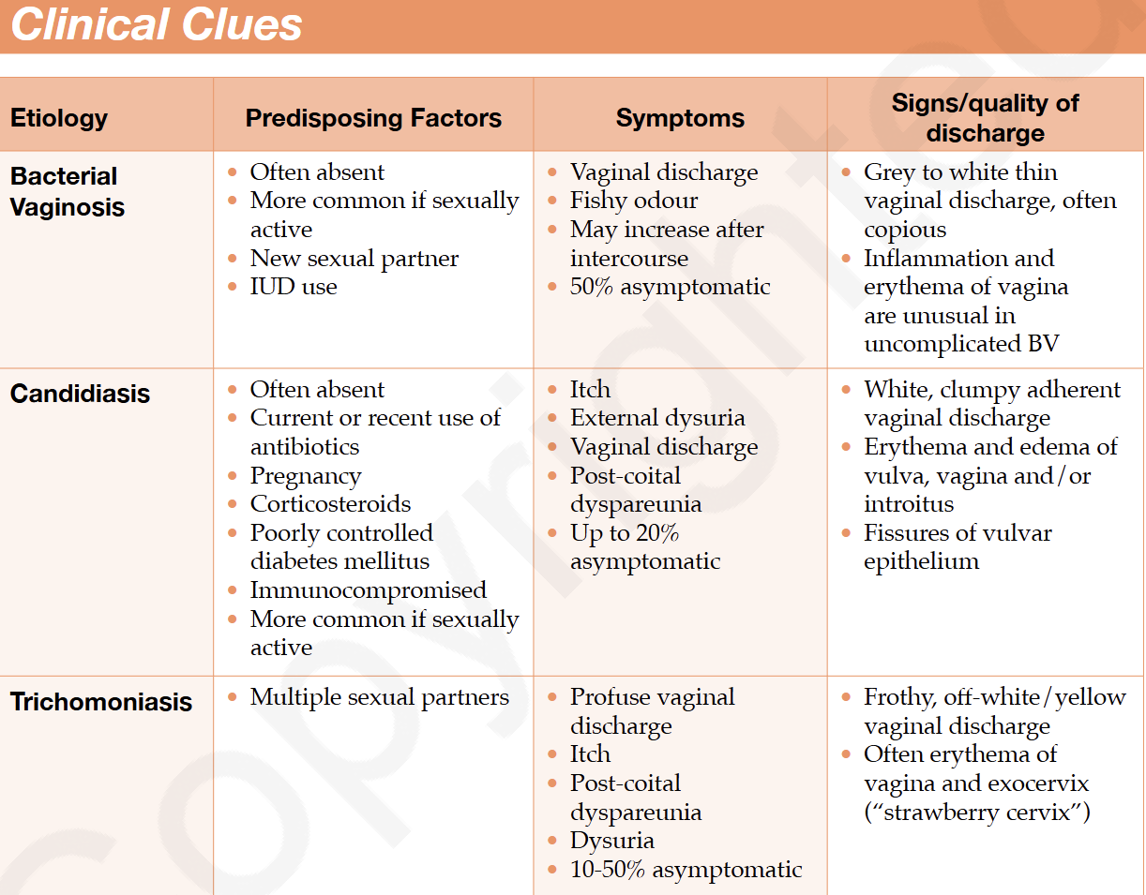
Pharmacological Therapy
Drug/Dose | Indication | Adverse fx (AE) and Drug interactions (DI) | Contraindications & special considerations
1st Line Therapies
Metronidazole 2g x1 OR 500mg BID x7d | Vaginitis (Trichomoniasis)  T. Vaginalis  Treat all cases and their sexual partners regardless of symptoms | Important to R/O cervicitis when diagnosing vaginitis. T vaginalis is sexually transmitted and 10-50% of pts are asymptomatic.  Most men with trich are asymptomatic but some may have mild urethritis | Pregnancy Considerations:  Asymptomatic - don’t treat  Symptomatic - same treatment  Lactation - Flagyl not C/I during breastfeeding but it does enter breast milk and may affect taste > withhold breastfeeding during tx and for 12-24h after last dose to reduce exposure of infant to flagyl; avoid high doses if breastfeeding

Vulvovaginitis: Bacterial Vaginosis (BV)
Def’n | - Non-inflammatory condition of vaginal flora  - BV is linked to gynecologicl risks like PID, cerviciits, post-op infx, and other STIs > important to R/O cervicitis when diagnosing BV
Pharmacological Therapy
Drug/Dose | Indication | Adverse fx (AE) and Drug interactions (DI) | Contraindications & special considerations
1st Line Therapies
No treatment unless:  High-risk pregnancy (e.g. prior pre-term delivery), prior to IUD insertion, or gyne surgery, induced abortion, or upper tract instrumentation |  | Asymptomatic  Mixed anaerobic/aerobic
Metronidazole 500mg BID x7d |  | Symptomatic  No tx needed for male sex partner  Overgrowth; G. vaginalis, M hominis, Anaerobes
Metronadizole 0.75% gel 1 applicatorful (5g) intravaginally once nightly x5 days
Clindamycin 2% cream - 1 applicatorful (5g) intravaginally once nightly x7 days
Metronadizole 500mg BID for 10-14d |  | Recurrent  Overgrowth; G vaginalis, M hominis, Anaerobes
Metronadizole 0.75% gel - 1 applicatorful (5g) intravaginally
-once nightly x10d
-then twice weekly for 4-6months
2nd Line Therapies
Metronidazole 2g x1 dose  *Single dose flagyl has a cure rate of 85% but higher relapse rate at 1 month |  | Symptomatic  No tx needed for male sex partner  G. vaginalis, M hominis, Anaerobes
Clindamycin 300mg BID x7d
Notes

Other notes | Pregnancy  - BV in preg. Assoc with adverse outcomes so all pregnant women with symptomatic BV need tx  - High-risk pregnancy: Screen and tx at 12-16 wks  - Low-risk and asymptomatic: DO NOT NEED screening and tx (no benefit)  - Flagyl:  - Avoid oral in 1st trimester  - Use topical flagyl instead for 1st and 2nd trimester  - Don’t use applicator after 7th month of pregnancy  - Oral therapy recommended in 3rd trimester to prevent subclinical infection of the chorioamnion  - Repeat testing after 1 month to ensure tx is effective  - Clinda  - Topical clinda assoc with AEs in newborn  - Oral should only be considered if flagyl not possible  Lactation:  - Interrupt breastfeeding until 24h after completing therapy since oral flagyl is excreted into breast milk in relatively large amounts; however no reported AEs on breastfed infants of moms who took flagyl; other experts prefer topical treatment  Lactobacilli preparations not effective in treatment of BV or VVC

Vulvovaginitis: Vulvovaginal Candidiasis (VVC)
Def’n | Caused by Candida spp or other fungi
Pharmacological Therapy
1st Line Therapies
No tx needed |  | Asymptomatic
Clotrimazole options (Pick any option below)  Intravaginal tab:  500mg tab x1 dose  200mg tab daily x3d  Intravaginal creams:  1% - 1 applicator daily x6d  2% - 1 applicator daily x3d  10% - 1 applicator intravag x1 dose |  | Symptomatic  No tx needed for mal sex partner unless candida balanitis is present (tx with fluconazole 150mg x1 dose or micronazole/ clotraminazole cream BID x7d)
Miconazole (pick any option)

Intravaginal ovules:
100mg ovule supp intravag daily x7 d

400mg ovule intravag daily x3 d

1200mg ovule intravag x1 dose

Intravaginal Creams:
2% - 1 applicator daily x7

4% - 1 applicator daily x3
Fluconazole
150mg oral x1 dose
Terconazole 0.4% 1 applicator intravag daily x7
Recurrent VVC (3+ episodes/year)
- Needs investigation for underlying causes (vag culture) and different therapeutic strategies; without maintenance therapy, VVC recurs in 50% of pts within 3 months
Fluconazole  150mg PO Q72h x3 doses  OR  Topical azole x10-14d |  | Induction treatment
Fluconazole  150mg PO weekly x6 months  * Main tx; the other ones below are alternatives |  | Maintenance therapy  (pick one)
Ketoconazole 100mg PO daily
Itraconazole 200-400mg PO once a month
Clotrimazole 500mg intravaginally once a month
Topical azole x7-14 d  OR  Fluconazole 150mg PO x 2 doses (2nd dose 72h after first) |  | Severe VVC (extensive vulvar erythema, edema, excoriation, fissure formation)
Notes
Monitoring | Expected resolution 2-3 days
Other notes | - R/O cervicitis when diagnosing VVC  - Topical and oral azoles equally effective  - Intravaginal products- bedtime administration preferable  - Limited evidence for use of lactobacilli preparations for treatment of BV and VVC  Pregnancy:  - Topical antifungal agents are tx of choice  - Longer tx (7 d) may be more effective than shorter courses  - Oral azoles not recommended during pregnancy (e.g. fluconazole) d/t spontaneous abortion and congenital anomalies  - Non-albicans VVC: longer duration of therapy needed (7-14 d) with non-fluconazole azole regimen (oral or topical)

Urethritis - Gonococcal (Adult & Children)
Algorithm | - It is recommended to routinely treat both gonorrhea and chlaymdia concomitantly as these 2 pathogens often accompany each other.  - If culture results are pending and there’s urethral discharge > treat for both.  - If no urethral discharge, defer antibiotics until results are available.Infx may be present without symptoms but if present, tx is required (I think they’re trying to say, we always treat if it’s detected even if they’re asymptomatic)  - Dual therapy recommended for gonorrhea d/t antibiotic resistance. Avoid monotherapy.
Pharmacological Therapy
Drug/Dose | Indication | Adverse fx (AE) and Drug interactions (DI) | Contraindications & special considerations
1st Line Therapies
Cefixime 400-800mg PO x1 dose  OR  Ceftriaxone IM 250mg x1  PLUS  Azithro 1g PO x1  OR  Doxy 100mg BIDx7d |  | Adolescents and adults >9 yo  Organisms: Gonorrhea, Chlamydia
Cefixime and ceftriaxone (assuming same dose as above)  Plus azithro 1g single dose  (doxy is contraindicated) |  | Pregnancy and nursing mothers
Cefixime 8mg/kg x1 dose (max 400mg)  OR  Ceftriaxone IM 25-50mg/kg x1 dose  PLUS  Azithro 10-15mg/kg x1 dose |  | Children <9 yo  Organisms: Gonorrhea, Chlamydia
Azithro 2g  PLUS  Gentamicin 240mg IM in 2 separate injections  OR  IV gentamicin |  | Penicillin Allergy
2nd Line Therapies
Cipro 500mg x1 dose (not approved for <18yo)  PLUS  Azithro 1g x1 dose  OR  Doxy 100mg BIDx7d |  | Adults
Notes
Monitoring | Test of Cure - all pts treated with low risk of ahderece, pregant, child, persisting s/s, or an alternative regimen should have a test of cure 1-2 weeks after completing therapy  - Culture is first line, test in 3-7 days post treatment  - If using NAAT, it should be done no earlier than 3-4 weeks post treatment to avoid false positive  - Repeat testing for people with gonococcal infx recommended in 6 months  Pregnancy: repeat culture 4-5 days post treatment
Referral | Reportable to public health - all sex partners within 60 days should be evaluated and treated
Other notes | - Azithro or doxy should not be withheld if chlamydia is negative on testing

Urethritis - Nongonococcal
Def’n | Any non-gonococcal urethritis; can be caused by various organisms
Therapeutic goals
Algorithm | Report all STIs except for trich***
Non-pharmacological options
Education/counseling
Pharmacological Therapy
Drug/Dose | Indication | Adverse fx (AE) and Drug interactions (DI) | Contraindications & special considerations
1st Line Therapies
Azithro 1g PO x1 |  | Adolescents and adults >9 yo  Chlamydia, U. urealyticum, M. genitalium
Doxy 100mg BID x7d
Azithro 10-15 mg/kg x1 dose (max 1g) |  | Children <9 yo
Azithro 1g x1  OR  Erythromycin (same as dose below) |  | Pregnancy
2nd Line Therapies
Erythromycin 2g/day divided QID x7 days  - If not tolerated, 1g/day divided QID x14 days |  | Adolescents and Adults >9 yo
Moxifloxacin (not for children <18)
400 mg daily x7-14 d
Flagyl 2g x1 dose  PLUS  Erythromycin 500mg QID for 7 days  OR  Azithro 1g single dose (if it wasnt used initially) |  | Recurrent or Persistent Cases (common in 20-60% of men)  Ensure compliance and that sex partners were treated; also consider other causes  If noncompliance and reinfection is ruled out, consider these meds
Notes
Monitoring | Reportable to public health - all sex contacts within 60 days should be tested and empirically treated regardless of clinical findings and without waiting for test results  Resolution: can take up to 7 days AFTER therapy completed  Test of cure NOT routinely recommended unless:  - Compliance is low  - Alternate regimen is used  - Persisting s/s  - Prepubital or pregnant (Children <14 yo0  - N genitalium detected  - Non-genital site (e.g. eye) is involved  - Erythromycin is used

Cervicitis
Def’n | - Inflammation of cervix with mucopurulent or purulent cervical discharge and an increased # polymorphonuclear leukocytes  - Doesn’t occur in pre-pubertal girls (the counterpart is prepubertal vaginitis)  - Cervicitis and vaginitis frequently co-exist so pts should be evaluated for both
Pharmacological Therapy
Drug/Dose | Indication | Adverse fx (AE) and Drug interactions (DI) | Contraindications & special considerations
1st Line Therapies
Cefixime 400-800mg PO x1
OR
Ceftriaxone IM 250mg x1

PLUS

Azithro 1g PO x1
OR
Doxy 100mg BID x7d
2nd Line Therapies
Cipro 500mg x1 dose (NOT FOR CHILDREN <18)

PLUS

Azithro 1g x1 dose
OR
Doxy 100mg BID x7d
OR
Erythromycin 2g/day divided QID for 7 days
- If not tolerated, then 1g/day divided QID for 14 d
- If erythro is used, repeat testing after tx is advised
Notes
Monitoring | Reportable to public health - all sex partners should be evaluated if theyve had sexual contact within 60 days prior to onset of symptoms
Other notes | - Defer tx until microbiological results are available in “at-risk” patients including sexually active women where no mucopurulent or purulent endocervical discharge and no gram negative intracellular diplococci are present  - Pregnancy: use cefixime or ceftriaxone. If penicillin allergy, then azithro or erythro can be used instead. Erythromycin estolate is C/I in pregnancy though  - Cipro: consider if Pseudomonas is suspected. D/t resistance, quinolones should only be considered if susceptibility is demonstrated. Quinolones shouldn’t be used if there’s a possibility the infx was acquired somewhere known to have increased resistance (e.g. South East Asia). If used in such cases, test of cure recommended  - If erythromycin used, repeat testing after tx is advised

Genital Herpes (HSV 1 or 2) - Adult & Children
Def’n | Herpes Simplex Virus 1 or 2 can cause genital herpes
Therapeutic goals
Algorithm
Non-pharmacological options
Education/counseling | - Abstain from sex when lesions or prodromal symptoms are present and encourage them to inform their sex partners  - Transmission of HSV can occur during asymptomatic periods when there are no lesions. Use of condoms during all sexual exposures with new partners should be encouraged although condoms may not prevent transmission because of location of lesions or asymptomatic shedding  - Counsel on natural hx of disease, asymptomatic shedding, sexual and perinatal transmission and metods to reduce transmission
Pharmacological Therapy
Drug/Dose | Indication | Adverse fx (AE) and Drug interactions (DI) | Contraindications & special considerations
NORMAL HOST
Duration: 5-10 days  Acyclovir 400mg TID  OR  Famiciclovir 250mg TID  OR  Valacyclovir 1g BID |  | 1st Symptomatic Episode
Acyclovir 400mg TID x5d OR 800mg BID x5d OR 800mg TID x2 days  OR  Famiciclovir 125mg BID x5d  OR  Valacyclovir 500 mg BID x3d OR 1g daily x3d |  | Acute recurrent <6 episodes/year
Usual Duration: 3-6 months  Acyclovir 400mg BID  OR  Famiciclovir 250mg BID  OR  Valacyclovir 250 mg BID or 500mg daily  - If >9 episodes per year then 1g daily is more effective than 500mg daily |  | Chronic suppressive >6 episodes/year (Non-Pregnant)  Frequency of recurrent genital herpes is reduced by 70-80% with suppressive therapy. Goal is to reduce frequency and severity of recurrences, reduce asymptomatic HSV shedding, and psychological benefit to patient  R/A therapy every 6-12 months. May want to discontinue suppressive therapy after 1 year to R/A recurrence frequency
PREGNANCY
Acyclovir 200mg 5 times daily OR 400 mg TID  x5-10 days |  | 1st symptomatic episode
Acyclovir 200mg QID or 400mg TID  OR  Valacyclovir 500mg BID |  | Prior infection within prev year  *Give prophylactically at 36 weeks gestation
CHILDREN (NORMAL HOST- not immunocompromised)
Acyclovir 80mg/kg/day divided QID x5-7 days |  | 1st symptomatic episode  *Initiate within 72 hours for most benefit (same with adults)
Acyclovir 200mg 5 times daily or 400mg TID  x5 days |  | Acute Recurrence
Acyclovir 60 mg/kg/day Q8H  x14 days if infx is limited to skin, eye, and mucous membranes.  x21 days if disseminated disease or disease involving CNS |  | Neonatal HSV infection
Notes
Monitoring
Referral | Immunocompromised host - more likely to require aggressive therapies (e.g. IV or high dose oral therapy)- consult with a colleague experienced in this area  Sexual abuse of child (known or suspected) must be reported to local child protection agency
Other notes | - Initiate therapy within 72 hours of onset of S/S for most benefit  - Recurrences: Ideally start therapy within 1 day of lesion onset or during prodrome to ensure effective treatment of recurrent herpes - pts can be provided with a supply of meds or a Rx so that self initiation of treatment can occur immediately when symptoms begin  - No role for topical antivirals  Pregnancy:  - A primary outbreak in the 1st trimester is a higher risk for perinatal transmission than recurrent infection and warrants treatment  - A vertical transmission when a primary outbreak occurs during delivery is 30-60%; consider C-section if infection is late in the 3rd trimester  Children:  - When child>3 months presents with genital herpes, consider possibility of sexual abuse > if suspicious, investigate other possible STIs as well and report to child welfare authorities

External Genital Warts (HPV)
Def’n | Caused by HPV- usually types 6 & 11
Therapeutic goals
Algorithm
Non-pharmacological options
Education/counseling
Pharmacological Therapy
Drug/Dose | Indication | Adverse fx (AE) and Drug interactions (DI) | Contraindications & special considerations
Patient Administered
Not appropriate for warts >4cm^2 - provider should take care of it
For successful therapy, pts must e able to see, recognize, and reach their warts and be able to follow application instructions successfully
Imiquimod 3.75% cream |  | - Apply at bedtime daily for up to 8 weeks  - Wash off 6-10 h after application with soap/water
Imiquimod 5% cream |  | - Apply at bedtime 3x/week for up to 16 weeks  - Wash off 6-10 hours after application
Podofilox 0.5% solution  Not for pregnancy or lactating pts |  | - Tx cycle: Apply BID x3 days followed by no therapy for 4 days  - Repeat tx cycle PRN up to max of 4 cycles
Sinecatechins 10% ointment  Not recommended in immunocompromised |  | - Apply 0.5cm ointment to each wart TID for up to 16 weeks  - Do NOT wash off after use
Provider Administered
Cryotherapy  -Effective for both dry and moist, external and internal warts |  | - Rpt application of liquid nitrogen or cryopobe Q1-2 weeks (for max 8 weeks)  -Using injected local or topical anesthetic not required but can reduce discomfort
Podophyllin resin 10-25% in compound tincture of benzoin  Not for pregnancy or lactating pts |  | - Apply small amount to warts, allow to dry  - Repeat weekly PRN  - Wash off resin 1-4 hours after application  - Total area treated should be <10cm^2, total volume used <0.5mL/day
Trichloracetic acid (TCA) 80-90% in 70% ethyl alcohol  -Not recommended for large volume warts  -May weaken condoms and vaginal diaphragrams |  | - Apply sparingly to warts, let dry and form a white frosting  -Repeat weekly PRN  - To prevent burning discomfort, apply 5% EMLA cream around warts to be treated 10-20 min prior to therapy  -If excess amount of CA is applied, the treated area should be powdered with talc, sodium bicarb or liquid soap to remove the unreacted acid  -Surrounding area should be protected with petroleum jelly
Laser therapy |  | Repeat laser vaporization is optional
Surgical removal |  | Tangential scissor excision, tangential shave excision, curettage, or electrosurgery
Notes
Monitoring
Referral | If extensive or resistant warts
Other notes | - When to biopsy: Wart should be confirmed by biopsy if diagnosis is uncertain, lesions are unresponsive or worsen under treatment, patient is immunocompromised (more likely to have dysplasia, poor response, relapse), or the wart is pigmented, indurated, fixed and/or ulcerated  - Deciding not to treat is an option at any site as warts resolve spontaneously in some patients within 6 months  - Warts on moist surfaces and/or skin folds respond better to topical tx than warts on drier surfaces  Wart treatment by type:  - Soft, non-keratinized warts > respond well to podofilox and TCA  - Kertainized lesions > better respond to physical ablative methods like cryotherapy or excision  - Imiquimod works for both types  Pregnancy  - Genital warts can proliferate and become friable during pregnancy so recommendation to remove them in pregnant women  - Safest options: cryotherapy, excision TCA, and ablative methods  Reducing recurrences:  - These treatments dont address the subclinical HPV infection  - Using imiquimod cream as an adjunct (either pre or post therapy) may reduce the high recurrence rates seen when treatments are used as monotherapy

Guideline: Recommendations for chlamydia, gonorrhea, and syphylis
https://www.canada.ca/en/services/health/publications/diseases-conditions/guidelines-sti-recommendations-chlamydia-trachomatis-neisseria-gonorrhoeae-syphilis-2019.html
Lots of screening recommendations- but seems more AHAD, so I did not summarize them.

Early diagnosis and tx lead to better health outcomes

Preferred STI treatment in absence of CIs, Allergies, or Pregnancy:
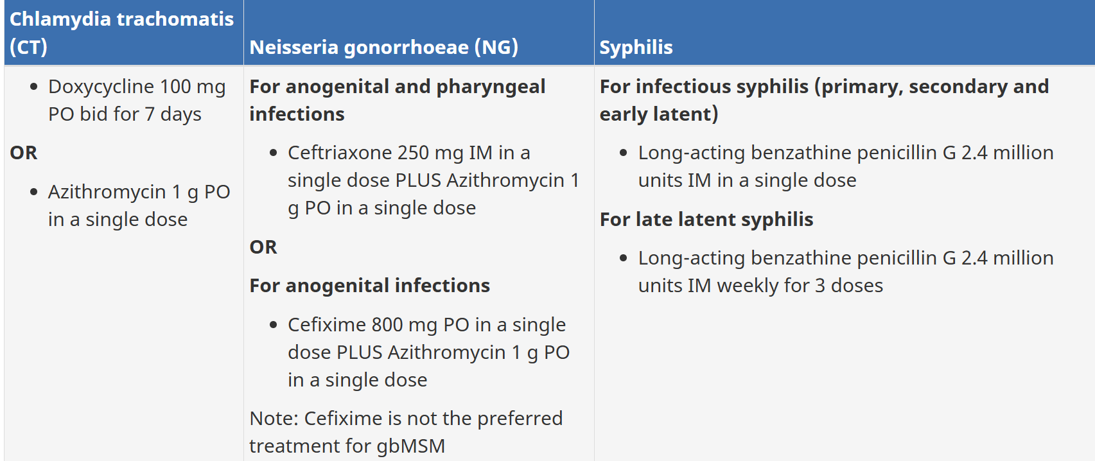

Tips for NG/CT infections:
- For NG infections: always use combo therapy to prevent resistance and treat possible chlamydia co-infection > use 2 antbx with different mechanisms of action to improve efficacy
- For CT infections: consider using azithro if poor compliance is expected
- Abstinence: Patients and their partners should abstain from sex until completion of a multi-dose treatment or for 7 days after single dose treatment
- All partners who have had sex with the individual within 60 days prior should be tested and treated

Tips for syphilis infections:
- Inform patients of potential Jarisch-Herzheimer rxn to penicillin tx
- Abstain from sex for 7 days after treatment
- All sex partners and perinatal contacts should be tested nd treated according ot the individual’s stage of infx and date of specimen collection or onset of symptoms:
  - Primary syphylis: 3 months
  - Secondary syphilis: 6 months
  - Early latent syphylis: 1 year
  - Late latent/tertiary: individual’s long-term sex partners and children as appropriate

Follow up
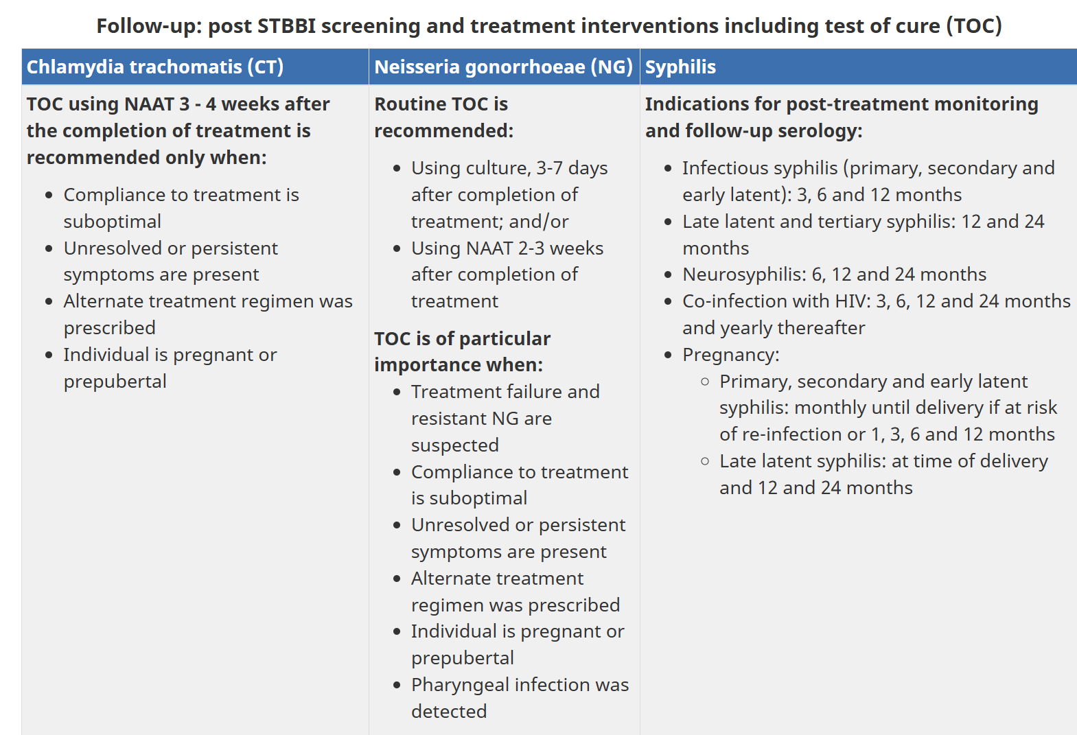
For syphilis, post treatment serology is used to assess tx response. For NG/CT - a NAAT is performed and repeat screening is recommended again 3-6 months post treatment d/t risk of reinfection

Age of Sexual Consent
https://www.justice.gc.ca/eng/rp-pr/other-autre/clp/faq.html
Def’n: age at which a person can legally agree to sexual activity; applies to all forms of sexual activity (from kissing and fondling to actual intercourse); otherwise it’s a criminal offence regardless of age

Age of consent: 16 years old - must be at least 16 to legally agree to sexual activity
- In some cases the age of consent is higher (e.g. when there’s a relationship of trust, authority, or dependency)

Close in age exceptions:
- 14 or 15 yo: can consent as long as partner is less than 5 years older (e.g. 14 year old can consent with 18 year old but NOT 19 year old) and there is no relationship of trust, authority or dependency or any other exploitation
- 12 or 13 yo: can consent if partner is less than 2 years older

16 or 17 yo: cannot consent to sexual activity if their partner is in a position of trust or authority, is dependent on them, or is exploitative

CNO Practice Guideline: Consent
Nurses have ethical and legal obligations to obtain consent, as outlined in the Health Care Consent Act, 1996 (HCCA) and the Substitute Decisions Act, 1992 (SDA). These laws emphasize informed consent and the rights of clients to make decisions about their care, including treatment, admission to care facilities, and personal assistance services. The key aspects of obtaining consent are as follows:
Health Care Consent Act (HCCA)
- Main Goals: Promote autonomy, communication, and involve family when a client is incapable of consenting.
- Consent Requirements: Specific, ongoing consent is required for treatment, admission to care facilities, and personal assistance services.
- Capacity Assessment: Nurses are responsible for assessing a client’s capacity to consent to treatment. Capacity can change, and the decision should be based on the person’s understanding of the treatment and the consequences of their decision.
- Substitute Decision-Makers: If a client is incapable, consent may be given by a substitute decision-maker, based on a legally defined hierarchy (spouse, relative, or other appointed person).
- Emergencies and Crises: In emergency situations or crises, consent may be waived to prevent harm, but reasonable efforts must be made to find a substitute decision-maker.
Substitute Decisions Act (SDA)
- The SDA addresses decision-making for incapable individuals on a continuing basis, such as for personal care or property.
- Appointing Decision-Makers: A person may designate someone (through power of attorney) to make decisions on their behalf if they become incapable.
- Capacity Assessment: Only trained capacity assessors are authorized to determine ongoing decision-making capacity.
Informed Consent
- Informed consent requires that a client understands the nature of the treatment, expected benefits, risks, alternatives, and consequences of refusing the treatment.
- Consent can be: Oral, written, or implied, as long as it meets the criteria of being informed, voluntary, and not coerced.
Steps for Obtaining Consent
- Assess Capacity: Determine if the client is capable of consenting. Nurses must assess if the client understands the treatment and consequences.
- Emergency Situations: Treatment may be provided without consent in emergencies where delaying could cause harm or suffering.
- Substitute Decision-Maker: If a client is found incapable, a substitute decision-maker, as per the hierarchy, must give consent.
- Best Interests of the Client: Substitute decision-makers should base their decisions on the client’s known wishes or, if unknown, in the client's best interests, considering their values and well-being.
Key Points
- Nurses must advocate for clients’ rights, ensuring they are informed and able to make decisions about their care.
- Consent can be withdrawn at any time, and it is the nurse's responsibility to ensure that consent is still valid.
- Substitute decision-makers have the right to the same information that a capable client would have access to.
These guidelines aim to ensure that consent is obtained in a legally and ethically sound manner, respecting the rights of individuals and ensuring safe, effective care.

CNO Practice Standard: Confidentiality and Privacy — Personal Health Information
The College of Nurses of Ontario outlines nursing standards for maintaining the confidentiality and privacy of personal health information (PHI) as part of ethical and legal responsibilities. Nurses are required to safeguard client health information, building trust by respecting confidentiality and privacy rights.
Key Points:
- Legislation and Standards:
  - Personal Health Information Protection Act (PHIPA) governs the privacy and security of PHI in Ontario. It ensures clients have control over their health data and balances this with the need for healthcare providers to access and share it for care.
  - Quality of Care Information Protection Act (QOCIPA) protects quality of care data from being used in litigation, promoting open discussion of care issues.
- Personal Health Information (PHI):
  - PHI includes any identifying data related to a person's health, treatment, family health history, and more. It can exist in written, verbal, or electronic form.
  - Information is "identifying" if it can be linked to a specific person, even indirectly.
- Nurses’ Roles and Responsibilities:
  - Nurses must adhere to PHIPA and use PHI only for the purpose it was collected. They are considered agents of healthcare custodians (e.g., hospitals, clinics), and must follow privacy and security protocols.
  - Nurses in independent practice are custodians and are directly responsible for safeguarding PHI.
- Consent:
  - Implied Consent: Nurses assume a client’s consent for the sharing of PHI within the healthcare team for care purposes unless the client objects.
  - Express Consent: Required when PHI is shared outside the healthcare team (e.g., with insurance companies) or used for non-care purposes like fundraising or marketing.
- Substitute Decision-Makers:
  - When a client cannot provide consent, a designated substitute decision-maker (e.g., a spouse or guardian) may provide consent on their behalf, following specific legal guidelines.
- A substitute decision-maker (SDM) can be a spouse or parent (for children under 16) if the client cannot make decisions about their care.
- The legislation provides guidance for SDMs on how to consent on behalf of clients and addresses potential conflicts between representatives.
- Client Rights:
  - Ownership of PHI: Clients have the right to control their health information, including the right to consent to, refuse, or withdraw consent for its collection, use, and disclosure.
  - Lockbox Provision: Clients can direct that certain parts of their PHI not be shared with other providers. Nurses must inform other providers if any relevant information is withheld.
  - Access and Corrections: Clients can request access to their health information and ask for corrections if the information is inaccurate or incomplete, though some requests may be refused (e.g., for professional opinions or certain confidential data).
  - Appeals: Clients can appeal if access to their information is denied or if they believe corrections are necessary.
- Disclosure of PHI:
  - Express Consent: Required for disclosing PHI outside the healthcare team or for purposes other than care. However, there are exceptions where consent is not needed, such as for risk management, quality care programs, and required reporting (e.g., child abuse or public health concerns).
  - Without Consent: PHI may be disclosed without consent in situations like emergencies, to confirm a client’s health status, or to reduce harm to individuals.
- Professional Misconduct:
  - Disclosing PHI to unauthorized individuals without the client’s consent is considered professional misconduct under the Nursing Act, 1991.
- Nurses' Responsibilities:
  - Nurses must ensure confidentiality, restrict access to PHI, safeguard digital and physical records, and ensure explicit consent before disclosing information outside the healthcare team.
  - Nurses are responsible for ensuring client access to their health records and assisting clients in correcting inaccurate information.
- Maintaining Confidentiality:
  - Nurses must adhere to security protocols to protect PHI from unauthorized access, loss, or disclosure. This includes using secure methods for communication (e.g., encrypted emails, password protection) and following proper disposal procedures.
- Quality Practice Setting:
  - Policies and Procedures: Employers and nurses must ensure policies are in place to manage the collection, use, and disclosure of PHI, including processes for handling access and correction requests.
  - Leadership and Education: Organizations should provide leadership in developing privacy policies, offer staff training on privacy laws, and ensure compliance with PHIPA and related regulations.
Summary:
Nurses are responsible for maintaining the confidentiality and privacy of personal health information, ensuring clients’ rights to access and amend their records, and obtaining proper consent for disclosure. Nurses must also comply with legal requirements for disclosing information in certain circumstances, protect PHI using security measures, and advocate for policies that support privacy within healthcare settings.

Infections Characterized by Genital Ulcers (CPS)
Def’n | Several STIs cause genital ulcers- genital herpes, syphylis, LGV, and chancroid  Syphylis - caused by Tremponema pallidum  Characterized by ulcers (chancres) which are often single, large, and painless  Vs. Genital herpes which are multiple, small, painful, and vesiculoulcerative  Primary syphylis- characterized by ulcerative infecitous lesions  Secondary syphilis - can include end organ involvement sometimes with serious complications (e.g. ocular syphylis, neurosyphylis) which require urgent consultation
Therapeutic goals | Treat infx, abolish symptoms, decrease transmission to others, prevent complications
Algorithm | 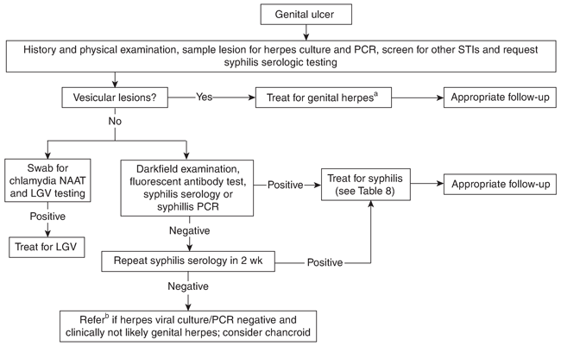
Pharmacological Therapy for SYPHYLIS
Drug/Dose | Indication | Adverse fx (AE) and Drug interactions (DI) | Contraindications & special considerations
1st Line Therapies
Benzathine Penicillin G | For primary, secondary, and early latent (<1 year duration) syphilis:  2.4 million units IM x1 dose (consider second dose 1 week later if patient is pregnant)  For late latent syphylis,syphylis unknown duration, cardiovascular syphilis, tertiary syphylis not involving CNS: 2.4 million units weekly IM x3 doses | AEs: Jarisch-Herxheimer rxn - not a drug allery; may occur at any stage but prevalent during early syphilis; fever, chills, rigors, sweating may occur; resolves within 24 h | Can be used in pregnant and breastfeeding patients  Consider penicillin desensitization in pregnant patients who are allergic to penciillin and in anyone with neurosyphylis - penicillin is incredibly important to treating neurosyphylis and syphilis in pregnant women and so those who are allergic to penicillin undergo a desensitization protocol to induce penicillin tolerance
Benzylpenicillin (penicillin G)  **Note: this is NOT the same med as benzathine penicillin G, don’t confuse them, they’re not the same  3-4 million units Q4H IV x10-14 days | Neurosyphylis
2nd Line Therapies (Alternative Regimens)
Ceftriaxone | All stages of syphilis (except neurosyphylis):  1g daily IV/IM x10d  Neurosyphylis:  2g daily IV/IM 10-14d | GI upset, hypersensitivity | Alternative regimen; only use in exception circumstances as last resort, including penicillin desensitization
Doxycycline | Primary, secondary, and early latent (<1 year duration) syphilis:  100mg PO BID x14d  Late latent syphylis, syphilis of unknown duration, cardiovascular syphylis, tertiary syphilis not involving CNS:  100mg PO BIX x28 days | AE: GI upset, rash, candidal vaginitis, photosensitivity  C/I: pregnancy, breastfeeding  DIs: decreased levels with antacids, iron, barbiturates, bismuth, carbamazepine, phenytoin; may decrease efficacy of penicillins | Alternative regimen; useful if pt allergic to penicillins;
Notes
Monitoring | Follow patients serologically for treatment response and monitor for possible treatment failure
Referral | Serious complications (e.g. ocular syphylis, neurosyphylis) require urgent consultation
Other notes | Test and treat sexual contacts

Ontario HIV Testing Guidelines
https://hivtestingontario.ca/wp-content/uploads/2023/03/Ontario-HIV-Testing-Guidelines-for-Providers.pdf
Def’n | PrEP (pre-exposure prophylaxis): use of antiviral medication to prevent HIV infection in adults who are at high risk.  PEP (post-exposure prophylaxis): 28 day course of antiviral medication started in 72hours of a high risk exposure to prevent infection.
- People with HIV who are diagnosed and on treatment and have an undetectable viral load (<200 copies) cannot transmit the virus to sexual partners: undetectable = untransmittable
- 97% of people living with HIV who are on antiretroviral therapy can suppress the virus to levels below 200 copies and they do not pass the virus to their partners causing first-time diagnoses levels to decrease
- HIV testing must be done with informed consent there are three types:
  - HIV laboratory-based diagnostic serology
    - Blood sample that is sent to public health ontario to screen for HIV
    - Any test that returns “reactive” is tested again
  - Rapid/Point of Care Testing:
    - Finger prick to screen for HIV done in less than 10 minutes
    - “Reactive” tests must be confirmed with laboratory serology
  - Self Tests:
    - Done at home and involve a finger prick to screen for HIV in less than 10 minutes
    - “Reactive” tests must be confirmed with laboratory serology
- Window Period:
  - Period during which might not have evidence of HIV infection in blood
  - 3months is window period for Rapid/point of care and self tests
  - 6 weeks is window period for HIV-laboratory diagnostic serology
- To confirm of rule out HIV infection offer laboratory serology testing:
    - Baseline -if negative
    - 3 weeks after exposure- if negative
    - At 6 weeks after exposure (3-6 testing)
  - Positive Result at any of the above times indicates HIV infection
  - Rule out HIV if: negative results at all 3 of these time points or a negative results 6 weeks after the high-risk exposure (if baseline and 3 week testing did not occur)
  - If patient only wants to use rapid/ point of care or self testing they still be tested baseline, 3 weeks, 6 weeks and 3 months after exposure to rule out HIV testing.

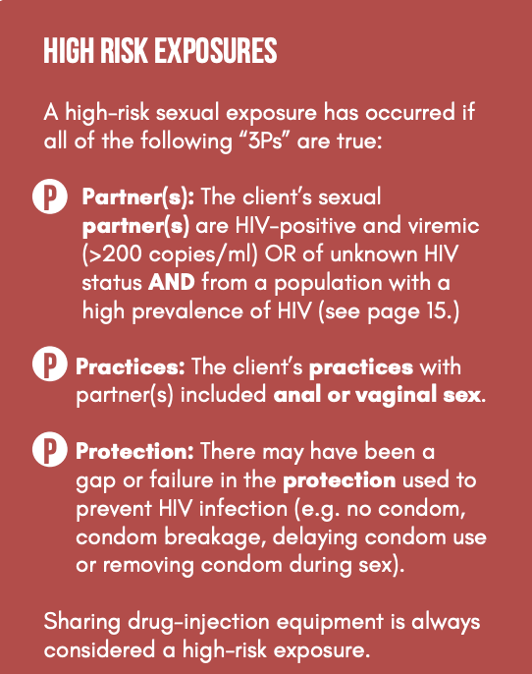
- Who to test:
- Report HIV or have a possible high-risk HIV exposure
  - If person is within 72 hours of exposure:
    - Offer baseline laboratory based HIV, STI, Hep C and B
    - Assess for start on PEP if indicated
  - If not on PEP:
    - Test for HIV again at 3 weeks and 6 weeks after high-risk exposure
  - If on PEP:
    - Test for HIV at 3 weeks and at 6 weeks after the person completes the 28 day course of PEP
    - If the person is ongoing high risk of HIV infection, transition from PEP to PrEP and test every 3 months and must be tested for HIV at 3 and 6 weeks after the person completes the 28 day course of PEP, and test for HIV every 3 months as per PrEP guidelines.
  - If person is within 3-21 days of high risk exposure:
    - Baseline laboratory based HIV, STI, Hep C and Hep B
    - Assess and start on PrEP
    - Test for HIV again at 3 weeks and 6 weeks after high risk exposure
    - If on PrEP test for HIV every 3 months
- Individuals who are sexual and or substance-using contact of people newly diagnosed
- Offer baseline HIV , ST, hep B and C testing
- Assess for start PrEP
- If exposure was recent (in last 6 weeks) test for HIV again at 3 weeks and 6 weeks after exposure using laboratory-based diagnostic serology testing
- If a person is on PrEP test for HIV every 3 months.
- Individuals who present with symptoms of other sexually transmitted and blood borne infection associated with HIV infection.
- Offer baseline HIV, STI, Hep B and C testing
- If recent high risk exposure (in last 6 weeks) offer 3-6 testing
- If person has received PEP for HIV in the past year or is high risk of HIV infection assess and start on PrEP
- Sexually transmitted blood borne infections assosciated with HIV:
  - Infectious syphilis, rectal bacterial STI (gonorrhea, chlamydia), Hep B, C
- Individuals presenting with symptoms of acute (early) HIV infection:
- Offer baseline HIV, STI, Hep B and C
- Test again for HIV at 3 weeks and 6 weeks after possible exposure
- Individuals in specific social and sexual networks in your area in response to notifications from Public Helath authorities.
Chronic Inections:
1. Recommend HIV testing for all individuals who has conditions associated with HIV infection that are recurrent, persistent or unknown origin.
2.Recommend HIV testing for individuals who present with TB or AIDS

Offer Testing to Population with higher rates of HIV:
- Gay, bisexual, trans men
- African, Caribbean, Black
- Indigenous
- Drug users (sharing equipment, using alcohol can cause more sexual risk taking)
- Cis and trans women

Factors that Increase Risk:
- Each persons risk depends on a mix of the 3 P’s:
  - Partner (HIV positive or a population with high risk)
  - Practices (sex, injecting drugs)
  - Protection (failure in protection condom breaks, sharing equipment).

Routine Testing in Populations with Higher Rates of HIV
- Recommend routine annual testing to sexually active members that are (Gay, bisexual, trans men, African, Caribbean, Black, Indigenous, Drug users, Cis and trans women).
- If they are high risk exposure -recommend HIV testing every 3 months or after every high risk exposure
- If present with a current STI- recommend HIV testing, assess for PrEP
- If these members are starting a new sexual relationship- start PrEP
- If while traveling engaged in unprotected sex or drug sharing
- If immigrated from a country where HIV was an endemic

Special Care situations people who should be tested for HIV
- Recommend HIV testing for all pregnant people as part of prenatal screening
  - If evidence of high risk exposure recommend HIV testing in 1st, 2nd and 3rd trimester, delivery,
  - If ongoing risk of exposure assess to start PrEP
- Recommend HIV testing if patient is on biologic (RA, lymphoma, methotrexate)
- Recommend HIV testing every 3 months for people on PrEP
- Give HIV testing for people who specifically request it even if they don’t meet the criteria
-HIV is reportable to public health unit, public health nurse will follow up with everyone who tests HIV positive to offer case and contact services
-Do not give positive results over the phone
-HIV treatment is highly effective with minimal side effects

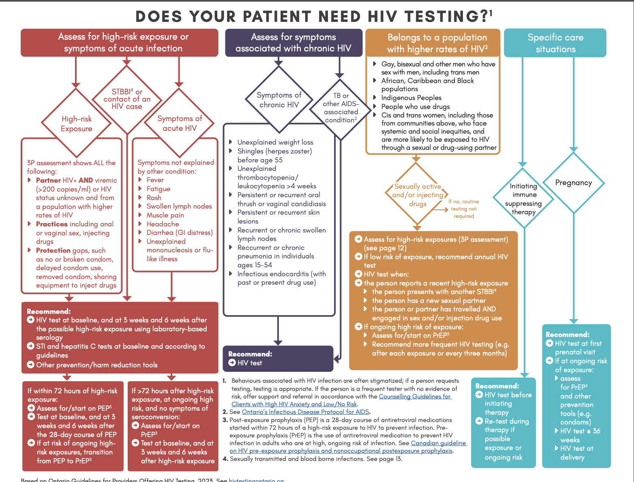
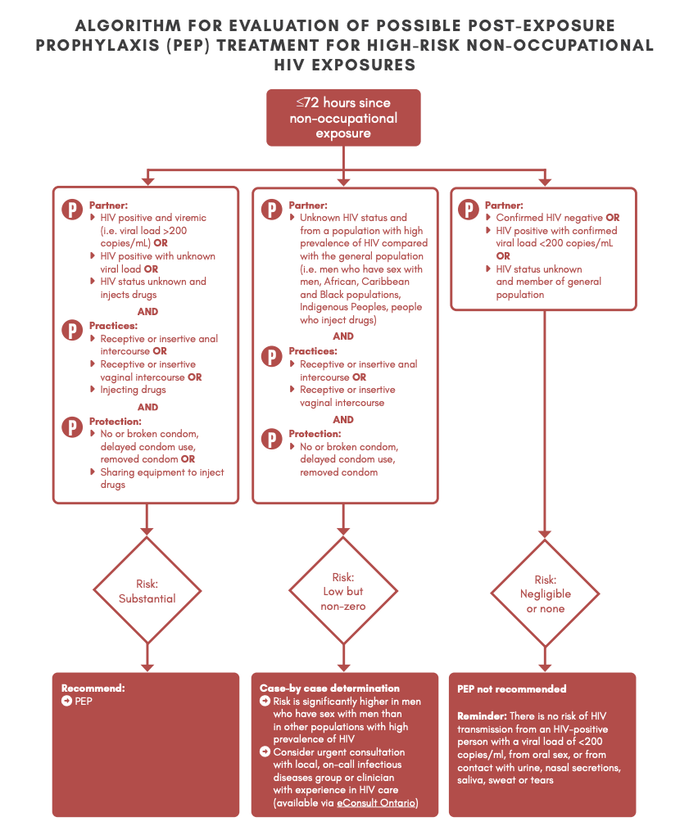

PrEP and HIV Newsletter (Rx files) (i dont know if the newsletter includes: HIV overview or drug comparison chart, drug interactions?)
-Post exposure prophylaxis to those at increased risk of HIV and caring for people living with HIV
-Most newly diagnosed HIV occurred in people who inject drugs, in Canada most cases were men who have sex with men
-routine HIV testing should be provided for every adult at least once
-those with increased chance of acquiring HIV should be tested more frequently (drug users, men having sex with men)
-HIV can not be transmitted if positive patient has an undetectable viral load
-PrEP decreases HIV transmission, adherence is critical
-patients with HIV therapy have the same life expectancy as those without HIV
-start HIV medications ASAP regardless of CD4 cell count
-
- Identify people at increased risk of HIV
- Conduct a baseline investigation
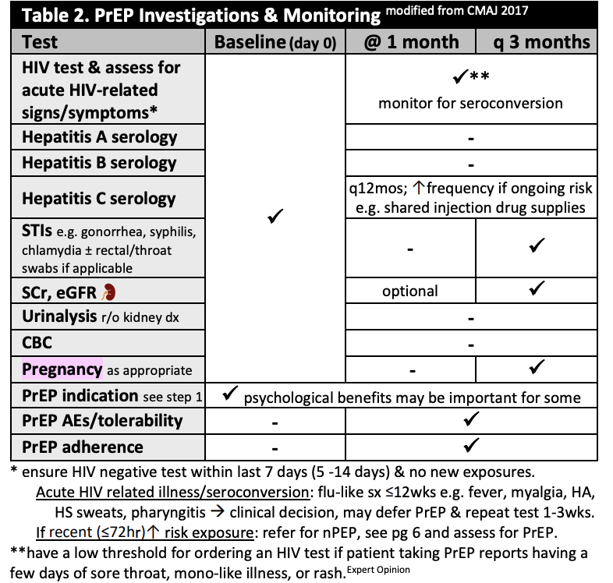
- Prescribe PrEP and provide patient education
- Follow up with patient in 1 month and then every 3 months
PrEP usually prescribed as emtricitabine + tenofovir disoproxil fumarate or Truvada
Less common: emtricitabine + tenofovir alafenamide or Descovy

PrEP = 1 tablet once daily, it contains 2 medications active against HIV.

-PrEP prevents HIV but does not protect against other STI
-must be HIV negative prior to receiving PrEP
-follow up after receiving PrEP includes: blood work, testing HIV and STI, follow up every 3 months

PrEP Adverse Effects:
-headache, nausea and vomiting after 1-2 weeks symptoms go away.

PrEP affects the kidneys and bone strength (more so truvada less so descoy).

Continuous Dosing:
-Must take PrEP everyday for 7 days in a row before you are protected during sexual activity and then:
-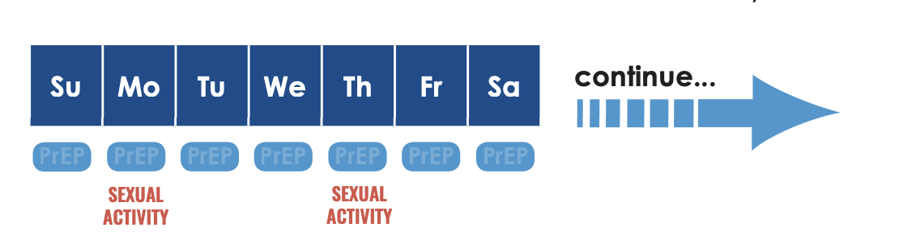
Dosing On Demand:
-Day 1: take two tabs 2-24 hours before sexual activity
-Day 2: one tab 24hours after first dose
-Day 3: one tab 48 hours after first dose
**** must take PrEP for two days after having sexual activity.

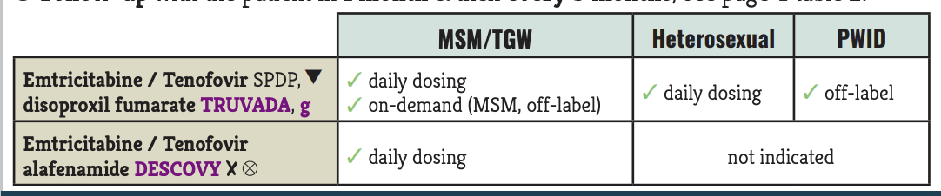

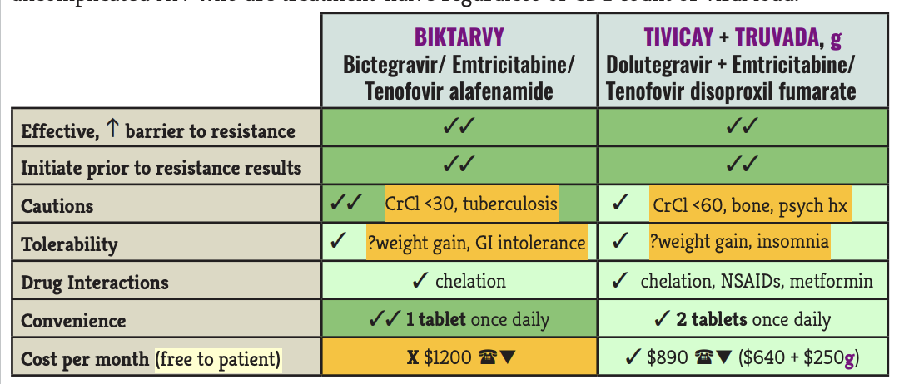

Pre-exposure Prophylaxis (PrEP) for Prevention of HIV
Def’n | - Indications for PrEP:  - Populations at high risk: MSM, heterosexuals with HIV-positive partners, injection drug users (IDU).  - High-risk behaviors: multiple partners, history of STIs, inconsistent condom use.  - Therapeutic Goal: Prevent HIV transmission by maintaining adequate plasma drug levels and ensuring adherence.  - Mechanism:  - PrEP works by inhibiting HIV reverse transcriptase, thus blocking viral replication at an early stage of infection.  Risk Factors for HIV: Higher transmission risk in partners with detectable viral load, high-risk sexual behavior, presence of STIs, and IDU.
Therapeutic goals
Algorithm
Non-pharmacological options
Education/counseling
Pharmacological Therapy
Drug/Dose | Indication | Adverse fx (AE) and Drug interactions (DI) | Contraindications & special considerations
1st Line Therapies
Truvada: Emtricitabine / Tenofovir disoproxil fumarate 200 mg emtricitabine / 300 mg tenofovir disoproxil fumarate, taken once daily. | Approved for all high-risk populations (MSM, heterosexuals, IDUs) | AEs: GI Symptoms: Nausea, diarrhea, mostly mild.  Renal Toxicity: Primarily with tenofovir (TDF); monitor renal function.  Bone Density Loss ONLY FOR TRUVADA: Especially with FTC/TDF; monitor bone health if prolonged use is anticipated.  DIs: Significant renal impairment (eGFR < 60 mL/min for FTC/TDF). Known hypersensitivity to PrEP components. | For MSM who may have irregular risk, an on-demand regimen can be used as follows: 2 tablets (FTC/TDF) 2-24 hours before sexual activity, then 1 tablet 24 hours after the first dose and 1 more tablet 24 hours later.  **PrEP is safe during pregnancy and breastfeeding; continue if high HIV exposure risk persists.
Descovy: Emtricitabine / Tenofovir alafenamide 200 mg emtricitabine / 25 mg tenofovir alafenamide, taken once daily. | Approved for MSM and transgender women; not indicated for cisgender women due to insufficient efficacy data.  *Doesn’t have bone density risk
2nd Line Therapies
Notes
Monitoring | Initial Screening Tests:  - HIV Testing: Confirm HIV-negative status to avoid resistance if already infected.  - Hepatitis B and C Testing: Check for active infection since PrEP has antiviral effects on Hepatitis B.  - Renal Function: Establish creatinine clearance (eGFR) as tenofovir affects renal function.  - STI Screening: Check for gonorrhea, chlamydia, and syphilis.  3-Month Interval Monitoring:  - HIV Testing: Every 3 months to confirm continued HIV-negative status.  - Kidney Function: Check serum creatinine and eGFR every 3 months to monitor for nephrotoxicity, especially for those on FTC/TDF.  - STI Screening: Routine screening for gonorrhea, chlamydia, and syphilis.  - Adherence and Side Effect Assessment: Support adherence and address any adverse effects to maintain efficacy.  Hep B?  - Monitor carefully as abrupt discontinuation of PrEP may cause HBV reactivation in co-infected individuals.
Referral
Other notes | PrEP is not indicated in serodifferent 1 partner HIV-positive, 1 partner HIV-negative relationships where the person who is HIV-positive is on HIV meds & negligible risk of HIV sexual transmission viral load <40-200 copies/mL or undetectable x 6mos & no known STIs.  Undetectable=Untransmittable

Acute UTI: Clinical Decision Aid
Clinical Decision Aid
Empirical tx of cystitis can result in 40% of women with urinary symptoms rec’ving abx unnecessarily for negative urine culture results. This tool assists in the treatment (NOT diagnosis) of pts presenting with acute cystitis.
gffvg
STEP 1:
If AFTER completing your assessment, you conclude pt likely has uncomplicated acute cystitis, determine the # of following criteria that are present:

Each worth 1 point each:
- Burning or pain on urination (dysuria)
- Presence of leukocytes (more than trace amnt)
- Presence of nitrites (any positive, including trace amnt)

STEP 2:
Suggested management based on score:

0-1 (26-38% risk of pos urine culture) - perform urine culture BEFORE deciding need for abx. Treat with empiric therapy if symptoms are SEVERE.

2-3 (>70% risk of pos urine culture) - start empiric abx without waiting for Ucx d/t to high likelihood of infx

Recurrent vs Reinfection vs Relapse
Recurrence: 2 uncomplicated UTIs within 6 mo OR >3 pos urine cultures in 12 months

Reinfection (most common): occurs after 2 weeks of completing abx; caused by a different organism, follows ascension of microbes from periurethral area into bladder

Relapse: occurs within 2 weeks of completing abx; caused by the original organism; bacteriuria often persists during therapy or reoccurs after 1-2 weeks of finishing abx

Acute UTI: Female, Uncomplicated
Def’n | Acute cystitis- characterized by a normal GU tract, limited morbidity, consistent microbiological spectrum
Non-pharmacological options | - In women <65 yo with mild symptoms, tx with NSAIDs (e.g. ibuprofen) may be considered to reduce abx use
Education/counseling | Encourage increased water intake (1 glass every hour)  Wipe front to back
Pharmacological Therapy
Drug/Dose | Indication | Adverse fx (AE) and Drug interactions (DI) | Contraindications & special considerations
1st Line Therapies
TMP/SMX  2 tabs BID or 1 DS tab BID x3 days | E Coli (80-90%), S. Saprophyticus, gram -’ve bacilli (e.g. P. mirabilis) | AEs:  DIs:
Trimethoprim
200mg daily x3 days
Nitrofurantoin
50-100mg QID
Or macrobid 100mg BID x5 days
Fosfomycin
3g PO once (dissolved in ½ cup cold water)
2nd Line Therapies
Amoxiclav
875/125mg BID x7d
Norfloxacin  400mg BID x3d | Reserve for severe situations to prevent resistance |  | Pts treated with FQs may be at increased risk of contracting community acquired E Coli UTIs that are quinolone or multi-drug resistant
Ciprofloxacin  250mg BID or 500mg daily x3 d | Reserve for Pseudomonas
Notes

Other notes | - The best indicators that abx is warranted are classic symptoms (e.g. dysuria, frequency, urgency) + pyuria  - No advantage to routinely sending urine samples ofr testing  - Urine culture not recommended unless failure to respond to empiric therapy or early (<1 month) recurrence  - Increase duration to 7 days for women with symptoms lasting >7 days or nursing home populations

Recurrent Cystitis - Female
Def’n | Recurrence: 2 uncomplicated UTIs within 6 mo OR >3 pos urine cultures in 12 months
Education/counseling | - Drink 1.5L water/day to reduce UTI recurrences  - Cranberry products can decrease risk of symptomatic UTIs in women with recurrent UTIs, in children, and in people susceptible to UTIs following interventions (no evidence for elderly, patients with bladder emptying problems, or pregnant women)
Pharmacological Therapy
Drug/Dose | Indication | Adverse fx (AE) and Drug interactions (DI) | Contraindications & special considerations
1st Line Therapies
TMP/SMX  2 tabs BID or 1 DS tab BID |  | Early Relapse <1 month  Duration: 7-14d  Choose a different agent than they got last time
Trimethoprim
100mg BID or 200mg daily
Nitrofurantoin
50-100mg QID or macrobid

C/I: infants <1 mo and CrCl <30-60
Fosfomycin
3g dissolved in ½ cup cold water x1
TMP/SMX  1 tab or ½ DS tab QHS  3 times weekly or post coital |  | Prophylaxis of frequent recurrence  (2+ episodes in 6 months or 3+ episodes in a year)  Continuous low-dose or post-coital abx (if recurrent UTIs are identified with intercourse). | R/A after 6 months of therapy  About 50% of women may exp recurrence 3 months after D/C prophylactic abx > if this happens, reinstitute prophylaxis for as long as 1-2 years
Trimethoprim
100mg QHS or post coital
Nitrofurantoin
50 mg or macrobid 100mg QHS or post coital

C/I: infants <1 mo and CrCl <30-60
2nd Line Therapies
Norfloxacin  400mg BID |  | Early Relapse <1 month
Ciprofloxacin  250mg BID or 500mg once daily |  | Early Relapse <1 month
Levofloxacin  250mg daily |  | Early Relapse <1 month
Cephalexin  125-250mg QHS or post coital |  | Prophylaxis of frequent recurrence  (2+ episodes in 6 months or 3+ episodes in a year)
Norfloxacin
200mg every other day or 3 times weekly or post-coital
Fosfomycin
3g dissolved in ½ cup cold water once every 10 days
Notes
Monitoring | - Culture and R/A for upper UTIs in women with recurrent cystitis  - Frequent recurrences despite prophylaxis may require GU investigation - vaginal estrogen is considered 1st line if moderate to severe symptoms or recurrent UTIs and should be recommended to peri and post menopausal women to reduce risk of future UTIs; vag estrogen can decrease genitourinary sympotms of menopause
Other notes | - Long-term low dose TMP/SMX usually does NOT result in increase of resistant flora; consider alternative when local resistance is anticipated to be >20%  - Reserve fluoroquinolones for severe cases  - Alternative strategy for recurrent infx: short course (e.g. 3 days) self treatment upon appearance of symptoms

Asymptomatic Bacteruria
Def’n
Algorithm | Only screen/treat during pregnancy and/or pre-op genitourinary procedures  Outside these situations, there are NO indications for screening or therapy for asymptomatic UTI (incl in the elderly- there is overtreatment of asymptomatic urinary infx in elderly and LTC residents- pos urine cultures are virtually always assoc with pyuria and neither is sufficient for dx or treatment of UTI)  GU: initiate abx therapy immediately before procedure and continue only for its duration unless indwelling catheter remains in place  Pregnancy: screen with urine culture at 12-16 wks gestation or at first prenatal visit if later.  - If pos, treat with 5-7 day abx course  - Perform F/U culture and retreat if necessary
Non-pharmacological options
Education/counseling
Pharmacological Therapy
Drug/Dose | Indication | Adverse fx (AE) and Drug interactions (DI) | Contraindications & special considerations
1st Line Therapies
Nitrofurantoin  50-100mg QID or macrobid 100mg BID | E. Coli (60-70%), Gram -’ve bacilli, Group B strep  Duration:  Pregnancy: 5-7 days  Pre-op: start immediately before procedure and continue only for its duration unless catheter remains in place | C/I: renal failure, pregnancy at term (36-42 wks gestation), during labour, and in neonates d/t possibility of hemolytic anemia
TMP/SMX  2 tabs BID or 1 DS tab BID |  | -Reasonable in first trimester if no appropriate alternatives are available; may limit availability of folic acid in fetus and lead to fetal abnormalities  -Avoid its use during last 6 weeks of pregnancy as sulfonamides may displace bilirubin from albumin binding sites, causing kernicterus in infants, especially if preterm
Trimethoprim
100mg BID or 200 mg Daily
Fosfomycin
3g dissolved in ½ cup water water x1
2nd Line Therapies
Cephalexin  500mg BID  Amoxicillin  500mg TID  Amoxiclav  500 mg TID or 875 mg BID  Norfloxacin  500 mg BID  Levofloxacin  250 mg daily | E. Coli (60-70%), Gram -’ve bacilli, Group B strep | Cephalexin not generally recommended but has a role in treating pregnant women  Avoid amox and amoxiclav if initiating tx before culture results are available  Fluoroquinolones should be avoided during pregnancy, esp in first trimester as safer alternatives available; only use if potential benefits outweigh risks to fetus
Notes
Other notes | - Macro-crystals may be better tolerated than micro-crystalline nitrofurantoin

Acute Cystitis in Pregnant Women
Pharmacological Therapy
Drug/Dose | Indication | Adverse fx (AE) and Drug interactions (DI) | Contraindications & special considerations
1st Line Therapies
Duration: 5-7 d unless otherwise indicated
Cephalexin
500mg BID
Nitrofurantoin  50-100mg QID OR macrobid 100mg BID |  | C/I: Pregnant patients at term (36-42 wks gestation), during labour, and in neonates d/t possibility of hemolytic anemia;  Can be used in 1st trimester if no alternative | Macro crystals may be better tolerated than micr-crystalline nitrofurantoin
Fosfomycin
3 g dissolved in ½ cup cold water
2nd Line Therapies
Amoxicillin  500mg TID x7 days | Use only after lab confirmation that the implicated bacteria are susceptible to amoxicillin d/t high rates of amox resistance in community E. Coli
TMP/SMX  2 tabs BID or 1 DS tab BID | Trimethoprim may limit availability of folic acid to fetus (leading to fetal abnormalities)  Reasonable to use in 1st trimester if there’s no appropriate alternatives available | C/I: Avoid Tmp/SMX during last 6 weeks of pregnancy as sulfonamides can displace bilirubin from albumin binding sites causing kernicterus in infants esp if preterm
Trimethoprim
100 mg BID or 200 mg daily
Notes
Monitoring | Monthly follow-up cultures in pregnant women who are susceptible to recurrence
Other notes | - For treatment of pyelo- use ceftriaxone 1-2g Q24h

American Geriatrics Society (AGS) updated Beers Criteria for Potentially Inappropriate Medication Use in Older Adults (2023)
https://pubmed.ncbi.nlm.nih.gov/37139824/
https://agsjournals.onlinelibrary.wiley.com/doi/epdf/10.1111/jgs.18372
-list of meds in tables that should not be prescribed to 65+; see paper for details

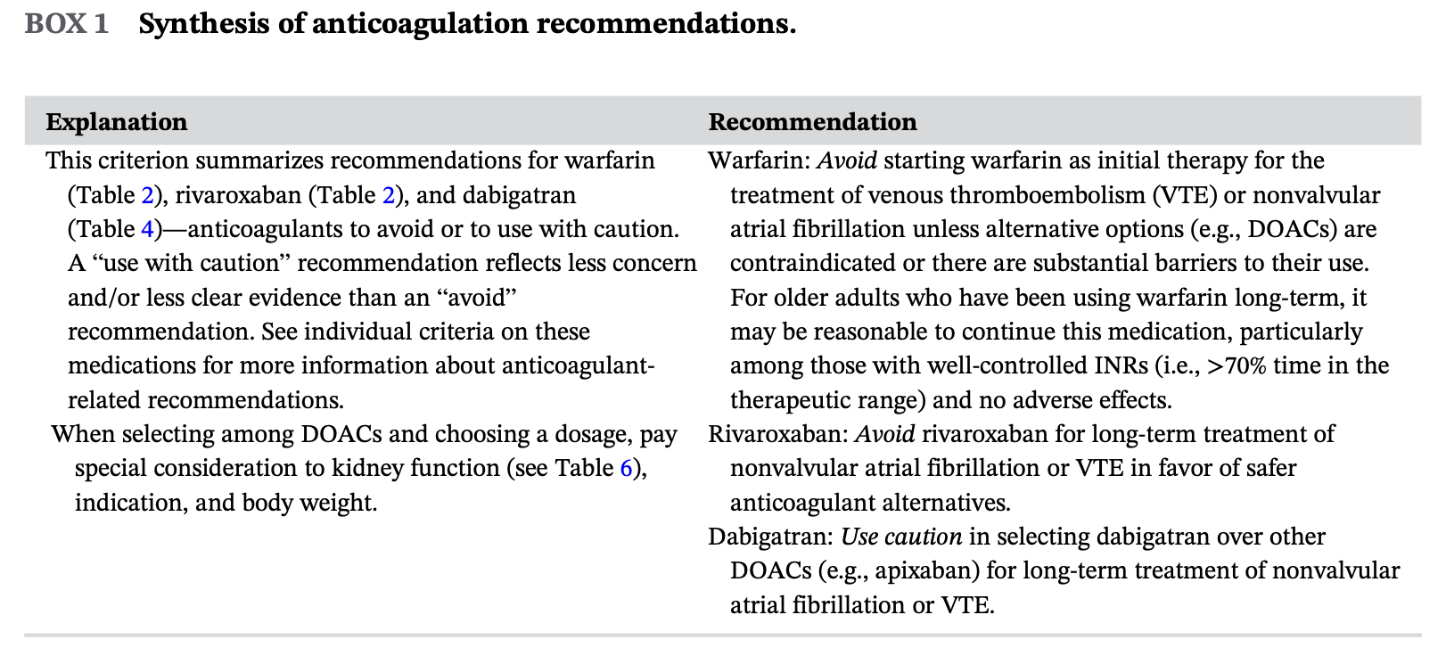
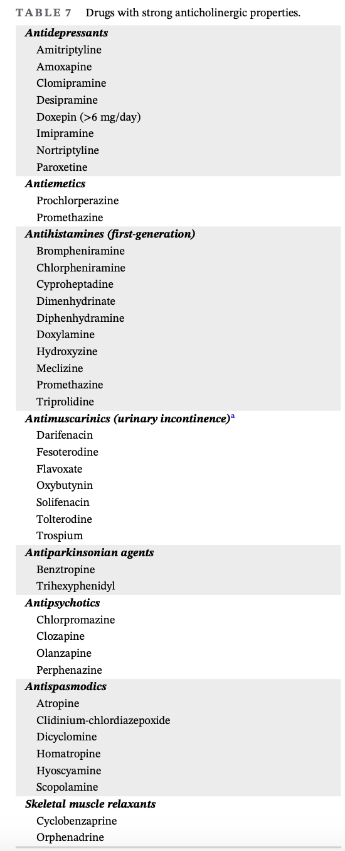

Benign Prostatic Hyperplasia (BPH) (eCPS)
Therapeutic goals | -improve lower urinary tract symptoms; delay or prevent progression of BPH, prevent obstruction (UTIs)
Algorithm | International Prostate Symptom Score- from not at all, <1 in 5 times, <half the time, about half the time, >half the time, almost always scoring from 0-5  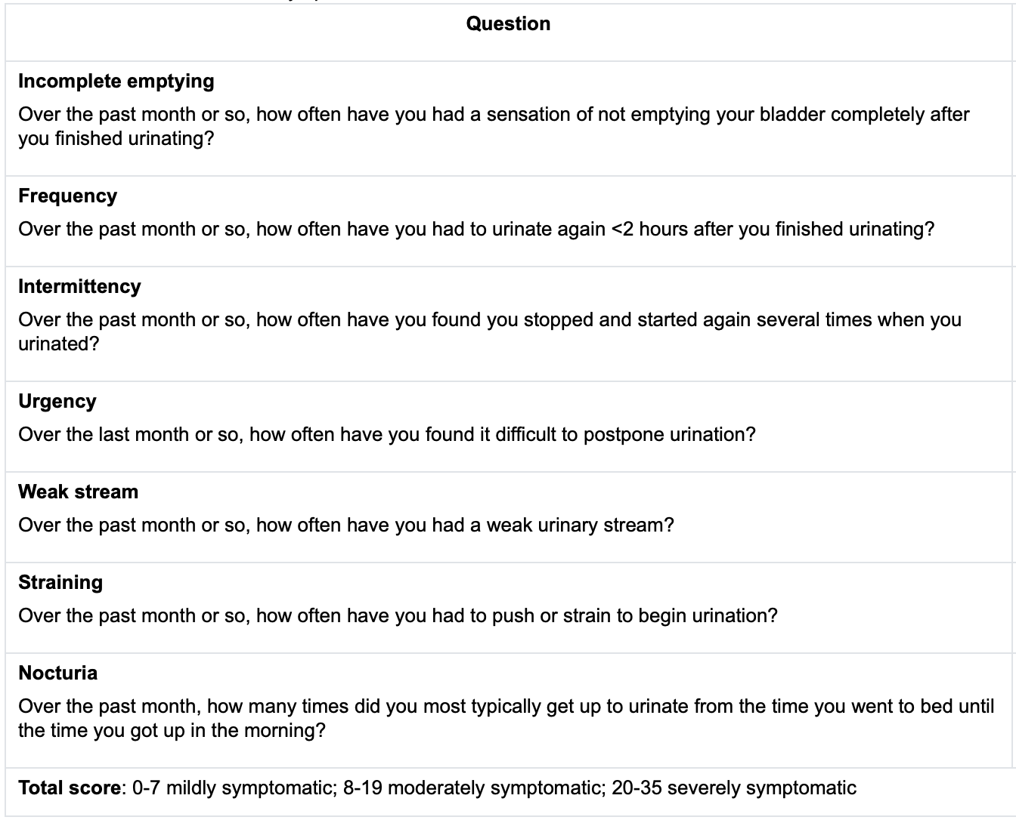
Non-pharmacological options | -avoid caffeine and alcohol for nocturia reduction
Pharmacological Therapy
Nonselective alpha1-adrenergic receptor antagonists
Alfuzosin (10mg daily), doxazosin (1-8mg HS), terazosin (1-10mg HS) | AEs: highest increased risk of cardiac failure  Syncope for D & T- start low dose  All- orthostatic hypertension, dizziness, headaches, nasal congestion  DIs: antihypertensive medications
Selective alpha1-adrenergic receptor antagonists
Silodosin | 8mg daily/ 4mg moderate renal impairment | AE: diarrhea, dizziness, headache, nasal congestion, orthostatic hypotension, decreased ejaculation volume
tamsulosin | 0.4mg daily | AE: dizziness, retrograde ejaculation  DIs: antihypertensive medications
5-alpha-reductase inhibitors *work best in large prostates (>40ml)
Dutasteride | 0.5mg once daily | AEs: sexual dysfunction  DI/CI: combination with CYP3A4 increases concentration; liver disease; increased risk of self-harm/depression >65, impact PSA values | *DO NOT TOUCH IF PREGNANT
finasteride | 5mg once daily | AEs: increased risk of self-harm/depression >65, impact PSA values
Phosphodiesterase Type 5 inhibitors
Tadalafil | 5mg daily | AE: back pain, dizziness, dyspnea, flushing, headaches, visual disturbances  DIs: nitrate drugs (nitroglycerin)
OTHER | Antimuscarinic (e.g., fesoterodine, oxybutynin, solifenacin, tolterodine) and beta 3-adrenoceptor agonist agents (e.g., mirabegron) alone or in combination with an alpha blocker may be effective in patients with predominant or persistently bothersome overactive bladder symptoms  Desmopressin for nocturia

Antibiotics for Urinary Tract Infections in Older People- Choosing Wisely Canada
Main symptom of UTI is burning feeling when urinating; urge and frequent urination and fever may be present too
Do not treat asymptomatic as side effects: fever, rash, diarrhea, vomiting, headache, tendon ruptures, nerve damage and yeast infections (result of killing good bacteria), as well as resistance requires caution in prescribing
Prevention: drink water; don’t hold pee in, use good hygiene (wipe front to back and urinate after sex)
Catheters: remove as soon as possible, replace after infection

Acute Urinary Tract Infection- Children (MUMs)
Def’n | -common infection, easily missed in young children; infants toddlers and preschoolers nonspecific symptoms; previous UTI or no circumcision increases risk  -No fluoroquinolones in children under 18 years old unless infectious disease consults  -Imaging studies indicated for:  - Pyelo  - 1st UTI in girls <3yo and any boy  - 2nd UTI in a girl >3yo  - 1st UTI in a child of any age with a fam hx of UTIs, abnormalities of urinary tract, abnormal voiding pattern, HTN, or poor growth
Pharmacological Therapy
1st Line Therapies
TMP/SMX | 5-10 mg/kg/day divided BID (q12h) 7-14 days
2nd Line Therapies
Amoxicillin | 40 mg/kg/day divided TID (q8h) 7-14 days *do not do short course due to resistance and high incidence of reflux in children <5
Cephalexin | 25-50 mg/kg/day divided QID (q6h) 7-14 days
Cefadroxil | 30 mg/kg/day divided BID or once daily (max 2g) 7-14 days
Trimethoprim | 4 mg/kg/day BID (q12h) 7-14 days *does not come in liquid but can be compounded
3rd Line Therapies
Cefixime | 8 mg/kg/day divided BID or once daily 7-14 days
Amoxi/Clav | 40 mg/kg/day divided BID 7-14 days

Urinary Incontinence in pediatric (CPS)
Def’n | -Most children should be successfully toilet trained by the age of 3  -Daytime incontinence in children is defined as daytime voiding of urine into clothes at least twice per week for 3 consecutive months in a child over 5.  -Day time incontinence is a problem if child is over age of four and wets bed daily, or who relapses after six months  -Enuresis: bed wetting during sleep more than twice a week beyond age of 5 for girls and 6 for boys
Therapeutic goals | -Identify and manage serious causes of urinary incontinence  -decrease the number of incontinence episodes per unit of time  -provide reassurance and guidance to both the child and caregiver
Algorithm | 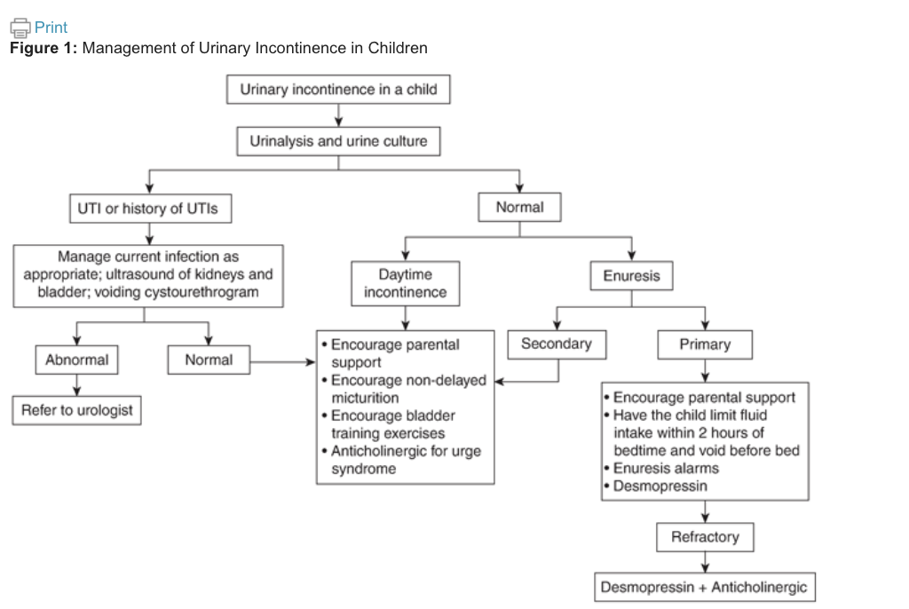
Non-pharmacological options | -child avoid excess fluid intake within two hours of bedtime and to empty bladder before going to bed  -void when feel need to  -enuresis alarms: attach to underpants or absorbent pad and they vibrate or produce sound when child voids, allow child to continue voiding in toilet  -wake child up at night to avoid until child learns to void on their own
Education/counseling | -if child experienced daytime incontinence and nocturnal enuresis: advice caregivers to avoid humiliating or punishing child and to instead use positive reinforcement such as reassurance
Therapeutic Tips | -More likely to have positive treatment outcomes if: the child is motivated, over age of ten and has a supportive family.  -More likely to have negative treatment outcomes if: child developmental delay, low self esteem, behavioral problems, wet bed at night, frequent daytime voiding, intolerance or annoyance of caregiver, unstable family  -enuresis alarms are superior to desmopressin lower chance of relapse  -desmopressin benefit over enuresis alarms works immediately
Pharmacological Therapy
Drug/Dose | Indication | Adverse fx (AE) and Drug interactions (DI) | Contraindications & special considerations
1st Line Therapies
Desmopressin (ADH)  DDAVP  120-360mcg QHS SL  200-600 mcg QHS PO  For six months | -Decreases urine production and reduces the number of wet nights  -Used when require a rapid response  -most effective in older children that have a normal bladder capacity and have large urine output | AEs: over hydration/ water intoxication, hyponatremia could cause seizure and death.  Headache, abdominal pain,  CI: do not use in children with kidney, heart failure, DM, cystic fibrosis | -Titrate off by not giving medication for one week every three months to see if treatment is still required  -to avoid hyponatremia limit fluid intake one hour before and eight hours after taking desmopressin. Hold the dose during illness and it may cause a fluid and electrolyte imbalance such as fever, vomiting, diarrhea  -medical emergency: child develops headache, nausea, vomiting - stop medication as child has hyponatremia
Desmoressin combined with enuresis alarm | If have relapse following treatment with either desmopressin or enuresis alarms then use combination of both  Refractory Enuresis: when not responsive to desmopressin at max dose, alarm therapy, combination of alarm and desmopressin further investigation is required
Anticholinergic Smooth Muscle Relaxant
Oxybutin | Used for reducing bladder contraction in detrusor overactivity | AEs: constipation, dry mouth, flushing. Mood changes | Combine with desmopressin for refractory
Tolterodine | Reserved if oxybutin is not well tolerated | AEs: constipation, dry mouth, headache, flushing, visual impairment, fatigue, mood changes
Solifenacin | Reserved if oxybutin is not well tolerated | AEs: constipation, dry mouth, flushing, visual impairment, fatigue, mood changes | Combine with desmopressin for refractory
Propiverine | Used for urinary incontinence and increased frequency and urgency of overactive bladder
2nd Line Therapies
Combination of desmopressin and anticholinergic | Used in children that have both detrusor overactivity and increased urine production.
Tricyclic antidepressants  Amitriptyline, desipramine, imipramine | Help reduce wet nights but not recommended due to adverse side effects  Used if child has failed to respond to all other treatment | AEs: dizziness, GI discomfort, headache, mood changes

Urinary Incontinence in adults (CPS)
Def’n | Lower urinary tract symptoms (LUTS)  Stress incontinence: increase abdominal pressure due to coughing, laughing causes pressure inside the bladder to overcome ability to close urethral sphincter causing urine leakage  Urgency Incontinence: leakage of urine due inability to delay voiding when an urge occurs. Due to detrusor hyperactivity or instability and CNS disorders.  Mixed Incontinence: both stress and urgency  Outflow incontinence: leakage of urine due to distended bladder, due to detrusor underactivity such as neurogenic bladder.  Functional Incontinence: loss of urine due to inability to mobilize or to use the toilet and does not involve changes in lower urinary tract. Such as physical constraints
Therapeutic goals | -relieve urinary symptoms  -prevent complications (depression, falls, skin breakdown, UTI)  -improve quality of life  -avoid treatment side effects  -improve bladder function
Algorithm | 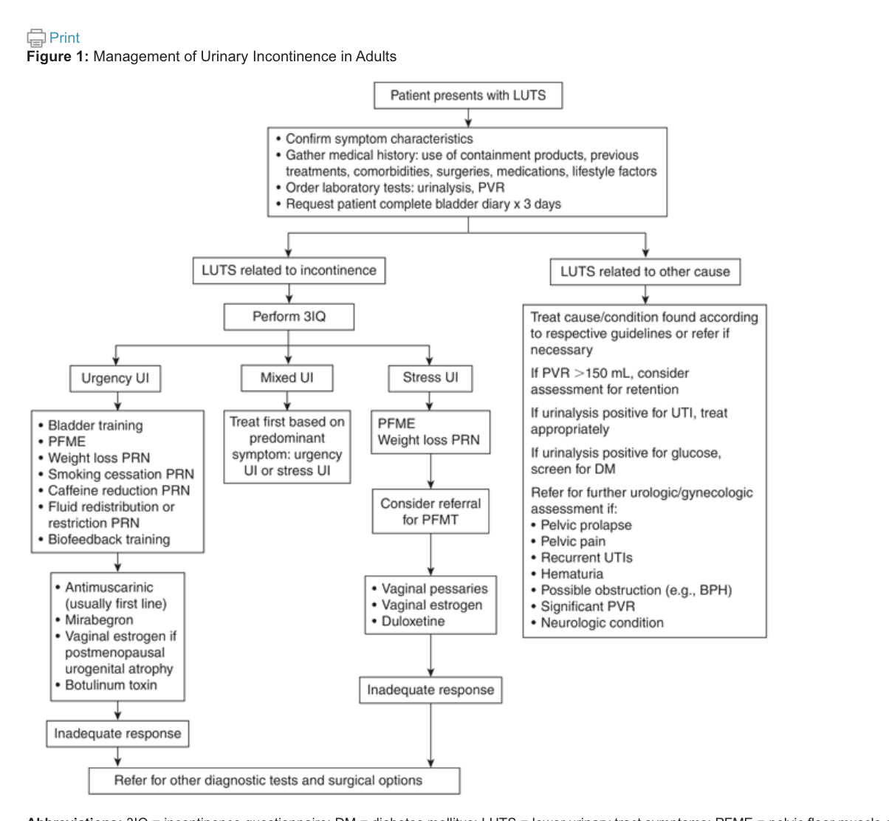
Stress incontinence  Non-pharmacological options | Non-pharmacological are first line treatments:  -pelvic floor muscle exercises (kegal exercises) which is 12-20 muscle contractions 3-5 times a day, each contraction 10 seconds, will take 6-8 weeks to see results  -biofeedback or electrical stimulation therapy  -weight loss  -vaginal devices for vaginal prolapse  -surgical options- midurethral mesh sling pelvic organ prolapse  Pharmacologic Choices  -vaginal estrogen: useful if postmenopausal mixed with urinary incontinence and vaginal atrophy  -do not need progesterone with vaginal estrogen  -no benefit with systemic estrogen  -duloxetine: SNRI as been found to be useful for women who cant have surgery and have stress incontinence.
Urgency Incontinence  Non-pharmacological | Non-pharmacological  Start conservative management/behavioral therapy when secondary causes have been ruled out  1.bladder training (timed voiding): voiding schedule that is gradually increased with minimal incontinence episodes  2.Pelvic floor exercises: perform 12-20 muscle contractions, held for 10 seconds each 3-5 times per day  3.weight loss  4.smoking cessation: less smoking causes less urinary frequency  5. Caffeine reduction: reduced urgency episodes and nocturnal enuresis  6. Fluid Restriction: decrease fluids to decrease urine however concentrated urine can contribute to bladder irritation and urgency  7. BIofeedback training: stimulation that teaches the patient to isolate and control pelvic floor muscles, neuromodulation is accepted as a third line approach for refractory urgency incontinence,  Pharmacological choices:  Antimuscarinics such as (darifenacin, fesoterodine, oxybutynin, propiverine, solifenacin, tolterodine, trospium)  Antimuscarinics are second line treatments for urgency incontinence when nonpharmacological options fail to provide adequate symptomatic relief**  These medications are not curative and the benefits may not be acceptable given the side effects  More beneficial if they are combined with nonpharmacological f  Take 4-8 weeks to determine benefit, discontinue at 8 weeks if there is no benefit or side effects are intolerable.  Side effects: anticholinergic side effects, to help manage start at a low dose and titrate slowly up, side effects more of a concern in older adults with increased risk of dementia  Diarifencin, solifenancin, trospium: have less side effects  Systemic estrogen should not be used for post menopausal urgency incontinence and instead should use vaginal estrogen as an adjuvant to behavioral and pharmacological treatment.  Beta3-adrenergic agonist used for the treatment of urgency incontinence, better tolerated than antimuscarinics and can have better adherence.  Used for refractory overactive bladder and in neurogenic detrusor overactivity, administered via cystoscopy, decreases urinary incontinence.  Most common complication: UTI
Pharmacological

Antimuscarinics

Vaginal Estrogen

Mirabegron

Intravesicular botulinum toxin
Mixed Incontinence | Treat patient with predominant symptoms either stress or urgency
Overflow Incontinence  Non-pharmacological  Parasympathomimetics | Non-pharmacological:  -treat the underlying condition causing chronic retention of urine  -causes may be detrusor underactivity or bladder outlet obstruction (BPH)  -first line approach: addressing reversible causes of overflow such as:  Medications (anti-cholinergics, calcium channel blockers)  -chronic underactivity can be treated with catheterization  -if overflow is due to BPH, medical or surgical intervention  Pharmacological Choices:  -chronic retention of urine because of detrusor underactivity is not responsive to pharmacological therapy  -poor tolerance to parasympathetics due to GI upset, blurred vision, bronchospasm, bradycardia  -can also try: alpha-adrenergic, antagonists, prostaglandins
Urinary Incontinence during pregnancy | Stress urinary incontinence is the most common type during pregnancy  Management: pelvic floor rehabilitation
Education/counseling | -Inform that pharmacological interventions provide symptomatic benefit but are not curative.  -provide patient education regarding management of alternatives  -treat all secondary causes  -non-pharmacological interventions require 6-12 weeks for benefit, pharmacological interventions take several weeks to achieve maximal effect  -for stress UI first line is pelvic floor muscle training, pharmacological therapy is adjuvant therapy  -for urgency UI bladder training is first line treatment, consider pharmacologic options if bladder training is unsuccessful  -educate on importance of persistence and adherence of non-pharmacological and pharmacological treatments.
Pharmacological Therapy
Drug/Dose | Indication | Adverse fx (AE) and Drug interactions (DI) | Contraindications & special considerations
Conjugated estrogen vaginal cream  Premarin, Estring, Vagifem | Used for:  Stress, urgency, mixed urinary incontinence if vaginal atrophy present. | AEs: local burning, irritation, vaginal leakage  DIs:systemic absorption is variable | No endometrial proliferation with vaginal estrogen
SNRI  Duloxetine (cymbalata) | Not approved in canada for stress incontinence  Not recommended for end stage renal disease (ClCr <30mL/min) | AEs: tachycardia, increased BP, palpitations, nausea, dry mouth, constipation, erectile dysfunction, flushing  DIs:  MAOI, CYP2D6, CYP1A2
Anticholinergics
Darifenacin  7.5mg daily PO | Urgency incontinence | AEs: dry mouth, constipation, delirium, increased intraocular pressure, glaucoma, dry eyes, tachycardia  DIs:CYP3A4, CYP2D6 | Avoid Severe hepatic impairment
Fesoterodine  4mg daily PO | Urgency incontinence | AEs: Back pain, constipation, cough, dry eyes, dry mouth  DIs: CYP3A4, CYP2D6 | Avoid Severe hepatic impairment
Oxybutynin  Solifenacin  Tolterodine | Urgency incontinence | AEs: dry mouth, constipation, delirium, increased intraocular pressure, glaucoma, dry eyes, tachycardia  DIs:CYP3A4, CYP2D6 | Avoid in renal and hepatic impairment
Beta 3 - adrenergic agonists
Mirabegron  25-50mg daily PO | Urgency incontinence | AEs: Hypertension, nasopharyngitis, UTI, headache, tachycardia, QTc prolongation  DIs: CYP3A4, CYP2D6 | Should not crushed or chewed  Should not be used in severe uncontrolled hypertension

Sexual Dysfunction: Drug Causes & Considerations (RX files)
Def’n | Types of female Sexual Dysfunction:  - Hypoactive sexual desire disorder  - Female sexual interest/arousal disorder  - Substance or medication induced  - Female orgasmic disorder (difficulty experiencing or decreased intensity of orgasms).  - Genito-pelvic pain/penetration disorder
Therapeutic goals
Algorithm
Non-pharmacological options | Females: psychotherapy, CBT, physio, dilators, diet  Psychological/Relational issues key!!  Set the mood before intercourse  Apart vaginal dryness sexual problems do not necessary increase with age  Male:  yohimbe effective for SSRI induced sexual dysfunction,  Fenugreek  Tribulus  Celery seed  Saffron in antidepressant induced sexual dysfunction,  DHEA androgenic not ineffective  Ginkgo-ineffective for sexual dysfunction from antidepressants  Life style/CV risk reduction: effective in ED!!  Healthy lifestyle (moderate exercise, not over or underweight)
Education/counseling | -Surgical menopause might have a greater effect than natural menopause  -Pelvic floor or bladder dysfunction, endometriosis, uterine fibroids, may be associated with dyspareunia.  -increased prolactin, renal failure, stoma, cancer can cause pain, decrease desire, anxiety, fear, guilt, body image, sleep apnea  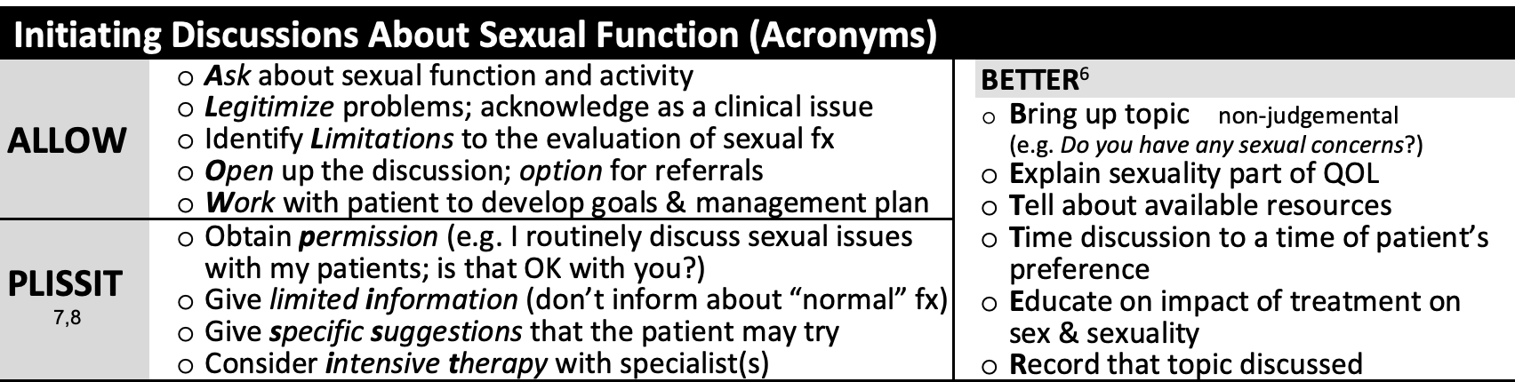
Drug Classes that cause sexual dysfunction
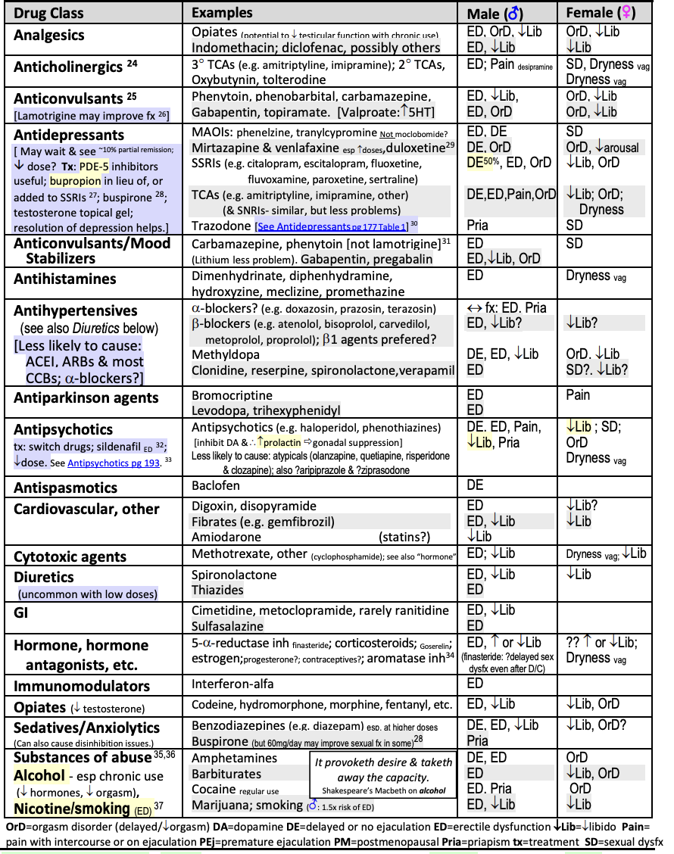
Pharmacological Therapy
Drug/Dose | Indication | Adverse fx (AE) and Drug interactions (DI) | Contraindications & special considerations
Drug Treatments for Female Dysfunction
Estrogens  -systemic, vaginal, creams, rings  Osemifene 60mg daily  Estradiol 4 and 10 mcg | Used for vaginal atrophy, dryness, dyspareunia  -systemic estrogen used for vasomotor sx  -vaginal estrogen used for vaginal atrophy, dryness | AEs:  Osemifene: increases hot flashes, increases stroke, DVT  Estradiol: headaches, dyspareunia, increased cardiovascular disease and cancer  DIs:
Testosterone (androgens)  Gel compounded 1%  Andriol oral | -used for decreased sexual desire |  | Masculization with doses used for males
Bupropion  Wellbutrin  150-300-400mg/day | –decreased sexual desire |  | Useful in SSRI-induced sexual dysfunction 150mg/day
Phosphodiesterase Inhibitors (PDE-5 inhibitors)  Sildenafil (viagara)  Tadalafil (cialis)  Vardenafil (levitra) | -little benefit in females may decrease SSRI adverse effects  -decrease sexual desire, arousal, orgasm, |  | May be effective in women with autonomic nerve damage such as multiple sclerosis
Vaginal Moisturizers  Replens-moisturizer  KY Jelly-lubricant  Gynatrof-Hyaluronic and Vitamine E gel | -vaginal dryness/ dyspareunia  -decreased arousal  -cant help resolve issues secondary to drugs causing dryness!! |  | Replens required daily use three times a week with minimal adverse effects  KY generally used intermittently before intercourse
KY intense, (Zestra): massage oils (borage seed oil, evening primrose oil, angelica root extract and coleus.

-used for genitalia to increase arousal but increases burning.

Flibanserin (Addyi) 100mg HS: hyperactive sexual desire pre and post menopausal.

AEs: hypotension, dizziness, somnolence, nausea, fatigue
DIs: 3A4/2C19, concomitant alcohol use, increased risk of depression and syncope, caution if liver disease
Bremelanotide (Vyleesi) hypoactive sexual desire

AEs: nausea and hypertension

DIs: naltrexone
Prasterone (Intrarosa): dehydroepiandrosterone for dyspareunia due to menopause, daily vaginal insert
AEs: abnormal pap smear and discharge

Alprostadil (caverject): cream apply locally, increased arousal
Apomorphine (Movapo): PO investigational, increased arousal, increased emesis
Topical lidocaine for dysparenunia: apply three min pre-penetration in women with history of breast cancer, decreased sexual distress score
Ospemifene (Osphena): estrogen agonist/antagonist 60mg PO OD
TCA may be effective in decreasing vulvodynia
Male Sexual Dysfunction
-always assess potential causes eg. distance biking, interpersonal issues, conflict
Tx: psychological, counselling

-may have erectile dysfunction due to poor sexual relationship
-assess for increased cardiac risk
-pornography: frequent access can contribute to: loss of libido, impotence, erectile dysfunction, critical to partner and relationship issues.
-decreased libido: age, androgen deficiency, psychological/depression, recreational drugs including alcohol, nicotine, marijuana and opioids.
-Erectile Dysfunction: can be caused by decreased blood flow to corpora cavernosa treat with PDE5 inhibitor, alprostadil, prothesis
-Gradual/complete loss of nocturnal erections: suggests possible neurologic or vascular disease.
-Non-sustained erections: after penetration due to: anxiety, vascular steal (increased oxygen demand during sex).
-Ejaculation disorder: delayed ejaculation caused by tissue damage in prostate surgery or failure of alpha adrenergic clamping of bladder neck sphincter resulting in retrograde ejaculation. Can be caused by medication.
-Premature ejaculation: common, persistent or recurrent with minimal stimulation. Provide:
1. Reassurance state its likely not a problem
2. Pause and squeeze technique
3. Start- stop technique
4. SSRI regular x 2 weeks with paroxetine, sertraline, fluoxetine.
5 clomipramine
6 anesthetic cream
7 music/relaxation

-uremia/renal failure: common (causes neuropathy, PVD, hypogonadism, drug induced, psychological)
Tx. maximize dialysis, correct anemia,
options: PDE5 inhibitor, psychotherapy, testosterone, vacuum device, alprostadil, zinc supplement, penile prosthesis.

Statins: can be effective for erectile dysfunction.

Notes
Other notes | -Sexual desire arousal and function is psychological complex  -Take a good sexual/relationship history before assigning a drug as the cause  -diseases such as: DM, atherosclerosis, cardiac CNS, depression, obesity can cause sexual dysfunction  -sexual health and active life wil benefit from good health, some drugs that maintain health  -drugs that maintain health and decrease pain will help sexual dysfunction

Erectile Dysfunction (RX files)
Def’n | Erectile dysfunction (ED) is a persistent or recurrent inability for at least 3 months to achieve and maintain a penile erection of sufficient rigidity to permit satisfactory sexual activity.
Therapeutic goals
Algorithm | For all patients:  -use below non-pharmacological approaches  -assess and treat the patients cardiovascular risk  -ED is often an early predictor for heart disease,  ED give a 2-5 year window to give time to reduce CV risk before first event occurs  -statins can be used to decrease CV events  -watch for drug caused ED
Non-pharmacological options | -weight loss  -physical activity  -stop smoking  -psychosexual therapy  -avoid cycling more than 3 hrs/week  -limit alcohol to less than 2 drinks/day  -avoid cannabis  -Mediterranean diet  -CPAP if sleep apnea
Education/counseling | -All erectile dysfunction drugs carry the risk of priapism (an erection lasting longer than 4 hours).  -There can be a placebo response to medications because there is a huge psychological component in erectile dysfunction  -Risk of CV even during sex with ED
Pharmacological Therapy
Drug/Dose | Indication | Adverse fx (AE) and Drug interactions (DI)  Contraindications (CI) | special considerations
PDE5 inhibitor are first line drug therapy (effective, convenient and well tolerated)
PDE5 work by reducing catabolism of cGMP which causes smooth muscle relaxation of corpus cavernosum and increases blood flow into penis (still require sexual stimulation to produce actual erection)
-all PDE5 medications appear equally effective
-have shown to work in all aspects of ED (vascular, neurological, hormonal, cavernosal, drug induced and psychogenic)
Off labe use: for Raynauds and BPH
Sildenafil  -viagara  -revatio  1 hour pre-sex  Initial: 25-50mg ac  Max: 100mg per 24hr  Usual: 50-100 mg ac | -PDE5 inhibitor they only work if sexual arousal and stimulation is functional  -they do not cause erections !!! they allow stronger erections but do not cause them!! | AEs: well tolerated overall  -flushing, headache, dyspepsia, myalgia, backpain, blue vision, nasal congestion, diarrhea, dizziness, blurred vision, rash  Serious and rare: MI, priaprism, QT prolongation, oc  CI:  Concurrent use of nitrates or riociguat, previous episode of non-arteritic anterior ischemic optic neuropathy  DIs:  -nitrates increase hypotension and heart rate  -Avoid nitrates within 24hr: of sildenafil, vardenafil  48hr of tadalafil  -Alpha 1 blocker (doxazosin) increases hypotension, space 4-6 hours apart  -other -antihypertensives and alcohol can worsen hypotensive effect.  -increased levels with CYP3A4 inhibitors (grapefruit)  -decreased levels with CYP3A4 inducers (St, Jons Wart) | -writing a prescription for multiple PDE5 inhibitors can increase patients autonomy  Precautions: -anatomical penis deformation, CVD (arrhythmia, MI, stroke, HTN, HF).  -increased risk of priapism (sickle cell anemia, multiple myeloma, leukemia)  -retinitis pigmentosa  -retinal abnormalities  Monitor:  -LFT  -Renal function (not for vardenafil)  -CV risk factors  -changes to visual acuity  -changes to hearing
Tadalafil
-Cialis
-acdrca

2 hours pre-sex
Initial: 5-10mg
Max: 20mg per 24 hr
Usual: 10-20mg

Option for daily use:
Use: 2.5-5mg daily
Vardenafil
-levitra
-staxyn

1 hour pre sex:
Initial: 5-10 mg ac
Max: 20mg per 24 hr
Usual: 10-20mg ac
Avanafil
-stendra
(not available in Canada)

30 min pre sex:
Initial: 50-100mg
Max: 200mg per 24 hr
Usual: 100-200mg

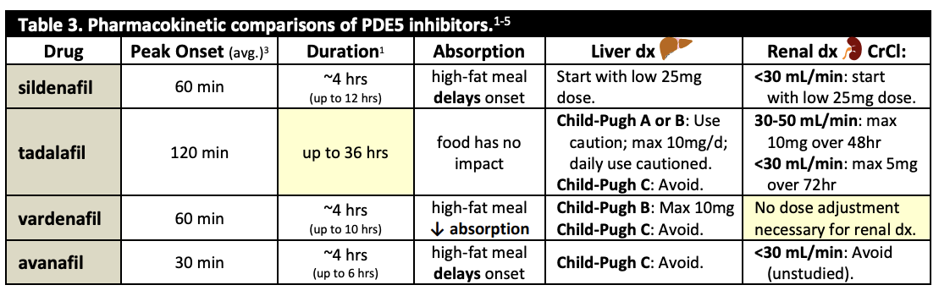
How to manage PDE5 inhibitor failure | -check patients administration: are they taking it on an empty stomach? How long before sex? This can help increase response (works on 40% of patients).  -Try daily tadalafil dosing instead of PRN: since its long acting it may increase response (works on 40% of patients).  -Try a higher dose (work on 20% of patients).  -Try an alternate PDE5 inhibitor (works on 10% of patients).  -Ensure an adequate trial was made (some recommend at least 4 attempts per agent are made).  -Reasess opportunity for nonpharm intensive lifestyle changes are effective.  -Hormonal Testing PDE5 and testosterone may increase response but only if Testosterone is low (under 10mmol/L)
Other notes for PDE5 inhibitors | -Benefits to start at a low dose:  -for PDE5 inhibitor since higher does have increased adverse effects  -if patient is pill splitting allows for lower dose and decreases cost  -Benefits to start at a high dose:  -Erectile dysfunction often have psychogenic component,  -if there is a low dose some patients may give up on therapy due to medication not working  Older adults: initiate at a low dose and increase risk of accumulation especially if patient is frail  Tadalafil: long t1/2=long effect, but can also means increased duration of adverse effects
Drugs that cause ED | 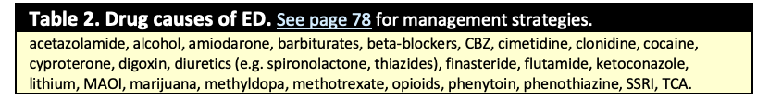
2nd Line Therapies Penile injections or urethral suppositories limited by pain, penile fibrosis, needle phobia
Alprostadil intracavernosal injection (caverject) | Prostagland E Class  -increased production of cAMP muscle and produces vasodilation  -also inhibits platelet aggregation and gastric secretion, stimulation of intestinal smooth muscle, uterine smooth muscle.  -most efficacious of injectable agents  General AE  AEs: common AE are decreased HR, dizziness, fever, headache, hypotension, penile pain, penile fibrosis, tachycardia, urethral burning  Serious AE:  -seizures, priapism, HF, second degree heart block, SVT, VF, disseminated intravascular coagulation.  DI:  Heparin: increase PTT and thrombin time, increased risk of hypotension, syncope, antihypertensives, alcohol  CI: anatomical penis deformation, penile implant, predisposition to priapism, sickle cell anemia | AEs: penile pain, penile fibrosis, priapism | Precautions: concurrent anticoagulant, vasoactive agents or bleeding abnormalities  -neonates with bleeding tendency  Used for vasculogenic, psychogenic, neurogenic and mixed ED  -onset- rapid (usually in work in 10 min)  -duration- less hour  -initial dose/titration should occur under medical investigation  -vascular requires larger doses than neurogenic ED  -injection no more than 3 doses/week (24hr in between doses).  -suppositories no more than 2 within 24 hours  -decrease dose if erection lasting over an hour  -seek medical assistance if tx results in erection that lasts over 4 hr.  -monitor: priapism (erection lasting over 4 hr) tx is needle aspiration of penile blood; intracavernosal -injection phenulephrine 200mg q5-10min up to 1000mg if needed
Alprostadil urethral suppository  (Muse) |  | AEs: penile pain, urethral bleeding, dizziness, decreased efficacy vs injection  Use condom if female is pregnant to avoid fetal exposure
Prostaglandin: injection corpora cavernosa transurethral gel
Papaverine  injection | Vasodilator  -produces arteriolar dilation and smooth muscle relaxation  -can be combined with prostaglandin and phentolamine | AEs: abdominal discomfort, anorexia, constipation, NVD, drowsiness, headache, vertigo, hypertension, tachycardia, pruritis, rash, blurred vision.  Serious AE: acidosis, ICP, hepatoxicity and priapism  CI: complete AV block  DI: decreased levodopa effect, ginkgo increases AE of papaverine  Monitor: intraocular pressure in glaucoma patients, liver function | Precautions: glaucoma, liver dx, recent MI, stroke, parkinson, sickle cell anemia  Used for idiopathic, postecephalitic and symptomatic ED  Onset: (rapid in 10min)  Duration: (less than hour)  Do not use if ischemia  Available as a combo  Consult prescriber if erection lasts longer than 4hr
Phentolamine  Oraverse  Submucosal injection | Alpha-Adrenergic Blocker:  -antagonizes anti-erectile sympathetic tone, increased perfusion  -poor efficacy alone so usually combined with prostaglandin and papaverine | AEs: chest pain, diarrhea, dizziness, headache, hypotension, nasal congestion, nausea, palpitations, increased HR and vomiting  -arrythmia  CI: MI, CAD, angina pectoris, hypersensitivity to phentolamine or mannitol, renal impairment, coronary or cerebral arteriosclerosis  DI:  Hypotension with: BB, tadalafil and vardenafil, disulfiram like reaction with alcohol, decreased effect with epherine (OTC cough and cold meds)  Monitor: BP changes, HR | Precations:  -arrhythmia, cerebral vascular spasm, occlusion, hypertension, increased HR  -used on idiopathic, postencephalitic and symptomatic  Peak:30-60min  Onset: 30-40min  Duration: 5-7hr  Found in natural product called “desire”
Alternative therapies | Vacuum pump  Works for only 30 minutes max | AEs: causes bending at base of penis, penis is cold to touch
Alternative therapies | Surgical prosthesis | AEs: increased scarring, penile shortening, infections
Alternative therapies | Red Ginseng  Yohimbe  Apomorphine | Caution:  PDE5 inhibitors are often added to herbal and male enhancement products

Dose Adjustments in Renal Impairment (CPS)
-patient has impaired renal function dose adjustments are needed to reduce drug toxicity
-dose adjustments are generally based off creatinine clearance rather than eGFR
-the approach does not apply to patients that are obese or receiving renal replacement therapy

Patient/Drug Considerations
Is the patient’s renal function impaired?

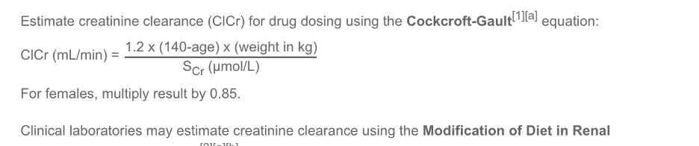
This is an example with a patient that has 70 kg formula is above
Use the following formula​ to estimate the weight-corrected creatinine clearance (ClCr) and to guide empiric dosage adjustments:
Males: ClCr (mL/min/70 kg) | = | (140 – age) × 90
 |  | serum creatinine (µmol/L)
Females: ClCr (mL/min/70 kg) = 0.85 × above equation
-To estimate the ClCr for dosage adjustment, use of a weight-corrected formula is recommended rather than the patient’s actual ClCr. This weight-corrected estimate standardizes the result to that of a “normal” ClCr for a certain weight

-patient elderly or malnourished: elderly over 65 years of age, have lower muscle mass therefore produce less creatinine, if actual serum creatinine is used an overestimation of renal function can occur **do not use the formula if serum creatinine is <100 µmol/L.

-staging CKD: report eGFR based on serum creatinine calculated using modification of diet in renal disease (MDRD) equation or CKD epidemiology collaboration (CKD-EPI)

-must titrate the dose whenever possible, and determine the correct dose by monitoring a patient’s response to the dose chosen.

-if ClCr falls below 60 mL/min/70 kg, empiric dosage adjustments should be based on the following questions:

-is the drug effective/safe in patients with renal impairment?
-is the drug nephrotoxic?
-is an immediate clinical effect required or can you titrate the dose
up? If life threatening you
require treatment regardless of kidneys, if not required then try to titrate
the dose up (start with ¼ or ½ dose and titrate up to clinical effect to
allow for the lowest possible dose to be used).

Approach to Empiric Dosage Adjustments:

-When dose titration is not possible or desired, base empiric dosage adjustments on estimates of renal function.

Interval versus Dose Adjustment
For drugs given intermittently, the dose or the dosing interval can be adjusted based on the desired goal. Often a combination of extending the interval and reducing the dose is effective and convenient. If the aim is to achieve steady-state maximum/peak and minimum/trough concentrations (e.g., aminoglycosides) similar to those seen in patients with normal renal function, extend the interval between doses. If a relatively constant steady-state concentration is desired (e.g., antihypertensives), reduce the dose.
Drugs Eliminated ≥75% by the Kidney
For frequently administered drugs (e.g., Q4H–Q12H), extending the interval may decrease the cost of administration or improve adherence.
Drugs Eliminated 50 to <75% by the Kidney
These drugs have a clinically important proportion of nonrenal clearance; therefore, empiric dosage adjustments are generally not required until renal function estimates are <45 mL/min/70 kg
Drugs Eliminated <50% by the Kidney
For drugs eliminated <50% by the kidney, empiric dosage adjustments are generally not required, assuming the drug has no active or toxic metabolites. However, these drugs may require dosage adjustment in patients with clinically important liver dysfunction.
Drugs with Active or Toxic Metabolites
Empiric dosage adjustments for drugs with active or toxic metabolites that are dependent on renal elimination should be made as though the drug were 75–100% renally eliminated

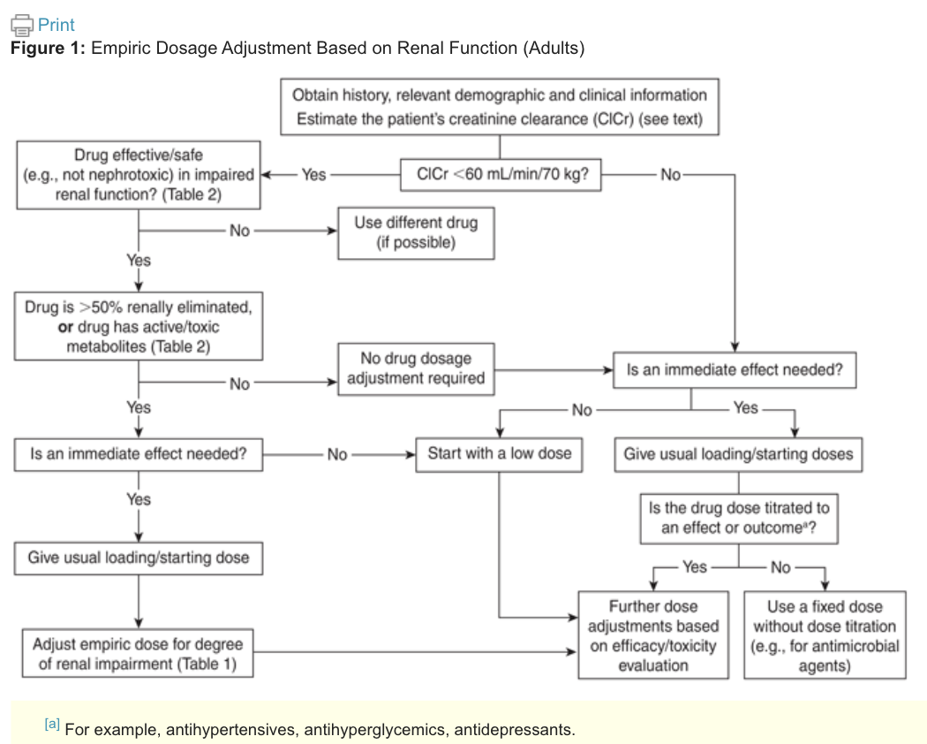

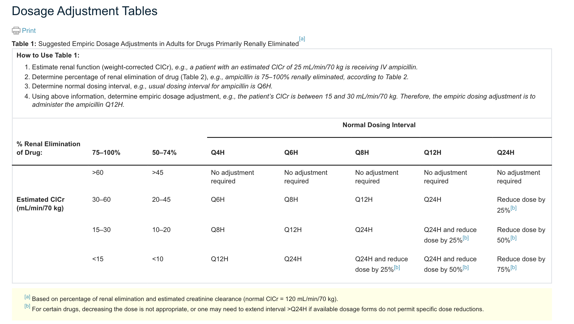

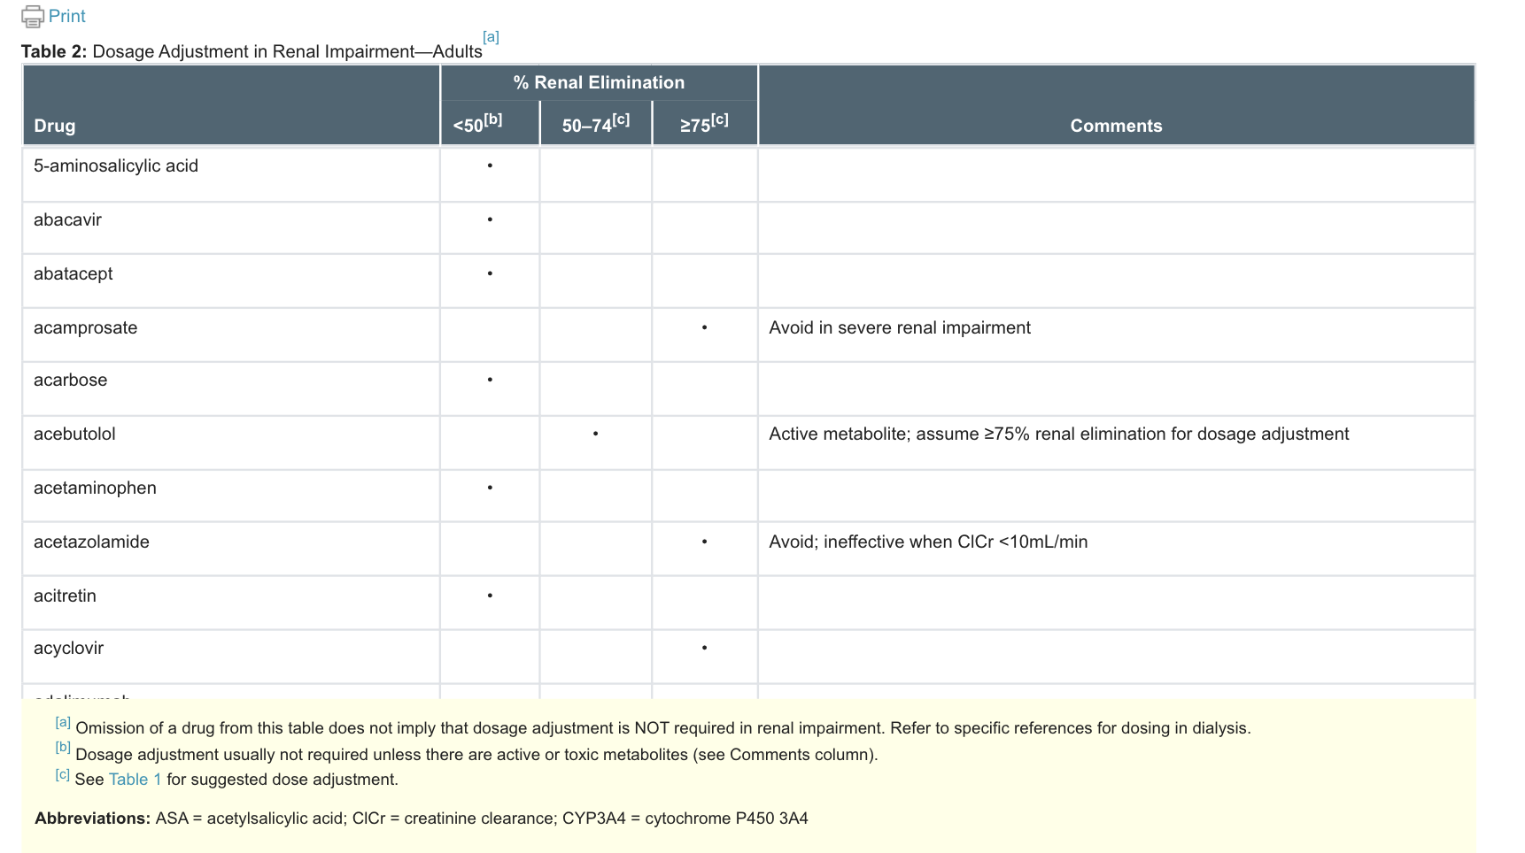

UTIs in Nursing Homes and Long Term Care (MUMs)
INFO | -obtain a urine specimen before initiating antimicrobial therapy  -do not routinely screen and treat asymptomatic bacteriuria  -treatment is 7 days UNLESS fever or severe systemic symptoms then 10-14 days; only prophylactic treatment prior to urological procedure  MINIMUM CRITERIA FOR INITIATING ABX for patient without catheter: acute dysuria alone OR fever AND at least one of: new or worsening urgency, frequency, suprapubic pain, gross hematuria, costovertebral angle tenderness or urinary incontinence  WITH CATHETER MIN CRITERIA: at least one of: fever, new costovertebral tenderness, rigors with or without identified cause, new onset delirium (change in urine colour or mental status not enough, need genitourinary symptoms)
Pharmacological Therapy- 7 days
1st Line Therapies
TMP/SMX | 2 tabs BID or 1 DS BID
Trimethoprim | 100mg BID or 200mg daily
Nitrofurantoin | 50-100mg QID or Macrobid 100mg BID **CI CrCl<30-60ml
Amoxicillin | 500mg TID **use only after confirmed susceptibility in lab,
2nd Line Therapies
Ciprofloxacin | 250mg BID or 500mg daily **for lower tract symptoms 3 day course of 250mg BID is as effective as 7 days
Levofloxacin | 250mg daily
Amoxi/Clav | 500mg TID or 875mg BID

Prostatitis- Chronic
Def’n | Chronic Prostatitis refers to long-term inflammation of the prostate, which may be bacterial or non-bacterial in nature. It is categorized into:  - Chronic Bacterial Prostatitis: Characterized by recurrent bacterial infections in the prostate, often due to the same organism, and typically requires prolonged antibiotic therapy.  - Chronic Non-Bacterial Prostatitis (Chronic Pelvic Pain Syndrome): This form has no identifiable bacterial cause and is often associated with symptoms like pelvic pain, urinary frequency, and painful ejaculation. Treatment for non-bacterial forms may include pain management, alpha-blockers, and other symptomatic therapies
Therapeutic goals
Other Notes (It was formatting weirdly when I put in the actual “other notes” section so i moved it here | Chronic bacterial prostatitis: Characterized by recurrent episodes of bacteriuria due to the same organism.  Chronic non-bacterial prostatitis: Of unknown etiology, does not respond to antibiotics.  Antibiotics: Generally not indicated unless there is an abscess or positive urine culture.  - Treatment Approaches:  - Alpha-blockers and antibiotics, as well as combinations of these therapies, show the greatest improvement in clinical symptoms compared to placebo  - Combination therapy is an option for patients with obstructive voiding symptoms.  - Additional Treatments for Symptoms:  - NSAIDs.  - Neuropathic pain medications: e.g., gabapentin, pregabalin.  - Pelvic floor physical therapy  - Ciprofloxacin:  - Active against Pseudomonas aeruginosa.
Non-pharmacological options
Education/counseling | Uncommon and difficult to diagnose; prevalence increases with age.  Symptoms may include dysuria, voiding complaints, ejaculatory or genital pain; some may be asymptomatic.  Prostate examination is usually normal
Pharmacological Therapy
Drug/Dose | Indication | Adverse fx (AE) and Drug interactions (DI) | Contraindications & special considerations
1st Line Therapies
Norfloxacin 400 mg BID for 4-6 weeks |  | AEs:  DIs:
Levofloxacin 500 mg once daily for 4-6 weeks

Ciprofloxacin 500 mg BID or 1 g (extended release) once daily for 4-6 weeks
2nd Line Therapies
TMP/SMX 2 tabs BID or 1 DS tab BID for 4-6 weeks
Trimethoprim 200 mg BID for 4-6 weeks

Notes
Monitoring
Referral | If no response in 4-6 weeks, refer to a urologist. Chronic cases are less likely to be true bacterial prostatitis.
Other notes

Prostatitis- Acute
Def’n | Acute Prostatitis is a sudden infection of the prostate gland, typically caused by bacteria. It is characterized by symptoms such as fever, chills, painful urination (dysuria), pelvic or lower abdominal pain, and sometimes urinary retention. The prostate may be swollen, tender, and warm upon examination. Acute prostatitis requires prompt treatment with antibiotics to prevent complications, such as prostate abscess or spread of infection to other areas.  - Acute onset of chills, fever, perineal and low back pain, irritative and obstructive voiding.  - Prostate is tender, swollen, indurated, and warm.  - Obtain a voided urine specimen before starting empiric therapy.  - If no improvement after 2 weeks, reassess. The prostate is often the source in older men with relapsing UTIs.  - Avoid prostate massage as it is painful and may cause bacteremia  - Acute prostatitis can occur in prepubertal boys, although it is rare.
Education/counseling | Duration of Therapy:  - Typically 10-14 days, but up to 4 weeks if symptoms persist after 2 weeks.  - Consider treatment for N. gonorrhoeae and C. trachomatis in men with high-risk sexual behavior.
Pharmacological Therapy
Drug/Dose | Indication | Adverse fx (AE) and Drug interactions (DI) | Contraindications & special considerations
1st Line Therapies
TMP/SMX 2 tabs BID or 1 DS tab BID for 10-14 days | First-line for mild to moderate | AEs:  DIs:
Trimethoprim 200 mg BID or 10-14 days | First-line for mild to moderate
Norfloxacin 400 mg BID or 10-14 days | First-line for mild to moderate
Levofloxacin 500-750 mg once daily or 10-14 days | First-line for mild to moderate
Ciprofloxacin 500 mg BID or 1 g (extended release) once daily or 10-14 days | First-line for mild to moderate
1st Line Therapies Sereve Cases
Ampicillin IV 1-2 g q4-6h  OR  Ceftriaxone IV 1-2 g q12-24h or 10-14 days | PLUS ANY ONE of the following→ | Gentamicin IV 6 4-7 mg/kg q24h  OR  Tobramycin IV 6 4-7 mg/kg q24
Notes
Monitoring | Voiding Difficulties:  - If the patient cannot void, hospitalization and catheterization may be necessary.  - Alpha-blockers may be considered  Antibiotic Therapy:  - TMP/SMX and TMP are only indicated after culture confirms sensitivity.  - Consider alternatives to TMP/SMX if local resistance > 20%.  Ciprofloxacin:  - Active against Pseudomonas aeruginosa.  Extended Therapy:  - After acute symptoms resolve, continue oral therapy for an additional 2-4 weeks, based on culture and sensitivity results.  - For patients intolerant or allergic to penicillin/aminoglycosides, use intravenous ciprofloxacin or levofloxacin.
Referral
Other notes

Pyelonephritis
Def’n | ​​Pyelonephritis is a type of urinary tract infection (UTI) that affects the kidneys. It occurs when bacteria or other pathogens infect the kidney tissue, typically starting from the lower urinary tract (bladder). This condition can be acute or chronic and is characterized by symptoms such as fever, flank pain, nausea, vomiting, and painful urination. In severe cases, it may lead to sepsis or kidney damage if not treated promptly. Pyelonephritis is often caused by common UTI pathogens, such as Escherichia coli (E. coli).
Therapeutic goals
Algorithm
Non-pharmacological options
Education/counseling | Duration of treatment is 10-14 days
Pharmacological Therapy
Drug/Dose | Indication | Adverse fx (AE) and Drug interactions (DI) | Contraindications & special considerations
1st Line Therapies
TMP/SMX (2 tabs BID or 1 DS tab BID) | First-line for mild to moderate UTI | AE: Rash, GI upset; DI: Warfarin (increased bleeding risk) | CI in sulfa allergy; monitor renal function
Trimethoprim (100 mg BID or 200 mg once daily) | First-line for mild to moderate UTI | Same as above | CI in sulfa allergy; monitor renal function
Ciprofloxacin (500 mg BID or 1 g extended release once daily) | First-line for mild to moderate UTI | AE: Tendinitis, GI upset; DI: Antacids, theophylline | Reserve for cases with resistant organisms to reduce resistance development
Norfloxacin (400 mg BID) | First-line for mild to moderate UTI | Same as Cipro | CI in pregnancy and breastfeeding
Levofloxacin (500 mg once daily for 10 days or 750 mg once daily for 5 days) | First-line for mild to moderate UTI | Same as Cipro | Use with caution in patients with QT prolongation
Gentamicin IV 4-7 mg/kg q24h  +/- Ampicillin IV 1-2 g q4-6h | First-line for severe UTI
2nd Line Therapies
Amoxicillin/Clavulanate (500 mg TID or 875 mg BID) | Second-line for mild to moderate UTI | AE: Diarrhea, rash; DI: Allopurinol (increased rash risk) | Use cautiously in penicillin-allergic patients
Ciprofloxacin IV  400 mg q12h | Second-line for severe UTI
Levofloxacin IV  250-500 mg q24h | Second-line for severe UTI
Cefotaxime IV 1-2 g q12h OR Ceftriaxone IV/IM 1-2 g q24h  +/- Gentamicin IV 6 4-7 mg/kg q24 | Second-line for severe UTI
Notes
Monitoring | - Follow-up cultures: Not required for asymptomatic patients  - If no improvement or worsening occurs after 72 hours, investigate for complications (e.g., renal infection, urinary obstruction) Hospitalization and IV antibiotics are recommended for patients with overt sepsis or those unable to tolerate oral medications.
Referral
Other notes | Low-grade Fever and Normal Leukocyte Count:  - Symptoms: Low-grade fever, normal or slightly elevated peripheral leukocyte count, without nausea or vomiting.  Antibiotics:  - Consider alternatives to TMP/SMX if local resistance > 20%.  Ciprofloxacin:  - Active against Pseudomonas aeruginosa.  - A 7-day course is adequate for less severe presentations.  Parenteral to Oral Therapy Transition:  - Switch to oral therapy after 3-4 days if clinically appropriate and once culture and sensitivity results are available.  Tobramycin:  - Can be used; refer to page 110 for aminoglycoside dosing cautions.  Special Populations (Diabetics and Pregnant Women):  - More susceptible to Group B Streptococcus; add ampicillin to treatment.

Complicated Urinary Tract Infection – Adult
Def’n
Therapeutic goals
Algorithm | N/A
Non-pharmacological options | Cranberry products
Education/counseling | Wipe from front to back  Urinate after sexual intercourse  Hygiene and bathing  Use nonscented/irritating products
Pharmacological Therapy
Drug/Dose | Indication | Adverse fx (AE) and Drug interactions (DI) | Contraindications & special considerations
1st Line Therapies
TMP/SMX (2 tabs BID or 1 DS tab BID) | First-line for mild to moderate | AE: Rash, GI upset; DI: Warfarin (increased bleeding risk) | Contraindicated in sulfa allergy; monitor renal function
Nitrofurantoin (50-100 mg QID) | First-line for mild to moderate | AE: Pulmonary fibrosis (long-term); DI: Antacids reduce efficacy | Avoid in CrCl < 60 mL/min
Ciprofloxacin (500 mg BID) | First-line for mild to moderate | AE: Tendinitis, GI upset; DI: Antacids, theophylline | Reserve for cases with resistant organisms to reduce resistance development
Ampicillin IV  1 g q6h  PLUS ONE OF THE FOLLOWING:  -Gentamicin IV 4-7 mg/kg q24h IV  -Tobramycin IV 4-7 mg/kg q24h | First-line for severe cases
2nd Line Therapies
Amoxicillin/Clavulanate (500 mg TID) | Second-line for mild to moderate | AE: Diarrhea, rash; DI: Allopurinol (increased rash risk) | Use cautiously in penicillin-allergic patients
Cefotaxime IV 1-2 g q12h | Second-line for severe cases |  | Use cautiously in penicillin-allergic patients
Ceftriaxone IV/IM 1-2 g q24h | Second-line for severe cases |  | Use cautiously in penicillin-allergic patients
Ciprofloxacin IV 200-400 mg q12 | Second-line for severe cases
Notes
Monitoring | Renal and liver function tests, symptom resolution, and potential AEs.
Referral | Consider referral for urologic evaluation in recurrent or severe cases.
Other notes | - Culture before Antibiotic Therapy:  - Obtain culture before starting antibiotics for accurate diagnosis.  - Duration of Therapy:  - Lower tract (bladder) infection: Treat for 7-10 days for mild to moderate symptoms.  - Upper tract (kidney) or systemic symptoms (e.g., fever, sepsis, vomiting): Treat for 10-14 days.  - Short-course therapy (e.g., 3 days) not recommended for complicated UTIs  - Complicated UTI:  - Factors: Male, immunocompromised, structural abnormalities (e.g., obstruction, chronic catheter, spinal cord injury).  - Referral to urologist for men with upper UTI if no response to antibiotics or recurrent UTIs  - Investigate underlying causes; recurrence is common if abnormalities persist (50% by 6 weeks).  - Antibiotics for UTI:  - Consider nitrofurantoin, TMP/SMX, fosfomycin, β-lactam for 7 days if pathogen susceptibility known.  - Use alternatives to TMP/SMX if local resistance is > 20%.  - Ciprofloxacin:  - Active against Pseudomonas aeruginosa.  - IV Therapy:  - Indicated if unable to tolerate oral therapy, impaired GI absorption, hemodynamic instability, or resistance to oral agents.  - Switch to oral therapy after 72-96 hours or once sensitivity results are available.

STD Summary

Condition | Test of Cure | Who to Treat | Special Considerations | Contact Trace | Report to Public Health | Empirical Treatment | Other Key Data
Epididymitis | Test of cure if quinolone used in resistant cases. | Sexually active men < 35 with C. trachomatis/N. gonorrhoeae; men > 35 with urinary tract abnormalities.  Usually those under 35 are sexually aquired. Those over 35 are usally UTI acquired. | Evaluate sexual partners from past 60 days. If there were no partners within this 60-day period, assess the last sexual partner.  Test for HIV and syphilis in sexually acquired cases. | Yes, 60-day lookback. | Yes, for sexually acquired cases. | Yes if under 35 and likely sexually aquired (ie. discahrge, multiple partners) | Rule out torsion (emergency). Treat pseudomonal cases with ciprofloxacin if resistance < 5%.
PID | Not stated however re-evaluate if no improvement in 48-72 hrs, if not improved then hospitalize. | Treat patient and all partners empirically within 60-day window. | Early treatment crucial; pregnancy rare after 1st trimester; add metronidazole if anaerobic infections suspected. | Yes, 60-day lookback. | Yes, for gonococcal PID. | Empirical treatment covering C. trachomatis and N. gonorrhoeae if contact in last 60 days. | Higher risk of infertility, ectopic pregnancy, and recurrent PID.
Trichomoniasis | None noted | All cases and their partners regardless of S/S except for is pregnant then only treat if symptomatic. | Avoid intravaginal gels. In breastfeeding, avoid high-dose metronidazole or delay breastfeeding after dose. | Yes, notify sexual partners. | No. | Empirical regardless of symptoms in partners. | Pregnancy: Treat symptomatic cases only. Resistance to metronidazole is rare but treatable with higher doses.
Gonorrhea | Yes, for alternate regimens (1-2 weeks after finishing meds) (excpet if using NAAT then wait 3-4 weeks post-treatment to avoid false-positive results).  If pregnant culture 4-5 days post treatment.  Repeat screening is recommended 6 months post-treatment | Assess and treat patient and all partners from past 60 days. | Dual antibiotic therapy recommended. Azithromycin should not be used alone due to resistance. | Yes, 60-day lookback. | Yes, all cases. | Empirical treatment for gonorrhea and chlamydia co-infections. | Re-screen in 6 months. Dual therapy essential due to resistance risks.
Non-gonococcal Urethritis (NGU) | Test of cure ONLY if alternate regimen used, pregnancy, children < 14, M. genitalium detected, or non-genital infections OR if erythromycin is used. | All sexual contacts within the last 60 days no matter is S/S. | Persistent/recurrent cases: consider T. vaginalis or resistance; treat both partners to prevent reinfection. | Yes, 60-day lookback. | Yes. | Yes, all sexual contacts within the last 60 days should be tested and empirically treated regardless of clinical findings and without waiting for test results. | Mycoplasma genitalium: Azithromycin preferred. Test compliance for recurrent cases.
Cervicitis | Not routinely unless erythromicin used. | Treat patient and partners empirically for gonorrhea/chlamydia. | Defer treatment if at-risk but no clinical signs. Pregnancy: Avoid tetracyclines and quinolones. | Yes, 60-day lookback. | Yes. | Defer treatment until results are available in “at-risk” patients including sexually active women, where no mucopurulent or purulent endocervical discharge and no gram-negative intracellular diplococci are present | Evaluate for coexisting vaginitis. Repeat testing if erythromycin used.
Genital Herpes (Adult) | No routine test of cure. | Symptomatic patients, especially with frequent recurrences. | Offer suppressive therapy for frequent recurrences. Reassess annually. Pregnancy: Initiate prophylaxis at 36 weeks. | No. | No, except in suspected sexual abuse cases. | Empirical for suspected HSV. | Neonatal herpes: Treat with IV acyclovir. Cesarean delivery for active lesions at term.

Chronic Pain Therapy
Def’n | Chronic pain is pain that persists over 3 months  Associated with emotional distress and functional disability
Therapeutic goals
Algorithm
Non-pharmacological options | Non-pharm is more effective for chronic non-pharm pain then pharm therapy.  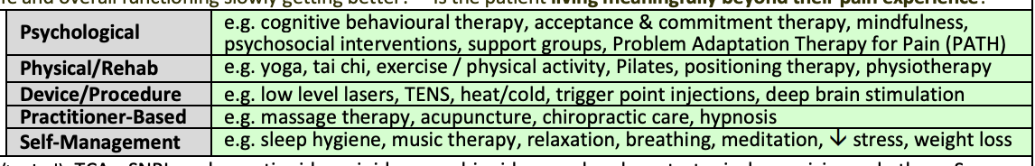
Education/counseling | Empathize: listen, provide validation and acknowledge symptoms as real, try to understand, pain has a psychological component  Help set goals: goals have to be long term and holistic, try to live alongside the pain, goals have to be realistic functional goals and not pain scores (ex. Ability to play with grandkids), monitor for changes in pain and severity (is their life function getting better).
Prescription Tips | Pharmacological agents include: ASA/NSAID, TCA, SNRI, gabapentinoids, opioids, cannabinoids, muscle relaxants, topical capsaicin.  Analgesics: ex. Acetaminophen, NSAID, opioids have a quicker onset, and are used PRN only prior to the activity that triggers the pain, frequency of dosing should be monitored closely.  -if patients have a stable scheduled dose there is increased benefit with switching to a long acting agent  -make only one drug therapy change at a time to have accurate benefits or adverse effects.  -make sure the patient is on the proper dose and duration before assessing for success and before stating patient has treatment failure.  -Before considering a class ineffective try one alternative in the class  -wait 4-6 weeks for full effect  -more benefits seen with a team approach and taking a hollistic approach and treating underlying cormobidities
Pediatric | Use faces pain scale revised for assessing pain in kids over the age of 4  Sucrose 24% used for infants over 18 months for procedural pain  Non-pharmacological pain: explanation of pain, distraction, breastfeeding, hot/cold  -”cough trick”- cough prior and a second cough at the same time as receiving vaccine to reduce pain  -Distraction Techniques for Kids:  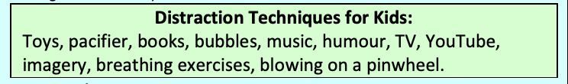  -use mg/kg dosing for medication  -avoid alternating acetaminophen and ibuprofen as there is room for potential errors  -avoid codeine-toxicity risk
Pharmacological Therapy
Drug/Dose | Indication | Adverse fx (AE) and Drug interactions (DI) | Contraindications & special considerations
1st Line Therapies
AEs:

DIs:
2nd Line Therapies
Notes
Monitoring
Referral
Other notes

Name of Condition (TEMPLATE- DO NOT REMOVE)
Def’n
Therapeutic goals
Algorithm
Non-pharmacological options
Education/counseling
Pharmacological Therapy
Drug/Dose | Indication | Adverse fx (AE) and Drug interactions (DI) | Contraindications & special considerations
1st Line Therapies
AEs:

DIs:
2nd Line Therapies
Notes
Monitoring
Referral
Other notes

Name of Condition (TEMPLATE- DO NOT REMOVE)
Def’n
Therapeutic goals
Algorithm
Non-pharmacological options
Education/counseling
Pharmacological Therapy
Drug/Dose | Indication | Adverse fx (AE) and Drug interactions (DI) | Contraindications & special considerations
1st Line Therapies
AEs:

DIs:
2nd Line Therapies
Notes
Monitoring
Referral
Other notes

Name of Condition (TEMPLATE- DO NOT REMOVE)
Def’n
Therapeutic goals
Algorithm
Non-pharmacological options
Education/counseling
Pharmacological Therapy
Drug/Dose | Indication | Adverse fx (AE) and Drug interactions (DI) | Contraindications & special considerations
1st Line Therapies
AEs:

DIs:
2nd Line Therapies
Notes
Monitoring
Referral
Other notes

Name of Condition (TEMPLATE- DO NOT REMOVE)
Def’n
Therapeutic goals
Algorithm
Non-pharmacological options
Education/counseling
Pharmacological Therapy
Drug/Dose | Indication | Adverse fx (AE) and Drug interactions (DI) | Contraindications & special considerations
1st Line Therapies
AEs:

DIs:
2nd Line Therapies
Notes
Monitoring
Referral
Other notes

